Statement of Account Portrait = 121
Go to reports/create

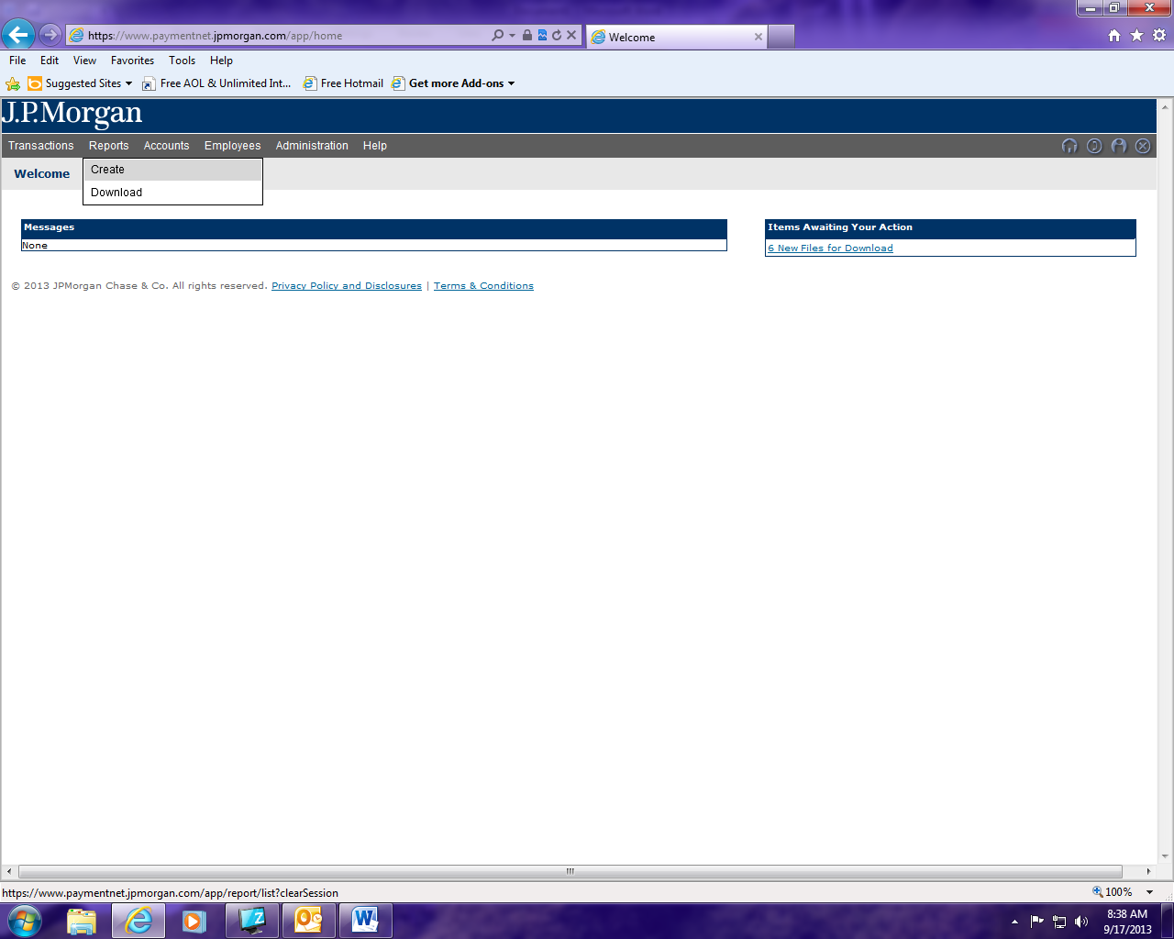

From the drop down menu select: Transaction

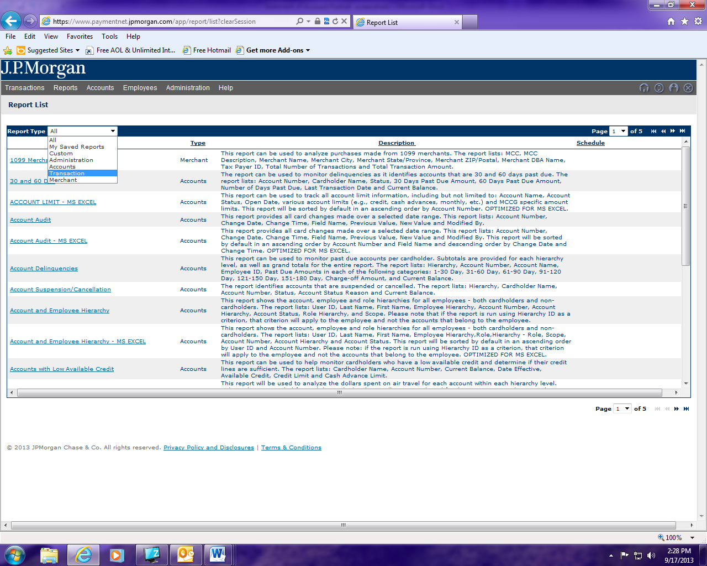

Locate the report Statement of Accounts Portrait and click on it.

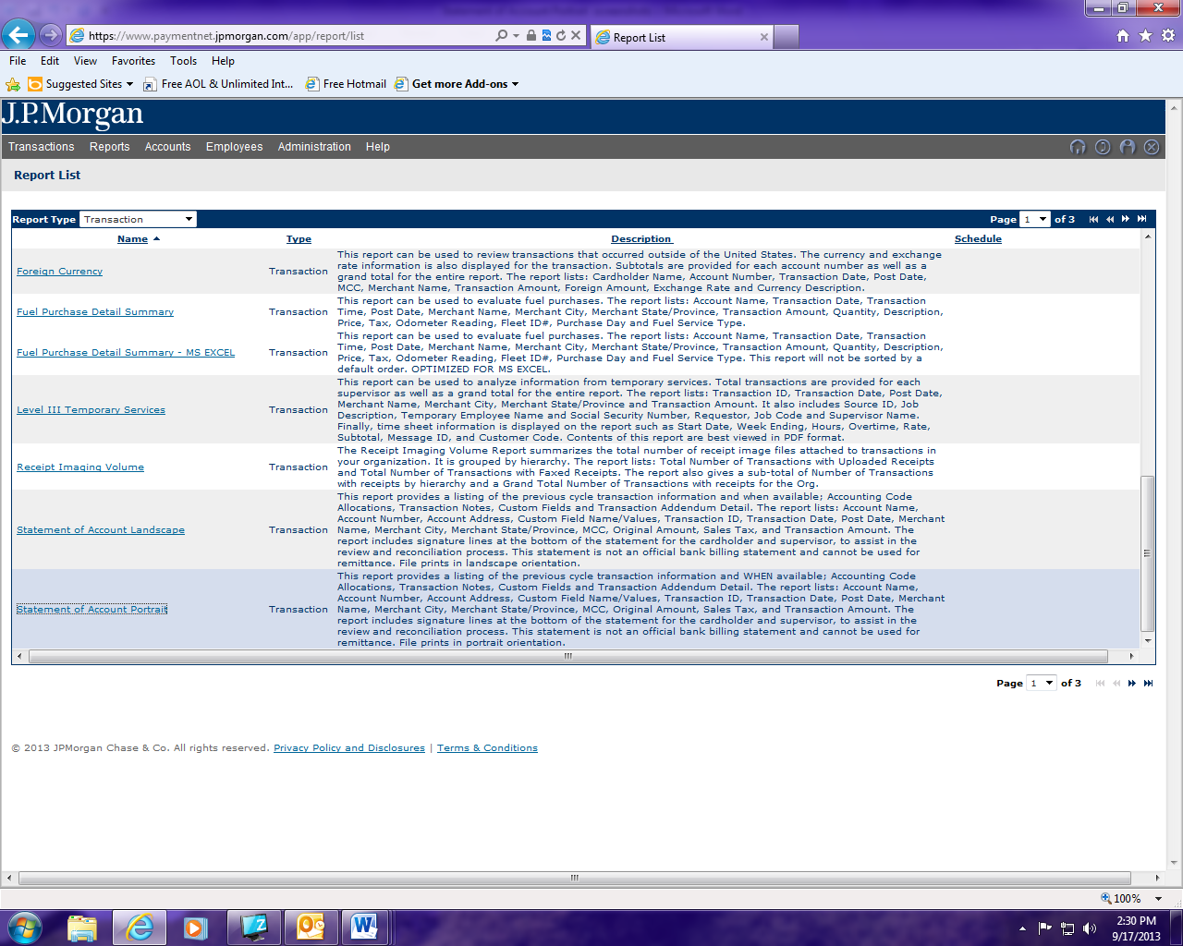

- Name your report/select report format
- Select your date range/from drop down menu select “cycle Is”/choose billing cycle needed
- Heirarchy: click on + icon and select your agency by clicking on the + sign next to ST of CT. Note if you remember the ID for your agency you can just key it in.
- Click on process report.

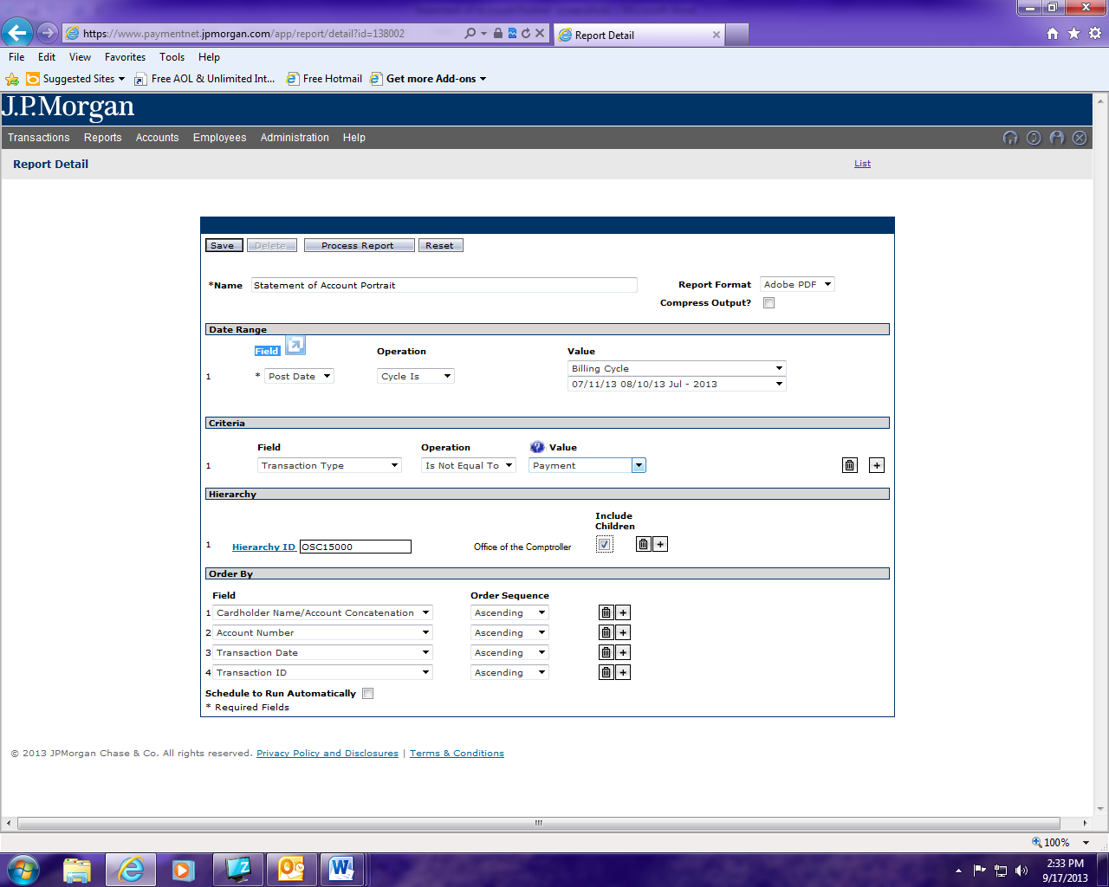

Available downloads screen will come up showing the status of the report just run.
Once report status is successful run the report by clicking on report.

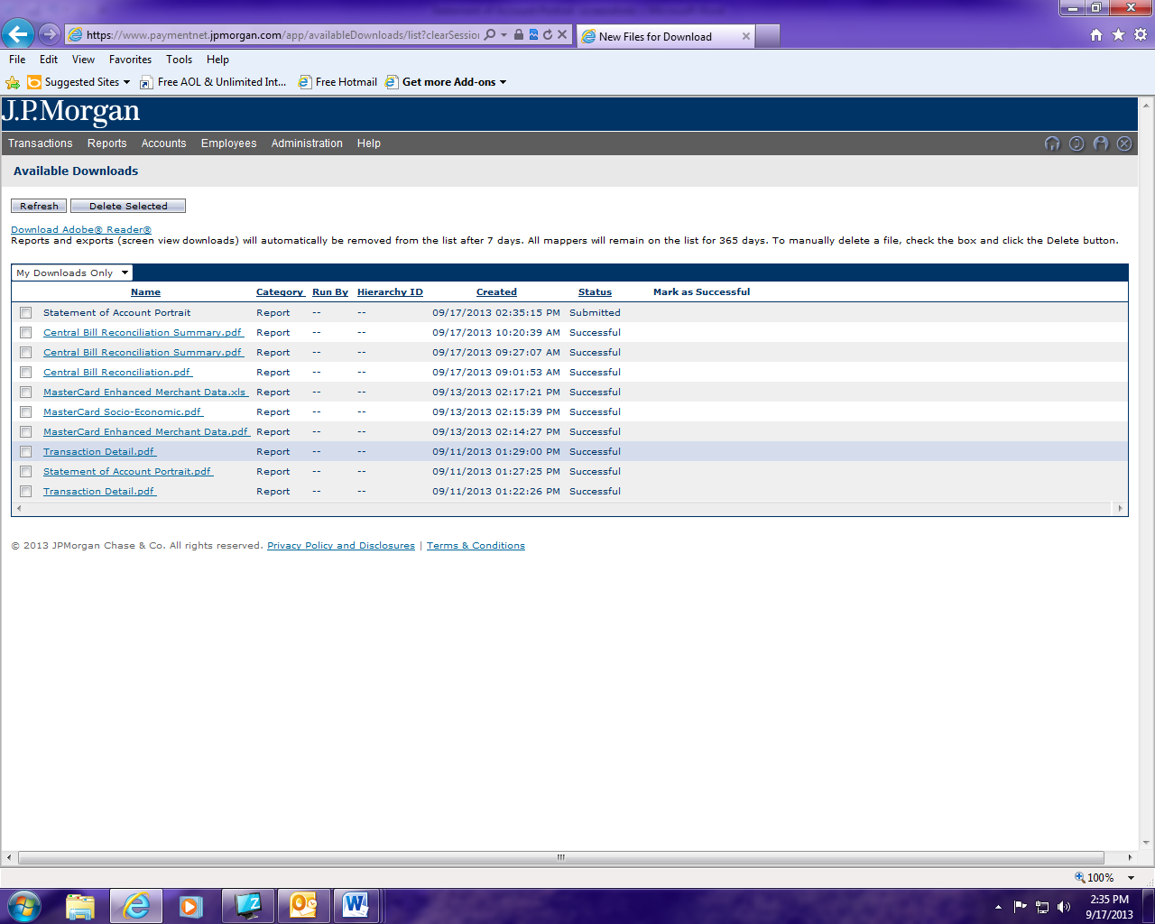

At bottom of screen you have the option to either open or save report.

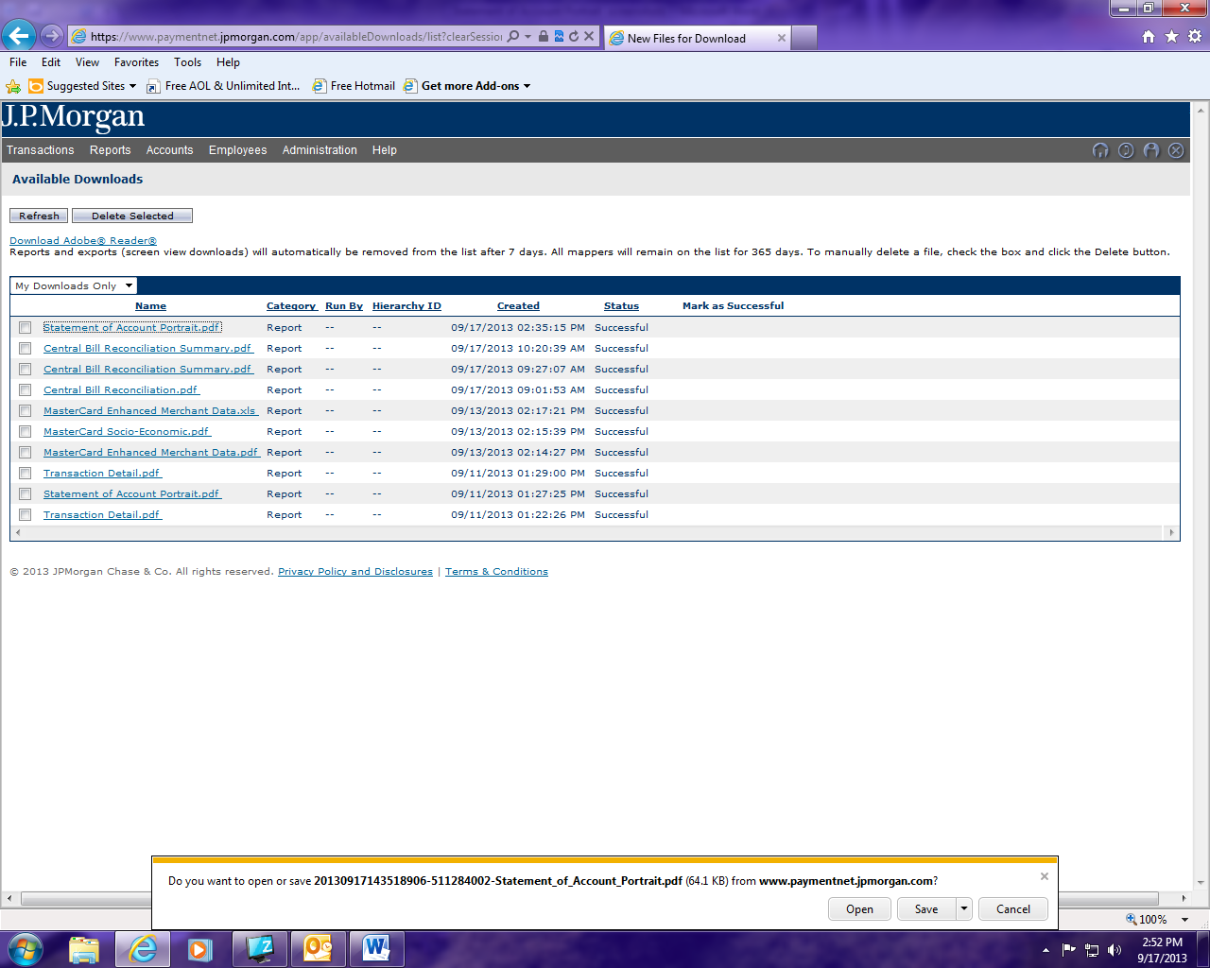

Sample of the report.

