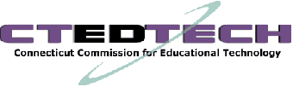

Meeting Agenda – March 25, 2010
State Office Building, 165 Capitol Ave Hartford, Room 307A
10:00-12:00

- Approval of Meeting Minutes, October 22, 2009

- Report of Commission Chair

- Tech-4-All-CT progress report

- Report on Educational Technology Initiatives, by Commission Membership

- Update on CT’s Technology Participation in the American Recovery and Reinvestment Act (ARRA)

  - Broadband
  - Educational Technology
  - Other

- Advisory Councils

- Announcements
  - May 21, 2010, 10:00 – 12:00, Charter Oak State College,
(New Britain)

- Public Comment

