|  |
| --- |
| Connecticut State Department of Education  Performance Office |
| SEDAC User Guide  Step by Step Procedures |
|  |

|  |
| --- |
| Version 9.0  10/1/2019 |

Table of Contents

Objective 3

Documentation Change Log 4

Entire document 5

Contact Information 7

Procedures 8

Administrative Procedures 8

How to Access SEDAC 8

How to Update Your Contact Information 12

How to Change Your Password 12

SEDAC Data Collection Procedures 13

How to Add an IEP Student to SEDAC 13

How to Add a Services Plan Student to SEDAC 17

How to Upload your Students to SEDAC 23

How to Exit a Services Plan Student from SEDAC 27

Citations of Noncompliance 29

How to Acknowledge a Citation of Noncompliance 29

Administrative Overrides (AO) 31

How to Acknowledge a Citation of Noncompliance/Generation of an Administrative Override (AO) 31

Data Cleaning 34

Potential Noncompliance 34

How to Resolve Cases of Potential Noncompliance due to District Error on the Misreported Student(s) in SEDAC Certified Oct 1 Child Count 34

How to Resolve Cases of Potential Noncompliance due to District Error on the Student(s) Missing from SEDAC Certified Oct 1 Child Count 36

How to Resolve Cases of Potential Noncompliance due to DCF 603 38

Case Management 39

How to Resolve an Orphan Record 39

How to Resolve Total School Hours over 40 Hours 40

How to Resolve Primary Disability for ED166 Discipline Report 41

How to Resolve Students Missing Nexus Information 42

How to Resolve Students with less than 25 Total School Hrs/Wk (KF-12) 43

How to Certify your SEDAC Student Data for the Federal Child Count 44

Mandatory Off-cycle Reports 45

How to add the Resolution Meetings data to SEDAC 45

How to Access the Birth to Three Notification Reports 47

CSDE's Statement of Nondiscrimination 55

# Objective

The purpose of the SEDAC User Guide is to provide Districts with procedures and guidance for submitting data regarding the use of this data collection.

The SEDAC User Guide is organized into four separate documents:

C:\Documents and Settings\Saumellr\Local Settings\Temporary Internet Files\Content.IE5\JZOM6L3F\MC900445732[1].wmfHandbook or reference guide on purpose of this collection and definition of data collected

C:\Documents and Settings\Saumellr\Local Settings\Temporary Internet Files\Content.IE5\ZJD4FI1X\MC900014130[1].wmfC:\Documents and Settings\Saumellr\Local Settings\Temporary Internet Files\Content.IE5\IHJIXT1V\MC900434539[1].wmfC:\Documents and Settings\Saumellr\Local Settings\Temporary Internet Files\Content.IE5\KYXMKMTR\MC900014132[1].wmf Step by step procedures for use of the system

C:\Documents and Settings\Saumellr\Local Settings\Temporary Internet Files\Content.IE5\AZNQ3Q82\MC900089048[1].wmf Frequently Asked Questions (FAQs)

C:\Documents and Settings\Saumellr\Local Settings\Temporary Internet Files\Content.IE5\AZNQ3Q82\MC900412396[1].wmf Appendix of terminology and references

***Documentation Standards***

Standards used in this documentation include the following:

* FIELDS displayed on a screen are referenced using ALL CAPS
* Field **values** are highlighted in **bold**
* *Screens* are referenced using *italics*
* **Buttons** or **menu selections** are in **bold**

Look for text in red where new information has been added or existing information has been changed.

 Represents important information or cautionary instructions related to data reporting.

Represents helpful tips and references to other sections of documentation for related topics.

 Represents reminders of information previously stated related to the current topic.

# Documentation Change Log

| Version | Section / Page | Date | Description |
| --- | --- | --- | --- |
| 1.00.00 |  | 8/12/11 | Published |
|  | Mandatory Off-cycle Reports p. 27 | 9/20/11 | Added How to add the Resolution Meetings data to SEDAC |
|  | How to Upload your Students to SEDAC p. 21 | 11/15/11 | For IEP Students, removed LAST NAME having to match. |
|  | How to add the Resolution Meetings data to SEDAC p. 27 | 4/30/12 | Updated step 7 HEARING REQUEST DATE to DATE HEARING REQUEST RECEIVED |
|  | Nondiscrimination Statement p. 55 | 4/30/12 | Updated with 9-30-2011 version |
|  | How to Resolve Cases of Potential Noncompliance due to District Error on the Student(s) Missing from SEDAC Certified Oct 1 Child Count p. 37 | 7/31/12 | Added note about when students will not be removed from a district’s report. |
|  | How to Acknowledge a Citation of Noncompliance/ Generation of an Administrative Override p. 32 |  | In order for Connecticut to be in compliance with Section 300.303 of IDEA, beginning with the SEDAC 10/1/2012 Child Count collection, the following citation warning for MRE has been added: if **MOST RECENT EVALUATION** is more than 3 years from the last reevaluation date, the District is **Out of Compliance**. |
|  | How to Access the Birth to Three Notification Reports  p.45 | 8/10/12 | Updated with 2011 IDEA Part C Regulations 303.209  Updated data is updated nightly |
|  | How to Resolve Primary Disability for ED166 Discipline Report p. 42 | 9/4/12 | Added NOTE about where a student may have been recently identified as a student with disabilities. |
|  | How to Upload your Students to SEDAC p. 23 | 9/28/12 | Added information on identifying SASID#s that do not exist under View IEP/Services Plan students and SASID#s that did not upload |
|  | How to Resolve an Evaluation Timeline Eligible Record not in SEDAC p.43 | 10/18/12 | Added |
|  | Early Intervention Participant P. 13 | 10/18/12 | Removed - moving this data field to Evaluation Timelines |
| 2.0 |  | 10/26/12 | Published |
|  | How to Resolve an Orphan Record p. 42 | 12/11/12 | Added Note about a student who is also listed under the correct SASID# in the View IEP Student list. |
|  | How to Acknowledge a Citation of Noncompliance/Generation of an Administrative Override (AO) p. 33 | 1/14/13 | Updated Note to reflect record will remain at a status code 5 (not 4) |
|  | How to Acknowledge a Citation of Noncompliance/Generation of an Administrative Override (AO) p. 34 & 35 |  | MRE beyond 3 years from Prev MRE, AR after 10/1 citation status at  ~~Initial Request~~ Finding Made, SDE Verification of Correction Needed |
|  | How to Access SEDAC, p. 8 | 9/23/13 | If you are using Windows 7 or later, preface your User name with sdectw\ (Username is entered as sdectw\username). |
|  | How to Resolve Students with less than 25 Total School Hrs/Wk (KF-12), p. 46 |  | Added |
|  | AGE, p. 14, 20 |  | age as-of October 1 of NEXT collection year |
|  | IEP Implementation Date, p. 15, 21 |  | Changed field name to IEP Start Date (pg. 11) |
| 3.0 |  | 11/1/13 | Published |
|  | Expected Grad Year | 1/7/14 | Removed all references to Expected Grad Year |
|  | Nondiscrimination Statement, p. 57 | 3/19/14 | Updated with March 2014 version |
| 4.0 |  | 11/3/14 | Published |
|  | How to Resolve Students Missing Nexus Information |  | Added |
| 5.0 |  | 11/13/15 | Published |
|  | How to Resolve an Evaluation Timeline Eligible Record, p. 45 | 2/24/16 | Updated |
|  | Entire document | 4/6/16 | Updated link name SEDAC (Batch and On-line Entry) to SEDAC: Special Education Data Application and Collection |
|  | How to Upload your Students to SEDAC, p. 26 | 8/17/16 | Updated identifying students where Record did not upload |
| 6.0 |  | 11/1/16 | Published |
|  | Fax Number | Jan 2017 | Updated |
|  | How to Certify your SEDAC Student Data for the Federal Child Count | Jan 2017 | Updated – Moved to Electronic Certification |
|  | Mandatory Off-cycle Reports, p. 77 |  | Moved Birth to Three Notifications sections here. |
|  | Nondiscrimination Statement p. 104 | 11/8/17 | Updated with 2-1-2017 version |
| 7.0 |  | 11/9/17 | Published |
|  | How to Resolve an Evaluation Timeline Eligible Record |  | Removed. This report was moved to Evaluation Timelines |
|  | What do we use for the NEXUS DISTRICT ENTRY DATE? | 5/8/18 | Clarified  Report the date in PSIS Registration:   * + 1. that the parent signed the IEP Consent for Initial Provision of Special Education (ED626), on or after Eligibility Determination.\***~~OR~~**   *In the case of a parent request for delayed entry into school for children ages 3, 4 or 5 report the District Entry Date (example: 4 year old found eligible for special education in May, parent requests to delay start of school until the fall).   1. ~~the 1st day the~~ if a student with disabilities is transferring into your district, report the District Entry Date. **~~OR~~** 2. if a DCF-603 is involved, report the “as of” date of the DCF-603. |
|  | Extracurricular Activities | May 2018 | Field Eliminated beginning with the 10/1/18 collection.  Removed all references. |
|  | Case Manager | May 2018 | Field Eliminated beginning with the 10/1/18 collection.  Removed all references. |
|  | Birth to Three Notification Reports | May 2018 | Updated titles & explanations of reports. |
| 8.0 |  | 9/14/2018 | Published |
|  | Child Count Verification Reports | 2/4/2019 | Replaced Federal Child Count Extract Sign-off with Federal Child Count Certification |
|  | How to Resolve cases on the Exit Report–SEDAC Certified Oct Collection compared to Subsequent PSIS Collections |  | Disabled Exit Report – SEDAC Oct compared to subsequent PSIS Collections 11/5/2018. Removed all references. |
| 9.0 |  | 10/1/19 | Published |

# Contact Information

SEDAC

| **Contact** | **Name** | **Email** | **Phone** |
| --- | --- | --- | --- |
| Bureau of Special Education Consultant | Your District Liaison | | 860-713-6910 |
| SDE Data Manager | Laura Guerrera | [Laura.Guerrera@ct.gov](mailto:Laura.Guerrera@ct.gov) | 860-713-6898 |
| Analyst | Diane Murphy | [Diane.Murphy@ct.gov](mailto:Diane.Murphy@ct.gov) | 860-713-6891 |

Resolution Meetings

| **Contact** | **Name** | **Email** | **Phone** |
| --- | --- | --- | --- |
| Bureau of Special Education Consultant | Mary Jean Schierberl | [Maryjean.Schierberl@ct.gov](mailto:Maryjean.Schierberl@ct.gov) | 860-713-6943 |
| SDE Data Manager | Laura Guerrera | [Laura.Guerrera@ct.gov](mailto:Laura.Guerrera@ct.gov) | 860-713-6898 |
| Analyst | Diane Murphy | [Diane.Murphy@ct.gov](mailto:Diane.Murphy@ct.gov) | 860-713-6891 |

Discipline / Suspension and Expulsion

| **Contact** | **Name** | **Email** | **Phone** |
| --- | --- | --- | --- |
| Bureau of Special Education Consultant | Mary Jean Schierberl | [Maryjean.Schierberl@ct.gov](mailto:Maryjean.Schierberl@ct.gov) | 860-713-6943 |
| SDE Data Manager/Analyst | Keryn Felder | [Keryn.Felder@ct.gov](mailto:Keryn.Felder@ct.gov) | 860-713-6833 |
| SEDAC – ED166 Primary Disability Report Manager | Laura Guerrera | [Laura.Guerrera@ct.gov](mailto:Laura.Guerrera@ct.gov) | 860-713-6898 |

**Caution:** The Family Educational Rights & Privacy Act (FERPA; 20 U.S.C. § 1232g; 34 CFR Part 99) prohibits disclosure of personally identifiable information from students' education records.

**DO NOT EMAIL Student Names**. You may email student SASIDs.

# C:\Documents and Settings\Saumellr\Local Settings\Temporary Internet Files\Content.IE5\ZJD4FI1X\MC900014130[1].wmfC:\Documents and Settings\Saumellr\Local Settings\Temporary Internet Files\Content.IE5\IHJIXT1V\MC900434539[1].wmfC:\Documents and Settings\Saumellr\Local Settings\Temporary Internet Files\Content.IE5\KYXMKMTR\MC900014132[1].wmf Procedures

## Administrative Procedures

### How to Access SEDAC

**Prerequisites**

* Authorization for the State of Connecticut Department of Education District website at <https://www.csde.state.ct.us/>
* Authorization for the SEDAC: Special Education Data Application and Collection system

**Step Action**

1. Using Internet Explorer, go to the <https://www.csde.state.ct.us/> website. The system displays the State Department of Education Home Page.
2. Select the **ENTER** button. The system displays the *Connect to sdectw.doit.state.ct.us* network login screen.

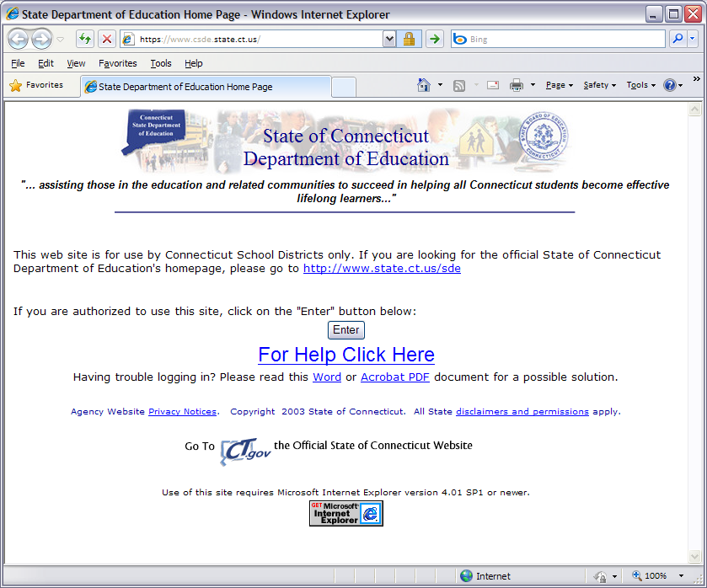

1. Enter your network USER NAME and PASSWORD and select **OK**. If you are using Windows 7 or later, preface your User name with sdectw\ (Username is entered as sdectw\username). The system displays the *State Department of Education Home Page*.

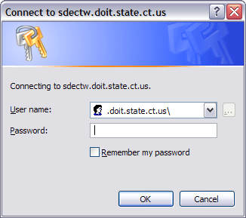

**Note:** If you do not have a network user name or password, please contact your Superintendent for authorization procedures.

1. Select the **SEDAC: Special Education Data Application and Collection** menu option. The system displays the *SEDAC Login to SEDAC* screen.

** Note:** If you do not have a SEDAC USER ID or you need your PASSWORD reset, please contact the CSDE SEDAC Data Manager.

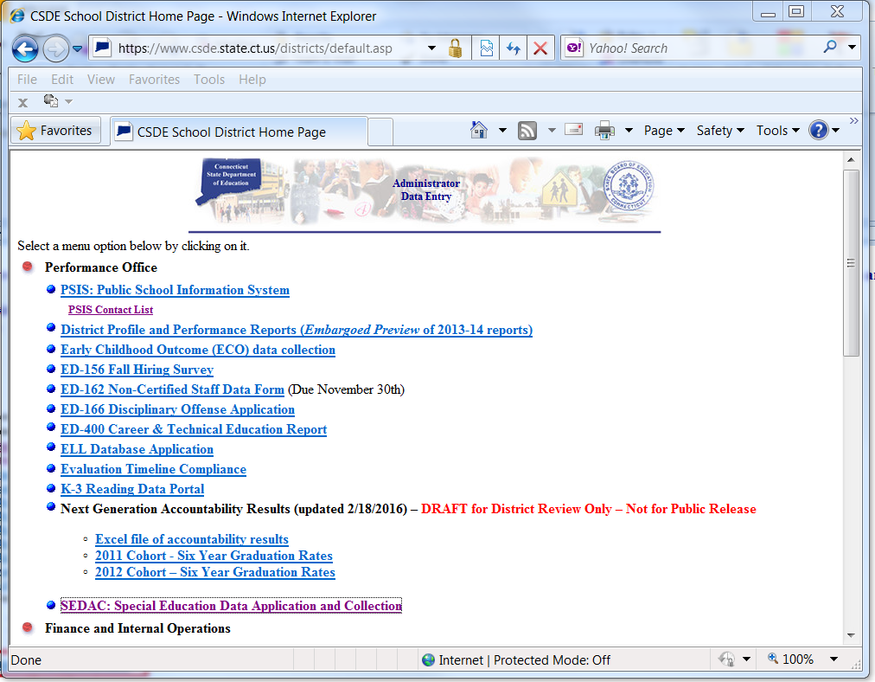

1. Read the terms of use and select the check box to indicate you have read and agree to the terms of the site. Enter your USER ID and PASSWORD, and select **Login**. The system displays the *Special Education Data Application and Collection* welcome screen.

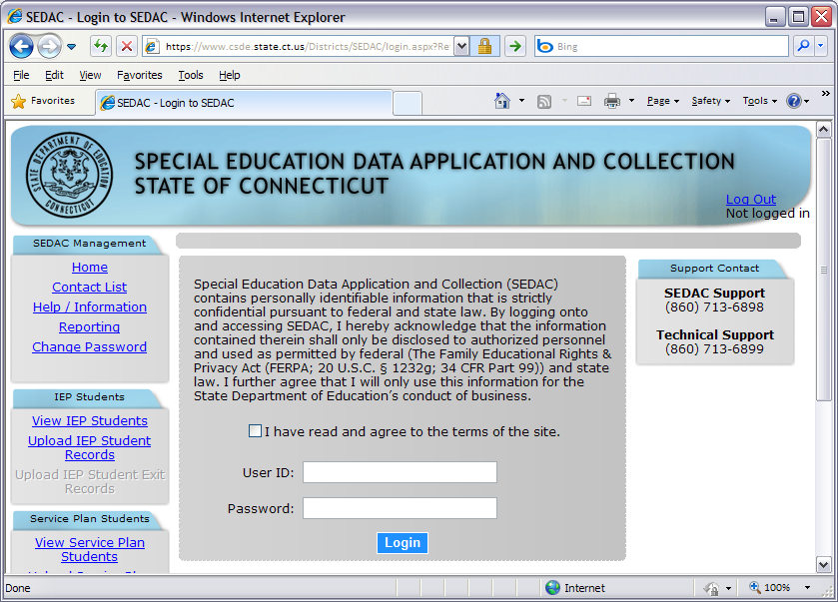

**Note:** All State systems have a 20 minute inactivity time-out period. If there is no activity, in SEDAC, the system will display this screen for you to log-in again.

1. Welcome to the Special Education Data Application and Collection (also known as SEDAC)!

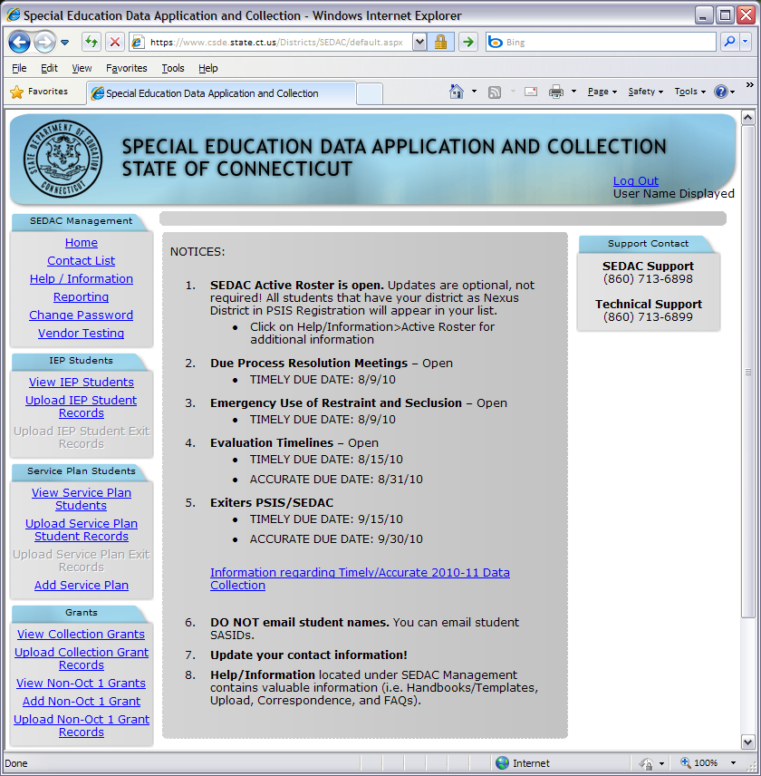

1. This procedure is complete.

### How to Update Your Contact Information

It is the districts’ responsibility to keep SEDAC contact and director information accurate. It is imperative the district’s contact information is kept up-to-date in SEDAC.  In addition to SEDAC using the contact information for all SEDAC correspondence, the director’s contact information is used by the Bureau of Special Education for correspondence.

**Prerequisites**

* Authorization for the SEDAC: Special Education Data Application and Collection system

**Step Action**

1. Select **Contact List** from the SEDAC Management menu. The system displays the *Contacts* screen with your district’s contact information at the top of the screen.
2. Select **Edit** to change your contact information. The system displays the *Contacts* screen for your changes.
3. Verify or update appropriate information and select **Update** when complete. The system displays the *Contacts* screen with your district’s new contact information at the top of the screen.
4. This procedure is complete.

### How to Change Your Password

**Prerequisites**

* Authorization for the SEDAC: Special Education Data Application and Collection system

**Step Action**

1. Select **Change Password** from the SEDAC Management menu. The system displays the *Reset Your Password* screen with your ASSIGNED DISTRICT and USER ID.
2. Enter a new Password twice to confirm entry and select **Reset Password**. The system displays a message indicating the password was saved successfully or instructions to reenter if the values do not match.
3. If the values did not match or were rejected for any reason, reenter the new password and its confirmation and select **Reset Password**.
4. This procedure is complete.

## SEDAC Data Collection Procedures

### How to Add an IEP Student to SEDAC

Use this procedure to enter your IEP student data using online or hand entry to the SEDAC collection. IEP Students are available for SEDAC reporting based on data reported in PSIS.

* During SEDAC October 1 Child Count the NEXUS DISTRICT and SPECIAL EDUCATION indicator of **Y-YES** are used from PSIS October Collection to determine the list of students displayed for your district.
* During SEDAC Active Roster the NEXUS DISTRICT is used from PSIS Registration to determine the list of students displayed for your district.

**Prerequisites**

* Authorization for the PSIS Registration and PSIS October Collection (PSIS Data Manager)
* Authorization for the SEDAC: Special Education Data Application and Collection system
* SEDAC open
* The collected data for entry into the system

**Step Action**

1. Log in to SEDAC
2. Does the student display in SEDAC on your district’s *View IEP Students* screen?
   * **Yes** - Go to Step 7.
   * **No** - Go to Step 3.

**Steps for PSIS Data Manager**

1. Log-in to PSIS Registration.
2. Enter student’s SASID and complete the following fields in PSIS.
   * **If this is a new student**, enter the following for SEDAC purposes, and any other PSIS required data:
     + NEXUS DISTRICT
     + NEXUS DISTRICT ENTRY DATE.
   * **If the student exists** **in PSIS** verify and update where necessary.
     + NEXUS DISTRICT
     + NEXUS DISTRICT ENTRY DATE.
3. Log-in to PSIS October Collection.

During SEDAC October 1 Child Count:

* + **If this is a new student**, enter the following for SEDAC purposes, and any other PSIS required data:
    - NEXUS DISTRICT
    - SPECIAL EDUCATION indicator is Yes.
  + **If the student exists in PSIS** verify and update where necessary.
    - NEXUS DISTRICT
    - SPECIAL EDUCATION indicator is Yes.

1. Your student is displayed in SEDAC for further data collection, once the NEXUS DISTRICT and during SEDAC October 1 Child Count, when the SPECIAL EDUCATION indicator is Yes.

**Steps for SEDAC Data Manager**

1. Select **View IEP Students** from the IEP Students menu. The system displays a list of students for your selection on the *viewing your students* screen.

** Reference:** Review the *PSIS and SEDAC Data Fields* section of the Handbook-Reference Guide document for descriptions of each field and the SEDAC rules of entry.

1. Select the NAME of your student. The system displays the *Viewing your student’s details* screen.

**Note:** If the student has been reported in SEDAC before, the data is retrieved from the most recent SEDAC October Collection.

1. On the **Student** tab:
   * The AGE calculated during the SEDAC October Collection is as of October 1 of the current school year.
   * During SEDAC Active Roster the AGE is calculated as of October 1 of NEXT collection year
2. Review the DATE OF BIRTH, GRADE, FACILITY CODE 1 and SPECIAL PROGRAM STATUS.
   * The SPECIAL PROGRAM STATUS during the SEDAC October Collection comes from the PSIS October collection.
   * Since PSIS Registration does not contain SPECIAL PROGRAM STATUS, it is available for selection during SEDAC Active Roster.
3. If this is a new student, enter the following fields, otherwise review and update when necessary:
   * HOME FACILITY CODE
   * PRIMARY DISABILITY
4. Select the **General Info** tab.
5. If this is a new student, enter the following fields, otherwise review and update when necessary:
   * MOST RECENT EVALUATION DATE (update every 3 years)
   * ANNUAL REVIEW / PPT TO DEVELOP THE FIRST IEP (update each year)
   * IEP Start Date (pg. 11)
   * PARENT ADDRESS information.
6. If this student is 16 or older (not allowed if younger than AGE of 14), enter the following fields:
   * SECONDARY TRANSITION IN PLACE
   * WAS THE STUDENT INVITED TO THE PPT?
   * DID THE STUDENT ATTEND THE PPT?
   * WAS AN OUTSIDE AGENCY INVITED TO THE PPT?
   * WHAT IS THE ACADEMIC PROGRAM?
7. Select the **Hours / Services** tab.
8. If this is a new student, enter the following fields, otherwise review and update when necessary:
   * TOTAL SCHOOL (HOURS/WEEK)
   * SPECIAL EDUCATION (HOURS/WEEK)
   * NON-DISABLED PEER (HOURS/WEEK)
     + % TWNDP (calculated in SEDAC) NON-DISABLED PEER (HOURS/WEEK) divided by TOTAL SCHOOL (HOURS/WEEK)
     + FEDERAL ENVIRONMENT CALCULATION (calculated in SEDAC)
       - Regular Class 80-100%
       - Regular Class 40-79%
       - Regular Class 0-39%
       - Separate School
       - Residential Facility
       - Hospital/Homebound
       - Correctional Facility
       - Parent Placement

** Reference**: For more information on the calculation of this field see the *SEDAC Reporting Categories* section of the *Appendix* document.

* + EXTENDED SCHOOL YEAR REQUIRED
  + RELATED SERVICES

1. Select the **PG 12 RDC** tab.
2. If this is a new student, enter the following fields, otherwise review and update when necessary:
   * FAPE AT THREE is calculated for students AGES **2 or 3** based on the ANNUAL REVIEW/PPT TO DEVELOP THE FIRST IEP date.
     + If date is before DATE OF BIRTH plus 3 years, then FAPE is **Met**
     + If date is after DATE OF BIRTH plus 3 years, then FAPE is **Not Met**
   * If AGE is **2 or 3** and FAPE AT THREE is **Not Met**, enter REASON FAPE AT THREE NOT ON TIME and FAPE AT THREE OTHER / DATE (if appropriate)
   * EC PROGRAM HOURS (Not part of the IEP)
   * AGE 3-5 PLACEMENT/SETTING (Not limited to the IEP)
   * PRIMARY REASON FOR EDUCATIONAL LOCATION
   * WHO ESTABLISHED NON-EDUCATION BOUNDARY
     + Required if PRIMARY REASON FOR EDUCATIONAL LOCATION is **12-Non-educational Restriction / Treatment Boundary**
   * WHERE DOES THE STUDENT LIVE
3. Select **Save** when changes are complete. The system redisplays the *Student* tabon the *Viewing your student’s details* screen.
4. Did a *Citation of Noncompliance* message display?
   * **Yes** - Go to the next step.
   * **No** - This procedure is complete.
5. Were noncompliant data reported on this student?
   * **Yes** -Refer to the Citations of Noncompliance and Administrative Overrides section of this document.
   * **No** - Select **Cancel** to return to the student details and correct the data entered.
6. This procedure is complete.

### How to Add a Services Plan Student to SEDAC

Use this procedure to enter your Services Plan student data using online or hand entry to the SEDAC collection. Prior to entry to SEDAC the district where the private school is located must also register and unregister the student in PSIS Registration so that their town is listed as Nexus District.

Because Services Plan Students are not included in PSIS collections, but are required to be reported in Federal IDEA reports, some PSIS information must be reported in addition to the required fields for all other IEP students.

**Prerequisites**

* Authorization for the PSIS Registration system (PSIS Data Manager) or obtain a SASID from your PSIS Data Manager.
* Authorization for the SEDAC: Special Education Data Application and Collection system
* SEDAC open
* The collected data for entry into the system
* Student cannot have an active Services Plan or IEP SEDAC record in any district.

***PSIS Registration for Services Plan Students***

* Services Plan students need a SASID created in PSIS Registration where NEXUS DISTRICT in the most recent PSIS Registration record matches the logged on District prior to reporting in SEDAC.
* Student cannot have an active PSIS Registration record in any district (must have an EXIT DATE and EXIT TYPE).
* Cannot be reported in any district PSIS October Collection.
* The district providing the services plan is the REPORTING DISTRICT and NEXUS DISTRICT.
* The HOME FACILITY CODE must match the FACILITY CODE 1.

 **Important:** One major hold-up to reporting Services Plan students has been the inability to obtain a SASID without the parents of the student visiting the Public School and filling out a Registration Form.

Please know that federal and state regulations have no requirement for the student to be registered in the district in order to receive a Services Plan.

Districts may have a policy requiring parents to fill out the registration, but this policy cannot interfere with the mandatory delivery of special education services or with the federal reporting requirements.

#### Services Plan Rules

For-profit private schools do not qualify as either an elementary or secondary school under IDEA (Sections 300.13 and 300.36 of IDEA respectively) and thus, you have no responsibility under state or federal law to provide Child Find activities or services to any of these students **who are not residents of your district’s geographical boundaries**.

Districts are required to report students with disabilities that have been Parentally Placed in Private Schools. These are students who have been enrolled by their parents or guardians in parochial or other private schools and whose basic education is paid through private resources and who receive special education and related services at public expense from a local educational agency or intermediate educational unit under a Services Plan. Sections 300.130-300.139 of IDEA

##### Eligible for Services Plan

###### Not-For-Profit Facility (K-12)

* + **Evaluation Responsibility – District where Facility is Located**
  + If Eligible - IEP is offered by Resident Town *
  + If *offer for* IEP is refused - student is eligible for Services Plan by Location District.

###### Not-For-Profit Facility (Preschool Plus at Minimum a Kindergarten)

* + **Evaluation Responsibility – District where Facility is Located**
  + If Eligible - IEP offered by Resident Town *
  + If *offer for* IEP is refused - student is eligible for Services Plan by Location District.

*\* LEAs DO NOT have to develop an IEP if parents inform the LEA that they do not intend to enroll the student in the public schools.*

**Note:** After the evaluation, if the student is found eligible, the district where facility is located must get parental permission to provide information back to the resident town. If parent refuses, student is eligible for Services Plan by the district where the facility is located.

##### Not Eligible for Services Plan

###### For-Profit Facility (regardless of grade…Preschool; K-12)

* + **Evaluation Responsibility is Resident Town**
  + If Eligible - IEP offered by Resident Town *
  + If *offer for* IEP is refused - student is not eligible for Services Plan.

###### Not-For-Profit Facility (Preschool Only)

* + **Evaluation Responsibility is Resident Town**
  + If Eligible - IEP offered by Resident Town *
  + If *offer for* IEP is refused - student is not eligible for Services Plan.

*\* LEAs do not have to develop an IEP if parents inform the LEA that they do not intend to enroll the student in the public schools.*

**Step Action**

1. Does the student display in SEDAC on your district’s *View Services Plan Students* screen?
   * **Yes** - Go to Step 8.
   * **No** - Go to Step 2.

**Steps for PSIS Data Manager**

1. Log-in to PSIS Registration.

 **Important:** Services Plan students must not be reported in any district PSIS collection.

1. Enter student’s SASID and complete the following fields in PSIS.

The district where the private school is located must register and un-register the student in PSIS Registration so that their town is listed as NEXUS DISTRICT.

 **Important:** The district providing the Services Plan is both the REPORTING and NEXUS DISTRICT for a Services Plan student.

* + **If this is a new student**, enter the following for SEDAC purposes, and any other PSIS required data:
    - NEXUS DISTRICT
    - NEXUS DISTRICT ENTRY/EXIT DATE and DISTRICT EXIT DATE must be the same with a date of 7/1/10 or later in order to capture new PSIS RACE/ETHNICITY
    - NUMBER OF DAYS OF MEMBERSHIP AND ATTENDANCE is **0** (zero)
    - EXIT TYPE - Use the following EXIT TYPES when a services plan student is registered and un-registered in PSIS in order to obtain a SASID
      * **04-Transfer to a private, non-religiously-affiliated school in the same LEA**
      * **07-Transfer to a private, religiously-affiliated school in the same LEA**
  + **If the student exists**, verify the following PSIS information and update where necessary.
    - NEXUS DISTRICT
    - NEXUS DISTRICT ENTRY/EXIT DATE and DISTRICT EXIT DATE must be the same with a date of 7/1/10 or later in order to capture new PSIS RACE/ETHNICITY
    - EXIT TYPE - Use the following EXIT TYPES when a services plan student is registered and un-registered in PSIS in order to obtain a SASID
      * **04-Transfer to a private, non-religiously-affiliated school in the same LEA**
      * **07-Transfer to a private, religiously-affiliated school in the same LEA**

**Steps for SEDAC Data Manager**

1. Log-in to SEDAC.
2. Select **Add Services Plan** from the Services Plan Students menu. The system displays the *Add new Services Plan Student* screen.

** Reference:** Review the *PSIS and SEDAC Data Fields* section of the Handbook-Reference Guide document for descriptions of each field and the SEDAC rules of entry.

1. Enter the student’s SASID, LAST NAME and DATE OF BIRTH and select **Search**. The system displays the *Student* tabon the *Viewing your student’s details* screen.

 **Important:** This student cannot be added if the SASID has not been registered and unregistered with a date of 7/1/10 or later in order to capture new PSIS RACE/ETHNICITY.

1. Select the NAME of your student. The system displays the *Viewing your student’s details* screen
2. Select **View Service Plan Students** from the Service Plan Students menu. The system displays a list of students for your selection on the *viewing your students* screen.
3. On the **Student** tab:
   * The AGE calculated during the SEDAC October Collection is as of October 1 of the current school year.
   * During SEDAC Active Roster the AGE is calculated as of October 1 of NEXT collection year
   * For Services Plan students verify Facility Code 1, GRADE and ELL or select the appropriate value if not specified.
4. If this is a new student, enter the following fields, otherwise review and update when necessary:
   * GRADE
   * FACILITY CODE 1
   * HOME FACILITY CODE
     + HOME FACILITY CODE must be the same as FACILITY CODE 1
       - ATTENDS HOME SCHOOL is **Yes** when FACILITY CODE 1 matches HOME FACILITY CODE
5. Select a PRIMARY DISABILITY.
6. Select the **General Info** tab.
7. If this is a new student, enter the following fields, otherwise review and update when necessary:
   * MOST RECENT EVALUATION DATE (update every 3 years)
   * ANNUAL REVIEW / PPT TO DEVELOP THE FIRST IEP (update each year)
   * IEP Start Date (pg. 11)
   * PARENT ADDRESS information.
8. Select the **Hours / Services** tab.
9. If this is a new student, enter the following fields, otherwise review and update when necessary:
   * TOTAL SCHOOL (HOURS/WEEK) should be typical for a student in the grade reported.
   * SPECIAL EDUCATION (HOURS/WEEK) should be minimal and reflect the Services Plan.
   * NON-DISABLED PEER (HOURS/WEEK) should reflect service delivery and be the same or close to the TOTAL SCHOOL HOURS PER WEEK for the student.
     + % TWNDP (calculated in SEDAC) is NON-DISABLED PEER (HOURS/WEEK) divided by TOTAL SCHOOL (HOURS/WEEK)
     + FEDERAL ENVIRONMENT CALCULATION (calculated in SEDAC)
       - Regular Class 80-100%
       - Regular Class 40-79%
       - Regular Class 0-39%
       - Separate School
       - Residential Facility
       - Hospital/Homebound
       - Correctional Facility
       - Parent Placement

** Reference**: For more information on the calculation of this field see the *SEDAC Reporting Categories* section of the *Appendix* document.

* + EXTENDED SCHOOL YEAR REQUIRED
  + RELATED SERVICES

1. Select the **PG 12 RDC** tab. Each year, review and update the following fields:
   * FAPE AT THREE is calculated for students AGES **2 or 3** based on the ANNUAL REVIEW/PPT TO DEVELOP THE FIRST IEP date.
     + If date is before DATE OF BIRTH plus 3 years, then FAPE is **Met**
     + If date is after DATE OF BIRTH plus 3 years, then FAPE is **Not Met**
   * If AGE is **2 or 3** and FAPE AT THREE is **Not Met**, enter REASON FAPE AT THREE NOT ON TIME and FAPE AT THREE OTHER / DATE (if appropriate).
   * EC PROGRAM HOURS (NOT PART OF THE IEP)
   * AGE 3-5 PLACEMENT/SETTING (not limited to the IEP)
   * PRIMARY REASON FOR EDUCATIONAL LOCATION
     + The PRIMARY REASON FOR EDUCATIONAL LOCATION must be **16-Services Plan**.
   * WHERE DOES THE STUDENT LIVE
2. Select **Save** when changes are complete. The system redisplays the *Student* tabon the *Viewing your student’s details* screen.
3. Did a *Citation of Noncompliance* message display?
   * **Yes** - Go to the next step.
   * **No** - This procedure is complete.
4. Were noncompliant data reported on this student?
   * **Yes -** Refer to the Citations of Noncompliance and Administrative Overrides section of this document.
   * **No** - Select **Cancel** to return to the student details and correct the data entered.
5. This procedure is complete.

### How to Upload your Students to SEDAC

Use this procedure to submit your IEP or Services Plan student data using a batch upload to the SEDAC collection.

IEP Students are available for SEDAC reporting based on data reported in PSIS.

* During SEDAC October 1 Child Count the NEXUS DISTRICT and SPECIAL EDUCATION indicator of **Y-YES** are used from PSIS October Collection to determine the list of students displayed for your district.
* During SEDAC Active Roster the NEXUS DISTRICT is used from PSIS Registration to determine the list of students displayed for your district. For Services Plan students not reported in the previous SEDAC Child Count, prior to entry to SEDAC the district where the private school is located must register and unregister the student in PSIS Registration so that their town is listed as Nexus District

** Reference:** The Upload Requirements section of the Handbook-Reference Guide document.

**Prerequisites**

* Authorization for the SEDAC: Special Education Data Application and Collection system
* SEDAC open
* Your computer has the technical requirements to upload a CSV file
* Verification your file is in proper format

**Reference:** Review the *Record Layout* section of the Handbook-Reference Guide document for details on format and required data. If the data are not in the correct format when you upload the file the records will be a STATUS of **4-Corrections Needed**. For example:

* Date fields are MMDDYYYY
* Primary Disability ##
* All required fields are complete for each record in your file
* During SEDAC October Child Count,for IEP students, the following fields in your upload file must match PSIS October Collection:
  + SASID
  + Date of Birth
  + Facility Code 1

During SEDAC Active Roster, for IEP students, the following fields in your upload file must match PSIS Registration:

* + SASID
  + Date of Birth

During both SEDAC October Child Count and Active Roster, for Services Plan students, the following fields in your upload file must match PSIS Registration:

* + SASID
  + Last Name
  + Date of Birth

**Step Action**

1. Using your worksheet program, save the file as a CSV file type by selecting **Save As**.

**Note**: The following screens are from Microsoft Office 2007. Your version may be different and therefore the steps may differ.

1. If your worksheet contains multiple sheets, the system displays the following message.

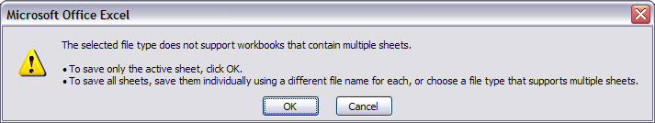

1. Select **OK**. The system continues the saving of the file and displays the following message.

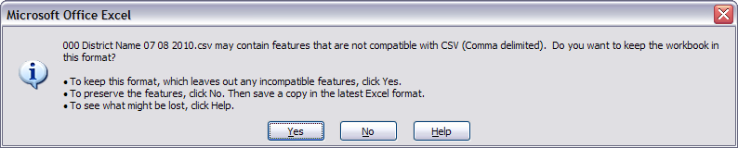

1. Select **Yes**. The system saves the file into the folder selected in Step 1.
2. Close the worksheet. The system displays the following message.

**Important**: Do not forget to close the file. If you do not close the file, you will receive CSV file errors when attempting to upload.

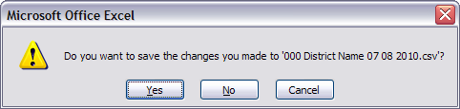

1. Select **Yes**. The system continues the saving of the file and displays the following message.

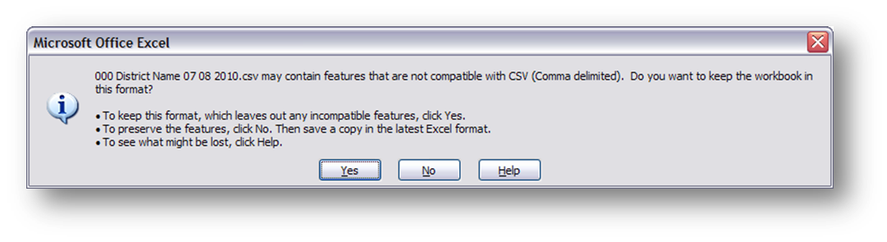

1. Select **Yes**. The system saves the file into the folder selected in Step 1.
2. Using the navigation menu on the left of the screen, select the **Upload IEP Student Records** or **Upload Services Plan Student Records** menu option. The system displays the *Upload* screen.
3. Select **Browse** and locate the file to upload. The system displays the Choose File to Upload dialog screen.
4. Locate and select your file and select **Open**. The system returns to the U*pload* screen.
5. Select **Upload**. The system displays the *Upload Results* screen. Error messages for each of the student entries are displayed on the screen after the upload is processed.
6. Select **Download Error Messages** to export the errors to a CSV file and Save the error messages report to your computer.

** Remember**: If you do not save the errors displayed on the screen, you will need to re-run the upload to get the errors again. They are not saved on a report at this time.

** Remember**: Every time you upload you replace the previously saved data. If corrections are made online, and the file is uploaded afterward, the online changes are overwritten with the data in the file. Please be sure to download your data each time changes are made online, if you want this data to be saved and updated on your local vendor system for future use.

1. Filter the Error Messages Report for Status=**Record did not upload**

**Identifying SASID #s that do not exist under View IEP/Services Plan students**

* For IEP students, Error=**The SASID could not be found** means the SASID# is not listed in SEDAC under View IEP students because in the PSIS October Collection
  + the SASID# is not reported, or
  + NEXUS indicator does not reflect your district, or
  + the SPECIAL EDUCATION indicator does not = YES
* For Services Plan students, Error=**The SASID could not be found** means the SASID# is not listed in SEDAC under View Services Plan students because in the PSIS Registration
  + the SASID# does not exist or
  + the SASID# has not been registered/unregistered with your town listed as NEXUS district

Contact the appropriate PSIS data manager to resolve immediately.

**Identifying SASID #s that exist under View IEP/Services Plan students, that did not upload**

* If a student’s SASID is found, but the student’s DOB or FACILITY CODE 1 cannot be matched the **Record did not upload**!
  + The SASID# is listed under IEP (Service Plan) Students, but NO data was uploaded.

**Important:** If completing via hand entry do not simply resolve red errors only, VERIFY every data field!

1. Once you have resolved each of the errors in your data file - Go to Step 1.
2. Select **View IEP [or Services Plan] Students** to review your student data.
3. This procedure is complete.

### How to Exit a Services Plan Student from SEDAC

Use this procedure when a student with disabilities transfers from one district to another, moves out of state, or returns to general education, they must be exited from SEDAC. Services Plan and IEP students are exited in two different methods.

**Step Action**

1. Log-in to SEDAC.
2. Select **View Services Plan Students** from the Services Plan Students menu. The system displays the *Viewing your students* screen.
3. If not already displayed, select the **previous** **Oct 1, YYYY Services Plan Students** collection from the VIEWINGlist. The system displays the *Viewing your students* screen for the data source selected.

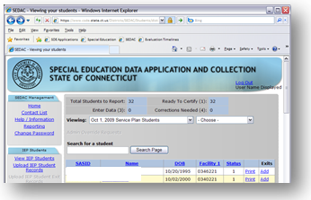

1. Select **Add** in the EXIT column.
2. Enter an EXIT DATE and select an EXIT TYPE. Select **Exit Student**. The system displays the *Viewing your students* screen.

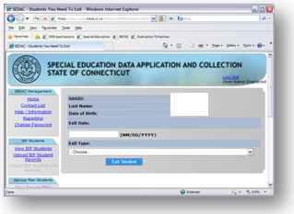

01 - Transfer to a different public school in the same local education agency in the same state

02 - Transfer to a public school in a different local education agency in the same state

03 - Transfer to a public school in a different state

04 - Transfer to a private, non-religiously-affiliated school in the same LEA

05 - Transfer to a private, non-religiously-affiliated school in a different LEA in the same state

06 - Transfer to a private, non-religiously-affiliated school in a different state

07 - Transfer to a private, religiously-affiliated school in the same LEA

08 - Transfer to a private, religiously-affiliated school in a different LEA in the same state

09 - Transfer to a private, religiously-affiliated school in a different state

10 - Transfer to a school outside the country

11 - Transfer to an institution

12 - Transfer to a charter school

13 - Transfer to home schooling

15 - Graduated with regular, advanced, International Baccalaureate, or other diploma type

16 - Completed school with other credentials

17 - Death

20 - Reached maximum age for services

21 - Discontinued schooling

23 - Transfer to GED program/EDP

24 - Transfer to a postsecondary education

25 - Moved, not known to be continuing

26 - Transfer to a state approved full-time magnet school

27 - Transfer to an Adult High School Credit Diploma (AHSCD) program

**Note**: For Services Plan students who return to your public school use EXIT TYPE **01-Transfer to a different public school in the same local education agency in the same state**.

**Note**: Services Plan students cannot return to general education. The assumption behind returning to general education is that the student is remaining in the public school setting. Therefore, if a Services Plan student stops receiving special education or related services due to completion of their IEP goals, then use EXIT TYPE **04-Transfer to a private, non-religiously-affiliated school in the same LEA OR 07-Transfer to a private, religiously-affiliated school in the same LEA.**

Student will remain in the *Viewing your students* screen for the **Oct 1, YYYY Services Plan Students** Collection year. Student no longer appears in the District’s Services Plan SEDAC Active Roster list.

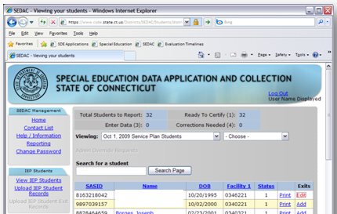

## Citations of Noncompliance

### How to Acknowledge a Citation of Noncompliance

Use this procedure when an exception condition arises for these specific SEDAC student data. These include:

* Secondary Transition – STUDENT INVITED TO ATTEND THE PPT
* Secondary Transition – OUTSIDE AGENCY INVITED TO ATTEND THE PPT
* FAPE AT THREE **Not Met**
* Student(s) Misreported in Certified Oct 1 Child Count
* Student’s Special Education indicator was changed from **Yes** to **No** in the PSIS October Collection; sometime after the SEDAC October 1 Child Count was certified.
* Missing Student(s) from Certified Oct 1 Child Count
* Student’s Special Education indicator was changed from **No** to **Yes** in the PSIS October Collection; sometime after the SEDAC October 1 Child Count was certified.

** Reference**: For more information on Citations of Noncompliance see *the Noncompliance Citation Messages* section of the *Appendix* document.

***Citation of Noncompliance***

STUDENT INVITED TO ATTEND THE PPT

**Action Needed:** You must review each citation below and select the check box to acknowledge each citation and then select OK.

Select **Cancel** if the data entered was incorrect.

You are out of compliance with Section 300.321 (b)(1) of IDEA, which states that you must invite the student with a disability to attend the PPT meeting where postsecondary goals and transition services will be discussed.

**🗹 Acknowledge Citation**

Example:

**Cancel**

**OK**

**Prerequisites:**

* Authorization for the SEDAC: Special Education Data Application and Collection system
* SEDAC October Collection or Active Roster open
* Acknowledgement of a Citation of Noncompliance requires all other data fields to have passed edit checks

**NOTE:** The record will remain at a status code 4 until the citation of noncompliance is acknowledged or the correct data are entered. The District can make the appropriate changes to a student’s record after the citation of noncompliance is acknowledged. If the reason the Citation was issued was found to be entered in error, once the correct data is entered, another pop-up notification will display, which the district will need to accept, in order to withdrawal the Citation from the District’s Summary of Noncompliance Report.

* **STUDENT INVITED TO ATTEND THE PPT**
  + IF the student is age 16 or older and STUDENT INVITED TO ATTEND THE PPT is **NO**, the District will be **Out of Compliance.**
* Citation will be displayed upon saving the record
  + Results in Noncompliance
* The District has to click the check box to acknowledge the citation and click OK
  + Adds tocitation count to the STUDENT INVITED TO ATTEND in the*Summary of Noncompliance Report in SEDAC*.
* **OUTSIDE AGENCY INVITED TO ATTEND THE PPT**
  + IF the student is age 16 or older and OUTSIDE AGENCY INVITED TO ATTEND THE PPT is **04-No, no outside agency was invited**, the District will be **Out of Compliance.**
* Citation will be displayed upon saving the record
  + Results in Noncompliance
* The District has to click the check box to acknowledge the citation and click OK
  + Adds tocitation count to the OUTSIDE AGENCY INVITED TO ATTEND in the*Summary of Noncompliance Report in SEDAC*.
* **FAPE AT THREE**
* IF the student is age 3 and FAPE AT THREE is **Not Met** and REASON FAPE AT THREE NOT ON TIME is **3-Other,** the District is **Out of Compliance**.
* Citation will be displayed upon saving the record
  + Results in Noncompliance
* The District has to click the check box to acknowledge the citation and click OK
  + Adds tocitation count to the FAPE AT THREE NOT ON TIME in the*Summary of Noncompliance Report in SEDAC*.
* **MISREPORTED STUDENT(S) IN SEDAC CERTIFIED OCT 1 CHILD COUNT (Handled after SEDAC is archived)**

Student’s Special Education indicator was changed from **Yes** to **No** in the PSIS October Collection, sometime after the SEDAC October Child Count was certified, the District may potentially be **Out of Compliance**.

* IF the Reason is 02 - District error
* Citation will be displayed upon clicking submit
  + Results in Noncompliance
* District has to click the check box to acknowledge the citation and click OK
* Adds to citation count to the STUDENT(S) MISREPORTED IN OCT 1 CHILD COUNT in the Summary of Noncompliance Report in SEDAC.
* **STUDENT(S) MISSING FROM SEDAC CERTIFIED OCT 1 CHILD COUNT (Handled after SEDAC is archived)**

Student’s Special Education indicator was changed from **No** to **Yes** in the PSIS October Collection, sometime after the SEDAC October Child Count was certified, the District may potentially be **Out of Compliance**.

* IF the Reason is 01 - Received DCF 603 after SEDAC freeze
  + Upon clicking submit, the District has to click the acknowledge check box and click OK.
  + The District must immediately fax the DCF 603 form to the attention of “SEDAC - Verification of DCF 603” to (860) 326-0547. *(Please note district name & SASID# on the DCF 603 form)*.
  + The CSDE will verify the DCF 603, if verified this will not result in noncompliance.
* IF the Reason is 02 - District error
  + Citation will be displayed upon clicking submit
    - Results in Noncompliance
  + District has to click the check box to acknowledge the citation and click OK
  + Adds tocitation count to the STUDENT(S) MISSING FROM OCT 1 CHILD COUNT in the*Summary of Noncompliance Report in SEDAC*.
  + Additionally, the district must enter the student in SEDAC Active Roster and update all fields reflecting the current IEP, so the record saves as a status code 1.

## Administrative Overrides (AO)

### How to Acknowledge a Citation of Noncompliance/Generation of an Administrative Override (AO)

Use this procedure when an exception condition arises for these specific SEDAC student data. These include:

* Primary Disability
* Annual Review
* Most Recent Evaluation
* Secondary Transition in Place

**NOTE:** The record will remain at a status code 5 until the override is approved or withdrawn.

The District can make the appropriate changes to a student’s record after an AO Citation is issued. If the reason the Citation was issued was found to be entered in error, once the correct data is entered, another pop-up notification will display, which the district will need to accept, in order to withdrawal the Citation from the District’s Summary of Noncompliance Report.

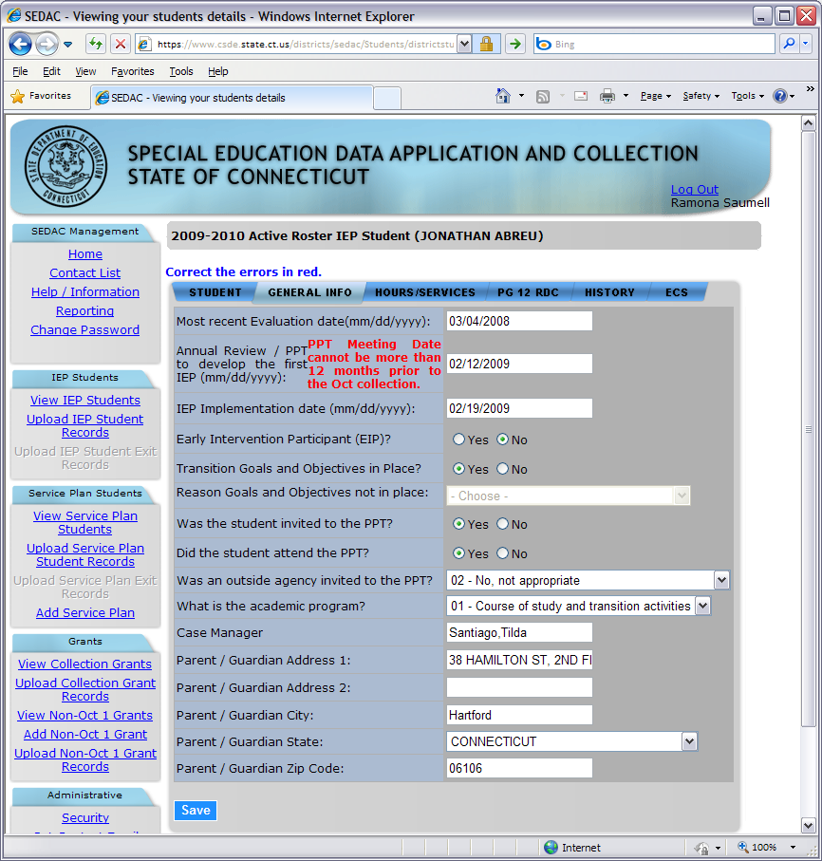

**OK**

**Cancel**

***Citation of Noncompliance***

**Action Needed:** You must review each citation below and select the check box to acknowledge each citation and then select OK. Select **Cancel** if the data entered was incorrect.

The Secondary Transition PPT Date entered is after 10/1. Secondary Transition is out of compliance as of 10/1 (Section 300.320(b) and (c) of IDEA).

The date entered is documentation of correction of noncompliance. An Administrative Override will be automatically submitted (or resubmitted) with a status of **Finding Made, SDE Verification of Correction Needed**.

**Please fax page 6 and 7 of the IEP to the attention of “SEDAC - Verification of Administrative Override” to (860) 326-0547.**

**🗹 Acknowledge Citation**

**Prerequisites:**

* Authorization for the SEDAC: Special Education Data Application and Collection system
* SEDAC Collection open
* Acknowledgement of a Citation of Noncompliance requires all other data fields to have passed edit checks
* Each citation must be acknowledged prior to an Administrative Override being generated. The user will not be able to continue until the citation has been acknowledged.
* **PRIMARY DISABILITY – Developmental Delay at age 6**
* IF the age of a student with disabilities is 6 or older and the **PRIMARY DISABILITIY** that is selected is option 15 – Developmental Delay (3-5) the District is **Out of Compliance**.
* Citation Issued, AO STATUS will be set to Initial Request.
* District must hold PPT immediately, to identify the PRIMARY DISABILITY of the student and reply back to the Department in writing that the noncompliance has been corrected and update active roster with the PPT Date and new eligibility determination.
* The CSDE will verify the corrections, and make an appropriate status change.
* **ANNUAL REVIEW/PPT to DEVELOP 1st IEP**
* IF the **ANNUAL REVIEW/PPT TO DEVELOP FIRST IEP DATE** is more than 365 days before 10/1 of this collection year, the District is **Out of Compliance**.
  + Citation will be displayed upon saving the record, AO STATUS will be set to Initial Request.
    - Results in Noncompliance
  + District has to click the check box to acknowledge the citation and click OK
    - The District must immediately hold PPT meeting;
      * Once the PPT has been held:
        + the District must report PPT date after 10/1;
        + the District must FAX in page 1 of the IEP
* The CSDE will verify the correction of noncompliance and approve the AO.
  + - Once the AO is approved, adds tocitation count to the ANNUAL REVIEW PPT DATE in the*Summary of Noncompliance Report in SEDAC*.
* IF the **ANNUAL REVIEW/PPT TO DEVELOP FIRST IEP DATE** was **Out of Compliance on 10/1** and the **district held the PPT after 10/1 in order to correct the noncompliance**:
* the District must report PPT date after 10/1;
* Citation will be displayed upon saving the record, AO STATUS will be set to Finding Made, SDE Verification of Correction Needed.
* Results in Noncompliance
* District has to click the check box to acknowledge the citation and click OK
  + - * + the District must FAX in page 1 of the IEP
    - The CSDE will verify the correction of noncompliance and approve the AO.
* Once the AO is approved, adds tocitation count to the ANNUAL REVIEW PPT DATE in the*Summary of Noncompliance Report in SEDAC*.
* **MOST RECENT EVALUATION**
* If **MOST RECENT EVALUATION** is more than 3 years before 10/1 of this collection year, the District is **Out of Compliance**.
  + Citation will be displayed upon saving the record, AO STATUS will be set to Initial Request.
    - Results in Noncompliance
  + District has to click the check box to acknowledge the citation and click OK
    - The District must immediately hold PPT meeting;
      * Once the PPT has been held:
        + the District must report PPT date after 10/1;
        + the District must FAX in page 1 of the IEP
* The CSDE will verify the correction of noncompliance and approve the AO.
  + - Once the AO is approved, adds tocitation count to the MOST RECENT EVALUATION DATE in the*Summary of Noncompliance Report in SEDAC*.
* If **MOST RECENT EVALUATION** was **Out of Compliance** and the **district held the PPT more than 3 years from the last reevaluation date in order to correct the noncompliance**:
* the District must report the PPT date held after the 3 years;
* Citation will be displayed upon saving the record, AO STATUS will be set to Finding Made, SDE Verification of Correction Needed.
* Results in Noncompliance
* District has to click the check box to acknowledge the citation and click OK
  + - * + the District must FAX in page 1 of the IEP
    - The CSDE will verify the correction of noncompliance and approve the AO.
* Once the AO is approved, adds tocitation count to the MOST RECENT EVALUATION DATE in the*Summary of Noncompliance Report in SEDAC*.
* **SECONDARY TRANSITION**
* IF **SECONDARY TRANSITION** is NO and the student is 16 years old or older, the District will be **Out of Compliance.**
  + Citation will be displayed upon saving the record, AO STATUS will be set to Initial Request.
    - Results in Noncompliance
  + District has to click the check box to acknowledge the citation and click OK
    - The District must immediately hold PPT meeting;
      * Once the PPT has been held:
        + the District must report the SECONDARY TRANSITION PPT DATE after 10/1;
        + the District must FAX in page 6 and 7 of the IEP
* The CSDE will verify the correction of noncompliance and approve the AO.
  + - Once the AO is approved, adds tocitation count to the SECONDARY TRANSITION NOT IN PLACE AT AGE 16 in the*Summary of Noncompliance Report in SEDAC*.
* IF **SECONDARY TRANSITION** was **Out of Compliance on 10/1** and the **district held the PPT after 10/1 in order to correct the noncompliance**:
* the District must report the SECONDARY TRANSITION PPT DATE after 10/1;
* Citation will be displayed upon saving the record, AO STATUS will be set to Initial Request.
* Results in Noncompliance
* District has to click the check box to acknowledge the citation and click OK
  + - * + the District must FAX in page 6 and 7 of the IEP
    - The CSDE will verify the correction of noncompliance and approve the AO.
* Once the AO is approved, adds tocitation count to the SECONDARY TRANSITION NOT IN PLACE AT AGE 16 in the*Summary of Noncompliance Report in SEDAC*.

## Data Cleaning

## Potential Noncompliance

### How to Resolve Cases of Potential Noncompliance due to District Error on the Misreported Student(s) in SEDAC Certified Oct 1 Child Count

**Step Action**

1. Log in to **SEDAC**.
2. Select **Reporting** from the SEDAC Management menu.
3. Select the **Data Cleaning**.
4. Select **Misreported Student(s) in PREVIOUS SEDAC Certified Oct 1 Child Count**
5. Verify the special education status for every child listed as of October 1, of the previous year.
   * If the student was receiving special education and related services on 10/1 of the previous year - Go to Step 6.
   * If the student was NOT receiving special education and related services on 10/1of the previous collection - Go to Step 8.

**Steps for PSIS Data Manager**

1. Communicate with the reporting district’s PSIS data manager to update the student’s NEXUS DISTRICT and SPECIAL EDUCATION STATUS to **Yes** in the previous PSIS Oct collection.
   * Once this is updated in the previous PSIS Oct collection the student will be removed from the report.
2. View the **Misreported Student(s) in SEDAC PREVIOUS Certified Oct 1 Child Count Report** again to verify this student is no longer displayed.

**Steps for SEDAC Data Manager**

1. In the PREVIOUS SEDAC OCT Archive column, select the **Y** link. The REASON screen is displayed.
2. Select the REASON **02-District Error** and select **Submit**.

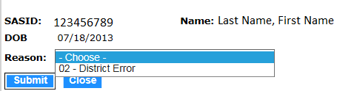

1. Click the check box to acknowledge the citation and click OK. The student will be removed from this report.

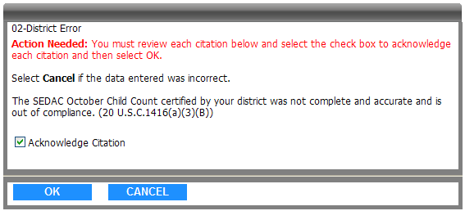

1. This procedure is complete.

### How to Resolve Cases of Potential Noncompliance due to District Error on the Student(s) Missing from SEDAC Certified Oct 1 Child Count

**Step Action**

1. Log in to **SEDAC**.
2. Select **Reporting** from the SEDAC Management menu.
3. Select the **Data Cleaning**.
4. Select **Student(s) Missing from PREVIOUS SEDAC Certified Oct 1 Child Count**
5. Verify the special education status for every child listed as of October 1, of the previous year.
   * If the student was NOT receiving special education and related services on 10/1 of the previous year - Go to Step 6.
   * If the student was receiving special education and related services on 10/1 of the previous collection - Go to Step 8.

**Steps for PSIS Data Manager**

1. Communicate with the reporting district’s PSIS data manager to update the student’s NEXUS DISTRICT and SPECIAL EDUCATION STATUS to **No** in the previous PSIS Oct collection.
   * Once this is updated in the previous PSIS Oct collection the student will be removed from the report.
2. View the **Student(s) Missing from PREVIOUS SEDAC Certified Oct 1 Child Count** again to verify this student is no longer displayed.

**Steps for SEDAC Data Manager**

1. In the PSIS OCT column for the previous year, select the Y link. The REASON screen is displayed.
2. Is the student listed on the report because the District **Received a DCF 603 after SEDAC freeze** or **District Error**?
   * IF **District Error** - Go to Step 10.
   * IF **Received a DCF 603 after SEDAC freeze** - Go to *How to Resolve Cases of Potential Noncompliance due to DCF 603*.
3. Select the REASON **02-District Error** and select **Submit**.

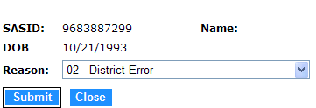

1. Click the check box to acknowledge the citation and click OK. The student will be removed from this report.



1. This procedure is complete.

### How to Resolve Cases of Potential Noncompliance due to DCF 603

**Prerequisites**

* Authorization for the SEDAC: Special Education Data Application and Collection system
* SEDAC Active Roster open

**Step Action**

1. Select **Reporting** from the SEDAC Management menu.
2. Select the **Data Cleaning**.
3. Select **Student(s) Missing from SEDAC Certified Oct 1 Child Count**
4. Is the student listed on the report due to the District receiving a DCF 603 after SEDAC freeze?
   1. **Yes** - Go to Step 5.
   2. **No** - Go to How to Resolve Cases of Potential Noncompliance due to District Error.
5. In the PSIS OCT column for the previous year, select the **Y** link. The REASON screen is displayed.
6. Select the REASON **01-Received DCF 603 after SEDAC freeze** and select **Submit**.

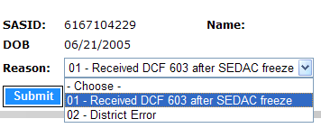

1. Click the acknowledge check box and click OK to remove this student record from your noncompliant data.

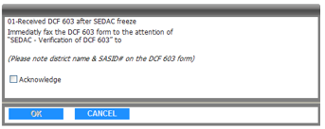

1. The District must immediately fax the DCF 603 form to the attention of “SEDAC - Verification of DCF 603” to (860) 326-0547. *(Please note district name & SASID# on the DCF 603 form)*.
2. The CSDE will verify the DCF 603, if verified this will not result in noncompliance.
3. This procedure is complete.

## Case Management

### How to Resolve an Orphan Record

**Prerequisites**

* Authorization for the SEDAC: Special Education Data Application and Collection system
* SEDAC Collection open

**Step Action**

1. Select **Reporting** from the SEDAC Management menu.
2. Select the **Data Cleaning**.
3. Select Orphan Records under Case Management
4. If **Total number of Students:** 0 - Go to Step 7.
5. An **ORPHAN RECORD** is created for a student when:
   * a student is initially reported in PSIS October Collection with SPECIAL EDUCATION of **Y-Yes** and then the student is removed from the collection or SPECIAL EDUCATION is changed to **N-No**. This causes the student to no longer show on your SEDAC list of students. Districts must resolve all orphans in order to certify their reported data.
6. Select the appropriate reason for each student
   * If you select either “Student was not our Nexus on 10/1”, “Student was not special education on 10/1” OR “Student is listed under View IEP Students with the correct SASID#” and click Update, the student will be removed from your Orphan Records.

**Note**: If a student is listed under the correct SASID# in your View IEP Student list, the student will remain on your View IEP Student list under the correct SASID#. Make sure you update your vendor system with the correct SASID#.

* + If you select “Student was special education on 10/1 and should be in our SEDAC list” and click Update, the student will remain on your Orphan Report.
    - Contact the appropriate PSIS Data Manager to correct the PSIS October Collection immediately.  Once the PSIS October Collection reflects SPECIAL EDUCATION of **Y-Yes** and your District as Nexus District, the student will show in your SEDAC list and will come off your orphan list.

1. This procedure is complete.

### How to Resolve Total School Hours over 40 Hours

**Prerequisites**

* Authorization for the SEDAC: Special Education Data Application and Collection system
* SEDAC Collection open

**Step Action**

1. Select **Reporting** from the SEDAC Management menu.
2. Select the **Data Cleaning**.
3. Select Total School Hours Over 40 under Case Management
4. If **Total number of Students:** 0 - Go to Step 7.
5. A **TOTAL SCHOOL HOURS OVER 40 HOURS RECORD** is created for a student when:
   * a student has more than 40 Total School Hours reported.
6. Select the appropriate reason for each student
   * Hours Confirmed, student is removed from this report.
   * SEDAC will be updated
     + Once SEDAC is updated the student will come off this report.
7. This procedure is complete.

### How to Resolve Primary Disability for ED166 Discipline Report

**Prerequisites**

* Authorization for the SEDAC: Special Education Data Application and Collection system
* SEDAC open

**Step Action**

1. Select **Reporting** from the SEDAC Management menu.
2. Select the **Data Cleaning**.
3. Select **ED166 Primary Disability Collection** under Case Management
4. An **ED166 RECORD** is created for a student when a student is reported in ED166 with a Disciplinary Incident and has a NEXUS DISTRICT in PSIS Registration and were not reported in the previous SEDAC October 1 collection. Do any students display?
   1. **Yes** - Go to Step 5.
   2. **No**, if District Total Number of Cases: 0 - Go to Step 6.
5. Select the appropriate PRIMARY DISABILITY for each student and click Save. The student will be removed from your ED166Primary Disability Report. Districts must resolve all cases.
   * Students without disabilities may also be included in this student report due to the rules for reporting general education state agency placement grants. A district will be able to designate these students with a primary disability code indicating “general education”.

**Note**: Where a student may have been recently identified as a student with disabilities, the district is required to report the disability.  We will attribute the Disciplinary Incidents that occurred before eligibility to the student as “general education” and after eligibility as the disability reported by the district.

**Note:** All State systems have a 20 minute inactivity time-out period. If there is no activity, in SEDAC, the system will display this screen for you to log-in again. If obtaining the student’s primary disability will take more than 20 minutes, you should print the report and note the Primary Disability. Once you have all students’ disabilities notated, log back into SEDAC and enter all disabilities into the report and then click save.

1. This procedure is complete.

### How to Resolve Students Missing Nexus Information

This report identifies students with disabilities reported in the past two SEDAC 10/1 Archives where Nexus is not being reported in PSIS. These students with disabilities may have:

* moved into your district
* left your district and returned to your district
* started attending a new school/program outside of your district, where your district is still Nexus

**Step Action**

1. Select **Reporting** from the SEDAC Management menu.
2. Select the **Data Cleaning**.
3. Select **Student Missing Nexus Information** under Case Management
4. If **Total number of Students:** 0 - Go to Step 7.
5. Select the appropriate reason for each student
   * If you select “**Student is spec ed, working with PSIS to correct**” and click Update, the student will remain on this report until PSIS is updated.

**Note:** if the student entered your district after 10/1, the student will not appear on your SEDAC 10/1 child count. The student will appear on your SEDAC Active Roster list.

* + If you select “**Student returned to general education, working with PSIS to correct**” and click Update, the student will remain on this report until PSIS is updated.
  + If you select “**Student returned to general education & withdrew from the district the same day, PSIS is accurate**” and click Update, the student will remain on this report until CSDE Verifies PSIS Registration.

1. Communicate with the Reporting District’s PSIS District Coordinator (Click [here](https://www.csde.state.ct.us/districts/psis/districtcontact.asp) for a list of PSIS Coordinators) the SASID #, Nexus District, Nexus District Entry Date and/or Nexus District Exit Date. Once PSIS Registration is updated the student will come off this report.

**Remember**

**What do we use for the NEXUS DISTRICT ENTRY DATE?**

Report the date in PSIS Registration:

1. that the parent signed the IEP Consent for Initial Provision of Special Education (ED626), on or after Eligibility Determination.

*In the case of a parent request for delayed entry into school for children ages 3, 4 or 5 report the District Entry Date (example: 4 year old found eligible for special education in May, parent requests to delay start of school until the fall).

1. if a student with disabilities is transferring into your district, report the District Entry Date.
2. if a DCF-603 is involved, report the “as of” date of the DCF-603.
3. This procedure is complete.

### How to Resolve Students with less than 25 Total School Hrs/Wk (KF-12)

Arecord is created for a student in GRADE **Kindergarten Full Day through 12** when the TOTAL SCHOOL HOURS **is less than 25** in SEDAC October 1 Collection.

**Prerequisites**

* Authorization for the SEDAC: Special Education Data Application and Collection system
* SEDAC Collection open

**Step Action**

1. Select **Reporting** from the SEDAC Management menu.
2. Select the **Data Cleaning**.
3. Select **Students with less than 25 Total School Hrs/Wk (KF-12)** under Case Management
4. If **Total number of Students:** 0 - Go to Step 6.
5. Select the appropriate reason for each student
   * If you select “**01-Homebound student missing special program status code (08 or 18); will update in PSIS October**” and click Update, the student will remain on this report.
     + Contact the appropriate PSIS Data Manager to correct the PSIS October Collection immediately.  Once the PSIS October Collection reflects SPECIAL PROGRAM STATUS CODE = 08 OR 18, the student will come off this report.
   * If you select “**02-Error in total school hours reported; will update in SEDAC**” and click Update, the student will remain on this report.
     + Update TOTAL SCHOOL HOURS, the student will come off this report.
   * If you select “**03-PPT decision to alter student's total school hours is documented in the IEP**”, the student will come off this report - Go to Step 6.
   * If you select “**04-Student Expelled**”, the student will come off this report - Go to Step 6
   * If one of the above does not apply, select “**05-will contact SDE**”, the student will remain on this report.
     + Contact SDE data manager to discuss
6. This procedure is complete.

### How to Certify your SEDAC Student Data for the Federal Child Count

Use this procedure when you have completed your review and data cleaning report follow-up, and all SEDAC data is accurate.

**Prerequisites**

* Authorization for the SEDAC: Special Education Data Application and Collection system
* SEDAC Collection is Archived
* All student records reported with a SEDAC STATUS of **1-Ready to Certify**
* Complete step 1, 2 and 3 in the *Preparing your data for SEDAC October Collection* section in the Reference chapter of this document

**Step Action**

1. Select **Reporting** from the SEDAC Management menu. The system displays the *Certification* screen.
2. Select **Child Count Verification Reports.**
3. Select **16. Federal Child Count Certification.**
4. Enter **your Name.**

 **Important:** you have to be a certified administrator.

1. Enter **your Title.**
2. Select **Certify**. The system displays the Certification Confirmation report.

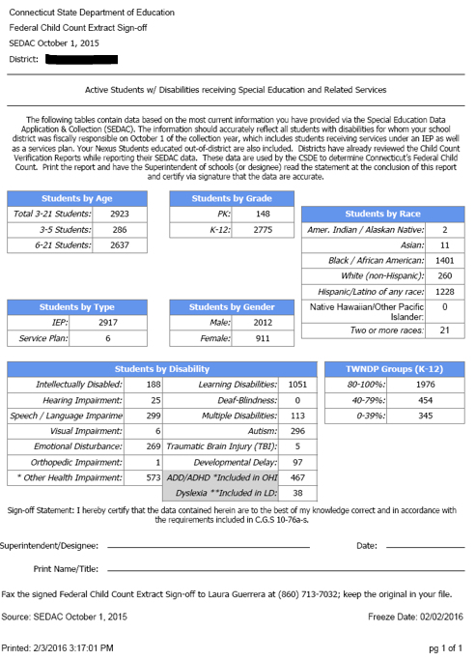

1. Print the Certification Confirmation report for your records.
2. This procedure is complete.

## Mandatory Off-cycle Reports

### How to add the Resolution Meetings data to SEDAC

Each district is presented with a list of individual students which are reported in the State Department of Education managed Due Process system between July 1 and June 30. Each student listed has had a hearing request initiated by a parent, student or parent surrogate.

Use this procedure to enter your resolution meeting data.

**Prerequisites**

* Authorization for the SEDAC: Special Education Data Application and Collection system
* SEDAC open
* The collected data for entry into the system

**Step Action**

1. Log-in to SEDAC (Batch and Online Entry)
2. Select **Reporting** from the SEDAC Management menu.
3. Select **Mandatory Off-cycle Reports**
4. Select **Due Process Hearing Requests**. The system displays a list of students on the *Due Process Hearing Requests Resolution Meetings* screen.
5. Is there a student displayed on this report?
   * **Yes** - Go to Step 6.
   * **No** - This procedure is complete.
6. Select the NAME of your student. The system displays the *Meetings Details* screen.
7. Review the DATE HEARING REQUEST RECEIVEDandRESOLUTION MEETING DUE BY.
8. Enter the DATE RESOLUTION MEETING HELD OR WAIVED.
9. Enter theRESOLUTION MEETING HELD OR WAIVED.
   * + If Held - Go to Step 10.
     + If Waived - Go to Step 11.
10. Enter DID THIS RESOLUTION MEETING RESULT IN A WRITTEN SETTLEMENT AGREEMENT.
11. Select **Save** when complete.
    * RECORD STATUS is calculated for each student.
      + If DATE RESOLUTION MEETING HELD OR WAIVED is before RESOLUTION MEETING DUE BY, then RECORD STATUS is **On-Time**
      + If DATE RESOLUTION MEETING HELD OR WAIVED is after RESOLUTION MEETING DUE BY, then RECORD STATUS is **Late**
    * The system displays

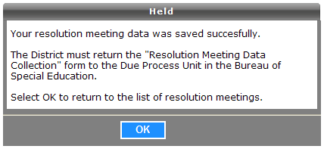

1. Select OK. The system redisplays the *Due Process Hearing Requests Resolution Meetings* screen.
2. This procedure is complete.

### How to Access the Birth to Three Notification Reports

Use this report to meet your responsibility for Child Find under IDEA and to ensure a smooth transition for those children who may be eligible for special education under Part B of IDEA.

In accordance with the Connecticut General Statutes, Section 17a-248d(e) and IDEA Part C (34 CFR Part 303), it is the responsibility of the Part C lead agency to notify local school districts and the SEA of all children enrolled in Birth to Three who reside in their town or who may become their educational responsibility.

This report is provided by the Office of Early Childhood (OEC), and notifies school districts about all children enrolled in Birth to Three who either reside in their district or who have nexus with their district (as determined by the Department of Children and Families).

* Data is updated nightly from Birth to Three to the SEDAC system.
* Reports are available in SEDAC year round.
* Districts should review reports weekly for additions/deletions.
* The data provided by OEC will result in four lists for each district:
  + **Children with Signed B23 Approval to Include LEA** - Children enrolled in Birth to Three whose parents agreed to include the school district in the child’s transition planning conference. *IMPORTANT: This is an Official Referral. Start referral process immediately.
  + **Notification of Children Over Age 2 ½ with No Release Or Approval To Include LEA** - Children enrolled in Birth to Three who are over the age of 2½ whose parents had not yet referred or signed a release of information as of the date of export from the Birth to Three system. This list also includes data for children whose parents had revoked a referral for an evaluation. *NOTE: The LEA has immediate Child Find responsibility for students on this list.
  + **Children Under Age 2 ½ With Release Of Information To LEA** - Children enrolled in Birth to Three whose parents had signed a release of information form but had not referred the child for evaluation as of the date of export from the Birth to Three system.  *NOTE: This is NOT a referral. However, the LEA has Child Find responsibility for students on this list.
  + **Children Under Age 2 ½ with No Release or Approval To Include LEA** - Children under the age of 2½ whose parents had not yet referred nor signed a release of information as of the date of export from the Birth to Three system.  *NOTE: This is NOT a referral. The LEA does NOT have Child Find responsibility for students on this list.
* Data from each report may be printed or exported to an MS Excel file. Individual student data may be displayed and/or printed by selecting the student’s name.

| **District Reports** |
| --- |
| Children with Referral to LEA |
| Notification of Children Over 2 ½ with No Release or Referral |
| Children Under Age 2 ½with Release of Information to LEA |
| Children Under 2 ½ with no Release or Referral |

**Prerequisites**

* Authorization for the State of Connecticut Department of Education District website at <https://www.csde.state.ct.us/>
* Authorization for the SEDAC: Special Education Data Application and Collection system

**Step Action**

1. Using the navigation menu on the left of the screen, select the **Reporting** menu option. The system displays the *SEDAC Reports* screen.
2. Select the **Mandatory Off-cycle Reports** report group. The system displays the *Mandatory Off-cycle Reports* list.

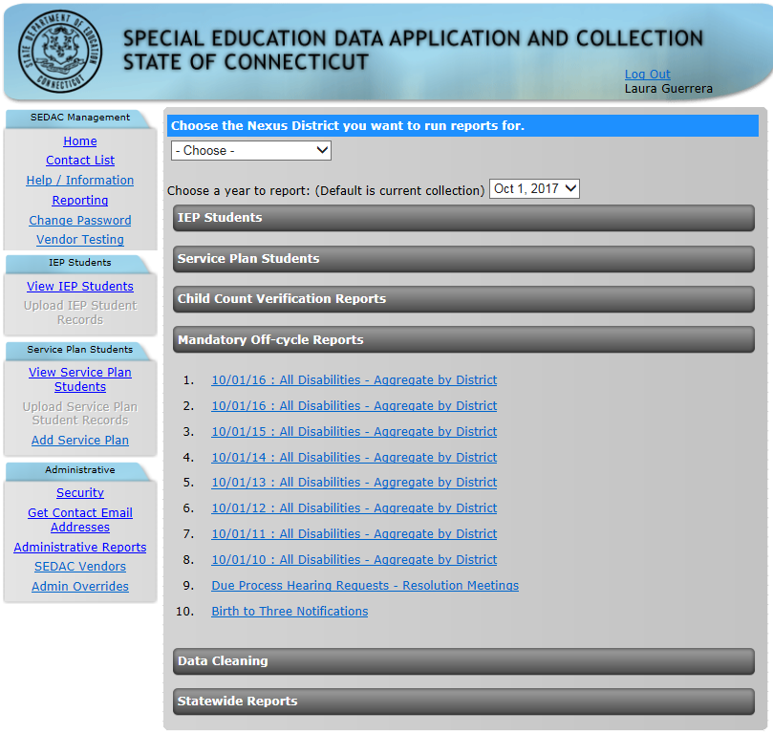

1. Select **Birth to Three Notifications.** The system displays the *Birth to Three Notifications* screen.

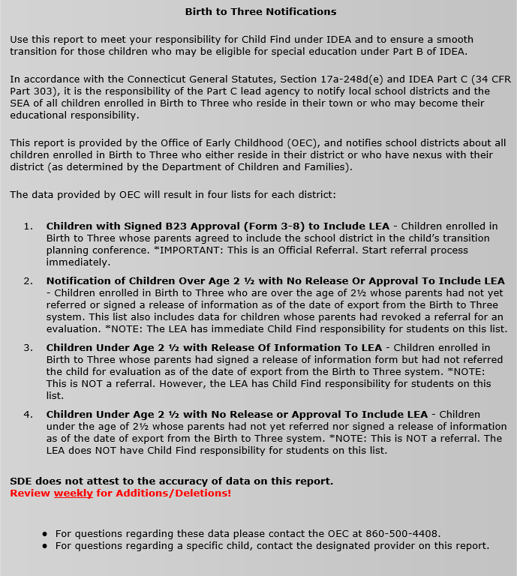

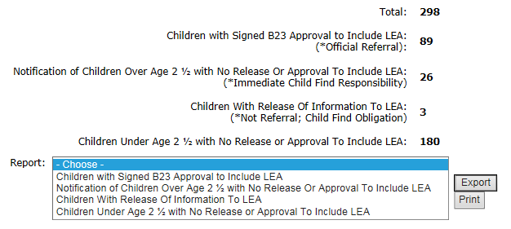

1. Select the **type of report to view**. The system displays a list of children according to your selection.

#### Children with Signed B23 Approval to Include LEA

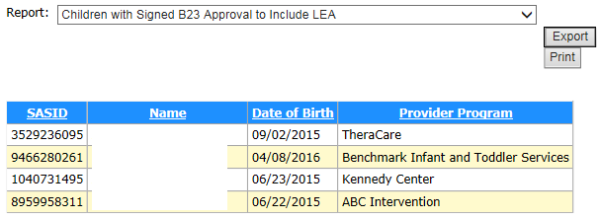

#### Notification of Children Over Age 2 ½ with No Release Or Approval To Include LEA

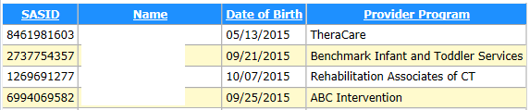

#### Children Under Age 2 ½ with Release of Information to LEA

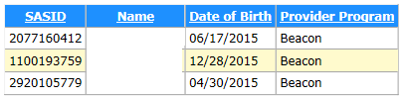

#### Children Under Age 2 ½with No Release or Approval To Include LEA

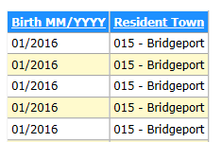

1. Do you want to print or export these reports?
   * **To print a list for your district** - Select the REPORT and select **Print**. The report is displayed in Adobe PDF format.
   * **To export a file of this data for your district** - Select the REPORT and select **Export**. The report is displayed in MS Excel format.
   * **To print the details for a single child** - Select the child NAME. The report is displayed in Adobe PDF format.

**Note:** These options are not available for the REPORT type of *Children Under Age 2 ½with No Release or Approval To Include LEA*.

1. This procedure is complete.

#### Examples

Individual Child Details - select Name

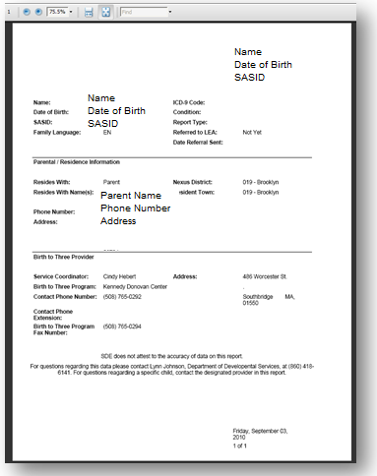

Exporting District List - select Export

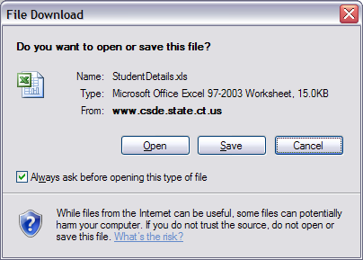

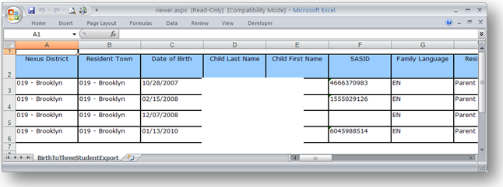

Printing District List - select Print

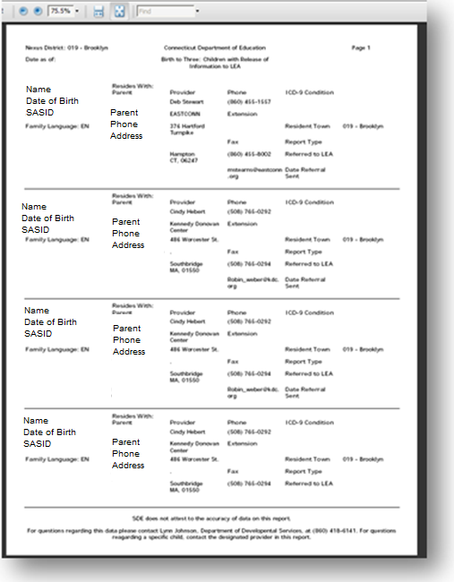

## CSDE's Statement of Nondiscrimination

The Connecticut State Department of Education is committed to a policy of equal opportunity/affirmative action for all qualified persons. The Connecticut State Department of Education does not discriminate in any employment practice, education program, or educational activity on the basis of **race, color, religious creed, sex, age, national origin, ancestry, marital status, sexual orientation, gender identity or expression, disability (including, but not limited to, intellectual disability, past or present history of mental disorder, physical disability or learning disability), genetic information, or any other basis prohibited by Connecticut state and/or federal nondiscrimination laws. The Connecticut State** **Department of Education does not unlawfully discriminate in employment and licensing against qualified persons with a prior criminal conviction.** Inquiries regarding the Connecticut State Department of Education’s nondiscrimination policies should be directed to:

Levy Gillespie

Equal Employment Opportunity Director/American with Disabilities Act Coordinator

Connecticut State Department of Education

450 Columbus Boulevard, Suite 607

Hartford, CT 06103

860-807-2071

[Levy.Gillespie@ct.gov](mailto:Levy.Gillespie@ct.gov)