|  |
| --- |
| Connecticut State Department of Education  Performance Office |
| SEDAC User Guide  Appendix of Terminology and References |

|  |
| --- |
| Version 9.0  10/1/2019 |

Table of Contents

Objective 3

Documentation Change Log 4

Contact Information 6

Appendix 7

Terminology 7

SEDAC References 9

Noncompliance Citation Chart 11

PSIS 20

Parent Initiated Placements (No IEP) 21

PSIS OPEN Choice 22

PSIS Special Program Status Codes 23

PSIS Unregister Exit Codes and Descriptions 26

FAPE Values 28

Fape_3 28

Fape_4 28

Fape_env 28

Fape 3-5 28

SEDAC Child Count Verification Report Samples 29

Summary Statistics 29

Year to Year Change Report 30

Count and Percentage of Students (K-12) by Racial / Ethnic Group with Disability Subgroups 33

Three TWNDP Categories: Students w/ Disabilities (K-12) 34

Ten TWNDP Categories: Students w/ Disabilities (K-12) 35

Educational Placement of Students w/ Disabilities (K-12) 36

Gender of Children with Disabilities by Educational Environment (K-12) 37

Extracurricular Participation by Students with Disabilities (K-12) 38

Preschool Student Data 39

Age of Child with Disabilities by Educational Environment (3-5) 40

Indicator 13 IEP Goals and Transition Services Summary Report (16-21) 40

Federal Child Count Certification 41

CSDE's Statement of Nondiscrimination 42

# Objective

The purpose of the SEDAC User Guide is to provide Districts with procedures and guidance for submitting data regarding the use of this data collection.

The SEDAC User Guide is organized into four separate documents:

C:\Documents and Settings\Saumellr\Local Settings\Temporary Internet Files\Content.IE5\JZOM6L3F\MC900445732[1].wmfHandbook or reference guide on purpose of this collection and definition of data collected

C:\Documents and Settings\Saumellr\Local Settings\Temporary Internet Files\Content.IE5\ZJD4FI1X\MC900014130[1].wmfC:\Documents and Settings\Saumellr\Local Settings\Temporary Internet Files\Content.IE5\IHJIXT1V\MC900434539[1].wmfC:\Documents and Settings\Saumellr\Local Settings\Temporary Internet Files\Content.IE5\KYXMKMTR\MC900014132[1].wmf Step by step procedures for use of the system

C:\Documents and Settings\Saumellr\Local Settings\Temporary Internet Files\Content.IE5\AZNQ3Q82\MC900089048[1].wmf Frequently Asked Questions (FAQs)

C:\Documents and Settings\Saumellr\Local Settings\Temporary Internet Files\Content.IE5\AZNQ3Q82\MC900412396[1].wmf Appendix of terminology and references

***Documentation Standards***

Standards used in this documentation include the following:

* FIELDS displayed on a screen are referenced using ALL CAPS
* Field **values** are highlighted in **bold**
* *Screens* are referenced using *italics*
* **Buttons** or **menu selections** are in **bold**

Look for C:\Documents and Settings\Saumellr\Local Settings\Temporary Internet Files\Content.IE5\8S3YI8CB\MC900105188[1].wmffor new or changed information and FAQs.

 Represents important information or cautionary instructions related to data reporting.

Represents helpful tips and references to other sections of documentation for related topics.

 Represents reminders of information previously stated related to the current topic.

# Documentation Change Log

| Version | Section / Page | Date | Description |
| --- | --- | --- | --- |
| 1.0 |  | 8/12/11 | Published |
|  | OPEN Choice | 9/27/11 | Updated with Appendix F PSIS Record Layout |
|  | PSIS Unregister Exit Codes and Descriptions | 9/27/11 | Updated with Table N from PSIS Record Layout |
|  | Noncompliance Citation Chart | 11/3/11 | Updated with updated version from FS-Administrative Overrides |
|  | Age of Child with Disabilities by Educational Environment (3-5) | 11/25/2011 | Updated picture of report. |
|  | SEDAC References | 4/11/12 | Added/Updates References for: Approved Transition/Vocational Programs, Educational Responsibility for Children Committed as Delinquent to the Department of Children and Families, and Facility Codes. |
|  | SEDAC References | 4/30/12 | SPP Indicator #13: Ensuring Compliance in Secondary Transition |
|  | Nondiscrimination Statement | 4/30/12 | Updated with 9-30-2011 version |
|  | Noncompliance Citation Chart | 8/1/12 | Under MOST RECENT EVALUATION DATE when to show citation added or more than 3 years from the last reevaluation date |
|  | PSIS Special Program Status Codes | 10/19/12 | Updated with Table E – Special Program Status Codes from 2012-13 PSIS Record Layout |
|  | Parent Initiated Placements (No IEP) | 10/19/12 | Added Appendix I – Parent Initiated Placements (No Individualized Education Program) from 2012-2013 PSIS Record Layout |
| 2.0 |  | 10/26/12 | Published |
| 3.0 | Child Count Verification Report Samples | 11/1/13 | [Indicator 13 IEP Goals and Transition Services Summary Report (16-21)](javascript:__doPostBack('ctl00$ContentPlaceHolder1$rpt_21','')) |
|  | Nondiscrimination Statement | 3/19/14 | Updated with March 2014 version |
|  | FAPE Values | 9/24/14 | Added FAPE Values |
| 4.0 |  | 11/3/14 | Published |
| 5.0 |  | 11/13/15 | Published |
|  | Home School Attendance by Students with Disabilities (K-12) | 2/24/16 | Effective 15-16 SEDAC no longer collected Home Facility Code. Removed this report from Child Count Verification Report Samples |
|  | Reporting Time with Non-disabled Peers (TWNDP) |  | Removed. In User Guide, under the SEDAC and PSIS Data Fields section added Note: For additional information refer to the Determination of Time with Non-Disabled Peers for Students with Disabilities memorandum (9/9/15). |
|  | PSIS OPEN Choice | 10/5/16 | Updated from the PSIS 16-17 Reference Guide 10/5/2016  Added Student sent out of the OPEN Choice receiving district to **a detention center** |
|  | Parent Initiated Placements (No IEP) | 10/5/16 | Updated from the PSIS 16-17 Reference Guide 10/5/2016  Added *(this includes Mediations, Hearings and Complaints)* |
|  | PSIS Special Program Status Code | 10/5/16 | Updated from the PSIS 16-17 Reference Guide 10/5/2016  Added 23 & 32 |
| 6.0 |  | 11/1/16 | Published |
|  | Fax Number | Jan 2017 | Updated |
|  | Terminology |  | Removed PSIS January Collection and SEDAC-G |
|  | PSIS Special Program Status Code | 9/29/17 | Updated from the PSIS 17-18 Reference Guide 9/29/2017 |
|  | Unregister Exit Codes and Descriptions | 9/29/17 | Updated from the PSIS 17-18 Reference Guide 9/29/2017 |
|  | Nondiscrimination Statement p. 104 | 11/8/17 | Updated with 2-1-2017 version |
|  | Contact Information p. 9 | 11/8/17 | Updated |
| 7.0 |  | 11/9/17 | Published |
|  | Best Practice for Reporting Students with Disabilities | May 2018 | Added |
|  | Parent Initiated Placements (No IEP) |  | Updated from the PSIS 18-19 Reference Guide 7/18/2018 |
|  | PSIS OPEN Choice |  | Updated from the PSIS 18-19 Reference Guide 7/18/2018 |
|  | PSIS Special Program Status Code |  | Updated from the PSIS 18-19 Reference Guide 7/18/2018 |
|  | Unregister Exit Codes and Descriptions |  | Updated from the PSIS 18-19 Reference Guide 7/18/2018 |
| 8.0 |  | 9/14/2018 | Published |
|  | Child Count Verification Reports | 2/4/19 | Replaced Federal Child Count Extract Sign-off with Federal Child Count Certification |
|  | Certification Confirmation | 2/4/19 | Added Example under Child Count Verification Report Samples |
|  | PSIS Special Program Status Code |  | Updated from the PSIS 19-20 Reference Guide Updated October 2019 |
| 9.0 |  | 10/1/19 | Published |

# Contact Information

SEDAC

| **Contact** | **Name** | **Email** | **Phone** |
| --- | --- | --- | --- |
| Bureau of Special Education Consultant | Your District Liaison | | 860-713-6910 |
| SDE Data Manager | Laura Guerrera | [Laura.Guerrera@ct.gov](mailto:Laura.Guerrera@ct.gov) | 860-713-6898 |
| Analyst | Diane Murphy | [Diane.Murphy@ct.gov](mailto:Diane.Murphy@ct.gov) | 860-713-6891 |

Resolution Meetings

| **Contact** | **Name** | **Email** | **Phone** |
| --- | --- | --- | --- |
| Bureau of Special Education Consultant | Mary Jean Schierberl | [Maryjean.Schierberl@ct.gov](mailto:Maryjean.Schierberl@ct.gov) | 860-713-6943 |
| SDE Data Manager | Laura Guerrera | [Laura.Guerrera@ct.gov](mailto:Laura.Guerrera@ct.gov) | 860-713-6898 |
| Analyst | Diane Murphy | [Diane.Murphy@ct.gov](mailto:Diane.Murphy@ct.gov) | 860-713-6891 |

Discipline / Suspension and Expulsion

| **Contact** | **Name** | **Email** | **Phone** |
| --- | --- | --- | --- |
| Bureau of Special Education Consultant | Mary Jean Schierberl | [Maryjean.Schierberl@ct.gov](mailto:Maryjean.Schierberl@ct.gov) | 860-713-6943 |
| SDE Data Manager/Analyst | Keryn Felder | [Keryn.Felder@ct.gov](mailto:Keryn.Felder@ct.gov) | 860-713-6833 |
| SEDAC – ED166 Primary Disability Report Manager | Laura Guerrera | [Laura.Guerrera@ct.gov](mailto:Laura.Guerrera@ct.gov) | 860-713-6898 |

**Caution:** The Family Educational Rights & Privacy Act (FERPA; 20 U.S.C. § 1232g; 34 CFR Part 99) prohibits disclosure of personally identifiable information from students' education records.

**DO NOT EMAIL Student Names**. You may email student SASIDs.

# C:\Documents and Settings\Saumellr\Local Settings\Temporary Internet Files\Content.IE5\AZNQ3Q82\MC900412396[1].wmfAppendix

## Terminology

| **Term** | **Definition** |
| --- | --- |
| **Active Roster** | The time period used to maintain and monitor the SEDAC Active Roster data by Districts through-out the school year. |
| **APR** | Annual Performance Report to the Office of Special Education Programs |
| **APSEP** | Approved Private Special Education Program |
| **CSDE** | Connecticut State Department of Education |
| **ECO** | Early Childhood Outcomes |
| **FAPE** | Free Appropriate Public Education |
| **IDEA** | Individuals with Disabilities Education Improvement Act |
| **IEP** | Individualized Education Program  A written education program for a child with a disability that is developed by a team of professionals (administrators, teachers, therapists, etc.) and the child’s parents; it is reviewed and updated at least yearly and describes the child’s present performance, what the child’s learning needs are, what services the child will {receive}, when and for how long, and identifies who provides the services. Refer to the IEP Manual for additional definitions of the required forms. |
| **LEA** | Local Educational Agency **- which** is either a city or town’s board of education, or a regional school district. |
| **Nexus** | The Nexus District is the district that has the legal responsibility to identify, educate, and pay for a special education student under the Individuals with Disabilities Education Improvement Act (IDEA 2004). |
| **OCR** | Office of Civil Rights |
| **Open Choice** | Open Choice is an inter-district public school program intended to improve academic achievement; reduce racial, ethnic and economic isolation; and provide a choice of educational programs for public school students.  The Open Choice program allows urban students to attend public schools in nearby suburban towns. It also allows suburban and rural students to attend public schools in a nearby urban center. The program includes Hartford, Bridgeport, New Haven and their surrounding school districts. |
| **OSEP** | Office of Special Education Programs |
| **PPT** | Planning and Placement Team |
| **PSIS** | Public School Information System |
| **PSIS June Collection** | The database containing all student enrollment data as at each districts last day of school. |
| **PSIS October Collection** | The database containing all student enrollment data as at, October 1. |
| **PSIS Registration** | The database used for all student registrations and ongoing maintenance of student information. |
| **Quasi-Public** | Endowed and Incorporated Academies |
| **RDC** | Required Data Collection – Pages contained with the IEP Manual |
| **RE** | General Education (previously referred to as Regular Education) |
| **RESC** | Regional Education Service Center |
| **SASID** | State Assigned Student ID |
| **SDE** | State Department of Education |
| **SEA** | State Educational Agency |
| **SEDAC** | Special Education Data Application and Collection |
| **SEDAC Active Roster** | The database used for SEDAC maintenance of special education data in non-collection periods. |
| **SEDAC October 1 Child Count** | The primary database used for SEDAC October 1 data collection and reporting. |
| **SEDAC Team** | The administrative personnel that monitor and manage the collection of data from all Districts. |
| **Services Plan** | Districts are required to report students with disabilities that have been Parentally Placed in Private Schools. These are students who have been enrolled by their parents or guardians in parochial or other private schools and whose basic education is paid through private resources and who receive special education and related services at public expense from a local educational agency or intermediate educational unit under a Services Plan.  Sections 300.130-300.139 of IDEA |
| **SPP** | State Performance Plan |

## SEDAC References

| **Reference** | **Website** |
| --- | --- |
| Approved Private Special Education Programs  *\*Note: there is a list of Alternate Names of Programs, Affiliated Programs and Operating Agencies* | <https://portal.ct.gov/SDE/Special-Education/Approved-Private-Special-Education-Programs> |
| Approved Transition/Vocational Programs  *Source: Bureau Bulletin December 2008/January 2009 - Page 4* | <https://portal.ct.gov/SDE/Special-Education/Secondary-Transition-Resources-for-Special-Education-Students> |
| Bureau of Special Education Website | <https://portal.ct.gov/SDE/Special-Education/Bureau-of-Special-Education> |
| Connecticut State Department of Education website | <http://www.sde.ct.gov/sde/site/default.asp> |
| Education Directory |  |
| **ENTER BUTTON**  SEDAC, ECO, ED166 and Evaluation Timelines system access | <https://www.csde.state.ct.us/> |
| Educational Responsibility for Children Committed as Delinquent to the Department of Children and Families  Source: Bureau Bulletin September 2009 - Page 5 | <https://portal.ct.gov/SDE/Special-Education/Special-Education-Updates> |
| **Facility Codes** – this data system uses the facility coding structure used in the Public School Information System (PSIS).  See PSIS TABLE A: Facility Codes | <https://portal.ct.gov/SDE/Performance/Data-Collection-Help-Sites/PSIS-Help-Site/Documentation> |
| **Facility Codes** - this data system uses the facility coding structure used in the Public School Information System (PSIS**).  See Non Public and Out of State Facility Codes** | <https://portal.ct.gov/SDE/Performance/Data-Collection-Help-Sites/PSIS-Help-Site/Documentation>   * **In-State APSEP** tab at the bottom of the excel document is a list of IN-STATE APPROVED PRIVATE SPECIAL EDUCATION PROGRAM FACILITY CODES. * **Transition Programs** tab at the bottom of the excel document is a list of AGE APPROPRIATE COMMUNITY BASED TRANSITION PROGRAM FACILITY CODES. * **Out of State** tab at the bottom of the excel document is a list of OUT OF STATE FACILITY CODES. (Note: Effective 7/1/17 ALL Out of State Codes will be either a Public School or Non-Public.) |
| Individuals with Disabilities Education Improvement Act of 2004 statute Title 1 Section 101 Part B Section 618 – IDEA 101 (B) 618 | <http://idea.ed.gov/explore/view/p/%2Croot%2Cstatute%2C> |
| IEP Manual | [**https://portal.ct.gov/SDE/Special-Education/Planning-and-Placement-Team-PPT-Process-and-Individualized-Education-Program-IEP-Forms/Documents**](https://portal.ct.gov/SDE/Special-Education/Planning-and-Placement-Team-PPT-Process-and-Individualized-Education-Program-IEP-Forms/Documents) |
| Office of Civil Rights | The U.S. Department of Education's Office for Civil Rights (OCR) recently issued a policy letter addressing students with disabilities’ access to advanced programs. OCR reaffirmed that Section 504 and Title II of the Americans with Disabilities Act (ADA) require that qualified students with disabilities be given the same opportunities to compete for and benefit from accelerated programs and classes as are given to students without disabilities*.* The letter can be downloaded from this link: <http://www.ed.gov/print/about/offices/list/ocr/letters/colleague-20071226.htm> |
| PSIS Tables |  |
| Public School Choice in Connecticut |  |
| Bureau of Special Education Resources | <https://portal.ct.gov/SDE/Special-Education/Bureau-of-Special-Education> |
| SPP and APR Website | <https://portal.ct.gov/SDE/Special-Education/Bureau-of-Special-Education/General-Monitoring-and-Support> |
| Parents Guide to Special Education | https://portal.ct.gov/SDE/Special-Education/Special-Education-Resources-for-Families |
| Time with Non-Disabled Peers (TWNDP) Memorandum (2015) | https://portal.ct.gov/SDE/Special-Education/Special-Education-Guidance-Documents-and-Topic-Briefs |
| Bureau Bulletin Article: Approved Transition/Vocational Programs | https://portal.ct.gov/SDE/Special-Education/Special-Education-Updates |
| Birth-3 Transition / Transition Birth to Three to Special Education (2014) | https://portal.ct.gov/SDE/Special-Education/Early-Childhood-Special-Education |
| SPP Indicator #13: Ensuring Compliance in Secondary Transition  *Source: Bureau Bulletin Spring 2011 - Page 5* | https://portal.ct.gov/SDE/Special-Education/Special-Education-Updates |
| [Guidance regarding Technical Edits and the IEP](https://www.csde.state.ct.us/Public/Help/SEDAC/Downloads/Technical_Edits_and_the_IEP.pdf) | <https://www.csde.state.ct.us/Public/Help/SEDAC/Downloads/Technical_Edits_and_the_IEP.pdf> |

## Noncompliance Citation Chart

| **Citation** | **When to Show** | **Federal or State / Regulation or Statute** |
| --- | --- | --- |
| **001 - PRIMARY DISABILITY** | | |
| The Primary Disability is out of compliance (C.G.S 10-76a-1 (5)(c)). PPT needs to be held immediately to determine primary disability.  Either click Cancel and enter the correct Primary Disability, or Acknowledge Citation and click OK and an Admin Override will be generated.  Once an override is generated, enter the scheduled PPT date in the COMMENTS in the **Admin Override Request**.  Upload Error:  Primary Disability - You may be out of compliance with C.G.S. 10-76a-1(5)(C). More information is available online. | AGE **is 6 or older** and PRIMARY DISABILITY is **15-Developmental Delay**  Displays error and citation, and requires override.  Status 5 when citation acknowledged and until override approved.  Adds toCITATION COUNTon **Administrative Overrides** section of*Summary of Noncompliance in SEDAC Data Reporting* when the Administrative Override STATUS is   * 5-Approved: Finding Made, Corrective Action Verified Before SEDAC 10/1 Freeze * 6-Approved: Finding Made, Corrective Action Verified Before 2/1 * 7-Approved: Finding Made, Corrective Action Verified After 2/1 * 8-Approved: Finding Made, No Verification at Freeze   * Age 5 and PRIMARY DISABILITY is **15-Developmental Delay** are displayed on the 5 year old report | R.C.S.A. 10-76a-1(4)  A child requiring special education means any exceptional a child who is, age three, four or five and is experiencing developmental delay, as defined in section 10-76a of the Connecticut General Statutes, that causes such child to require special education.  C.G.S. 10-76a-1(5)(C)  A child requiring special education means any exceptional child who is age three to five, inclusive, and is experiencing developmental delay that causes such child to require special education.  C.G.S 10-76a-1(6)  Developmental delay" means significant delay in one or more of the following areas: (A) Physical development; (B) communication development; (C) cognitive development; (D) social or emotional development; or (E) adaptive development, as measured by appropriate diagnostic instruments and procedures and demonstrated by scores obtained on an appropriate norm-referenced standardized diagnostic instrument. |
| **002 - MOST RECENT EVALUATION DATE** | | |
| The meeting date is out of compliance (Section 300.303 of IDEA). PPT needs to be held immediately!  Either click Cancel and enter the correct Most Recent Evaluation Date, or Acknowledge Citation and click OK and an Admin Override will be generated.  Once an override is generated, enter the scheduled PPT date in the COMMENTS in the **Admin Override Request**.  Upload Error:  MOST RECENT EVALUATION DATE - You may be out of compliance with Section 300.303 of IDEA. More information is available online. | MOST RECENT EVALUATION DATE is more than 3 years before 10/1 of this collection year or more than 3 years from the last reevaluation date  Displays error and citation, and requires override.  Status 5 when citation acknowledged and until override approved.  Adds toCITATION COUNTon **Administrative Overrides** section of*Summary of Noncompliance in SEDAC Data Reporting* when the Administrative Override STATUS is   * 5-Approved: Finding Made, Corrective Action Verified Before SEDAC 10/1 Freeze * 6-Approved: Finding Made, Corrective Action Verified Before 2/1 * 7-Approved: Finding Made, Corrective Action Verified After 2/1 * 8- Approved: Finding Made, No Verification at Freeze | Section 300.303 of IDEA  **Reevaluations.**  (a) **General**. A public agency must ensure that a reevaluation of each child with a disability is conducted in accordance with Sec. Sec. 300.304 through 300.311--  (1) If the public agency determines that the educational or related services needs, including improved academic achievement and functional performance, of the child warrant a reevaluation; or  (2) If the child's parent or teacher requests a reevaluation.  (b) **Limitation**. A reevaluation conducted under paragraph (a) of this section--  (1) May occur not more than once a year, unless the parent and the public agency agree otherwise; and  (2) Must occur at least once every 3 years, unless the parent and the public agency agree that a reevaluation is unnecessary. |
| **003 - MOST RECENT EVALUATION DATE** | | |
| Date entered is more than 3 years from the last reevaluation date. By holding the most recent evaluation PPT meeting after 3 years, the reevaluation is out of compliance (Section 300.303 of IDEA).  The date entered is documentation of correction of noncompliance. An Administrative Override will be generated with a status of Finding Made, SDE Verification of Correction Needed.  Please fax page 1 of the IEP to the attention of “SEDAC - Verification of Administrative Override” to (860) 326-0547.  Upload Error:  MOST RECENT EVALUATION DATE - You may be out of compliance with Section 300.303 of IDEA. More information is available online. | MOST RECENT EVALUATION DATE is more than 3 years from the last reevaluation date  Displays error and citation, and override request is automatically submitted.  Status 5 when citation acknowledged and until override approved.  Adds toCITATION COUNTon **Administrative Overrides** section of*Summary of Noncompliance in SEDAC Data Reporting* when the Administrative Override STATUS is   * 5-Approved: Finding Made, Corrective Action Verified Before SEDAC 10/1 Freeze * 6-Approved: Finding Made, Corrective Action Verified Before 2/1 * 7-Approved: Finding Made, Corrective Action Verified After 2/1 * 8- Approved: Finding Made, No Verification at Freeze | Section 300.303 of IDEA  **Reevaluations.**  (a) **General**. A public agency must ensure that a reevaluation of each child with a disability is conducted in accordance with Sec. Sec. 300.304 through 300.311--  (1) If the public agency determines that the educational or related services needs, including improved academic achievement and functional performance, of the child warrant a reevaluation; or  (2) If the child's parent or teacher requests a reevaluation.  (b) **Limitation**. A reevaluation conducted under paragraph (a) of this section--  (1) May occur not more than once a year, unless the parent and the public agency agree otherwise; and  (2) Must occur at least once every 3 years, unless the parent and the public agency agree that a reevaluation is unnecessary. |
| **004 - ANNUAL REVIEW/PPT TO DEVELOP FIRST IEP DATE** | | |
| The meeting date is out of compliance on 10/1 (Section 300.324 of IDEA). PPT needs to be held immediately!  Either click Cancel and enter the correct Annual Review Date, or Acknowledge Citation and click OK and an Admin Override will be generated.  Once an override is generated, enter the scheduled PPT date in the COMMENTS in the **Admin Override Request**.  Upload Error:  Annual Review/PPT To Develop First IEP Date - You may be out of compliance with Section 300.324 of IDEA. More information is available online. | ANNUAL REVIEW/PPT TO DEVELOP FIRST IEP DATE is more than 365 days before 10/1 of this collection year  Displays error and citation, and requires override.  Status 5 when citation acknowledged and until override approved.  Adds toCITATION COUNTon **Administrative Overrides** section of*Summary of Noncompliance in SEDAC Data Reporting* when the Administrative Override STATUS is   * 5-Approved: Finding Made, Corrective Action Verified Before SEDAC 10/1 Freeze * 6-Approved: Finding Made, Corrective Action Verified Before 2/1 * 7-Approved: Finding Made, Corrective Action Verified After 2/1 * 8- Approved: Finding Made, No Verification at Freeze | Section 300.324(b)(1)(i) of IDEA with consideration of paragraph (a) of this section  **Development, review, and revision of IEP.**  (b) **Review and revision of IEPs.** (i) Reviews the child's IEP periodically, but not less than annually, to determine whether the annual goals for the child are being achieved. |
| **005 - ANNUAL REVIEW/PPT TO DEVELOP FIRST IEP DATE** | | |
| ANNUAL REVIEW/PPT TO DEVELOP FIRST IEP DATE  Date entered is after 10/1. By holding the annual review PPT meeting after 10/1, the annual review is out of compliance (Section 300.324 of IDEA).  The date entered is documentation of correction of noncompliance. An Administrative Override will be generated with a status of Finding Made, SDE Verification of Correction Needed.  Please fax page 1 of the IEP to the attention of “SEDAC - Verification of Administrative Override” to (860) 326-0547.  Upload Error:  Annual Review/PPT To Develop First IEP Date - You may be out of compliance with Section 300.324of IDEA. More information is available online. | ANNUAL REVIEW/PPT TO DEVELOP FIRST IEP DATE is after 10/1 of this collection year  Displays error and citation, and override request is automatically submitted.  Status 5 when citation acknowledged and until override approved.  Adds toCITATION COUNTon **Administrative Overrides** section of*Summary of Noncompliance in SEDAC Data Reporting* when the Administrative Override STATUS is   * 5-Approved: Finding Made, Corrective Action Verified Before SEDAC 10/1 Freeze * 6-Approved: Finding Made, Corrective Action Verified Before 2/1 * 7-Approved: Finding Made, Corrective Action Verified After 2/1 * 8- Approved: Finding Made, No Verification at Freeze | Section 300.324(b)(1)(i) of IDEA with consideration of paragraph (a) of this section  **Development, review, and revision of IEP.**  (b) **Review and revision of IEPs.** (i) Reviews the child's IEP periodically, but not less than annually, to determine whether the annual goals for the child are being achieved. |
| **006 - SECONDARY TRANSITION IN PLACE** | | |
| SECONDARY TRANSITION IN PLACE  Secondary Transition goals and objectives are required to be in place by student age of 16. You are out of compliance (Section 300.320(b) and (c) of IDEA).  A Secondary Transition PPT Date is required when Secondary Transition is out of compliance. Entry of this date is documentation of correction of noncompliance.  Either click Cancel and enter the correct Secondary Transition Data, or Acknowledge Citation and click OK and an Admin Override will be generated.  Once an override is generated, enter the scheduled PPT date in the COMMENTS in the **Admin Override Request**.  Upload Error:  Secondary Transition Not In Place - You may be out of compliance with Section 300.320(b) and (c) of IDEA. More information is available online. | AGE is 16 or older, SECONDARY TRANSITION IN PLACE is **N-No** and SECONDARY TRANSITION PPT DATE is blank  Displays error and citation, and requires override.  Status 5 when citation acknowledged and until override approved.  Adds toCITATION COUNTon **Administrative Overrides** section of*Summary of Noncompliance in SEDAC Data Reporting* when the Administrative Override STATUS is   * 5-Approved: Finding Made, Corrective Action Verified Before SEDAC 10/1 Freeze * 6-Approved: Finding Made, Corrective Action Verified Before 2/1 * 7-Approved: Finding Made, Corrective Action Verified After 2/1 * 8- Approved: Finding Made, No Verification at Freeze   * Age 15 and SECONDARY TRANSITION IN PLACE is N-No are displayed on the 15 year old report | Section 300.320(b) and (c) of IDEA  **Definition of individualized education program.**  **(b) Transition services**. Beginning not later than the first IEP to be in effect when the child turns 16, or younger if determined appropriate by the IEP Team, and updated annually, thereafter, the IEP must include--  (1) Appropriate measurable postsecondary goals based upon age appropriate transition assessments related to training, education, employment, and, where appropriate, independent living skills; and  (2) The transition services (including courses of study) needed to assist the child in reaching those goals.  **(c) Transfer of rights at age of majority**. Beginning not later than one year before the child reaches the age of majority under State law, the IEP must include a statement that the child has been informed of the child's rights under Part B of the Act, if any, that will transfer to the child on reaching the age of majority under Sec. 300.520. |
| **007 - SECONDARY TRANSITION IN PLACE** | | |
| SECONDARY TRANSITION IN PLACE  The Secondary Transition PPT Date entered is after 10/1. Secondary Transition is out of compliance as of 10/1 (Section 300.320(b) and (c) of IDEA).  The date entered is documentation of correction of noncompliance. An Administrative Override will be generated with a status of Finding Made, SDE Verification of Correction Needed.  Please fax page 6 and 7 of the IEP to the attention of “SEDAC - Verification of Administrative Override” to (860) 326-0547.  Upload Error:  Secondary Transition Not In Place - You may be out of compliance with Section 300.320(b) and (c) of IDEA. More information is available online. | AGE is 16 or older, SECONDARY TRANSITION IN PLACE is **N-No** and SECONDARY TRANSITION PPT DATE is after 10/1 of this collection year  Displays error and citation, and requires override.  Status 5 when citation acknowledged and until override approved.  Adds toCITATION COUNTon **Administrative Overrides** section of*Summary of Noncompliance in SEDAC Data Reporting* when the Administrative Override STATUS is   * 5-Approved: Finding Made, Corrective Action Verified Before SEDAC 10/1 Freeze * 6-Approved: Finding Made, Corrective Action Verified Before 2/1 * 7-Approved: Finding Made, Corrective Action Verified After 2/1 * 8-Approved: Finding Made, No Verification at Freeze | Section 300.320(b) and (c) of IDEA  **Definition of individualized education program.**  **(b) Transition services**. Beginning not later than the first IEP to be in effect when the child turns 16, or younger if determined appropriate by the IEP Team, and updated annually, thereafter, the IEP must include--  (1) Appropriate measurable postsecondary goals based upon age appropriate transition assessments related to training, education, employment, and, where appropriate, independent living skills; and  (2) The transition services (including courses of study) needed to assist the child in reaching those goals.  (c) **Transfer of rights at age of majority**. Beginning not later than one year before the child reaches the age of majority under State law, the IEP must include a statement that the child has been informed of the child's rights under Part B of the Act, if any, that will transfer to the child on reaching the age of majority under Sec. 300.520. |

|  |  |  |
| --- | --- | --- |
| **008 - STUDENT INVITED TO ATTEND THE PPT** | | |
| You are out of compliance with Section 300.321 (b)(1) of IDEA, which states that you must invite the student with a disability to attend the PPT meeting where postsecondary goals and transition services will be discussed.  Upload Error:  Student Invited to PPT - You may be out of compliance with Section 300.321 (b)(1) of IDEA. More information is available online. | AGE is 16 or older, STUDENT INVITED TO ATTEND THE PPT is **N-No**  Displays error and citation. Status 4 until citation acknowledged.  Adds toCITATION COUNTon **Other Noncompliance** section of*Summary of Noncompliance in SEDAC Data Reporting* when the Citation Message is acknowledged.   * 11-Approved: Finding Made, Citation Acknowledged   The CITATION COUNT is reduced or subtracted when field changed from **N-No** to back to **Y-Yes**. | Section 300.321(b)(1) of IDEA  **IEP Team.**  (b) **Transition services participants**. (1) In accordance with paragraph (a)(7) of this section, the public agency must invite a child with a disability to attend the child's IEP Team meeting if a purpose of the meeting will be the consideration of the postsecondary goals for the child and the transition services needed to assist the child in reaching those goals under Sec. 300.320(b). |
| **009 - OUTSIDE AGENCIES INVITED TO ATTEND THE PPT** | | |
| You are out of compliancewith Section 300.321(b)(3) of IDEA, which states, if appropriate, you must invite a representative of any participating agency likely to provide or pay for the transition services to be discussed in the PPT meeting.  Upload Error:  Outside Agency Invited to PPT - You may be out of compliance with Section 300.321(b)(3) of IDEA. More information is available online. | AGE is 16 or older, OUTSIDE AGENCIES INVITED TO ATTEND THE PPT is **04-** **No, no outside agency was invited**  Displays error and citation. Status 4 until citation acknowledged.  Adds toCITATION COUNTon **Other Noncompliance** section of*Summary of Noncompliance in SEDAC Data Reporting* when the Citation Message is acknowledged.   * 11-Approved: Finding Made, Citation Acknowledged   The CITATION COUNT is reduced or subtracted when field changed from **04-** **No, no outside agency was invited** to **any other value.** | Section 300.321(b)(3) of IDEA  **IEP Team.**  (b) **Transition services participants**. (3) To the extent appropriate, with the consent of the parents or a child who has reached the age of majority, in implementing the requirements of paragraph (b)(1) of this section, the public agency must invite a representative of any participating agency that is likely to be responsible for providing or paying for transition services. |
| **012 - FAPE AT THREE NOT MET** | | |
| **You are out of compliance** with Section 300.101(b) of IDEA, which states that FAPE must be made available by age 3.  Upload Error:  FAPE at Three - You may be out of compliance with Section 300.101(b) of IDEA. More information is available online. | AGE is 3, FAPE AT THREE is **Not Met** and REASON FAPE AT THREE NOT ON TIME is **3-Other**  Displays error and citation. Status 4 until citation acknowledged.  Adds toCITATION COUNTon **Other Noncompliance** section of*Summary of Noncompliance in SEDAC Data Reporting* when the Citation Message is acknowledged.   * 11-Approved: Finding Made, Citation Acknowledged   The CITATION COUNT is reduced or subtracted when field changes from **Not Met** to **Met**. | Section 300.101(b) of IDEA  **FAPE for children beginning at age 3.**  (1) Each State must ensure that-- (i) The obligation to make FAPE available to each eligible child residing in the State begins no later than the child's third birthday; and (ii) An IEP or an IFSP is in effect for the child by that date, in accordance with Sec. 300.323(b).  (2) If a child's third birthday occurs during the summer, the child's IEP Team shall determine the date when services under the IEP or IFSP will begin. |
| **010 – STUDENT(S) MISREPORTED** | | |
| The SEDAC October Child Count certified by your district was not complete and accurate and is out of compliance. (20 U.S.C.1416(a)(3)(B)) | Student’s Special Education indicator was changed from **Yes** to **No** in the PSIS October Collection, sometime after the SEDAC October Child Count was certified.  Adds toCITATION COUNTon **Potential Noncompliance** section of*Summary of Noncompliance in SEDAC Data Reporting* when the REASON for a student listed is changed to **02-District Error** and the district user acknowledges the citation. | **20 U.S.C.1416(a)(3)(B)** |
| **011 - MISSING STUDENT(S)** | | |
| The SEDAC October Child Count certified by your district was not complete and accurate and is out of compliance. (20 U.S.C.1416(a)(3)(B)) | Student’s Special Education indicator was changed from **No** to **Yes** in the PSIS October Collection, sometime after the SEDAC October Child Count was certified.  Adds toCITATION COUNTon **Potential Noncompliance** section of*Summary of Noncompliance in SEDAC Data Reporting* when the REASON for a student listed is changed to **02-District Error** and the district user acknowledges the citation.  The CITATION COUNT is reduced or subtracted when field is changed to 01 - Received DCF 603 after SEDAC freeze. | **20 U.S.C.1416(a)(3)(B)** |

## Best Practice for Reporting Students with Disabilities

The SDE recommends that districts **communicate the below *at a minimum* on a MONTHLY basis.**

It is crucial that SEDAC data managers use your district’s vendor system to identify a list of students that fit the criteria below and communicate this to PSIS district coordinators to help ensure nexus information and special education status is reported accurately in PSIS for every student:

1. Students who your district have evaluated, found eligible and determined you will be servicing for special education, the PSIS district coordinator needs to enter the Nexus District Entry Date in PSIS Registration to ensure the accuracy of subsequent collections.
2. Students who moved into your district with an IEP from another district, the PSIS district coordinator needs to enter the Nexus District Entry Date in PSIS Registration to ensure the accuracy of subsequent collections. *SEDAC Nexus Missing data cleaning report is there to help you - resolve ALL cases within 10 days.*

* **What do we use for the NEXUS DISTRICT ENTRY DATE?**

Report the date in PSIS Registration:

* + 1. That the parent signed the IEP for initial Consent for Special Education Placement (ED626), on or after Eligibility Determination.

*In the case of a parent request for delayed entry into school for children ages 3, 4 or 5 report the District Entry Date(example: 4 year old found eligible for special education in May, parent requests to delay start of school until the fall).

1. If a student with disabilities is transferring into your district, report the District Entry Date.
2. If a DCF-603 is involved, report the “as of” date on the DCF-603.

cid:image004.jpg@01D3DBA3.E8FE79E0*Reminder:* additional FAQs around Nexus District are located in the Frequently Asked Questions (FAQs) document located on the [SEDAC Help Site](http://portal.ct.gov/SDE/Performance/Data-Collection-Help-Sites/SEDAC-Help-Site).

1. Students who Returned to Regular Education, the PSIS district coordinator needs to enter the Nexus District Exit Date in PSIS Registration to ensure the accuracy of subsequent collections.
2. Students whose placement (facility code 1) has changed and the date of that change, the PSIS district coordinator needs to enter this in PSIS Registration to ensure the accuracy of subsequent collections.

Additionally, the SDE recommends that districts **upload Evaluation Timelines data on a MONTHLY basis**.

Once a district submits their Evaluation Timelines data, they can use the “**No Nexus Info**” report to resolve all cases where a student was reported as “Eligible”, but Nexus District and Nexus Entry Date has not been entered in PSIS Registration.

**How this will help your district:**

* **PSIS:**
  + Nexus Information and Special Education field will be reported in a timely/accurate manner
  + Eliminate the need to open past PSIS collections to update special education status
* **SEDAC:**
  + Students with disabilities will be reported in a timely/accurate manner
  + Decrease in the number of citations a district receives for Student(s) Missing from Certified Oct 1 Child Count
* **Other Implications:**
  + Restraint and Seclusion (R/S) special education incidents will be entered accurately and within the mandatory two business day state reporting rule
  + Assessment Demographic Fields in PSIS Registration will be reported in a timely/accurate manner; which impacts Accountability Reporting

## PSIS

### Parent Initiated Placements (No IEP)

APPENDIX H – Parent Initiated Placements (No Individualized Education Program)

Do not report student in PSIS in cases where:

1. Parent rejects District individualized education program (IEP),
2. Student was unilaterally placed in a private facility by parents, and
3. District has not accepted programmatic responsibility for the child’s education through the development and implementation of an IEP.

FAQs

1. Parent rejects District IEP, student is parent-enrolled in a facility. District, in order to settle (potential or pending) litigation, provides some funding to offset the parent's costs.  District has not accepted programmatic responsibility for the child’s education through the development and implementation of an IEP.
   * District DOES NOT report in PSIS or SEDAC.
   * Not eligible for SEECG

1. Parent rejects District IEP, student is parent-enrolled in a facility.  Parent and District have not come to an agreement at collection time.  Parent and/or District have **not** filed for Due Process.
   * District DOES NOT report in PSIS or SEDAC.
   * Not eligible for SEECG.

1. Parent rejects District IEP, student is parent-enrolled in a facility.  Parent and District have not come to an agreement at collection time.  Parent and/or District have **filed for Due Process** *(this includes Mediations, Hearings and Complaints)*.
   * District reports in PSIS and SEDAC.
   * May be eligible for SEECG
   * Once the Due Process is resolved, if the hearing decision is that the district is NOT responsible for the student the District would exit the student effective the hearing officer decision date and delete the student from affected PSIS collections.

If you have questions regarding PSIS reporting, please contact Kendra Shakir at (860) 713-6896 or [kendra.shakir@ct.gov](mailto:kendra.shakir@ct.gov).  Questions regarding students with disabilities (SEDAC) should be referred to Laura Guerrera at (860) 713-6898 or [laura.guerrera@ct.gov](mailto:laura.guerrera@ct.gov). Questions concerning the reporting of students in the Special Education Excess Cost Grant (SEECG) Application can be referred to Kevin Chambers at (860) 713-6455 or [kevin.chambers@ct.gov](mailto:kevin.chambers@ct.gov)

### OPEN Choice

APPENDIX E – Reporting Guidelines for the OPEN Choice Program

Students participating in the OPEN Choice program are always reported in PSIS by the receiving district, generally in the same way as other students enrolled in the district. However, the nature of the OPEN Choice program requires specialized reporting in PSIS for the fields identified below.

1. Student educated in a public school of the OPEN Choice receiving district:

* Special Program status Code “02”.
* Facility Code 1 – the OPEN Choice receiving district facility where the student is enrolled.
* Nexus District – complete only if the student is Special Education; use the Nexus code for the OPEN Choice receiving district (Reporting District).

2. Student sent out of the OPEN Choice receiving district to a **private** special education facility in accordance with an IEP or other special circumstances:

* Special Program status Code “12”.
* Facility Code 1 – the private special education facility attended by the student.
* Facility Code 2 – the OPEN Choice receiving district facility where the student **would otherwise be** enrolled if not outplaced.
* Nexus District – complete only if the student is Special Education; nexus code for the OPEN Choice receiving district (Reporting District).

3. Student sent out of the OPEN Choice receiving district to **another public school district (including RESC)** facility in accordance with an IEP or other special circumstances. Students in this situation are the **only** students attending another public school district (including RESC) facility that are not reported by that district but instead are reported by the OPEN Choice receiving district:

* Special Program status Code “22”.
* Facility Code 1 – the generic “Other” facility code 9990199.
* Facility Code 2 – the OPEN Choice receiving district facility where the student **would otherwise be** enrolled if not outplaced.
* Nexus District – complete only if the student is Special Education; nexus code for the OPEN Choice receiving district (Reporting District).

4. Student sent out of the OPEN Choice receiving district to **a detention center**:

* Special Program status Code “32”.
* Facility Code 1 – the detention center where the student is placed.
* Facility Code 2 – the OPEN Choice receiving district facility where the student **would otherwise be** enrolled if not in a detention center.
* Nexus District – complete only if the student is Special Education; nexus code for the OPEN Choice receiving district (Reporting District).

### Special Program Status Codes

**Table E – Special Program Status Codes**

|  |  |
| --- | --- |
| Code | Description |
| 00 or Blank | This is the default if codes 01 – 32 below do not apply to student’s status. |
| 01 | APPLIES TO FACILITY CODE 1:  To be used if the student 1) attends a Agricultural Science and Technology Education Center in your district and 2) receives his/her academic instruction in your district. (i.e., The student attends your schools on a full-time basis.) This code should be used for students entering your district from another district, if appropriate. It should also be used for your own students, in your own high school, attending the ASTE Center.  This code is limited to the following Reporting Districts:  Bloomfield, Bridgeport, Glastonbury, Killingly, Lebanon, Ledyard, Middletown, New Haven, Southington, Stamford, Suffield, Trumbull, Vernon, Wallingford, Region 1, Region 6, Region 7, Region 12, Region 14, and Region 19.  Bloomfield, Bridgeport, and Glastonbury should not use this code for any students who come into district solely for ASTE and not for academic coursework. (i.e., this code should not be used for any students attending your district on a part-time basis.) |
| 02 | APPLIES TO FACILITY CODE 1:  To be used if the student is a participant in the OPEN Choice Program and is not attending a private special education facility or RESC-operated special education facility. Refer to Appendix E for guidance regarding reporting of OPEN Choice students. |
| 03 | APPLIES TO FACILITY CODE 1:  To be used if the student attends a State-approved full-time Magnet School Program. Please see Appendix B for a list of State-approved Magnet Schools.  This code is limited to the following Reporting Districts:  Bloomfield, Bridgeport, Danbury, East Hartford, Hartford, New Haven, New London, Norwalk, Stamford, Waterbury, Windham, CREC, CES, ACES, LEARN, and EASTCONN. |
| 04 | APPLIES TO FACILITY CODE 1:  To be used if the student attends your school through an Interdistrict Cooperative Arrangement.  This code is limited to the following Reporting Districts: East Lyme and Plainfield. |
| 05 | APPLIES TO FACILITY CODE 1:  To be used if the student pays tuition, comes from a district which does not maintain its own high school, and attends your school through a formal Designated High School arrangement. (If the student is enrolled in the Agricultural Science and Technology Education Center at his/her Designated High School, use Code 06.)  This code is limited to the following Reporting Districts:  Bolton, Colchester, Granby, Griswold, Killingly, Lebanon, Ledyard, Montville, New Fairfield, New Milford, Stafford, Region 12, Region 19, Gilbert School, Norwich Free Academy, and Woodstock Academy. |
| 06 | APPLIES TO FACILITY CODE 1:  To be used if the student attends the Agricultural Science and Technology Education program at his/her Designated High School. (i.e., the student meets the conditions of both codes 1 and 5 above.)  This code is limited to the following Reporting Districts: Killingly, Lebanon, and Ledyard, Region 12, Region 19. |
| 07 | To be used if the student attends the Bristol Technical Education Center (Bristol Satellite). |
| 08 | To be used if the student is homebound and is being tutored at home or receiving other instructional services at the expense of your district. |
| 09 | To be used if the student is placed by the court into a detention center and is receiving instruction at the expense of your district. |

**Table E – Special Program Status Codes (cont.)**

|  |  |
| --- | --- |
| 10 | Code 10 - To be used if the student attends two facilities simultaneously in accordance with an IEP or other special circumstances.  (i.e., general or special education students attending one facility for academics and a different facility for 1) job/vocational training, 2) special education services, 3) other mandated programs like drug/alcohol rehab/anger management, 4) etc.) |
| 11 | To be used if the student attends two facilities simultaneously in accordance with an IEP or other special circumstances, and;  1) attends a ASTE Center in your district and 2) receives his/her academic instruction in your district. (i.e., The student attends your schools on a full-time basis.) This code should be used for students entering your district from another district, if appropriate. It should also be used for your own students, in your own high school, attending the ASTE.  This code is limited to the following Reporting Districts:  Bloomfield, Bridgeport, Glastonbury, Killingly, Lebanon, Ledyard, Middletown, New Haven, Southington, Stamford, Suffield, Trumbull, Vernon, Wallingford, Region 1, Region 6, Region 7, Region 12, Region 14, and Region 19.  Bloomfield, Bridgeport, and Glastonbury should not use this code for any students who come into district solely for ASTE and not for academic coursework. (i.e., this code should not be used for any students attending your district on a part-time basis.) |
| 12 | To be used if the student attends a private special education facility in accordance with an IEP or other special circumstances, and;  is a participant in the OPEN Choice Program. Refer to Appendix E for guidance regarding reporting of OPEN Choice students. |
| 13 | To be used if the student attends two facilities simultaneously in accordance with an IEP or other special circumstances, and;  Attends a State-approved full-time Magnet School Program. Please see Appendix B for a list of State-approved Magnet Schools.  This code is limited to the following Reporting Districts:  Bloomfield, Bridgeport, Danbury, East Hartford, Hartford, New Haven, New London, Norwalk, Stamford, Waterbury, Windham, CREC, CES, ACES, LEARN, and EASTCONN. |
| 14 | To be used if the student attends two facilities simultaneously in accordance with an IEP or other special circumstances, and;  Attends your school through an Interdistrict Cooperative Arrangement.  This code is limited to the following Reporting Districts: East Lyme and Plainfield. |
| 15 | To be used if the student attends two facilities simultaneously in accordance with an IEP or other special circumstances, and;  Student pays tuition, comes from a district which does not maintain its own high school, and attends your school through a formal Designated High School arrangement. (If the student is enrolled in the ASTE Center at his/her Designated High School, use Code 06.)  This code is limited to the following Reporting Districts:  Bolton, Colchester, Granby, Griswold, Killingly, Lebanon, Ledyard, Montville, New Fairfield, New Milford, Stafford, Region 12, Region 19, Gilbert School, Norwich Free Academy, and Woodstock Academy. |

**Table E – Special Program Status Codes (cont.)**

|  |  |
| --- | --- |
| 16 | To be used if the student attends two facilities simultaneously in accordance with an IEP or other special circumstances, and;  Attends the Agricultural Science and Technology Education program at his/her Designated High School. (i.e., the student meets the conditions of both codes 01 and 05 above.)  This code is limited to the following Reporting Districts: Killingly, Lebanon, Ledyard, Region 12, and Region 19. |
| 17 | To be used if the student attends two facilities simultaneously in accordance with an IEP or other special circumstances, and;  Attends the Bristol Technical Education Center (Bristol Satellite). |
| 18 | To be used if the student attends two facilities simultaneously in accordance with an IEP or other special circumstances, and;  The student is homebound and is being tutored at home or receiving other instructional services at the expense of your district. |
| 19 | Reserved for future use |
| 20 | To be used for truant students ONLY WHERE ALL THREE OF THE FOLLOWING CONDITIONS ARE MET: 1) the student has not shown up at all since the start of the school year, 2) the student is known to be truant, and 3) a formal truancy process is underway, in accordance with your district’s local truancy policy and in accordance with the state’s definition of a truant student. |
| 21 | Reserved for future use |
| 22 | To be used if the student is outplaced for special education to another public school district (including RESC) in accordance with an IEP or other special circumstances, and;  Is a participant in the OPEN Choice Program. Refer to Appendix E for guidance regarding reporting of OPEN Choice students. |
| 23 | To be used if the student was placed by court in a detention center and;    Is enrolled in a State-approved full-time Magnet School Program.  Please see Appendix B for a list of State-approved Magnet Schools.  This code is limited to the following Reporting Districts:  Bloomfield, Bridgeport, Danbury, East Hartford, Hartford, New Haven, New London, Norwalk, Stamford, Waterbury, Windham, CREC, CES, ACES, LEARN, and EASTCONN. |
| 32 | To be used if the student was placed by court in a detention center and;  Is a participant in the OPEN Choice Program.  Refer to Appendix E for guidance regarding reporting of OPEN Choice students. |

### Unregister Exit Codes and Descriptions

Table N – Exit Type

|  |  |
| --- | --- |
| **Code** | **Description** |
| 01 | **Transfer to a different public school in the same local education agency in the same state or to a private special education facility in accordance with an IEP or other special circumstances** - A student who transfers to a public school that is located within the administrative boundaries of the same local education agency or to a private special education facility in accordance with an IEP or other special circumstances. |
| 02 | **Transfer to a public school in a different local education agency in the same state** - A student who transfers to a public school that is not located within the administrative boundaries of the same local education agency but is in the same state. |
| 03 | **Transfer to a public school in a different state** - A student who transfers to a public school that is located in another state or to a United States overseas dependents school. This also includes U.S. territories. |
| 04 | **Transfer to a private, non-religiously-affiliated school in the same local education agency** - A student who transfers to a private school (operated by a non-governmental, non­religious group or organization) that is located within the administrative boundaries of the same local education agency. |
| 05 | **Transfer to a private, non-religiously-affiliated school in a different local education agency in the same state** - A student who transfers to a private school (operated by a non­governmental, non-religious group or organization) that is not located within the administrative boundaries of the same local education agency but is in same state. |
| 06 | **Transfer to a private, non-religiously-affiliated school in a different state** - A student who transfers to a private school (operated by a non-governmental, non-religious group or organization) that is located in another state. |
| 07 | **Transfer to a private, religiously-affiliated school in the same local education agency** - A student who transfers to a private school (affiliated with and operated by a non­governmental, religious group or organization) that is located within the administrative boundaries of the same local education agency. |
| 08 | **Transfer to a private, religiously-affiliated school in a different local education agency in the same state** - A student who transfers to a private school (affiliated with and operated by a non-governmental, religious group or organization) that is not located within the administrative boundaries of the same local education agency but is in the same state. |
| 09 | **Transfer to a private, religiously-affiliated school in a different state** - A student who transfers to a private school (affiliated with and operated by a non-governmental, religious group or organization) that is located in another state. |
| 10 | **Transfer to a school outside of the country** - A student who transfers to a school outside the country that is not a United States overseas dependents school (includes private and public school systems). |
| 11 | **Transfer to an institution** - A student who transfers to an institution that has an educational program. This includes mental health institutions, correctional institutions, juvenile service agencies and care shelters. These codes should only be used for students transferring to Unified School District #1 (USD #1) Department of Correction or Unified School District #2 (USD #2) Department of Children and Families or the Department of Mental Health and Addiction Services (DMHAS). Do not use this code for students in municipal detention centers. |
| 12 | **Transfer to a charter school** *-* A student who transfers to an institution designated as a charter school. |

**Table N – Exit Type (cont.)**

|  |  |
| --- | --- |
| **Code** | **Description** |
| 13 | **Transfer to home schooling** - A student who transfers to a period of instruction in a home environment for reasons other than health. |
| 15 | **Graduated with regular, advanced, International Baccalaureate, or other type of diploma** - A student who has received a regular high school diploma upon completion of state and local requirements for both coursework and assessment or a high school diploma from a program other than the regular school program. |
| 16 | **Completed school with other credentials** - A student who has received a certificate of completion or attendance in lieu of a high school diploma. This code is only to be used for students with disabilities. |
| 17 | **Death** - A student whose membership is terminated because he or she died during or between regular school sessions. |
| 20 | **Reached maximum age for services** *-* A student who left school because he or she has reached the maximum age to receive instructional services allowed by federal, state, or local laws. |
| 21 | **Discontinued schooling –**   * A student who is at least 18 years old who notifies the school and stops attending school for reasons with a specified length of time considered by the state or district to constitute “dropping out.” OR * A student whose parent or person having control of the child exercises his/her option of not sending the child to school until the child is 7 years of age, and completes an option/withdrawal form. This includes students who are no longer receiving special education services at a service provider location (previously known as itinerant service students).   Note: Pursuant to C.G.S. Section 10-184, students under the age of 18 cannot drop without parental consent.  This code shall NOT be used to exit students from your district who will be away from school for a period of time for travel and/or vacation. |
| 23 | **Transfer to GED program/EDP** - A student who meets one of the following conditions:   * A student who has transferred to a GED program prior to the completion of his or her secondary education and will receive a CT State High School Diploma upon completion of the GED program * A student who completes a portfolio assessment to earn a high school diploma by his or her Local Education Agency |
| 24 | **Transfer to a postsecondary education** *-* A student who has transferred to an accredited postsecondary institution prior to his or her graduation from high school. |
| 25 | **Moved, not known to be continuing** *-* A student who has moved outside his or her attendance area and is not known to be continuing his or her elementary or secondary education. This includes students who were registered, but never showed up for instruction. |
| 26 | **Transfer to a state approved full-time magnet school** - A student who has transferred to an institution designated as a magnet school in another Local Education Agency. |
| 27 | **Transfer to an Adult High School Credit Diploma (AHSCD) program** - A student who has transferred to an AHSCD program with **confirmation of enrollment** and will earn an adult high school diploma issued by a Local Education Agency. See Appendix G for a list of AHSCD programs. |

## FAPE Values

### Fape_3

Fape_3: used on strategic school profiles

1 = In-district

2 = Other Public School District

3 = Other/Private Settings

### Fape_4

Fape_4: used on indicator #5 of SPP and APR

1 = 79.1-100% TWNDP

2 = 40.1-79.0% TWNDP

3 = 0-40.0% TWNDP

4 = Other/Private Settings

### Fape_env

Fape_env: used for federal table #3

1 = 79.1-100% TWNDP

2 = 40.1-79.0% TWNDP

3 = 0-40.0% TWNDP

4 = separate school

5 = residential facility

6 = hospital homebound

7 = correctional facility

8 = parental placement into private (ie. Service plan)

### Fape 3-5

Fape 3-5: used on indicator #6 of SPP and APR

1 = EC Program **at least** 10 hrs/wk; Majority of special education delivered **within** the Regular EC Program

2 = EC Program **at least** 10 hrs/wk; Majority of special education delivered **outside** the Regular EC Program

3 = EC Program **less than** 10 hrs/wk; Majority of special education delivered **within** the Regular EC Program

4 = EC Program **less than** 10 hrs/wk; Majority of special education delivered **outside** the Regular EC Program

5 = Special Education EC Program: Separate Class

6 = Special Education EC Program: Separate School

7 = Special Education EC Program: Residential Facility

8 = Home

9 = Service Provider Location

## Child Count Verification Report Samples

### Summary Statistics

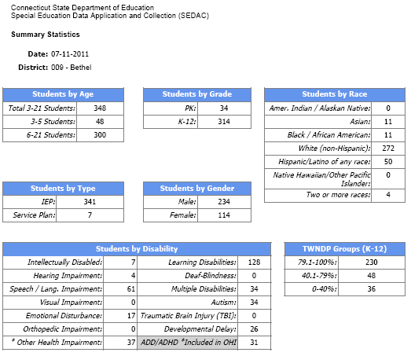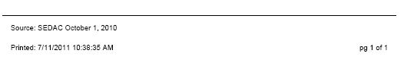

### Year to Year Change Report

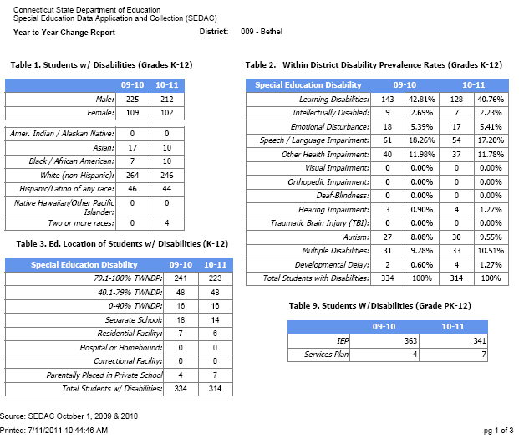

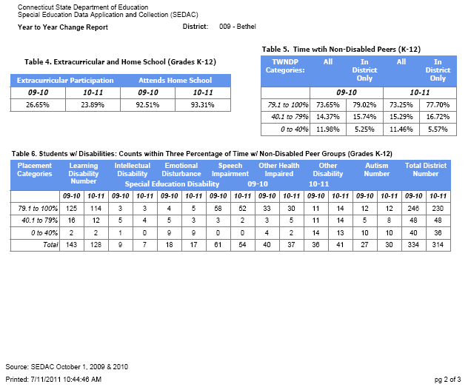

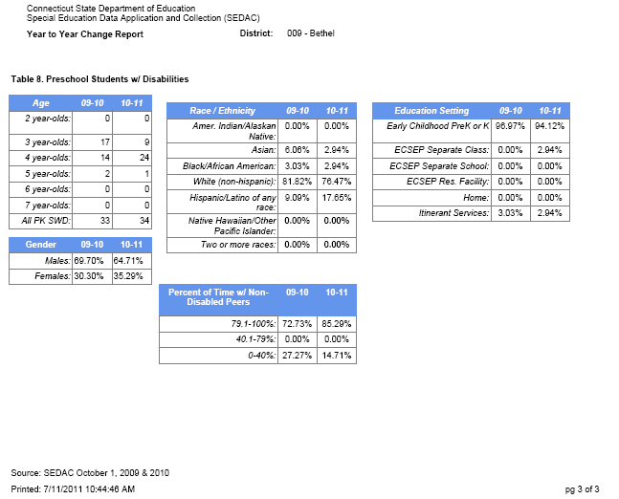

### Count and Percentage of Students (K-12) by Racial / Ethnic Group with Disability Subgroups

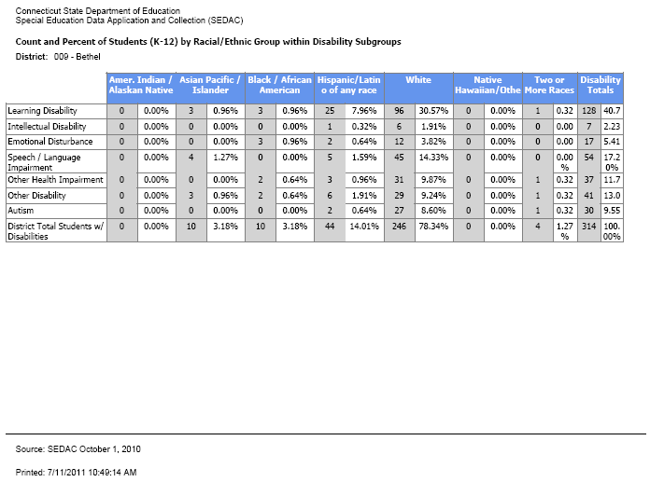

### Three TWNDP Categories: Students w/ Disabilities (K-12)

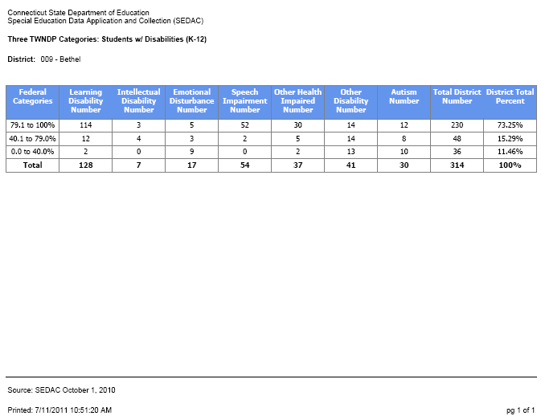

### Ten TWNDP Categories: Students w/ Disabilities (K-12)

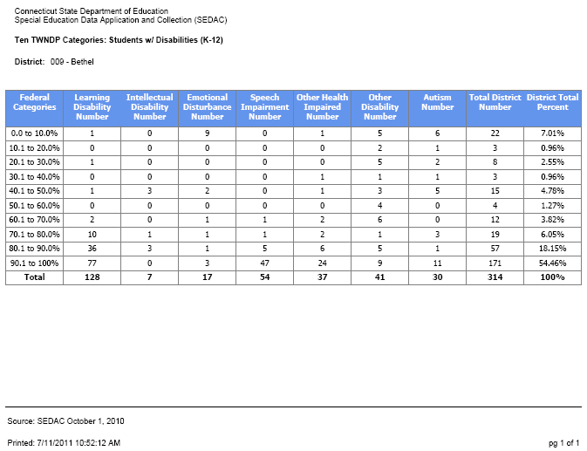

### Educational Placement of Students w/ Disabilities (K-12)

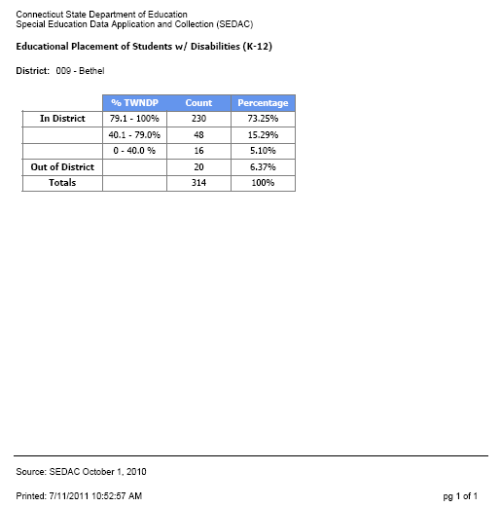

### Gender of Children with Disabilities by Educational Environment (K-12)

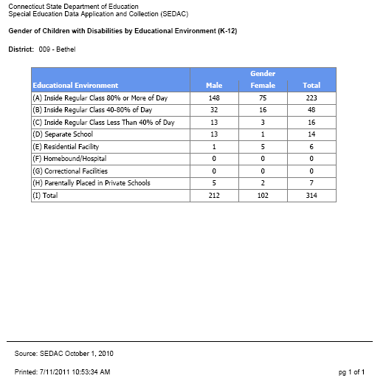

### Extracurricular Participation by Students with Disabilities (K-12)

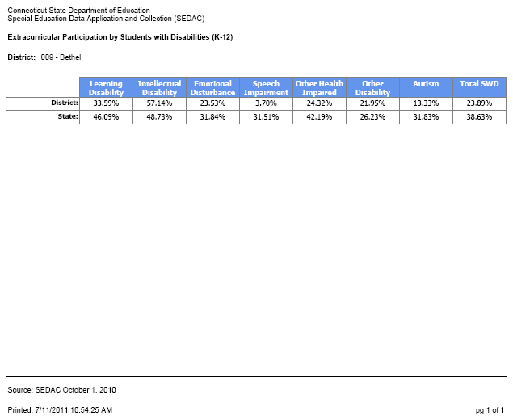

### Preschool Student Data

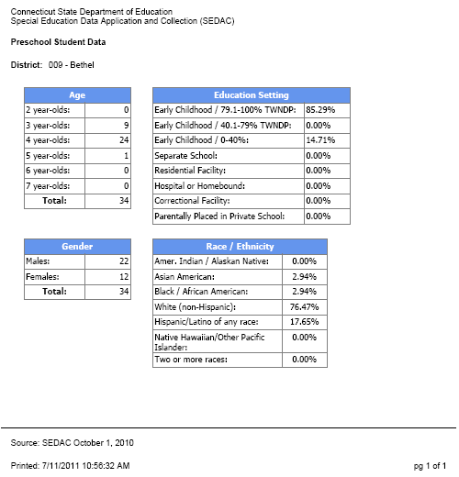

### Age of Child with Disabilities by Educational Environment (3-5)

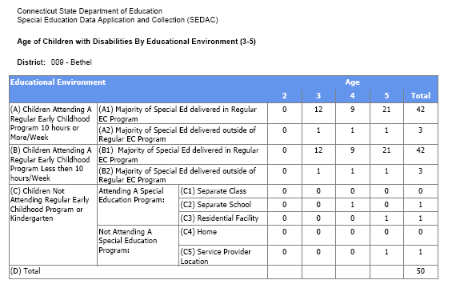



### Indicator 13 IEP Goals and Transition Services Summary Report (16-21)

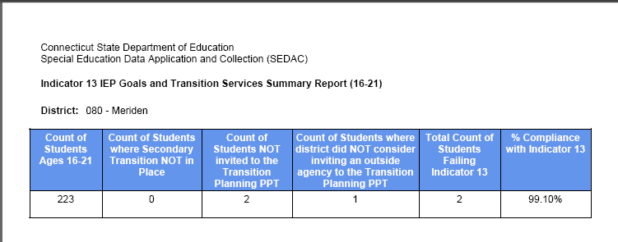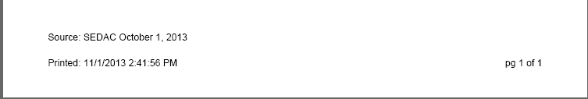

### Federal Child Count Certification

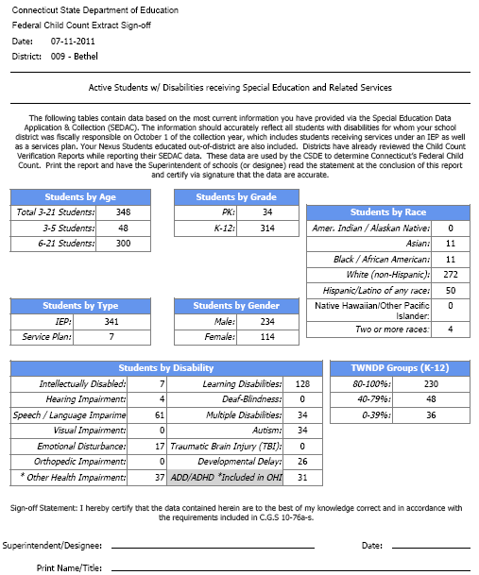





### Certification Confirmation

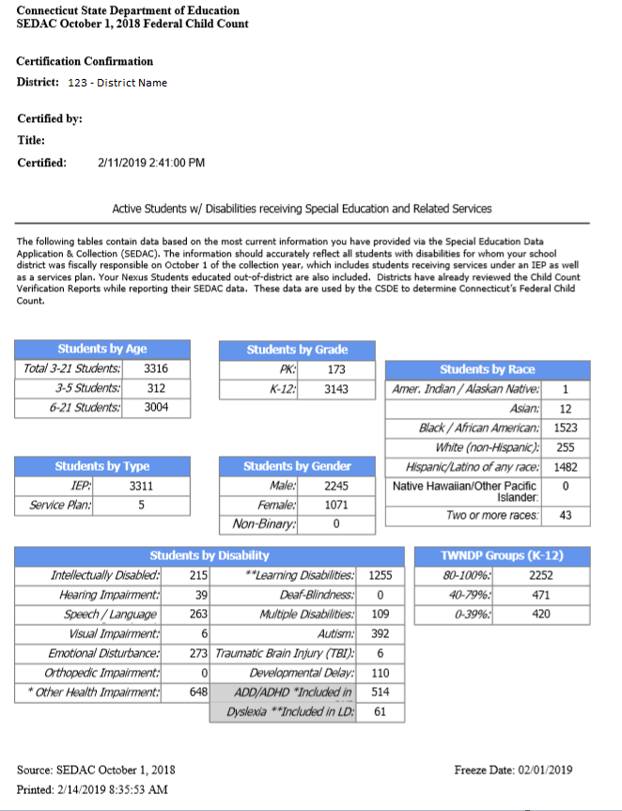

## CSDE's Statement of Nondiscrimination

The Connecticut State Department of Education is committed to a policy of equal opportunity/affirmative action for all qualified persons. The Connecticut State Department of Education does not discriminate in any employment practice, education program, or educational activity on the basis of **race, color, religious creed, sex, age, national origin, ancestry, marital status, sexual orientation, gender identity or expression, disability (including, but not limited to, intellectual disability, past or present history of mental disorder, physical disability or learning disability), genetic information, or any other basis prohibited by Connecticut state and/or federal nondiscrimination laws. The Connecticut State** **Department of Education does not unlawfully discriminate in employment and licensing against qualified persons with a prior criminal conviction.** Inquiries regarding the Connecticut State Department of Education’s nondiscrimination policies should be directed to:

Levy Gillespie

Equal Employment Opportunity Director/American with Disabilities Act Coordinator

Connecticut State Department of Education

450 Columbus Boulevard, Suite 607

Hartford, CT 06103

860-807-2071

[Levy.Gillespie@ct.gov](mailto:Levy.Gillespie@ct.gov)