This form includes the information required from the Recipient Agency for the Connecticut State Department of Education to submit complaints regarding USDA Foods direct delivery items. Complete all information and e-mail to allison.calhoun-white@ct.gov and monica.pacheco@ct.gov. For questions, please contact Allison Calhoun-White at 860-807-2008 or Monica Pacheco at
860-807-2086.

- Sales order number (starts with 5000): Click or tap here to enter text.
NOTE: To find the sales order number, go under Reports, click on Requisition Status Report, then enter the following information:
  - Program: Enter “NSLP.”
  - Req. Delivery Date: Enter “7/1/<insert current year, e.g., 2017>” in the first field and enter the current date in the second field), for example, “7/1/2017” to “1/9/2018.”
  - Material Code: Enter the material code of the product for which you are reporting the complaint.
  - Sold-To Party: This field should automatically populate with your seven-digit BPID number.

Hit Execute. Scroll over to the column for Sales Order # to locate the sales order number that applies to the complaint (there may be multiple delivery dates).

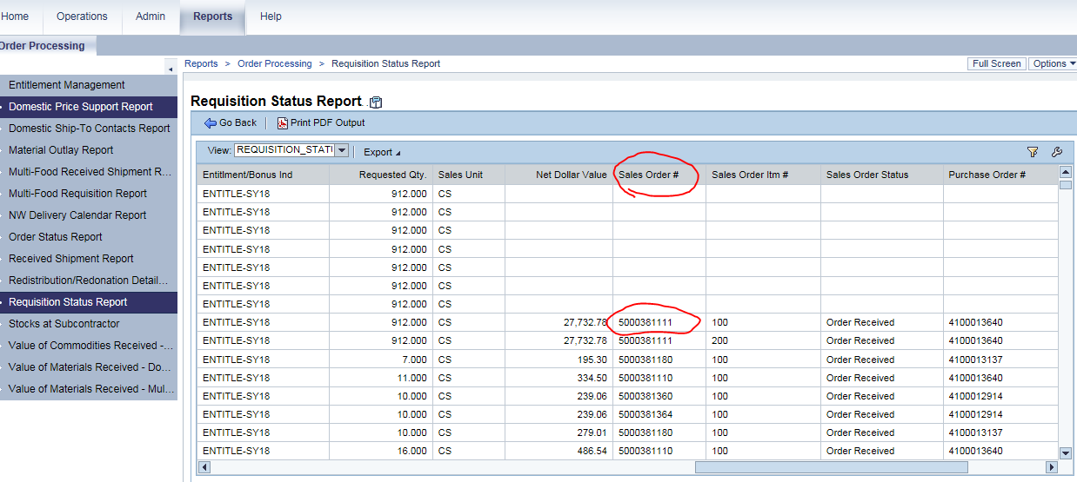

- Incident date:Click or tap here to enter text.
- Date received: Click or tap here to enter text.
- District/school contact name: Click or tap here to enter text.
- Contact organization: Click or tap here to enter text.
- Contact phone: Click or tap here to enter text.
- Contact e-mail: Click or tap here to enter text.
- Street address of remaining product: Click or tap here to enter text.
- Quantity received: Click or tap here to enter text.
- Quantity affected: Click or tap here to enter text.
- Quantity remaining: Click or tap here to enter text.
- Please include photos of:
  - the affected product (for example, if product is freezer burned, please send a photo that clearly shows the freezer burn);
  - the case and all labels on the case; and
  - any additional photos that would be beneficial to assess the situation.

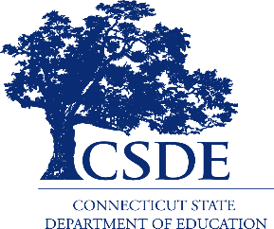
For information on the Connecticut Food Distribution Program (FDP), visit the CSDE’s Food Distribution Program (USDA Foods) webpage or contact the FDP program staff in the CSDE’s Bureau of Health/Nutrition, Family Services and Adult Education, 450 Columbus Boulevard, Suite 504, Hartford, CT 06103-1841.
This document is available at https://portal.ct.gov/-/media/SDE/Nutrition/FDP/USDAFoodsComplaintForm.docx.

In accordance with Federal civil rights law and U.S. Department of Agriculture (USDA) civil rights regulations and policies, the USDA, its Agencies, offices, and employees, and institutions participating in or administering USDA programs are prohibited from discriminating based on race, color, national origin, sex, disability, age, or reprisal or retaliation for prior civil rights activity in any program or activity conducted or funded by USDA.  Persons with disabilities who require alternative means of communication for program information (e.g. Braille, large print, audiotape, American Sign Language, etc.), should contact the Agency (State or local) where they applied for benefits. Individuals who are deaf, hard of hearing or have speech disabilities may contact USDA through the Federal Relay Service at (800) 877-8339. Additionally, program information may be made available in languages other than English.  To file a program complaint of discrimination, complete the USDA Program Discrimination Complaint Form, (AD-3027) found online at: How to File a Complaint, and at any USDA office, or write a letter addressed to USDA and provide in the letter all of the information requested in the form. To request a copy of the complaint form, call (866) 632-9992. Submit your completed form or letter to USDA by:  (1) mail: U.S. Department of Agriculture  Office of the Assistant Secretary for Civil Rights  1400 Independence Avenue, SW  Washington, D.C. 20250-9410;  (2) fax: (202) 690-7442; or  (3) email: program.intake@usda.gov.  This institution is an equal opportunity provider. | The Connecticut State Department of Education is committed to a policy of equal opportunity/affirmative action for all qualified persons. The Connecticut Department of Education does not discriminate in any employment practice, education program, or educational activity on the basis of age, ancestry, color, criminal record (in state employment and licensing), gender identity or expression, genetic information, intellectual disability, learning disability, marital status, mental disability (past or present), national origin, physical disability (including blindness), race, religious creed, retaliation for previously opposed discrimination or coercion, sex (pregnancy or sexual harassment), sexual orientation, veteran status or workplace hazards to reproductive systems, unless there is a bona fide occupational qualification excluding persons in any of the aforementioned protected classes.  Inquiries regarding the Connecticut State Department of Education’s nondiscrimination policies should be directed to: Levy Gillespie, Equal Employment Opportunity Director/Americans with Disabilities Coordinator (ADA), Connecticut State Department of Education, 450 Columbus Boulevard, Suite 607, Hartford, CT 06103, 860-807-2071, levy.gillespie@ct.gov.

