Module 5  Facilitator Guide | Focus on Sustaining Change

Section 5

Connecticut Core Standards for Mathematics

Grades 6–12

Systems of Professional Learning

Connecticut Core Standards Systems of Professional Learning
The material in this guide was developed by Public Consulting Group in collaboration with staff from the Connecticut State Department of Education and the RESC Alliance. The development team would like to specifically thank Ellen Cohn, Charlene Tate Nichols, and Jennifer Webb from the Connecticut State Department of Education; Leslie Abbatiello from ACES; and Robb Geier, Elizabeth O’Toole, and Cheryl Liebling from Public Consulting Group.
The Systems of Professional Learning project includes a series of professional learning experiences for Connecticut Core Standards District Coaches in English Language Arts, Mathematics, Humanities, Science, Technology, Engineering, Mathematics (STEM), and Student/Educator Support Staff (SESS).
Participants will have continued support for the implementation of the new standards through virtual networking opportunities and online resources to support the training of educators throughout the state of Connecticut.
Instrumental in the design and development of the Systems of Professional Learning materials from PCG were: Sharon DeCarlo, Debra Berlin, Jennifer McGregor, Judy Buck, Michelle Wade, Nora Kelley, Diane Stump, and Melissa Pierce.

Published 2014. Available online at http://ctcorestandards.org/
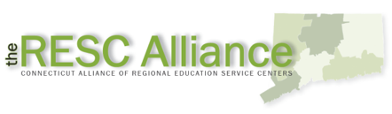

Session at-a-Glance

Section 5: Sustaining Change (30 minutes)

Training Objectives:
To receive feedback on coaching plans.
To wrap up Modules 1‒5.
Participants will complete a gallery walk in which they will visit four different spots around the room. At each spot, they will discuss with others each of the four areas covered by Modules 1‒4:
Understanding the Standards
Content Knowledge
Instructional Practices
Designing CCS-Math Learning
For each topic, participants will discuss any remaining questions/needs, and provide suggestions or strategies for meeting the needs, etc. Then, they will add either a question, need, or strategy to the chart paper for the corresponding topic. After everyone has addressed all four topics, participants will come together as a large group to discuss their needs and strategies for each. The facilitator will wrap up this section by providing additional resources for building coaching skills and answer any remaining questions.

Supporting Documents:
Additional Ideas for Support

Materials:
Chart paper, markers, sticky notes

PowerPoint Slides:
52–54

Systems of Professional Learning Project Updates and Reminders (5 minutes)
Introduce participants to other initiatives going on around the state.

PowerPoint Slides:
55–59

Session Implementation
Section 5
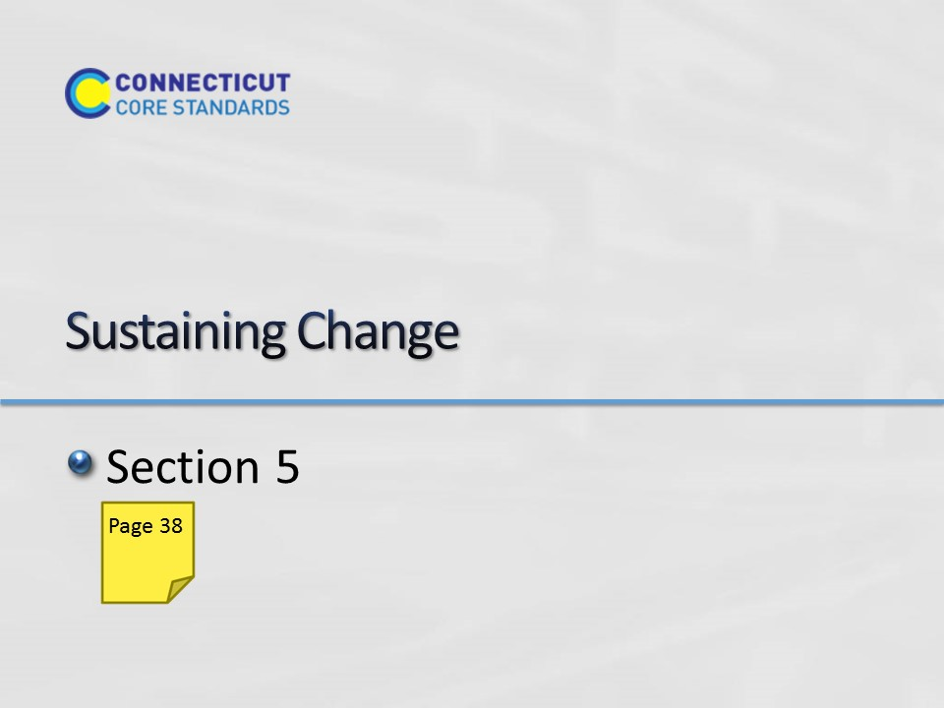Slide 52
Section 5: Sustaining Change
Section 5 Time: 30 minutes

Section 5 Training Objectives:
- To receive feedback on coaching plans.
- To wrap up Modules 1‒5.

Section 5 Outline:
- (25 minutes) Participants will complete a gallery walk in which they will visit four different spots around the room. At each spot, they will discuss with others each of the four areas covered by Modules 1‒4:
- Understanding the Standards
- Content Knowledge
- Instructional Practices
- Designing CCS-Math Learning
For each topic, participants will discuss any remaining questions/needs, and provide suggestions or strategies for meeting the needs, etc. Then, they will add either a question, need, or strategy to the chart paper for the corresponding topic.

- (5 minutes) After everyone has addressed all four topics, participants will come together as a large group to discuss their needs and strategies for each. The facilitator will wrap up this section by providing additional resources for building coaching skills and answer any remaining questions.

Section 5 Supporting Documents
Additional Ideas for Support

Section 5 Materials
Chart paper
Markers
Sticky Notes
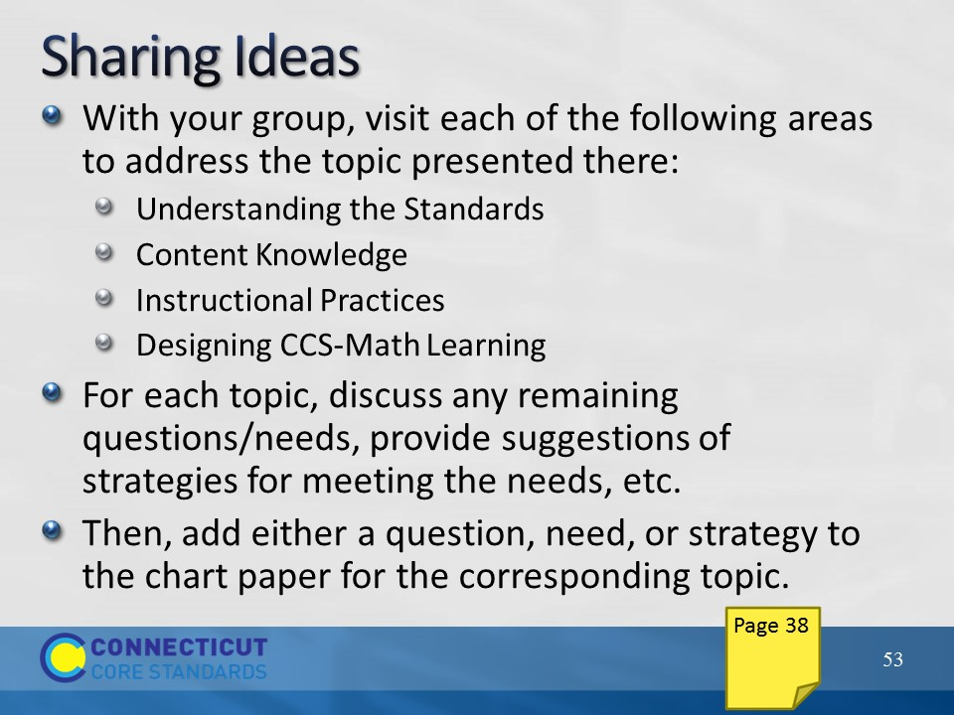Slide 53
Sharing Ideas
Place participants in grade level alike or course alike groups and explain that with their group they will visit and rotate through each of the following areas:
- Understanding the Standards
- Content Knowledge
- Instructional Practices
- Designing CCS-Math Learning

At each piece of chart paper, groups should discuss any remaining needs that they have found in that area and should add a question and a need to the chart paper. Then, if they have an answer/idea/strategy to address a question posted by another group, they should add that answer/idea/strategy to the chart paper as well. Allow approximately 15-20 minutes for participants to visit each piece of chart paper.
Then, bring everyone back together and review what is on each piece of chart paper as a result of their work and provide strategies and/or ideas for any remaining needs that have not been addressed.
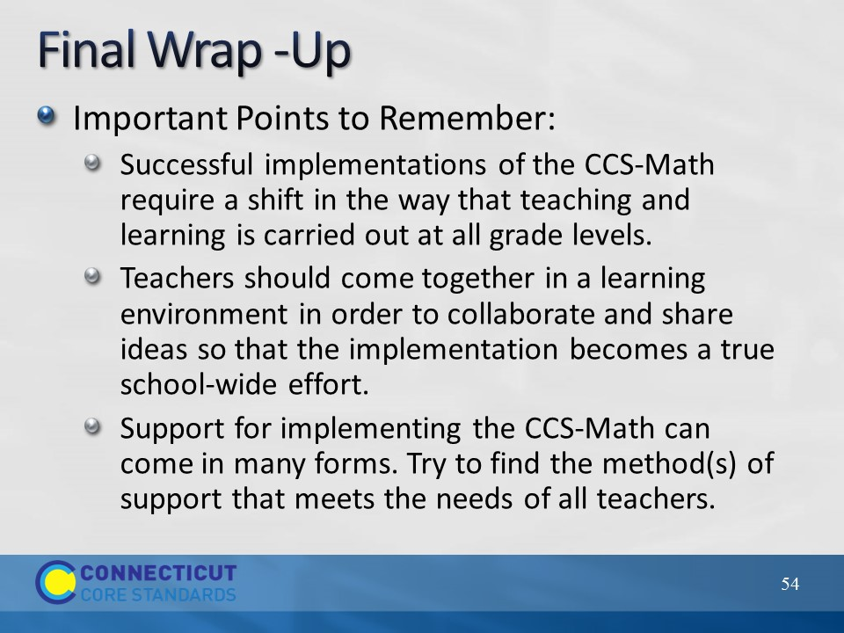Slide 54
Final Wrap-Up
Wrap-up Modules 1-5 by providing the important points to remember on the slide. Ask if there are any remaining questions and then close out the session by transitioning to the closing activities.
Systems of Professional Learning Project Updates and Reminders
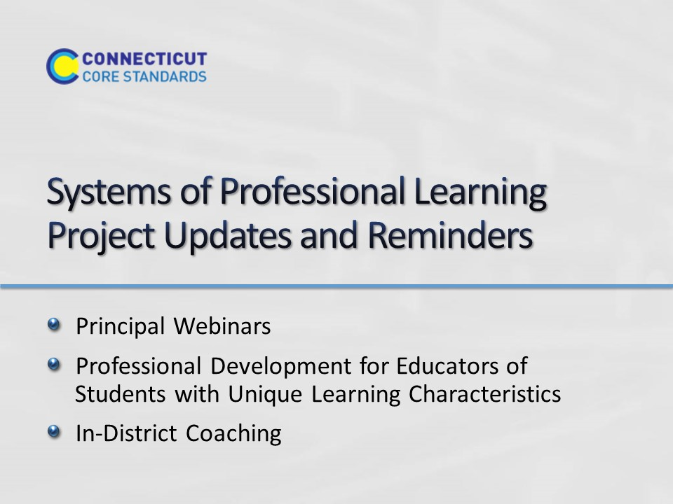Slide 55
Blank.
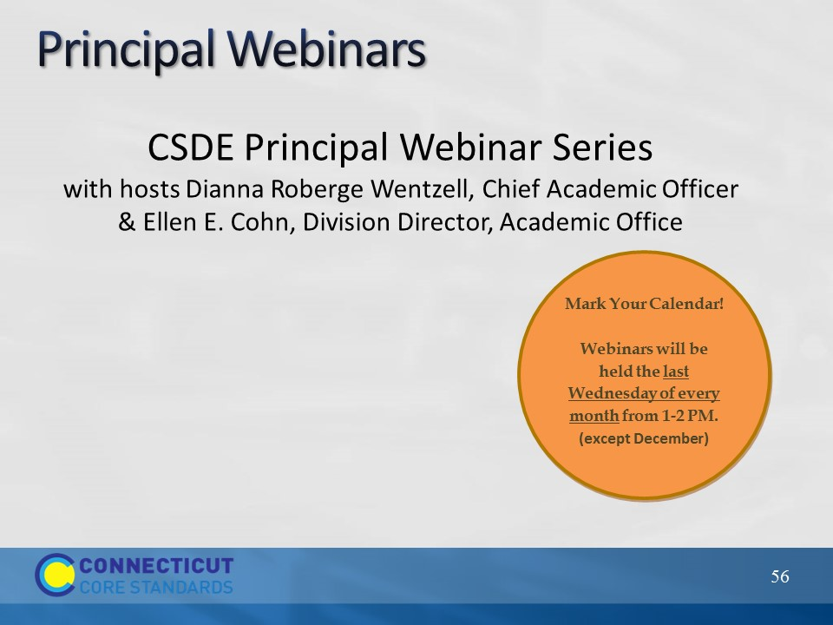Slide 56
CSDE is hosting a series of webinars for principals this year. These are interactive sessions where principals can gain information about the Systems of Professional Learning project, ask questions, and share experiences. To register and for more information about the series, please visit ctcorestandards.org. Use the screenshot on the next slide to show participants where to look for more information.
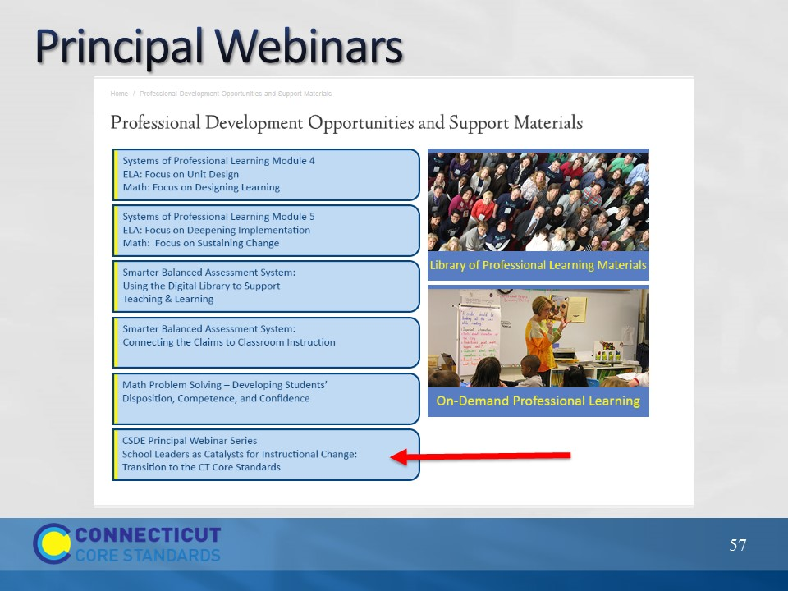Slide 57
More information about the sessions and registration information can be found under “Professional Development Opportunities” on the CT Core Standards website.
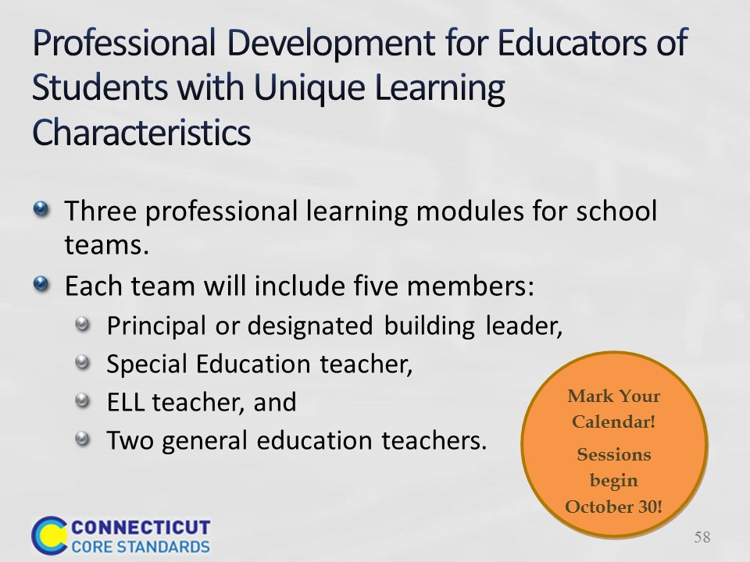Slide 58
In partnership with the Connecticut State Department of Education, Public Consulting Group (PCG) will present a professional development series for educators working with students with unique learning characteristics. The goal of this professional development series is to enable local educators to implement CCS-aligned curriculum, instructional practices, and assessments to meet the needs of a wide variety of learners.
Participants will attend as teams to empower educators to align efforts resulting in an inclusive environment, and increase their capability to foster change in their school systems.
Registration is open through the PCG “RegisterMe” website and accessible on the ctcorestandards.org website under the Professional Development link.
In the first module to be offered October through December, the full team from each school, including educators who work with English language learners (ELL) and students with disabilities (SwD), will explore the importance of a culture of academic optimism underpinned by the belief that through high expectations, trust in students and parents, and teacher efficacy that all students can learn. The morning will provide participants an overview of the power of a growth mindset in both students and teachers and discuss implications of adopting a culture of academic optimism in their schools and the collaboration required to achieve that goal. In the afternoon, teams will form a common understanding of Universal Design for Learning (UDL), which provides the foundation and springboard for two subsequent modules that expand participants’ ability to support all learners through using a UDL approach to planning and teaching.
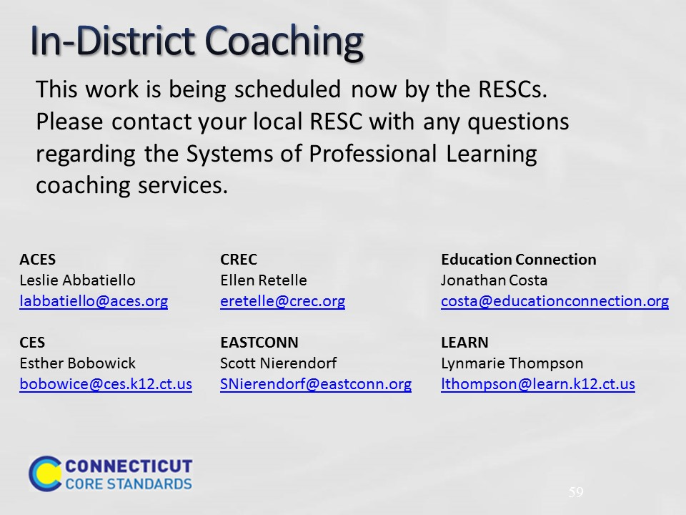Slide 59
The CSDE has announced that 66 LEAs have received an allocation of in-district coaching services to support implementation of the Connecticut Core Standards for the 2014-2015 school year. For information about your district’s allocation, check with your district administration and your local RESC.

