Module 5  Facilitator Guide | Focus on Sustaining Change

Section 4

Connecticut Core Standards for Mathematics

Grades 6–12

Systems of Professional Learning

Connecticut Core Standards Systems of Professional Learning
The material in this guide was developed by Public Consulting Group in collaboration with staff from the Connecticut State Department of Education and the RESC Alliance. The development team would like to specifically thank Ellen Cohn, Charlene Tate Nichols, and Jennifer Webb from the Connecticut State Department of Education; Leslie Abbatiello from ACES; and Robb Geier, Elizabeth O’Toole, and Cheryl Liebling from Public Consulting Group.
The Systems of Professional Learning project includes a series of professional learning experiences for Connecticut Core Standards District Coaches in English Language Arts, Mathematics, Humanities, Science, Technology, Engineering, Mathematics (STEM), and Student/Educator Support Staff (SESS).
Participants will have continued support for the implementation of the new standards through virtual networking opportunities and online resources to support the training of educators throughout the state of Connecticut.
Instrumental in the design and development of the Systems of Professional Learning materials from PCG were: Sharon DeCarlo, Debra Berlin, Jennifer McGregor, Judy Buck, Michelle Wade, Nora Kelley, Diane Stump, and Melissa Pierce.

Published 2014. Available online at http://ctcorestandards.org/

Session at-a-Glance

Section 4: Supporting Professional Growth (65 minutes)

Training Objectives:
To identify and examine tools and strategies that can be used to provide teachers opportunities for continued professional growth.
Section 4 focuses on helping participants plan for supporting and sustaining change within their school. This section begins with the participants discussing, in small groups, strategies that they currently employ to provide teachers with ongoing professional support, the opportunities teachers have to collaborate and the topics/tasks at the center of those activities, and the resources that they use to increase communication and collaboration with and among their teachers.
Within their small group, participants will break up into three smaller, micro groups. Each micro group will focus on one of three topics: ongoing professional support, opportunities for collaboration, and tools for collaboration and communication. Micro groups will then meet with others for the topic that they have chosen to explore and discuss provided resources, topics, and so forth. Participants will add any information, resources, etc., that they wish to use to help with addressing areas of need identified in Section 1 and to move their school’s CCS-Math implementation forward.

Supporting Documents:
Resources for Collaboration and Communication
Strategies for Ongoing Professional Support
Ways to Work Together

Materials:
Chart paper, markers, sticky notes

PowerPoint Slides:
47–51

Session Implementation
Section 4
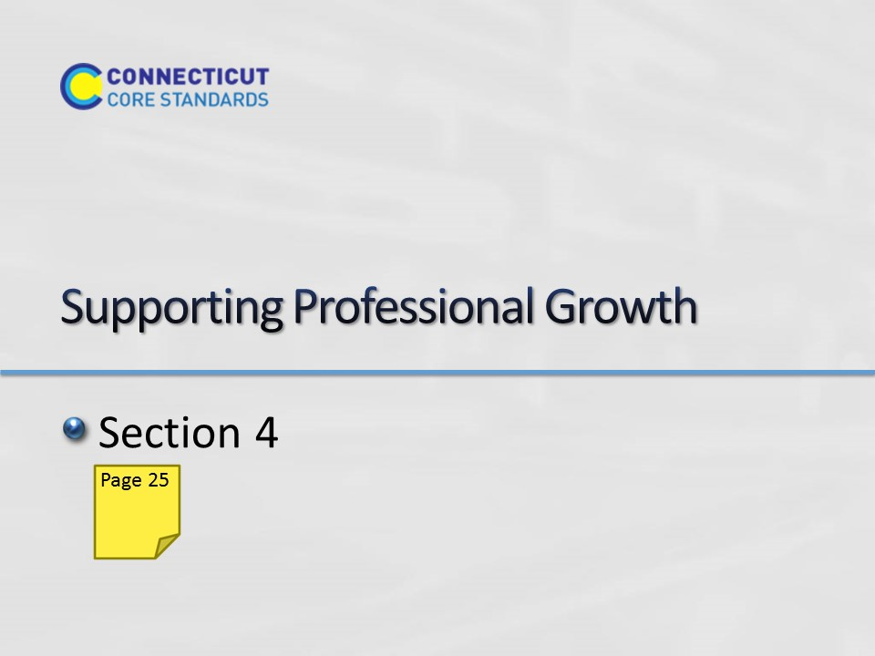Slide 47
Section 4: Supporting Professional Growth
Section 4 Time: 65 minutes

Section 4 Training Objectives:
- To identify and examine tools and strategies that can be used to provide teachers opportunities for continued professional growth.

Section 4 Outline:
- (10 minutes) Section 4 focuses on helping participants plan for supporting and sustaining change within their school. This section begins with the participants discussing, in small groups, strategies that they currently employ to provide teachers with ongoing professional support, the opportunities teachers have to collaborate and the topics/tasks at the center of those activities, and the resources that they use to increase communication and collaboration with and among their teachers.
- (25 minutes) Within their small group, participants will break up into three smaller, micro groups. Each micro group will focus on one of three topics: ongoing professional support, opportunities for collaboration, and tools for collaboration and communication. Micro groups will then meet with others for the topic that they have chosen to explore and discuss provided resources, topics, and so forth.
- (20 minutes) When the exploration and discussion time is over, participants will rejoin their work group and take time to provide information and insights gained from their micro group discussions.
- (10 minutes) As a result of the small group discussion, participants will add any information, resources, etc., that they wish to use to help with addressing areas of need identified in Section 1 and to move their school’s CCS-Math implementation forward.

Section 4 Supporting Documents
Resources for Collaboration and Communication
Strategies for Ongoing Professional Support
Ways to Work Together

Section 4 Materials
Chart paper
Markers
Sticky Notes
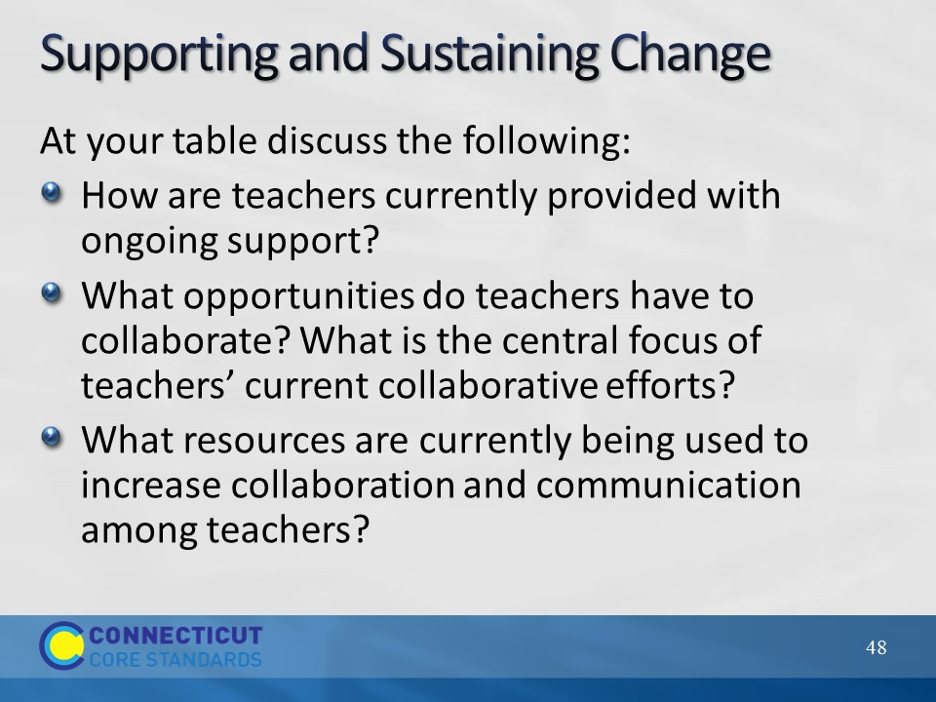Slide 48
Supporting and Sustaining Change
Section 4 focuses on helping participants plan for supporting and sustaining change within their school by thinking about ongoing teacher support, collaboration, and communication. Begin this section by explaining to participants that now that they have had the opportunity to examine various modes of support and, in particular, coaching conversations, they will now look at some ways to provide ongoing support to teachers that do not always require face-to-face interaction and through ongoing opportunities for collaboration and communication. Ask participants to start this conversation by discussing, in small groups, strategies that they currently employ to provide teachers with ongoing professional support, the opportunities teachers have to collaborate and the topics/tasks at the center of those activities, and any resources that they use to increase communication and collaboration with and among their teachers. Allow approximately 5-7 minutes for this small group discussion, and then bring the whole group back together to debrief their small group discussions. Ask for volunteers to share their ideas and, as they share, chart their responses on three separate pieces of chart paper labeled: Ongoing Professional Support, Opportunities for Collaboration, and Tools for Collaboration and Communication. Hang the chart paper strategically in the room as these will be utilized later in this section.
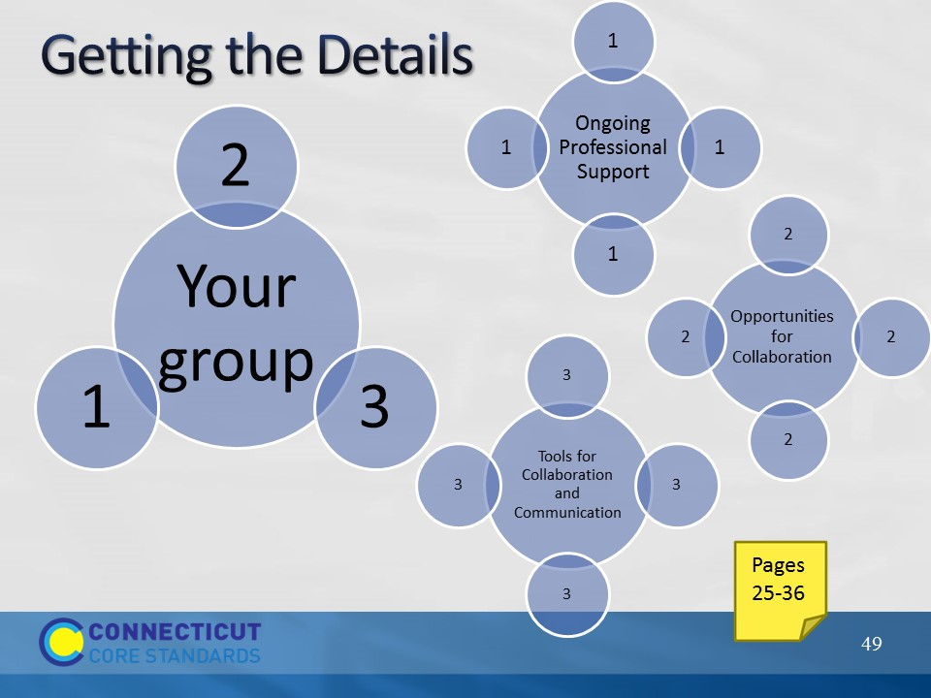Slide 49
Getting the Details
Explain to participants that in order to get ‘maximum coverage’ of ideas and discussions they will now jigsaw the strategies provided within the Participant Guide. Have each person within a table group count off from 1 to 3 and then instruct all of the 1’s to go to one table, 2’s to another, and 3’s to a third. Depending on the total number of participants there may be multiples of each table which is fine. Further explain that within their smaller, micro groups, they will focus on one of three topics: ongoing professional support, opportunities for collaboration, and tools for collaboration and communication. Assign a focus area to each group and then allow 20-25 minutes for each group to complete the focus area assignment/discussion in their Participant Guide. As groups work, be sure to visit each group to offer specific assistance and answer specific questions. Note: As participants begin their work, explain that each of the three areas has several strategies associated with the focus. For example, opportunities for collaboration has eight different strategies associated with this focus.
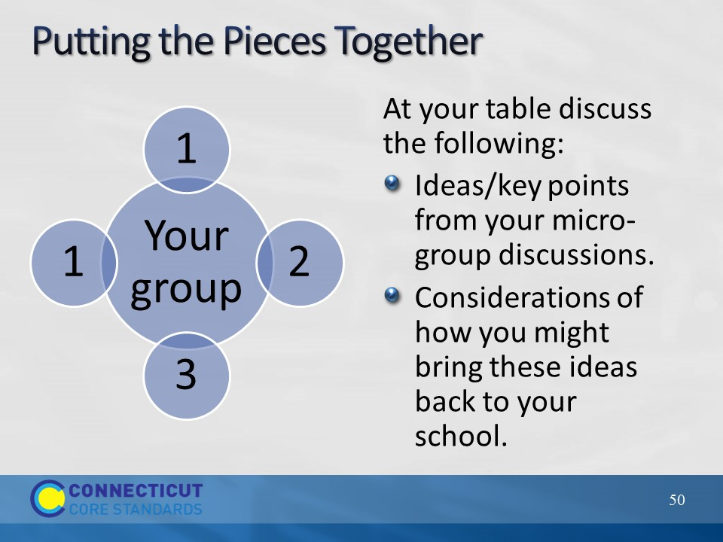Slide 50
When the exploration and discussion time is over, have participants rejoin their work group and take approximately 10-15 minutes to provide information and insights gained from their micro-group discussions. Begin to wrap-up Section 4 by debriefing the small group discussions and add to the chart paper created during the opening discussion for Section 4. Be sure to highlight the types of needs that can be addressed.
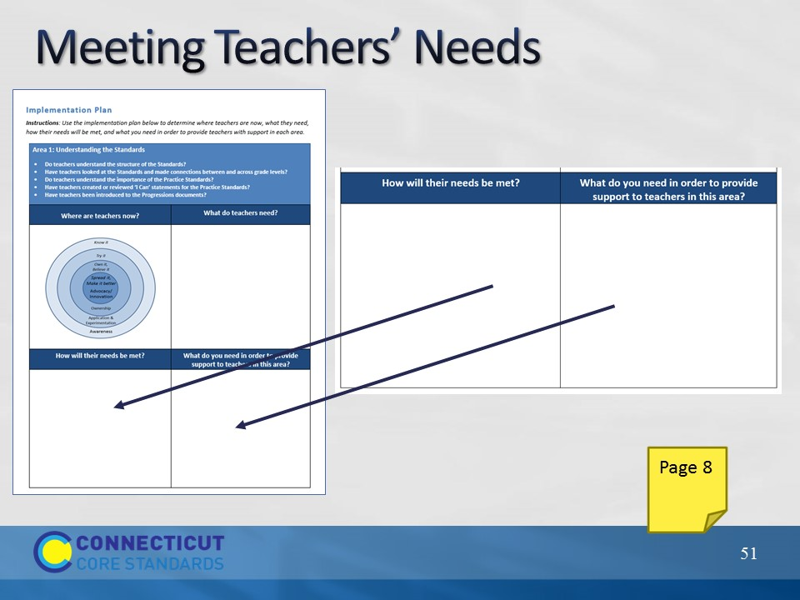Slide 51
Meeting Teachers’ Needs
Before transitioning to Section 5, have participants go back to their implementation plan and continue to fill in ideas that they have for how teachers’ needs will be met and to identify anything they might need in order to continue to provide support to teachers. Note: As participants are working place four pieces of chart paper around the room in anticipation for Section 5 work. Label each piece either: Understanding the Standards, Content Knowledge, Instructional Practices, and Designing CCS-Math Learning.

