Module 5  Facilitator Guide | Focus on Sustaining Change

Section 3

Connecticut Core Standards for Mathematics

Grades 6–12

Systems of Professional Learning

Connecticut Core Standards Systems of Professional Learning
The material in this guide was developed by Public Consulting Group in collaboration with staff from the Connecticut State Department of Education and the RESC Alliance. The development team would like to specifically thank Ellen Cohn, Charlene Tate Nichols, and Jennifer Webb from the Connecticut State Department of Education; Leslie Abbatiello from ACES; and Robb Geier, Elizabeth O’Toole, and Cheryl Liebling from Public Consulting Group.
The Systems of Professional Learning project includes a series of professional learning experiences for Connecticut Core Standards District Coaches in English Language Arts, Mathematics, Humanities, Science, Technology, Engineering, Mathematics (STEM), and Student/Educator Support Staff (SESS).
Participants will have continued support for the implementation of the new standards through virtual networking opportunities and online resources to support the training of educators throughout the state of Connecticut.
Instrumental in the design and development of the Systems of Professional Learning materials from PCG were: Sharon DeCarlo, Debra Berlin, Jennifer McGregor, Judy Buck, Michelle Wade, Nora Kelley, Diane Stump, and Melissa Pierce.

Published 2014. Available online at http://ctcorestandards.org/

Session at-a-Glance

Section 3: Supporting Meaning Reflection (100 minutes)

Training Objectives:
To examine the role of a coach.
To understand the role of questioning and feedback, fostering meaningful reflection on the part of the teacher.
To practice providing feedback on lesson plans and classroom observations.
The facilitator will engage participants in thinking about the role of a CCS-Math Core Standards coach. Using slides that clarify what the coach does and does not do, the facilitator will remind participants that most often a coach’s role is non-evaluative. In “coaching conversations”, teachers are provided with feedback on lesson planning or classroom visits that should promote meaningful reflection on the part of the teacher. The coach will often help the teacher by either raising questions or making suggestions for refinement of the lesson. Participants will be paired in order to engage in coaching conversations about the lessons designed in Module 4. A person from one table group will take on the role of a coach and take about 10 minutes to look over the planned lesson designed by a “teacher” from a different table group and form purposeful questions for the teacher (using the EQuIP Rubric or the UDL Principles as a basis for these questions). The two participants will then flip roles and the process will be repeated for the other participant’s completed lesson design template. Participants will debrief this activity during a large group discussion. Explain that they will now turn their attention to providing prompts for reflection on observed classroom practices. Sample “lenses” that could be used for data gathering by the coach are listed on page 21 in their Participant Guide. Table groups will decide on a lens to use when observing a video lesson. After viewing the lesson, groups will discuss reflection prompts, based on the observation lens that they would use during a follow-up coaching conversation. A “jigsaw” approach will be used to allow participants to share their discussion prompts with other tables.

Supporting Documents:
Notes on Coach’s Role recording sheet
Purposeful Questions recording sheet
Forming Questions on a Lesson Design recording sheet
EQuIP Rubric
UDL Principles
Reflecting on the Coaching Conversation recording sheet
Lenses for Data Gathering
Data Gathering Tool
Classroom Observation Feedback recording sheet
Video
Teaching Channel video ‒ Probability of Dependent and Independent Events https://www.teachingchannel.org/videos/teaching-dependent-and-independent-events

Materials:
Chart paper, markers

PowerPoint Slides:
32–45

Session Implementation
Section 3
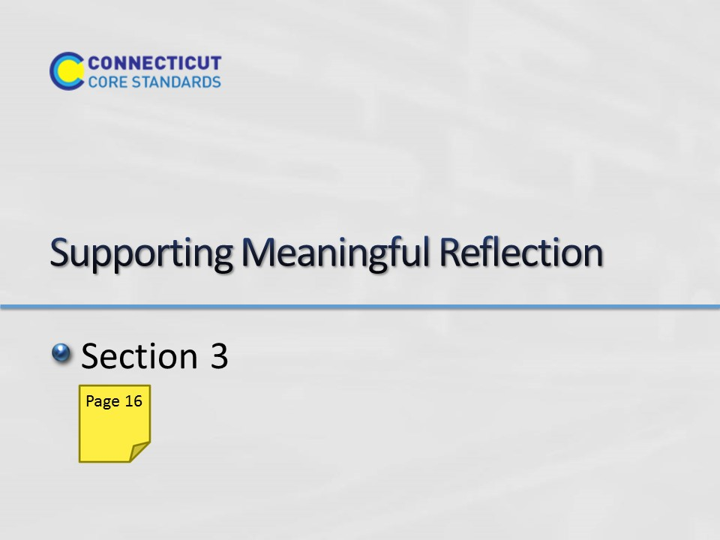Slide 32
Section 3: Supporting Meaningful Reflection
Section 3 Time: 100 minutes

Section 3 Training Objectives:
- To examine the role of a coach.
- To understand the role of questioning and feedback, fostering meaningful reflection on the part of the teacher.
- To practice providing feedback on lesson plans and classroom observations.

Section 3 Outline:
- (10 minutes) The facilitator will engage participants in thinking about the role of a CCS-Math Core Standards coach. Using slides that clarify what the coach does and does not do, the facilitator will remind participants that most often a coach’s role is non-evaluative. In “coaching conversations”, teachers are provided with feedback on lesson planning or classroom visits that should promote meaningful reflection on the part of the teacher. The coach will often help the teacher by either raising questions or making suggestions for refinement of the lesson.
- (10 minutes) The facilitator will show a few slides on the characteristics of effective coaching questions. The facilitator will ask the large group if there are other tips for forming questions that will build trust in the coaching relationship while promoting the teacher’s spirit of inquiry and reflection and expand possible options for the lesson.
- (35 minutes) Participants will be paired in order to engage in coaching conversations about the lessons designed in Module 4. A person from one table group will take on the role of a coach and take about 10 minutes to look over the planned lesson designed by a “teacher” from a different table group and form purposeful questions for the teacher (using the EQuIP Rubric or the UDL Principles as a basis for these questions). Another 5 minutes will be given for the coach to ask the questions about the intended implementation of the lesson. For example, “How will your students be engaged in productive struggle in this lesson?” or “Are there some other types of action and expression the students could be engaged in?” The two participants will then flip roles and the process will be repeated for the other participant’s completed lesson design template. Participants will debrief this activity during a large group discussion.
- (45 minutes) Explain that they will now turn their attention to providing prompts for reflection on observed classroom practices. Sample “lenses” that could be used for data gathering by the coach are listed on page 21 in their Participant Guide. Table groups will decide on a lens to use when observing a video lesson. After viewing the lesson, groups will discuss reflection prompts, based on the observation lens that they would use during a follow-up coaching conversation. A “jigsaw” approach will be used to allow participants to share their discussion prompts with other tables.

Section 3 Supporting Documents
Notes on Coach’s Role recording sheet
Purposeful Questions recording sheet
Forming Questions on a Lesson Design recording sheet
EQuIP Rubric
UDL Principles
Reflecting on the Coaching Conversation recording sheet
Lenses for Data Gathering
Data Gathering Tool
Classroom Observation Feedback recording sheet

Video
Teaching Channel ‒ Probability of Dependent and Independent Events
https://www.teachingchannel.org/videos/teaching-dependent-and-independent-events
- stop the video at about 4:16. Although this is a grade 6 classroom, Probability is grade 7.
Section 3 Materials
Chart paper
Markers
Sticky Notes
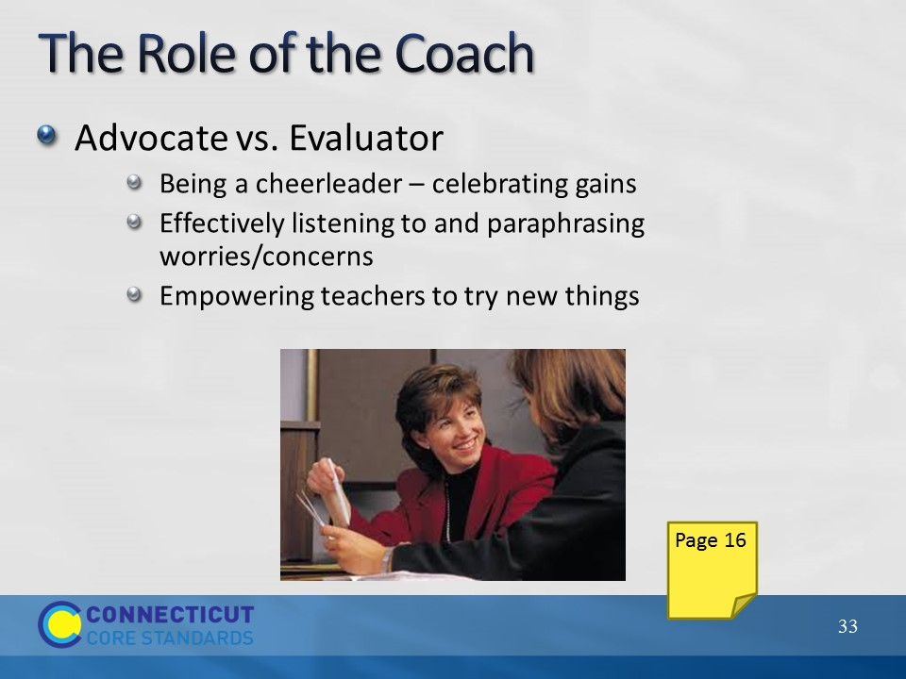Slide 33
The Role of Coach
Clarify the coach’s role by using the next 3 slides. Participants can start making notes on these descriptions of the Coach’s Role in their Participant Guide. Remind participants that most often the coach’s role is as an advocate vs. as an evaluator. Make the following points:
- Effective coaching requires mutual respect. Building trust and developing a friendly working relationship is key. It’s important that teachers know that you value the job they are presently doing in school with their students (Felux, C., Snowdy, P., 2006). It is also important to regularly celebrate the gains that the teacher is making, even if they are small. Some teachers may need reassurance that they are making a difference. The coach needs to be mindful that change is a slow and incremental process.
- The coach needs to be a good listener - paraphrasing is a tool for building rapport in a coaching relationship. It lets the teacher know you are listening and that you have a shared understanding of the difficulty (Bay-Williams, J. & McGatha, M., 2014).
- Empower teachers – help them think about the things they can control and give them the freedom to take risks.
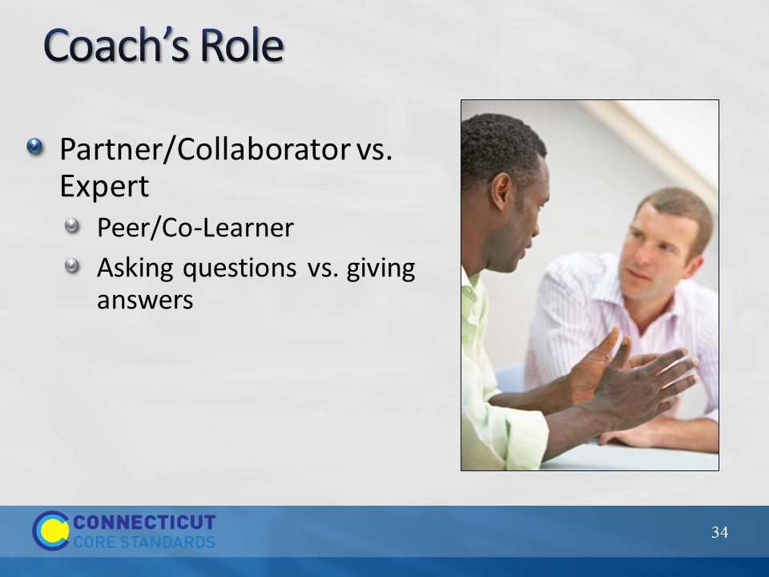Slide 34
Explain that the coach, in this non-evaluative role, should act as a partner/collaborator vs. an expert. The teacher should perceive the coach as a peer/co-learner rather than someone who already knows all the answers. The coach acts as a researcher on effective mathematics instruction. As has already been mentioned in Section 2, during a coaching conversation with teachers, the coach will provide feedback on lesson planning or classroom visits. Rather than telling the teacher how to improve, the coach can engage the teacher in meaningful reflection either by raising questions or making suggestions for refinement of the lesson or classroom practices. The coach should allow teachers the freedom to test things out and learn from their mistakes.
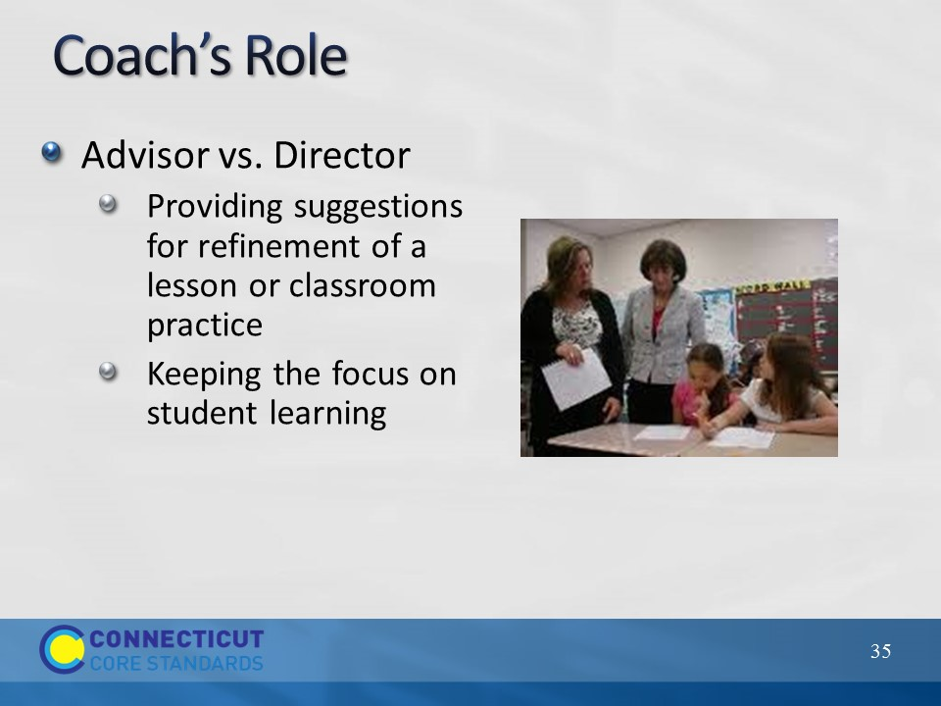Slide 35
The coach also acts as an advisor vs. a director by providing suggestions vs. giving answers. This empowers the teacher to make their own choices. You can build trust by keeping the focus on student learning rather than on the teacher.

Tell the participants that the focus of the remainder of this section is on developing skills in supporting meaningful reflection through the raising of questions and through making suggestions for refinement.
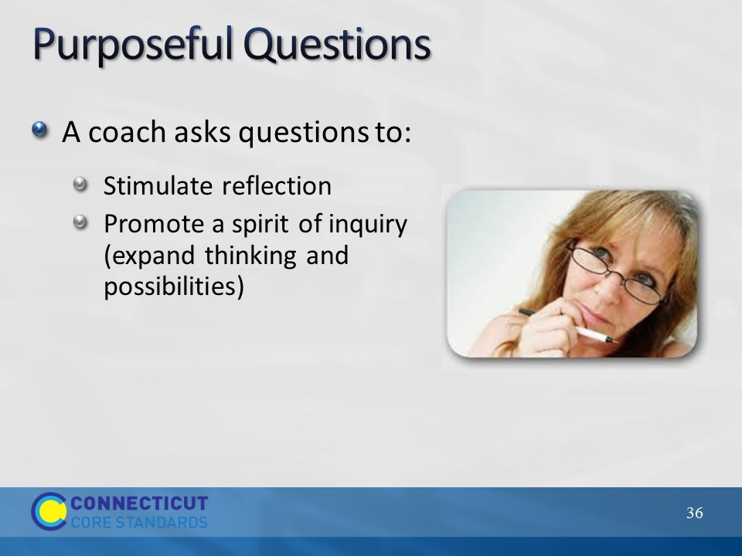Slide 36
Explain that a coach needs to work at forming questions that will stimulate reflection on how content can be taught effectively to engage students. With well-worded questions the coach can build trust in the coaching relationship. The coach will often pose questions in a planning (pre-lesson) conversation and also in a reflection (post-lesson) conversation.
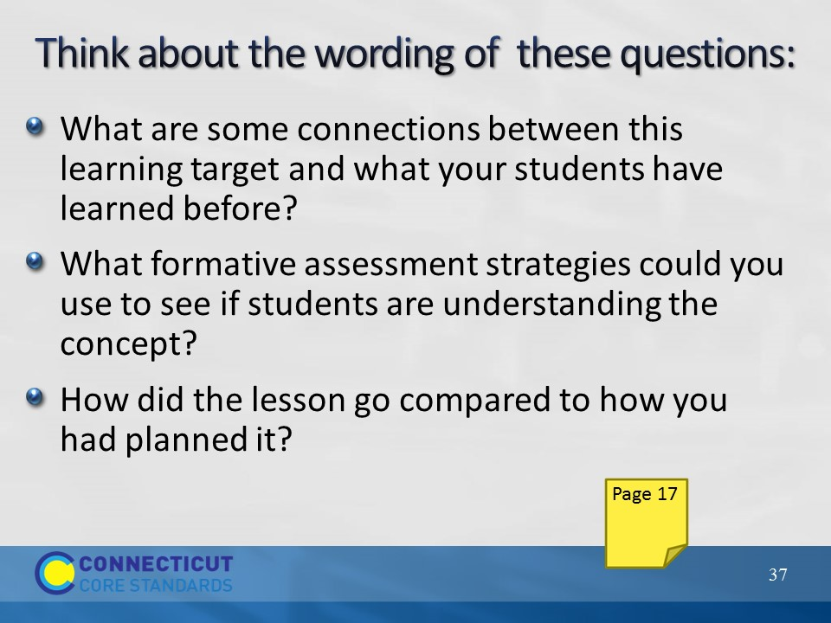Slide 37
Ask participants to read the questions on the slide (also in their Participant Guide) and give them a couple minutes to discuss in their table groups what they notice about the wording of the questions. Have members from different table groups share what they noticed with the large group. If participants don’t mention the plurals used or the tentative language (“some”, “could”), bring these characteristics out. These techniques open the conversation up to additional options – the coach should try to use open-ended questions to allow the teacher to express his or her ideas. Also note that the word “compare” in the last question elicits higher-order thinking. The next slide lists some of these facets of well-crafted questions.
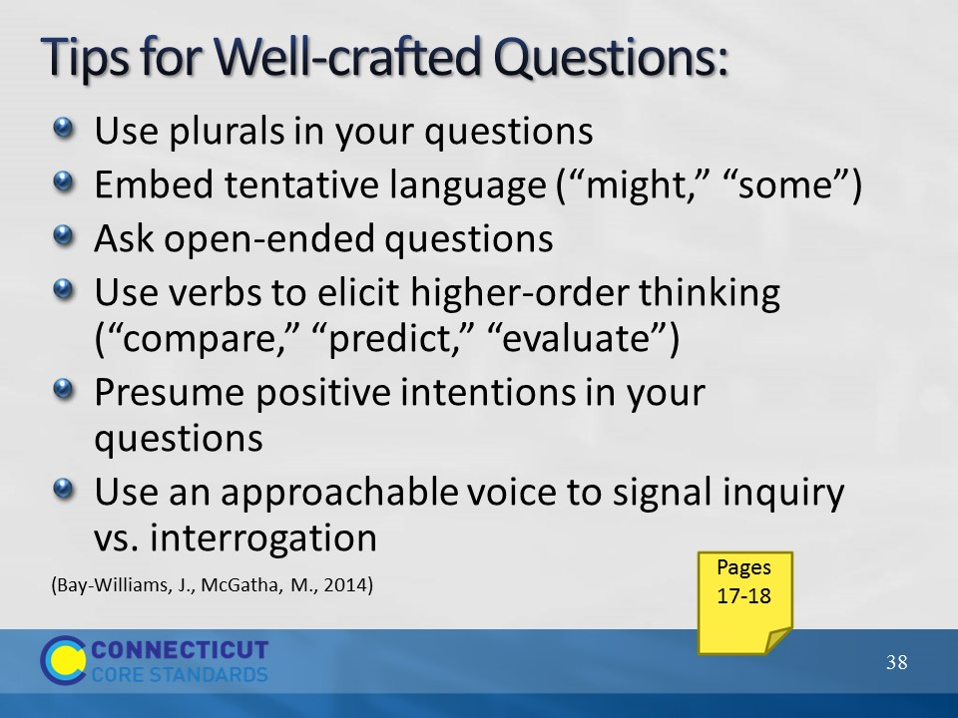Slide 38
Participants can record notes about these ideas in the notes section of the Purposeful Questions chart in their Participant Guide. This list is adapted from a book mentioned in the resources (Bay-Williams, J. & McGatha, M., 2014). Ask the large group if they would add other tips for forming questions that will build trust in the coaching relationship while promoting the teacher’s spirit of inquiry and reflection and expanding possible options for the lesson. Another example if not suggested: Try to avoid starting question with “Why…”? as this often puts a person on the defensive.

In preparation for the next activity, ask the participants to use their Lesson Design from Module 4 and pair up with a person from another table (you might help facilitate this by matching tables with the same number of participants) so that they can engage in coaching conversations about those lessons). Participants should make sure that they pair up with a person who was at a different table in Module 4.

Note: If participants do not have the Lesson Design from Module 4, have them go online and access a lesson that they can use for the activities in this section.
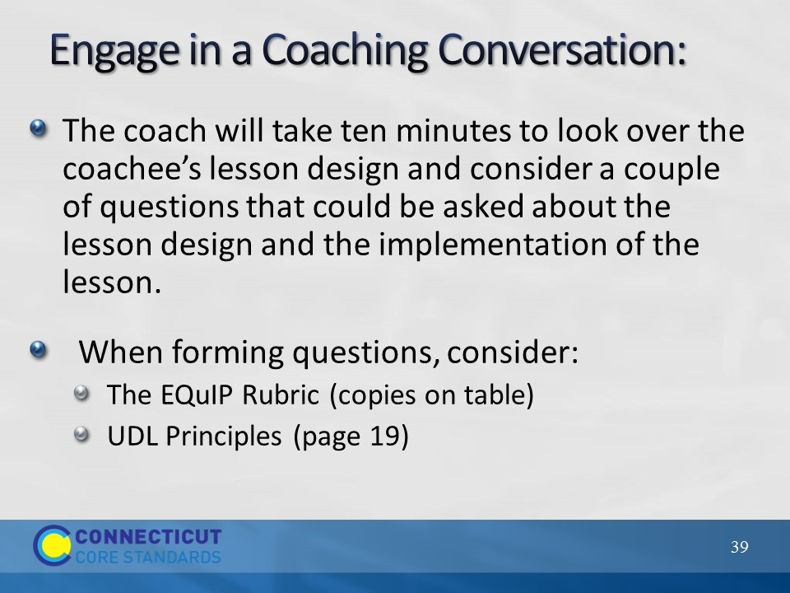Slide 39
Explain the process for engaging in coaching conversations with the large group. In each pair, a person from one table group will take on the role of a coach and take some time to look over the planned lesson designed by the “coachee” from a different table group and ask questions for clarification as necessary to understand the lesson itself. The coach should then draft at least two questions that they would use in terms of the coaching conversation. When drafting these questions the coach should think about the phrasing of questions about the lesson design and/or the intended implementation of the lesson (recording sheet for these is in their Participant Guide, Forming Questions on a Lesson Design). Suggest that they use the EQuIP Rubric or the UDL Principles as a basis for these questions. You might provide a few examples, such as, “How will your students be engaged in productive struggle in this lesson?”, “Are there some other types of action and expression the students could be engaged in?”
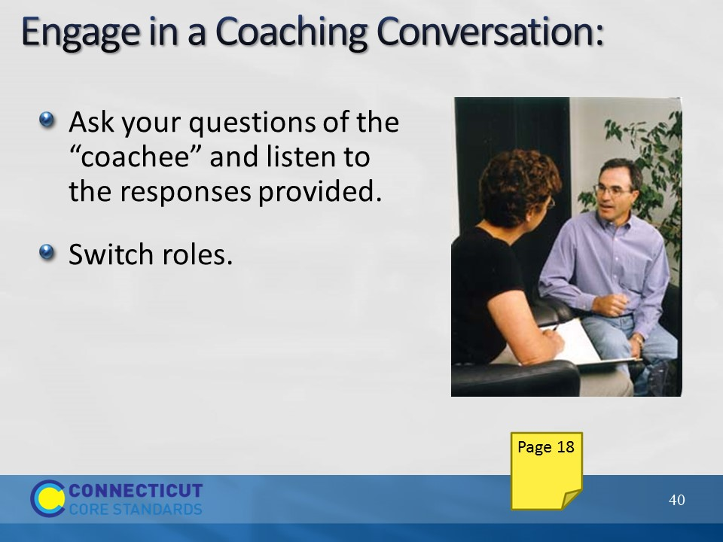Slide 40
Participants will have about 10 minutes to ask their questions of the “coachee” and listen to the responses provided. Give the signal for the two participants to switch roles and repeat the process for the other participant’s completed lesson design template. (15 minutes)
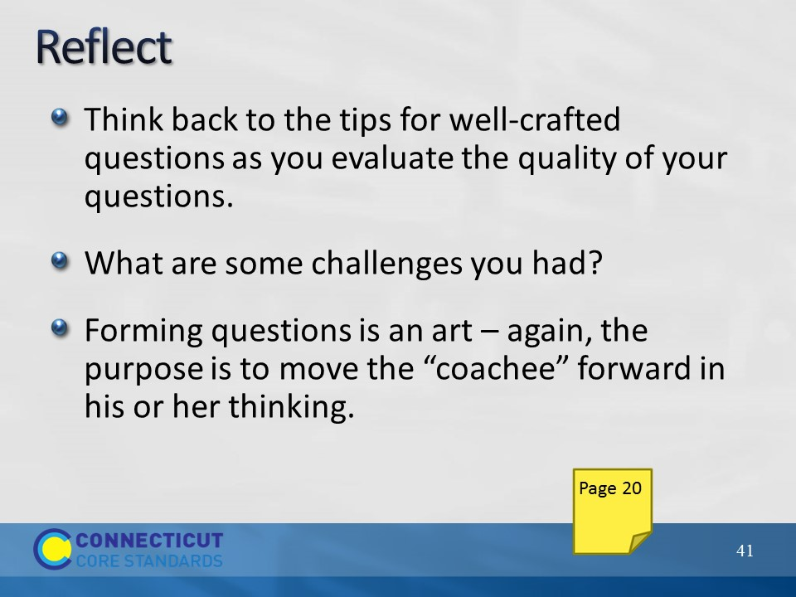Slide 41
The facilitator will wrap up this part of the section by debriefing with the large group about experiences during the coaching conversations. They can make notes about the experience in their Participant Guide. Remind participants that asking well-crafted questions is an art and will take practice and reflection. (5 minutes)
Explain that they will now turn to their attention to providing feedback on classroom instruction.
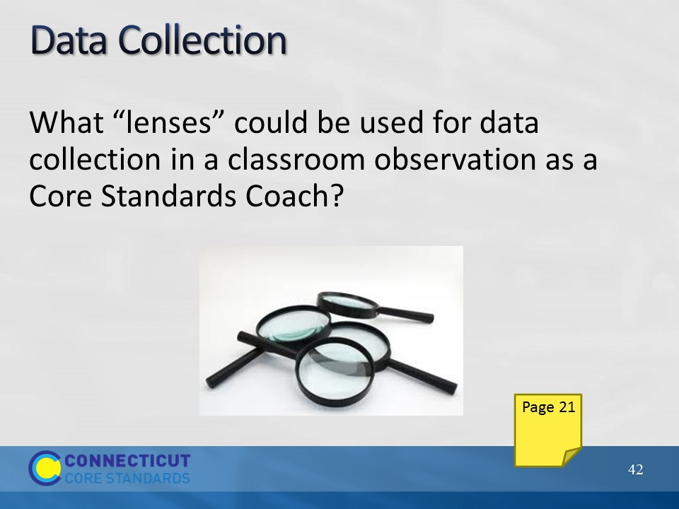Slide 42
Explain that the focus of data collection in a classroom observation may be something identified by the teacher, a teacher team, or in response to a school-wide goal for the improvement of CCS-Math instruction. A classroom observer should set aside judgment and only make notes on what they see and hear (Bay-Williams, J., McGatha, M., 2014). Ask participants to turn to the Lens for Gathering Data in their Participant Guide where some possible lenses for data collection considered crucial for learning are listed and sorted into 4 categories (content, classroom management, student engagement, and discourse). Have them look through the possibilities and ask if there are other lenses they would add to the list. (5 minutes)
Transition to the next slide by asking each table group to decide on one of the lenses to use when observing a video lesson. Coaches need to be cautious about overwhelming teachers with too many change expectations at once, so focusing on 1 or 2 lenses is probably best while observing a lesson.
Note: Point out that the CCS Classroom “Look Fors” have been placed on the tables. If all the members of a table group are already familiar with these, they can choose one of the 6-8 “Look Fors” under the categories of Coherence or Rigor (p. 20) or one of the “Look Fors” described for the Standards of Mathematical Practice (p. 23–24) instead of one of the lenses in the participant guide.
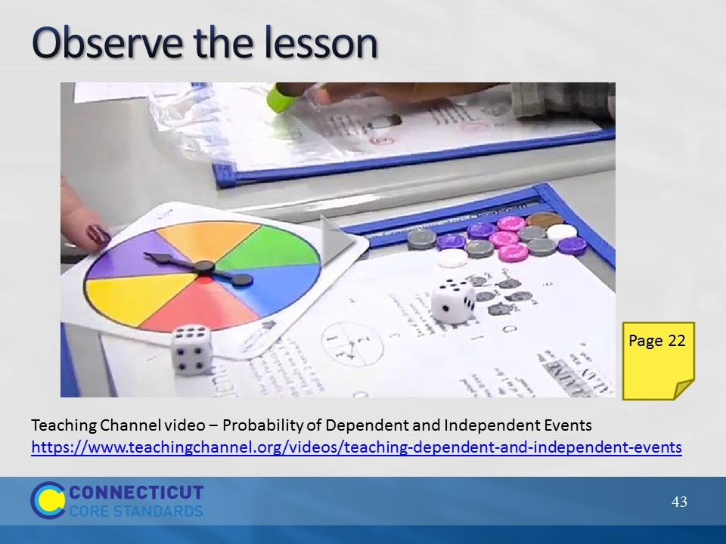Slide 43
Instruct participants to use the Data-gathering Tool in their Participant Guide when observing the video lesson (Teaching Channel video ‒ Probability of Dependent and Independent Events
https://www.teachingchannel.org/videos/teaching-dependent-and-independent-events
- stop the video at about 4:16). Although this is a grade 6 classroom, Probability is grade 7. Each table will use their chosen lens to focus their observation. Emphasize that the coach will want to use the results from data gathering to engage the teacher in critical reflection about student learning.
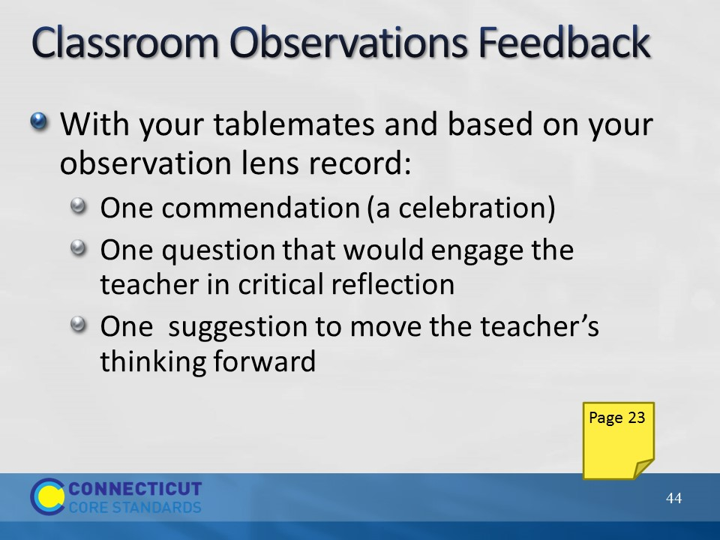Slide 44
After viewing the video, ask the table groups to discuss what a coaching conversation that provides supportive feedback might look like using the Classroom Observations Feedback recording sheet (10 minutes). Use a jigsaw approach to have participants share their reflection prompts with other tables that had different lenses (10 minutes). Begin to wrap up Section 3 by bringing the whole group back together and discussing the potential benefits, challenges, and roadblocks that they might encounter when providing teachers with feedback on lesson plans and/or lesson implementations. One roadblock that might come up is that teachers may not feel comfortable with allowing them in to observe a lesson. If this is the case, explain that the culture of the school or how observations have been handled by others in the past may be the cause of this being a roadblock now. One way to address this for coaches is to invite teachers into their own classrooms to observe them teaching. And then having a coaching conversation with the teacher that completed the observation playing the role of the coach. This will model the process for the teacher and allow them to see firsthand what the experience is like and to perhaps get them to open up to the idea. Another potential roadblock is time. Many coaches and/or teachers may not have the time throughout the day to conduct an observation. If this is the case, one way that this could be addressed is through videotaping oneself teaching. If there are no volunteers, again the coach can model this and tape themselves and offer it to other teachers during a working session in order to receive feedback from teachers. Or, and this allows for the teaching of the observation/feedback process, watch a school-neutral video online and everyone can participate in providing ‘feedback’ to the teacher just as we did in this session. As time permits, ask for suggestions such as these in order to address some of the other challenges and/or roadblocks.
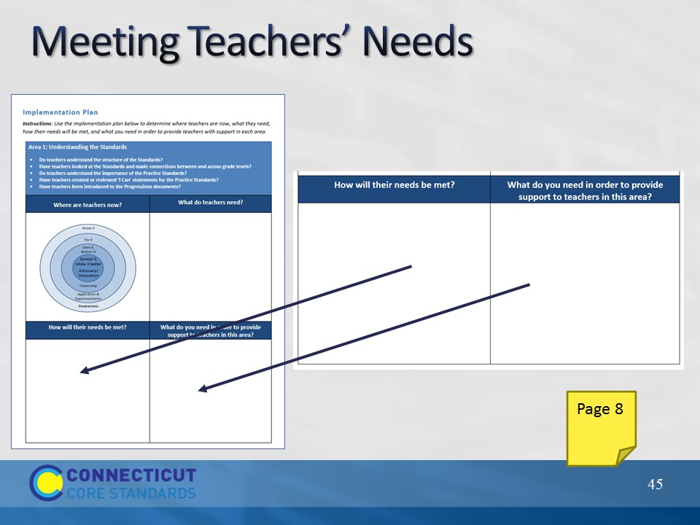Slide 45

