Module 5  Facilitator Guide | Focus on Sustaining Change

Section 2

Connecticut Core Standards for Mathematics

Grades 6–12

Systems of Professional Learning

Connecticut Core Standards Systems of Professional Learning
The material in this guide was developed by Public Consulting Group in collaboration with staff from the Connecticut State Department of Education and the RESC Alliance. The development team would like to specifically thank Ellen Cohn, Charlene Tate Nichols, and Jennifer Webb from the Connecticut State Department of Education; Leslie Abbatiello from ACES; and Robb Geier, Elizabeth O’Toole, and Cheryl Liebling from Public Consulting Group.
The Systems of Professional Learning project includes a series of professional learning experiences for Connecticut Core Standards District Coaches in English Language Arts, Mathematics, Humanities, Science, Technology, Engineering, Mathematics (STEM), and Student/Educator Support Staff (SESS).
Participants will have continued support for the implementation of the new standards through virtual networking opportunities and online resources to support the training of educators throughout the state of Connecticut.
Instrumental in the design and development of the Systems of Professional Learning materials from PCG were: Sharon DeCarlo, Debra Berlin, Jennifer McGregor, Judy Buck, Michelle Wade, Nora Kelley, Diane Stump, and Melissa Pierce.

Published 2014. Available online at http://ctcorestandards.org/
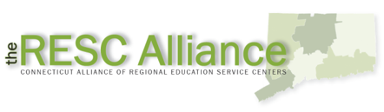

Session at-a-Glance

Section 2: Modes of Support (60 minutes)

Training Objectives:
To discuss, share, and determine coaching strategies to be used to meet teacher needs.
The facilitator will begin by discussing the fact that some needs can be met by providing information, some by having a conversation, but others may need a more formal approach such as modeling, or working side-by-side with the teacher. The facilitator will refer participants to descriptions of various examples of modes of support in their Participant Guide. Throughout the examination of support types, it will be stressed that the role of the Core Standards Coach is to provide support, not to evaluate teachers. The facilitator will ask each table group to discuss an assigned mode of support and create a poster. A representative from each table group will share the main ideas from their poster with the large group.

Supporting Documents:
Modes of Support
Notes on Modes of Support

Materials:
Chart paper, markers, sticky notes

PowerPoint Slides:
26–30

Session Implementation
Section 2

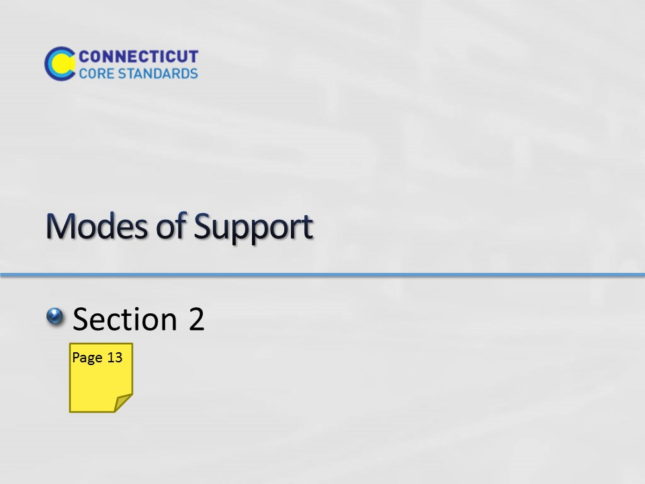Slide 26
Section 2: Modes of Support
Section 2 Time: 60 minutes

Section 2 Training Objectives:
- To discuss, share, and determine coaching strategies to be used to meet teacher needs.

Section 2 Outline:
- (5 minutes) The facilitator will begin by discussing the fact that some needs can be met by providing information, some by having a conversation, but others may need a more formal approach such as modeling, or working side-by-side with the teacher. The facilitator will refer participants to descriptions of various examples of modes of support in their Participant Guide. Throughout the examination of support types, it will be stressed that the role of the Core Standards Coach is to provide support, not to evaluate teachers.
- (20 minutes) The facilitator will ask each table group to discuss an assigned mode of support. As small groups discuss, they will create a poster to promote their assigned mode of support and the benefits that can be had by both teacher and coach engaging in this manner of support. Examples of support to be examined are:
- Modeling
- Co-teaching
- Co-planning
- Coaching conversations
- Analyzing student work
- (20 minutes) A representative from each table group will share the main ideas from their poster with the large group.
- (15 minutes) This section will wrap-up with participants discussing with their table group initial ideas for filling in the ‘how will their needs be met’ section of their Implementation Plan template.

Section 2 Supporting Documents
Modes of Support
Notes on Modes of Support

Section 2 Materials
Chart paper
Markers
Sticky Notes
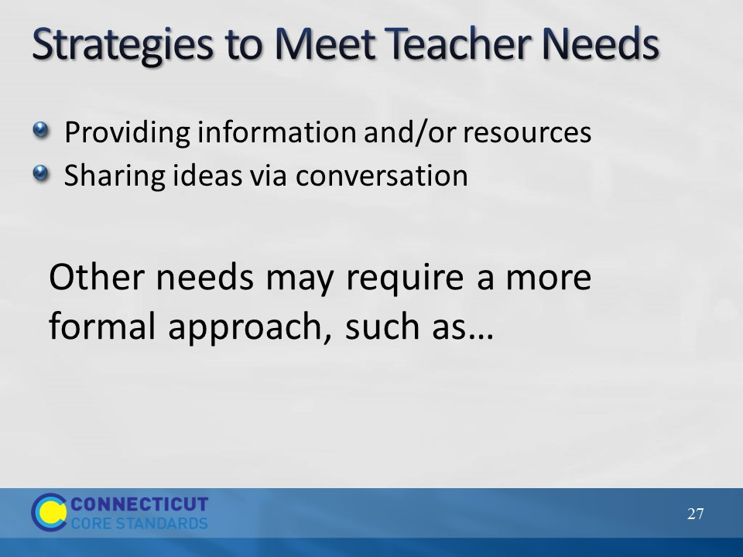Slide 27
Strategies to Meet Teacher Needs
Stress that the role of the Core Standards Coach is to provide support, not to evaluate teachers. Explain that some teacher needs can be met by providing information and/or resources, some by having a conversation, but others may need a more formal approach. The next slide names some of these approaches.
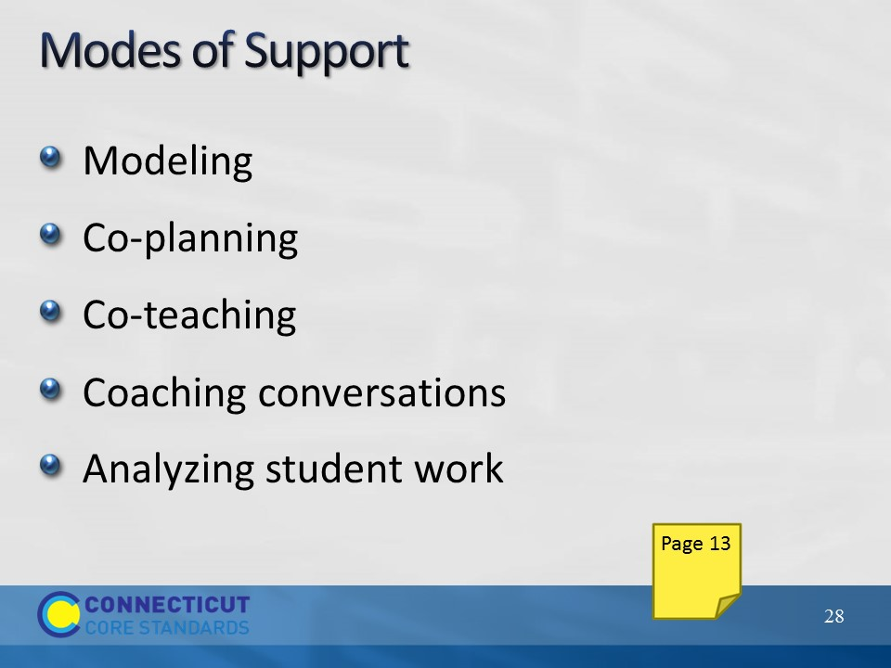Slide 28
Modes of Support
Refer to the descriptions of each of these modes of support in the Participant Guide and ask each participant to begin reading through the descriptions as you transition to the next slide. Also, remind participants that all of these are suggestions and that they need to think about each in terms of their current role and think about how they might modify any particular mode of support to fit both their own needs as well as the needs of the teachers with which they work.

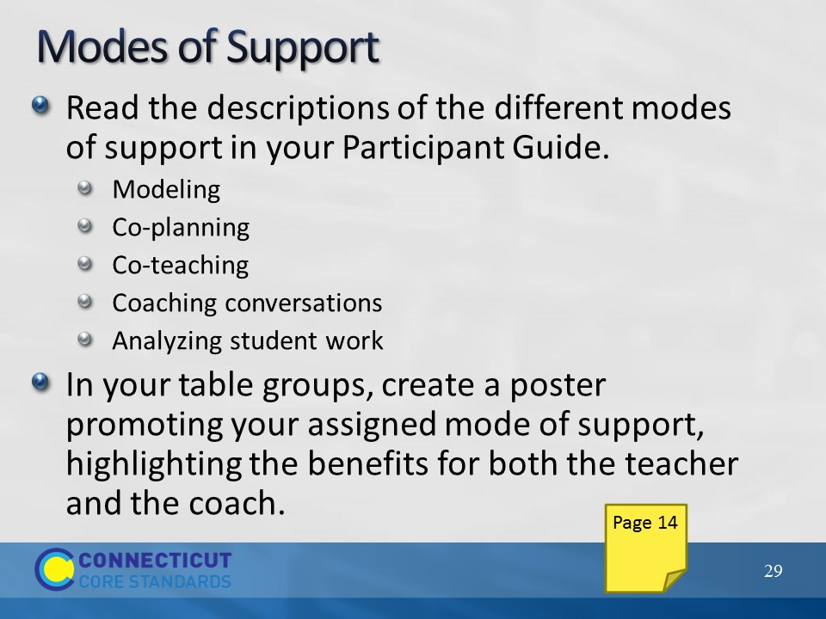Slide 29
Modes of Support
Referring to the list on the slide, assign each table group one of the modes of support listed. As small groups discuss the benefits of engaging in the mode of support for both the teacher and coach, they will create a poster to promote it. As an example: if a coach and a teacher co-plan a lesson, the level of cognitive demand can be addressed because there are two people determining the level of cognitive demand of a task, making modifications to increase the level of cognitive demand of the problem, and planning for instructional strategies that will allow the level of cognitive demand to stay at the desired level.
Ask a representative from each table group to display the table’s poster and describe the benefits of the mode of support that they were assigned to the large group. As each group presents, participants can record notes in their Participant Guide.
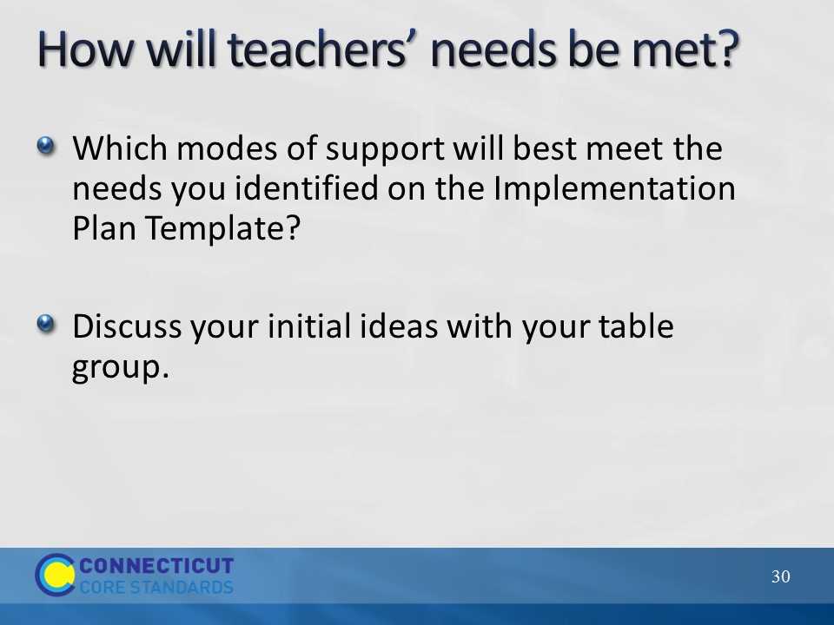Slide 30
How will teachers’ needs be met?
Ask participants, given the exploration of various modes of support, to consider how they could fill in the ‘how will their needs be met’ section of the Implementation Plan template for each of the four areas, and discuss their initial ideas with their small group. Remind participants that how to meet teachers’ needs is not limited to the ways that were discussed. In some cases, providing resources or having a conversation may meet a need. A key point here is that participants are examining needs and matching the best mode of support for meeting that need.

Transition to the next section by telling participants that whatever mode of support they choose, the primary purpose is to engage their teachers in meaningful reflection that will lead to change in their instructional practices.

Note: Depending on where you are with time, and with when lunch is scheduled at your location, either release teachers for lunch now, or go ahead and begin Section 3 and release them when there is a natural break in the section.

