Module 5 Facilitator Guide | Focus on Deepening Implementation

Activity 3b

Connecticut Core Standards for English Language Arts and Literacy

Grades K–5

Systems of Professional Learning

Connecticut Core Standards Systems of Professional Learning
The material in this guide was developed by Public Consulting Group in collaboration with staff from the Connecticut State Department of Education and the RESC Alliance. The development team would like to specifically thank Ellen Cohn, Charlene Tate Nichols, and Jennifer Webb from the Connecticut State Department of Education; Leslie Abbatiello from ACES; and Robb Geier, Elizabeth O’Toole, and Cheryl Liebling from Public Consulting Group.
The Systems of Professional Learning project includes a series of professional learning experiences for Connecticut Core Standards District Coaches in English Language Arts, Mathematics, Humanities, Science, Technology, Engineering, Mathematics (STEM), and Student/Educator Support Staff (SESS).
Participants will have continued support for the implementation of the new standards through virtual networking opportunities and online resources to support the training of educators throughout the state of Connecticut.
Instrumental in the design and development of the Systems of Professional Learning materials from PCG were: Sharon DeCarlo, Debra Berlin, Mary Ellen Hannon, Jennifer McGregor, Judy Buck, Michelle Wade, Nora Kelley, Diane Stump, and Melissa Pierce.
Published 2014. Available online at http://ctcorestandards.org/

Session at-a-Glance

Activity 3b: Reviewing the Quality of a Written Lesson with the EQuIP Rubric
Based on the selected text, A Closer Look at “Mother to Son”, participants will review the quality of a written lesson using the EQuIP Rubric and discuss ways to use the rubric within their school.

Supporting Documents:
- EQuIP Rubric. Retrieved from http://www.achieve.org/EQuIP
- Sample Lesson: A Closer Look at “Mother to Son”. Retrieved from http://www.achieve.org/files/4-21-14%20A_Closer_Look_at__Mother_to_Son_.pdf

PowerPoint Slides:
- 42‒43

Session Implementation
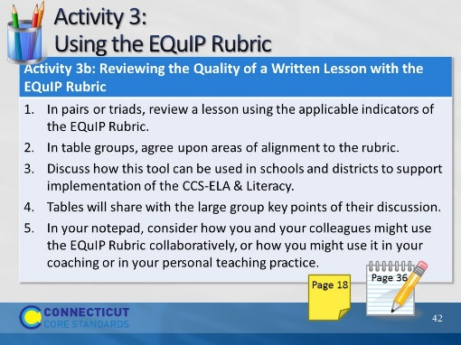Slide 42
30 minutes
In pairs or triads, participants will review a lesson using the applicable indicators of the EQuIP Rubric. Table groups will discuss areas of alignment to the rubric and how this tool can be used in their schools and districts to support implementation of the CCS-ELA & Literacy. Tables will share with the large group key points of their discussion.
Supporting Documents:
EQuIP Rubrics for Lessons and Units: http://www.achieve.org/files/EQuIP-ELArubric-06-24-13-FINAL.pdf
One lesson for elementary
Notepad: Reflection on EQuIP Rubric
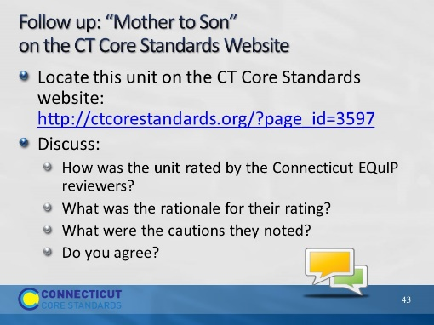Slide 43
Blank

