Module 5 Facilitator Guide | Focus on Deepening Implementation

Introductory Activities

Connecticut Core Standards for English Language Arts and Literacy

Grades 6–12

Systems of Professional Learning

Connecticut Core Standards Systems of Professional Learning
The material in this guide was developed by Public Consulting Group in collaboration with staff from the Connecticut State Department of Education and the RESC Alliance. The development team would like to specifically thank Ellen Cohn, Charlene Tate Nichols, and Jennifer Webb from the Connecticut State Department of Education; Leslie Abbatiello from ACES; and Robb Geier, Elizabeth O’Toole, and Cheryl Liebling from Public Consulting Group.
The Systems of Professional Learning project includes a series of professional learning experiences for Connecticut Core Standards District Coaches in English Language Arts, Mathematics, Humanities, Science, Technology, Engineering, Mathematics (STEM), and Student/Educator Support Staff (SESS).
Participants will have continued support for the implementation of the new standards through virtual networking opportunities and online resources to support the training of educators throughout the state of Connecticut.
Instrumental in the design and development of the Systems of Professional Learning materials from PCG were: Sharon DeCarlo, Debra Berlin, Mary Ellen Hannon, Jennifer McGregor, Judy Buck, Michelle Wade, Nora Kelley, Diane Stump, and Melissa Pierce.
Published 2014. Available online at http://ctcorestandards.org/  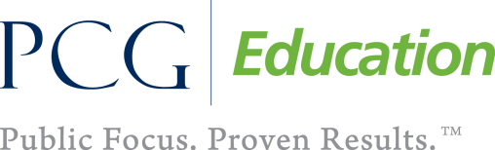 |  | 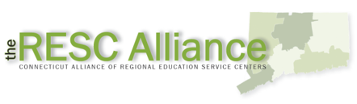

Session at-a-Glance

Introduction (10 minutes)
- Welcome and introduction to module outcomes
- Session agenda

Introductory Activity
Welcome participants and spend few minutes going over some of the other initiatives that are going on around the state (slides 4‒8). Then, participants will spend a few minutes completing a Pre-Assessment.

Supporting Documents:
- Pre-assessment

PowerPoint Slides:
- 1–10

Session Implementation
Module 5 Introduction
Slide 1
Blank
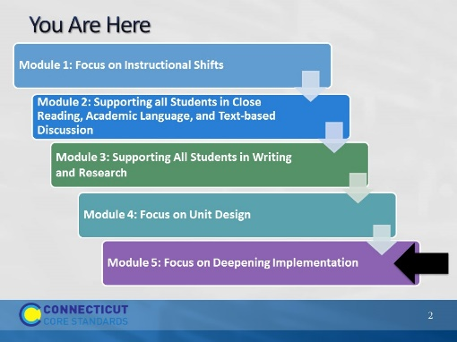Slide 2
Slides 1-10, will take about 10 minutes including introductions.
This slide provides a visual showing how the topics for the professional development modules fit together. Briefly explain to participants.
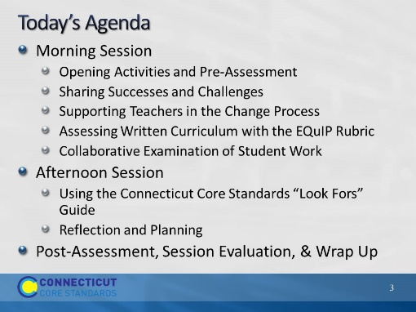Slide 3
Review the agenda, noting there will be a break for lunch as well as a short morning and afternoon break. You may want to add the importance of coming back from breaks on time to ensure enough time to complete all the work of the day.
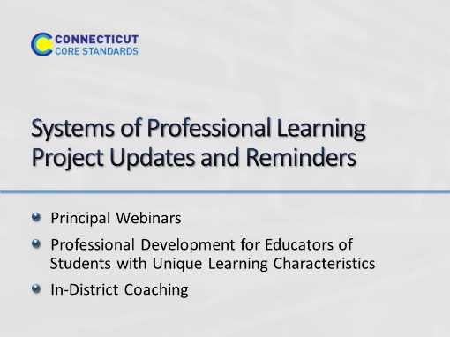Slide 4
Blank
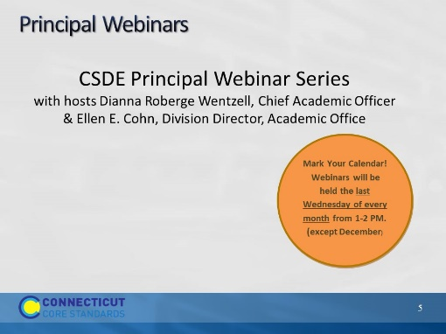Slide 5
CSDE is hosting a series of webinars for principals this year. These are interactive sessions where principals can gain information about the Systems of Professional Learning project, ask questions, and share experiences. To register and for more information about the series, please visit ctcorestandards.org. Use the screenshot on the next slide to show participants where to look for more information.
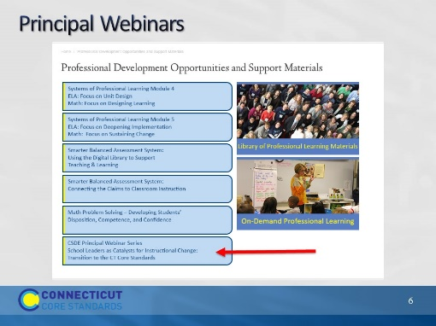Slide 6
More information about the sessions and registration information can be found under “Professional Development Opportunities” on the CT Core Standards website.

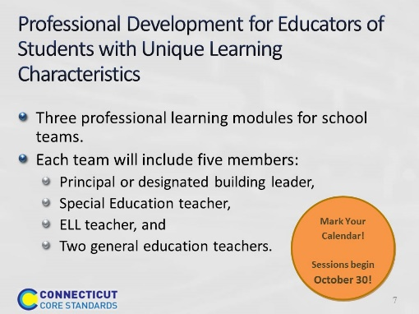Slide 7
In partnership with the Connecticut State Department of Education, Public Consulting Group (PCG) will present a professional development series for educators working with students with unique learning characteristics. The goal of this professional development series is to enable local educators to implement CCS-aligned curriculum, instructional practices, and assessments to meet the needs of a wide variety of learners.
Participants will attend as teams to empower educators to align efforts resulting in an inclusive environment, and increase their capability to foster change in their school systems.
Registration is open through the PCG “RegisterMe” website and accessible on the ctcorestandards.org website under the Professional Development link.
In the first module to be offered October through December, the full team from each school, including educators who work with English language learners (ELL) and students with disabilities (SwD), will explore the importance of a culture of academic optimism underpinned by the belief that through high expectations, trust in students and parents, and teacher efficacy that all students can learn. The morning will provide participants an overview of the power of a growth mindset in both students and teachers and discuss implications of adopting a culture of academic optimism in their schools and the collaboration required to achieve that goal. In the afternoon, teams will form a common understanding of Universal Design for Learning (UDL), which provides the foundation and springboard for two subsequent modules that expand participants’ ability to support all learners through using a UDL approach to planning and teaching.

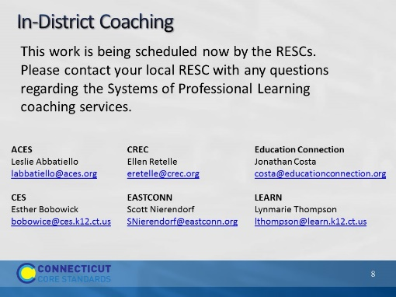Slide 8
The CSDE has announced that 66 LEAs have received an allocation of in-district coaching services to support implementation of the Connecticut Core Standards for the 2014-2015 school year. For information about your district’s allocation, check with your district administration and your local RESC.
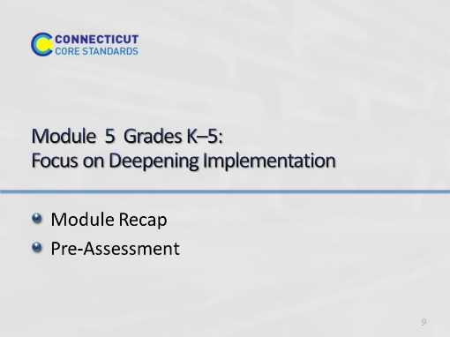Slide 9
Blank
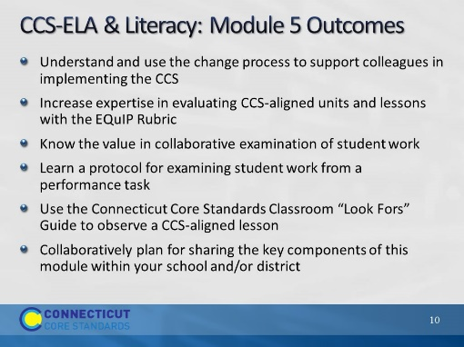Slide 10
Review the expected outcomes. Explain that in each part of today’s module, we will discuss techniques and ideas for supporting colleagues in implementing the CCS through collegial coaching.

