Module 5 Facilitator Guide | Focus on Deepening Implementation

Activity 3a

Connecticut Core Standards for English Language Arts and Literacy

Grades 6–12

Systems of Professional Learning

Connecticut Core Standards Systems of Professional Learning
The material in this guide was developed by Public Consulting Group in collaboration with staff from the Connecticut State Department of Education and the RESC Alliance. The development team would like to specifically thank Ellen Cohn, Charlene Tate Nichols, and Jennifer Webb from the Connecticut State Department of Education; Leslie Abbatiello from ACES; and Robb Geier, Elizabeth O’Toole, and Cheryl Liebling from Public Consulting Group.
The Systems of Professional Learning project includes a series of professional learning experiences for Connecticut Core Standards District Coaches in English Language Arts, Mathematics, Humanities, Science, Technology, Engineering, Mathematics (STEM), and Student/Educator Support Staff (SESS).
Participants will have continued support for the implementation of the new standards through virtual networking opportunities and online resources to support the training of educators throughout the state of Connecticut.
Instrumental in the design and development of the Systems of Professional Learning materials from PCG were: Sharon DeCarlo, Debra Berlin, Mary Ellen Hannon, Jennifer McGregor, Judy Buck, Michelle Wade, Nora Kelley, Diane Stump, and Melissa Pierce.
Published 2014. Available online at http://ctcorestandards.org/

Session at-a-Glance

Part 3: Assessing Written Curriculum with the EQuIP Rubric (60 minutes)

Activity 3a: Building Expertise with the EQuIP Rubric
Using a jigsaw approach, participants will read, discuss, and build expertise on one section of the EQuIP Rubric and share with their table groups.

Supporting Documents:
- EQuIP Rubric. Retrieved from http://www.achieve.org/EQuIP

PowerPoint Slides:
- 36‒41

Session Implementation
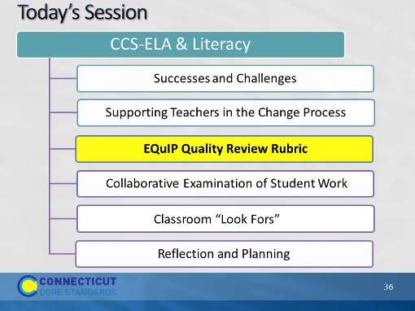Slide 36
40 minutes
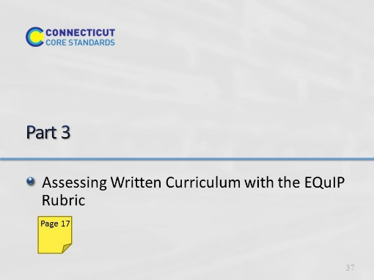Slide 37
Starts at 10:15 – Part 3: 60 minutes total, including introduction.

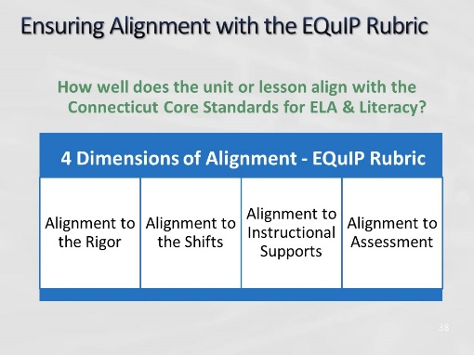Slide 38
In Activity 2, participants will become familiar with the EQuIP Rubric to determine if a lesson is aligned to the CCS for ELA & Literacy. Participants will be involved with several activities to help understand its purpose and value. They will discuss how this tool can be used by teachers and teacher leaders to ensure quality design of CCS-aligned units and lessons.
Educators Evaluating Quality Instructional Products (EQuIP) is a collaborative of states working to increase the supply of quality instructional materials that align with the Connecticut Core Standards for use in elementary, middle, and high schools. This rubric was developed by Massachusetts, Rhode Island, and New York as the Tri-State Rubric, with the assistance of Achieve. The rubric is now available for use by all states.
The rubric helps educators examine the following dimensions:
  - Alignment to the rigor of the Connecticut Core Standards for ELA & Literacy: For example, are the standards identified and addressed? Is the purpose of instruction clear? Are appropriately complex texts used?
  - Key areas of focus: 1) content-rich text; 2) reading closely; 3) purposeful writing; 4) academic language
  - Instructional supports: engagement; variety of opportunities to engage with challenging text; scaffolding for all learners
  - Assessment: observable evidence that students are working towards proficiency on specified standards; use of aligned rubrics to assess writing
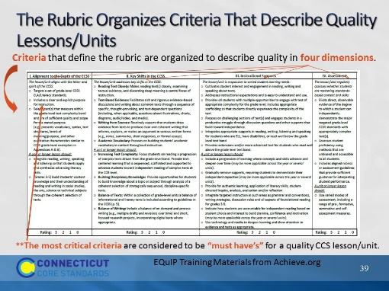Slide 39
Blank
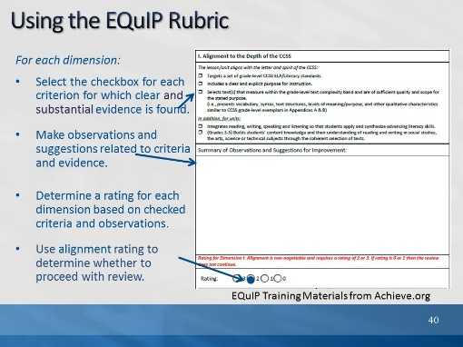Slide 40
This slide illustrates how quality review rating teams use the rubric. Explain to participants that if the unit/lesson is not well aligned in Dimension 1, the review doesn’t continue. Have them read the criteria in Dimension 1, then show the feedback example on the next slide.
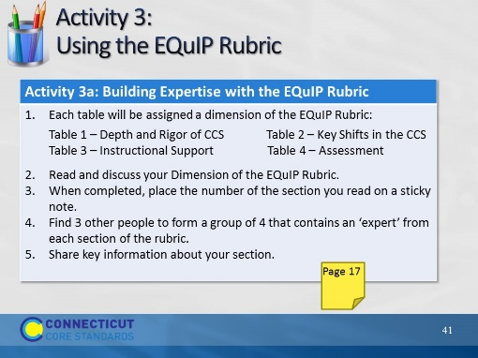Slide 41
15 minutes
Using a jigsaw protocol, table groups will read, discuss, and build expertise on one section of the EQuIP Rubric. Participants will then remix with “experts” from other sections to share key information about their section of the rubric. With the full group, participants will briefly discuss how closely the current units and lessons they use might fare when evaluated with the EQuIP Rubric. Point out that the EQuIP Rubric is not used to evaluate teaching performance, it is solely used to evaluate units and lessons.

