Module 5 Facilitator Guide | Focus on Deepening Implementation

Activity 2b

Connecticut Core Standards for English Language Arts and Literacy

Grades 6–12

Systems of Professional Learning

Connecticut Core Standards Systems of Professional Learning
The material in this guide was developed by Public Consulting Group in collaboration with staff from the Connecticut State Department of Education and the RESC Alliance. The development team would like to specifically thank Ellen Cohn, Charlene Tate Nichols, and Jennifer Webb from the Connecticut State Department of Education; Leslie Abbatiello from ACES; and Robb Geier, Elizabeth O’Toole, and Cheryl Liebling from Public Consulting Group.
The Systems of Professional Learning project includes a series of professional learning experiences for Connecticut Core Standards District Coaches in English Language Arts, Mathematics, Humanities, Science, Technology, Engineering, Mathematics (STEM), and Student/Educator Support Staff (SESS).
Participants will have continued support for the implementation of the new standards through virtual networking opportunities and online resources to support the training of educators throughout the state of Connecticut.
Instrumental in the design and development of the Systems of Professional Learning materials from PCG were: Sharon DeCarlo, Debra Berlin, Mary Ellen Hannon, Jennifer McGregor, Judy Buck, Michelle Wade, Nora Kelley, Diane Stump, and Melissa Pierce.
Published 2014. Available online at http://ctcorestandards.org/

Session at-a-Glance

Activity 2b: Providing Effective Feedback
Participants identify five essential skills for CT coaches that will support them when providing feedback to teachers. Through the use of a coaching session video, they will recognize the use of the essential skills to enable the teacher to grow instructional skills in the classroom.

Supporting Documents
- Essential Skills for Coaches in Action tool

Video
- Observation and Feedback: Probing to Identify the Problem (2012). Retrieved from https://www.youtube.com/watch?v=bBeNs1Q2kXk

PowerPoint Slides:
- 31‒34

Session Implementation
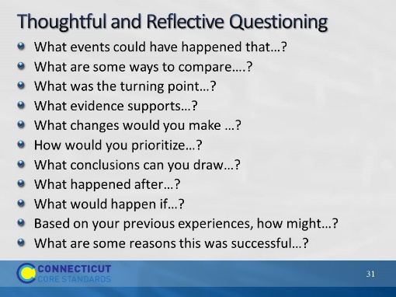Slide 31
These are question stems that may be useful for CCS coaches. Do they have others they can add that work well for them? Relate these stems to the norms of “pausing,” “paraphrasing,” and “probing for specificity.”
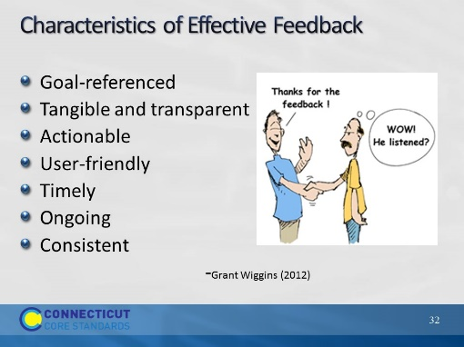Slide 32
Effective feedback is key to teachers’ growth. It will also assist teachers in better understanding the changes that they need to embrace as their school adopts new curriculum and instructional practices. Teachers receive feedback during their annual evaluation process, but many times it does little to help teachers identify ways to improve their skills and their students’ achievement levels. As you review the slide, reinforce this important step in supporting teachers in their professional growth throughout the school year.
Grant Wiggins- helpful feedback is goal-referenced; tangible and transparent; actionable; user-friendly (specific and personalized); timely; ongoing; and consistent.
Goal Referenced- At the beginning of the school year sit down with teachers to determine what they want to focus on in their instruction and student learning
Tangible and Transparent-
Actionable-
User-friendly-
Timely-
Ongoing-
Consistent-
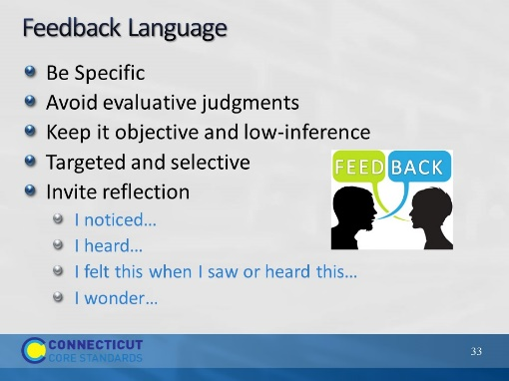Slide 33
This slide is a transition to watching a coaching session in action. Review how language is important to ensure that teachers are not putting up barriers to improvement. Be sure to relate back to Seven norms. Review with participants the guidelines for providing effective feedback to teachers.
Be Specific
Avoid evaluative judgments
Speak about what was observed
Give with care
Invite reflection
I noticed…
I heard…
I felt this when I saw or heard this…
I wonder…
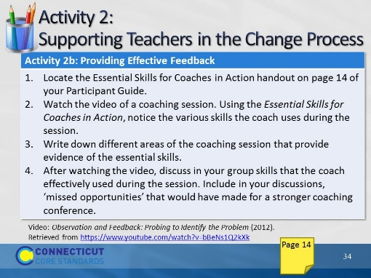Slide 34
25 minutes
Direct the participants to the Essential Skills for Coaches in Action in their Participant Guide. Review the expectations of the activity before starting the video (https://www.youtube.com/watch?v=bBeNs1Q2kXk).
Once they have viewed the video, ask the participants to discuss the video and their notes regarding evidence of the essential skills that were present during the conference. Ask them to also note what missed opportunities they saw that would have made for stronger professional learning for the teacher.

