Module 5 Facilitator Guide | Focus on Deepening Implementation

Activity 1

Connecticut Core Standards for English Language Arts and Literacy

Grades 6–12

Systems of Professional Learning

Connecticut Core Standards Systems of Professional Learning
The material in this guide was developed by Public Consulting Group in collaboration with staff from the Connecticut State Department of Education and the RESC Alliance. The development team would like to specifically thank Ellen Cohn, Charlene Tate Nichols, and Jennifer Webb from the Connecticut State Department of Education; Leslie Abbatiello from ACES; and Robb Geier, Elizabeth O’Toole, and Cheryl Liebling from Public Consulting Group.
The Systems of Professional Learning project includes a series of professional learning experiences for Connecticut Core Standards District Coaches in English Language Arts, Mathematics, Humanities, Science, Technology, Engineering, Mathematics (STEM), and Student/Educator Support Staff (SESS).
Participants will have continued support for the implementation of the new standards through virtual networking opportunities and online resources to support the training of educators throughout the state of Connecticut.
Instrumental in the design and development of the Systems of Professional Learning materials from PCG were: Sharon DeCarlo, Debra Berlin, Mary Ellen Hannon, Jennifer McGregor, Judy Buck, Michelle Wade, Nora Kelley, Diane Stump, and Melissa Pierce.

Part 1: Sharing Successes and Challenges (20 minutes)

Activity 1: Sharing Success and Challenges
Participants will note successes, challenges, activities, and conversations that have arisen in their school or district relative to Module 4.

Supporting Documents:
- Notepad responses

Materials:
- Chart paper, sticky notes

PowerPoint Slides:
- 11‒15

Session Implementation
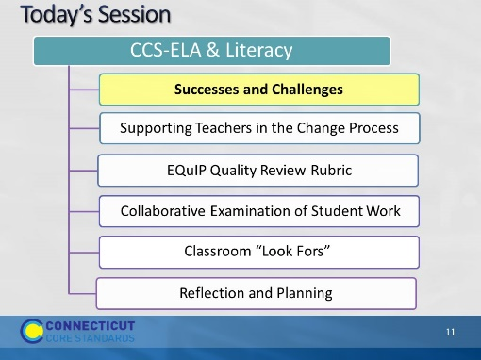Slide 11
Blank
Part 1
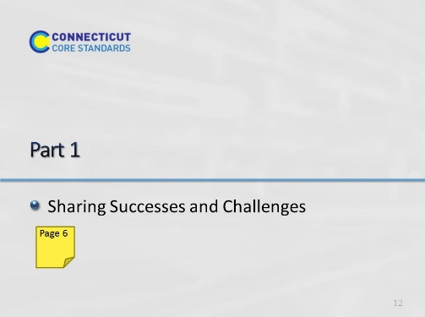Slide 12 | F
Start at 8:40
Part 1: 25 minutes total, including directions.
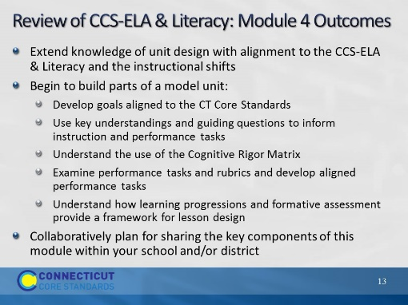Slide 13
Begin by quickly reviewing the key ideas developed in Module 4. In Module 4, they looked at best practices for creating units and lessons. In this module, they will look at how to effectively implement and evaluate units, looking for alignment to the CCS, and how to support colleagues in this change process.
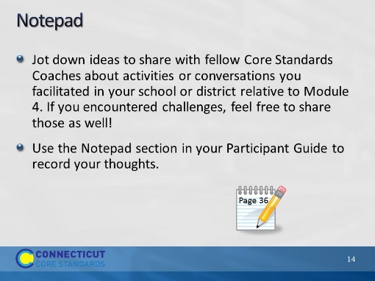Slide 14
Facilitator: Remind participants that use of the Notepad is optional. Some participants like to take notes electronically.
Participants will take a few minutes to jot down in their Notepad ideas (or challenges) to share with fellow Core Standards Coaches about activities or conversations in their school or district relative to Module 4. You may want to go back to slide 8 so participants can view the topics from Module 4.
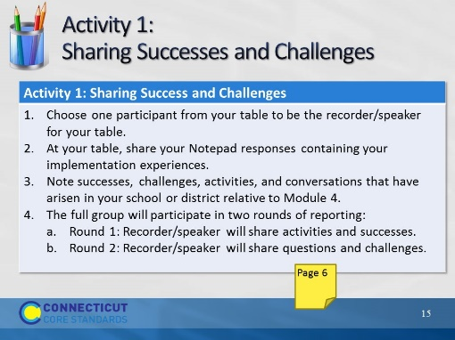Slide 15
Activity 1: 20 minutes total for this activity.
Materials:
Chart Paper
Topics list in the Participant Guide (also found on Slide 8)
Facilitator: At table groups, participants will pick a recorder/speaker and share their implementation experiences.
- At your table, share your Notepad responses containing your implementation experiences.
- Note successes, challenges, activities, and conversations you have had in your school or district relative to Module 4.
- Choose one participant from your table to be the recorder/speaker for your table.
- Afterwards, using a whip around the room (or last man standing) tables will first share successes/activities coaches were able to accomplish.
- Next, we will conduct a second whip around the room and tables will share their implementation challenges and questions which may have been raised in their district or school.
After the short-group discussions, lead a brief large-group discussion and chart questions that have come up regarding Module 4, either for the participants or for the teachers with which they work.
The facilitator will transition to Part 2 by explaining that the remainder of Module 5 will provide tools and strategies for collaboratively deepening understanding, assessing the alignment of written curriculum and enacted instruction, and supporting colleagues in fully implementing the CCS-ELA & Literacy.

