Hot Air Balloon

The graph below shows the altitude during a hot air balloon ride with Berkshire Balloons. The altitude of the hot air balloon is a function of time.

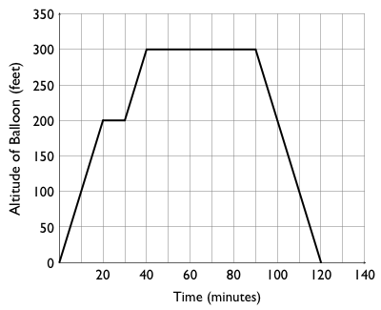

- Find the domain and range of the function graphed above.

Domain: Range:

- Find ƒ(30) and explain what it means in the context of the problem.

- If ƒ(x) = 100, find all values of x and explain what they mean in the context of the problem.

- When is the balloon at 200 feet?

- For how long are you flying at an altitude at or above 200 feet?

- If ƒ(x) = 300, find all values of x.

