Representing Relations II
A relation is a connection between an input and an output. The following table gives the top-rated NFL quarterbacks in terms of the percentage (PCT) of their completed passes (as of 11/13/10). The measures used to find the percentages are passes attempted (ATT) and passes completed (COMP). Use the data to express the relations in a variousl ways.

NFL Quarterback Passing Statistics - 2010  PLAYER TEAM ATT COMP PCT  Drew Brees Saints 374 261 70  Tony Romo Cowboys 213 148 70  David Garrard Jaguars 149 101 68  Eli Manning Giants 271 178 66  Philip Rivers Chargers 329 215 65  Peyton Manning Colts 350 228 65  Matt Schaub Texans 267 170 64  Tom Brady Patriots 261 166 64  http://espn.go.com/nfl/statistics/player/_/stat/passing/sort/completionPct |  | - Mapping Diagram  Player PCT  D. Brees T. Romo D. Garrard E. Manning P. Rivers P. Manning M. Schaub T. Brady 70 68 66 65 64
- Ordered Pairs (Player, PCT Passes Complete)  ( _________________________, ________ )  ( _________________________, ________ )  ( _________________________, ________ )  ( _________________________, ________ )  ( _________________________, ________ )  ( _________________________, ________ )  ( _________________________, ________ )  ( _________________________, ________ ) | - Graph (Attempted passes, Completed passes)  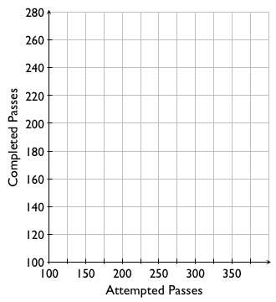

- Map the gender of your teachers to the subject they teach.  Gender Subject | - Map the subjects of your classes to the gender of the teacher.  Subject Gender
- Make a table for each relation. You may need to look things up in an atlas, an almanac, or online.

State Capital City  Connecticut  Massachusetts  Rhode Island  Maine  New Hampshire  Vermont | State Ocean it Borders  Maine  Oregon  Virginia  Florida  Washington  California
- List ordered pairs with famous actors as the inputs, and the movies they were in as the outputs.

( ___________________________________________, ________________________________ )

( ___________________________________________, ________________________________ )

( ___________________________________________, ________________________________ )

- List the ordered pairs (x, y) that are plotted on the graph to the right.  A ( ________, _______ ) B ( ________, _______ )  C ( ________, _______ ) D ( ________, _______ )  E ( ________, _______ ) F ( ________, _______ )  - Which of the relations in 1–8 are functions? Which are not? Explain. |  | 