Representing Relations I

A relation is a connection between an input and an output. Relations can be expressed in five different ways: mapping diagrams, tables, ordered pairs, graphs, and equations. However, not all relations are easily expressed using all five methods. The following table shows artists, their average ticket price and their gross income for the tour. Use the data to express the relations in various ways.

2011 Top Concert Tours  Artist Ticket Price Income (in millions)  U2 97 232  Bon Jovi 94 149  Taylor Swift 71 104  Elton John 120 103  Rihanna 75 90  Kenny Chesney 73 85  Source: Pollstar |  | - Mapping Diagram  (Ticket Price, Income in millions)  Ticket Price Income  97 103  94 104  71 149  120 90  75 85  73 232
A relation can also describe a connection between things that aren’t numbers, like the artist and the income for the tour, or the artist and the stage manager.

- Ordered Pairs  (Artist, Income in millions)  ( ___________________, ________ )  ( ___________________, ________ )  ( ___________________, ________ )  ( ___________________, ________ )  ( ___________________, ________ )  ( ___________________, ________ )  ( ___________________, ________ ) | - Graph (Ticket Price, Income in millions)  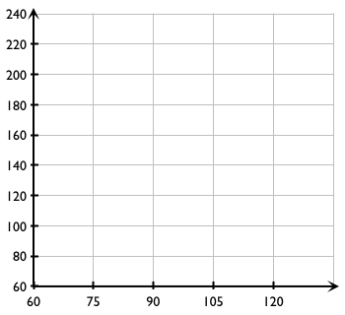

- Map five students to their English teacher  Student English Teacher  - Make tables for the relations above.  Student English Teacher | 5. Map a number of siblings to five students  # of Siblings Student  # of Siblings Student
- List ordered pairs with famous athletes as the inputs and the sports they play as the outputs.

( ___________________________________________, ________________________________ )

( ___________________________________________, ________________________________ )

( ___________________________________________, ________________________________ )

- List three ordered pairs on the graph below.  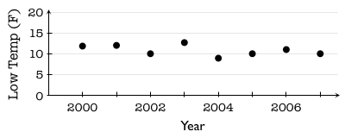 |  | Input: _________________  Output: ________________  ( ____________, __________ )  ( ____________, __________ )  ( ____________, __________ )
- Which of the relations in 1–8 are functions? Which are not? Explain.

