**Fractal Geometry**

A *fractal* is an image that is obtained when a geometric pattern is repeated over and over at ever smaller scales. Fractals have the property of *self-similarity*, meaning that any part of a fractal can be repeatedly magnified, and each magnification will resemble all or part of the original fractal. This phenomenon can be seen in objects like snowflakes, ferns, and tree bark. Fractal simulations have been used to generate lifelike images of complicated, irregular natural objects, including rugged terrains and foliage used in movies and video games. The term fractal is derived from the Latin word fractus (“fragmented”).

We are going to create simple fractal images. Here is an example of the process:

**Stage 0**: Start with a single shape.

1 unshaded region

 **Stage 1**: Divide the region into four parts, shading two of the four parts.

2 unshaded regions

 **Stage 2**: Divide each unshaded region into four parts, shading two of the four parts.

_____ unshaded regions

How many unshaded regions do you predict will be in stage 3? _______________

Each of the following figures represents **Stage One** of a fractal image. (Recall that Stage Zero is the shape before you began to divide it.) You will be creating a Stage Three or Stage Four fractal image to hang in our classroom! Follow the directions below.



1. 2. 3. 4. 5.

1. Choose the pattern you find most appealing and select the proper template.
2. Draw the first stage, shading appropriately with a colored pencil.
3. Record the number of unshaded regions, ignoring the grid lines, in the table.
4. To produce the next stage, draw a scaled version of Stage One in all unshaded regions.
5. Record the number of unshaded regions in the table.
6. Repeat steps D & E until you reach Stage Three or Stage Four.
7. Write a rule for the number of unshaded regions in stage *n*. Record your rule in the table.

1.

|  |  |  |  |  |  |  |  |  |  |  |  |  |  |  |  |
| --- | --- | --- | --- | --- | --- | --- | --- | --- | --- | --- | --- | --- | --- | --- | --- |
|  |  |  |  |  |  |  |  |  |  |  |  |  |  |  |  |
|  |  |  |  |  |  |  |  |  |  |  |  |  |  |  |  |
|  |  |  |  |  |  |  |  |  |  |  |  |  |  |  |  |
|  |  |  |  |  |  |  |  |  |  |  |  |  |  |  |  |
|  |  |  |  |  |  |  |  |  |  |  |  |  |  |  |  |
|  |  |  |  |  |  |  |  |  |  |  |  |  |  |  |  |
|  |  |  |  |  |  |  |  |  |  |  |  |  |  |  |  |
|  |  |  |  |  |  |  |  |  |  |  |  |  |  |  |  |
|  |  |  |  |  |  |  |  |  |  |  |  |  |  |  |  |
|  |  |  |  |  |  |  |  |  |  |  |  |  |  |  |  |
|  |  |  |  |  |  |  |  |  |  |  |  |  |  |  |  |
|  |  |  |  |  |  |  |  |  |  |  |  |  |  |  |  |
|  |  |  |  |  |  |  |  |  |  |  |  |  |  |  |  |
|  |  |  |  |  |  |  |  |  |  |  |  |  |  |  |  |
|  |  |  |  |  |  |  |  |  |  |  |  |  |  |  |  |
|  |  |  |  |  |  |  |  |  |  |  |  |  |  |  |  |

|  |  |  |  |  |  |  |
| --- | --- | --- | --- | --- | --- | --- |
| **Stage** | 0 | 1 | 2 | 3 | 4 | *n* |
| **Total number of**  **unshaded regions** | 1 |  |  |  |  |  |

2.

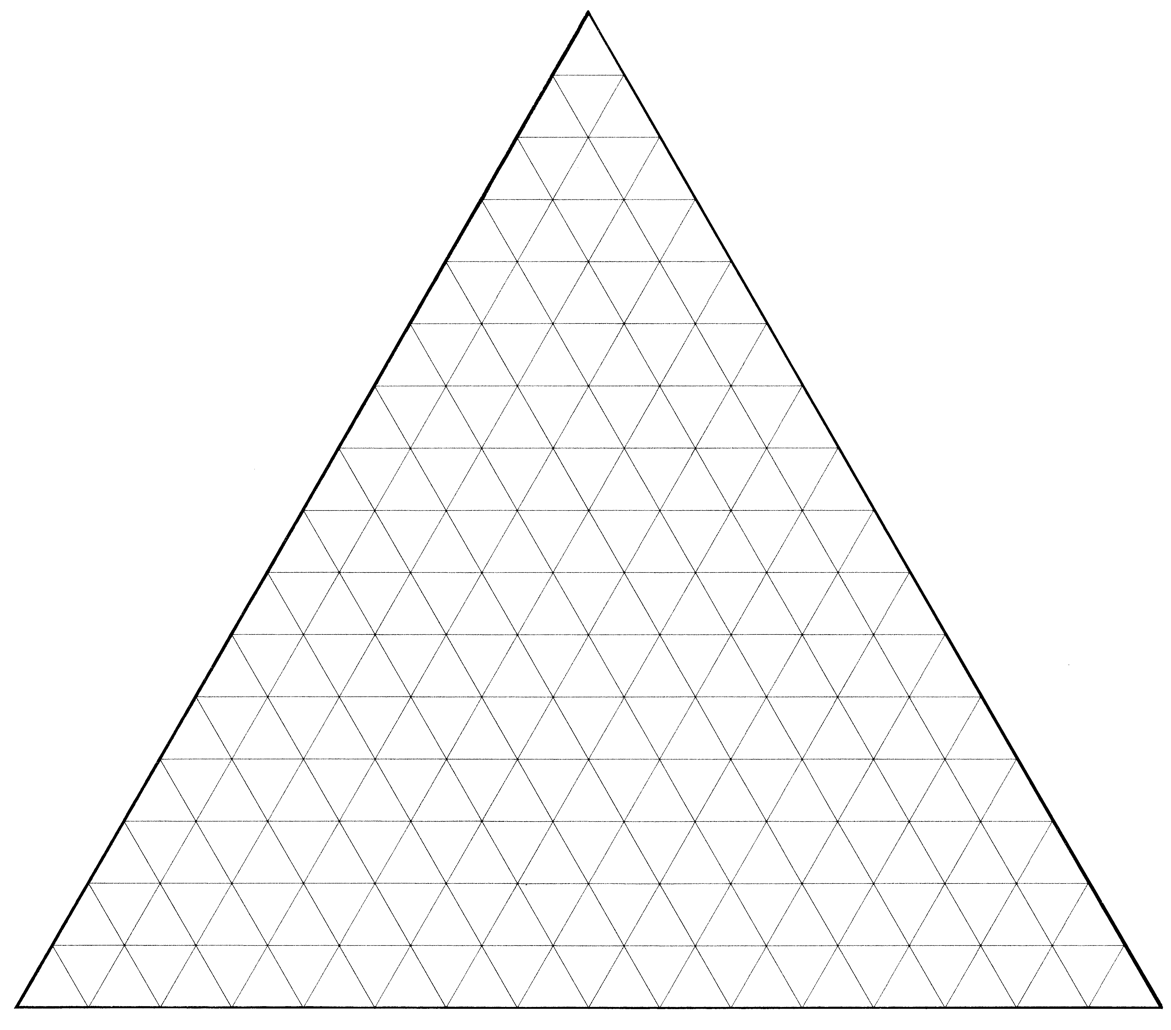

|  |  |  |  |  |  |  |
| --- | --- | --- | --- | --- | --- | --- |
| **Stage** | 0 | 1 | 2 | 3 | 4 | *n* |
| **Total number of**  **unshaded regions** | 1 |  |  |  |  |  |

3.

|  |  |  |  |  |  |  |  |  |  |  |  |  |  |  |  |  |  |  |  |  |  |  |  |  |  |  |
| --- | --- | --- | --- | --- | --- | --- | --- | --- | --- | --- | --- | --- | --- | --- | --- | --- | --- | --- | --- | --- | --- | --- | --- | --- | --- | --- |
|  |  |  |  |  |  |  |  |  |  |  |  |  |  |  |  |  |  |  |  |  |  |  |  |  |  |  |
|  |  |  |  |  |  |  |  |  |  |  |  |  |  |  |  |  |  |  |  |  |  |  |  |  |  |  |
|  |  |  |  |  |  |  |  |  |  |  |  |  |  |  |  |  |  |  |  |  |  |  |  |  |  |  |
|  |  |  |  |  |  |  |  |  |  |  |  |  |  |  |  |  |  |  |  |  |  |  |  |  |  |  |
|  |  |  |  |  |  |  |  |  |  |  |  |  |  |  |  |  |  |  |  |  |  |  |  |  |  |  |
|  |  |  |  |  |  |  |  |  |  |  |  |  |  |  |  |  |  |  |  |  |  |  |  |  |  |  |
|  |  |  |  |  |  |  |  |  |  |  |  |  |  |  |  |  |  |  |  |  |  |  |  |  |  |  |
|  |  |  |  |  |  |  |  |  |  |  |  |  |  |  |  |  |  |  |  |  |  |  |  |  |  |  |
|  |  |  |  |  |  |  |  |  |  |  |  |  |  |  |  |  |  |  |  |  |  |  |  |  |  |  |
|  |  |  |  |  |  |  |  |  |  |  |  |  |  |  |  |  |  |  |  |  |  |  |  |  |  |  |
|  |  |  |  |  |  |  |  |  |  |  |  |  |  |  |  |  |  |  |  |  |  |  |  |  |  |  |
|  |  |  |  |  |  |  |  |  |  |  |  |  |  |  |  |  |  |  |  |  |  |  |  |  |  |  |
|  |  |  |  |  |  |  |  |  |  |  |  |  |  |  |  |  |  |  |  |  |  |  |  |  |  |  |
|  |  |  |  |  |  |  |  |  |  |  |  |  |  |  |  |  |  |  |  |  |  |  |  |  |  |  |
|  |  |  |  |  |  |  |  |  |  |  |  |  |  |  |  |  |  |  |  |  |  |  |  |  |  |  |
|  |  |  |  |  |  |  |  |  |  |  |  |  |  |  |  |  |  |  |  |  |  |  |  |  |  |  |
|  |  |  |  |  |  |  |  |  |  |  |  |  |  |  |  |  |  |  |  |  |  |  |  |  |  |  |
|  |  |  |  |  |  |  |  |  |  |  |  |  |  |  |  |  |  |  |  |  |  |  |  |  |  |  |
|  |  |  |  |  |  |  |  |  |  |  |  |  |  |  |  |  |  |  |  |  |  |  |  |  |  |  |
|  |  |  |  |  |  |  |  |  |  |  |  |  |  |  |  |  |  |  |  |  |  |  |  |  |  |  |
|  |  |  |  |  |  |  |  |  |  |  |  |  |  |  |  |  |  |  |  |  |  |  |  |  |  |  |
|  |  |  |  |  |  |  |  |  |  |  |  |  |  |  |  |  |  |  |  |  |  |  |  |  |  |  |
|  |  |  |  |  |  |  |  |  |  |  |  |  |  |  |  |  |  |  |  |  |  |  |  |  |  |  |
|  |  |  |  |  |  |  |  |  |  |  |  |  |  |  |  |  |  |  |  |  |  |  |  |  |  |  |
|  |  |  |  |  |  |  |  |  |  |  |  |  |  |  |  |  |  |  |  |  |  |  |  |  |  |  |
|  |  |  |  |  |  |  |  |  |  |  |  |  |  |  |  |  |  |  |  |  |  |  |  |  |  |  |
|  |  |  |  |  |  |  |  |  |  |  |  |  |  |  |  |  |  |  |  |  |  |  |  |  |  |  |

|  |  |  |  |  |  |  |
| --- | --- | --- | --- | --- | --- | --- |
| **Stage** | 0 | 1 | 2 | 3 | 4 | *n* |
| **Total number of**  **unshaded regions** | 1 |  |  |  |  |  |

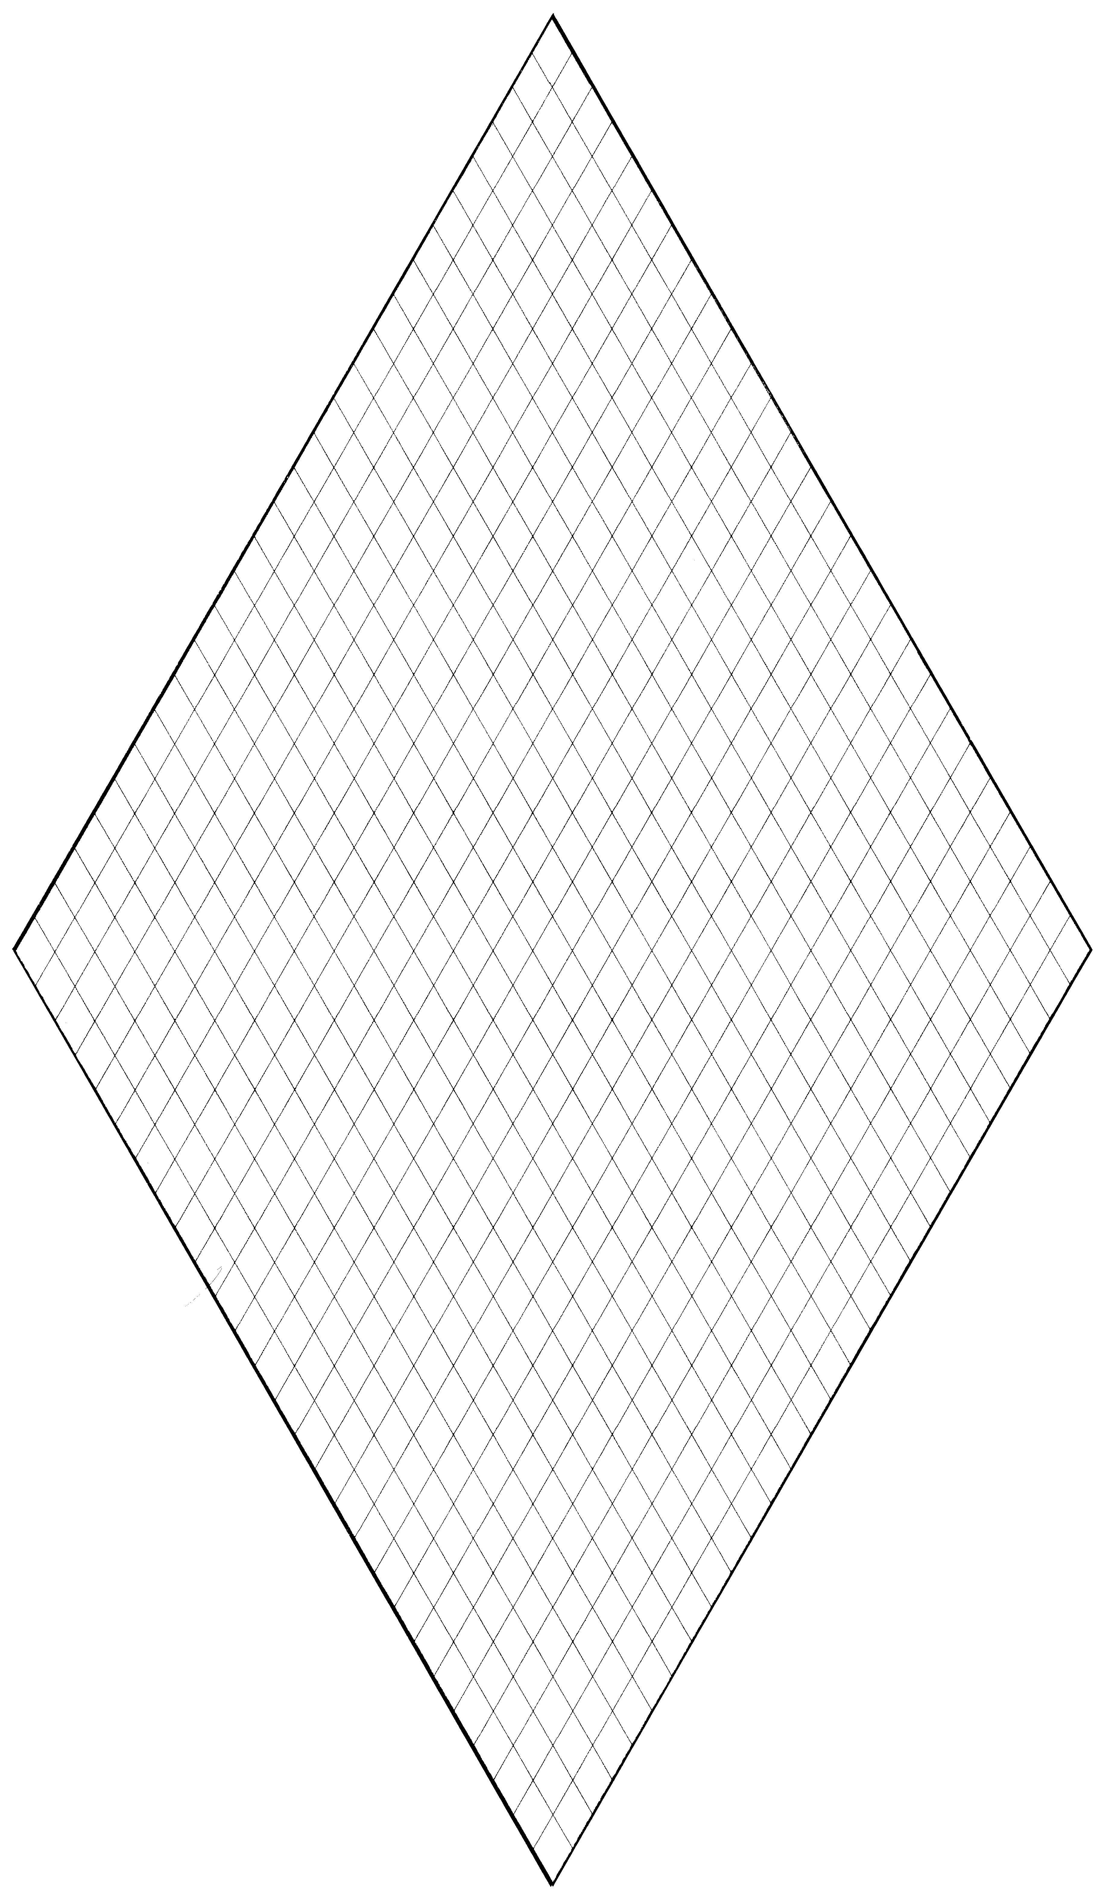

4.

|  |  |  |  |  |  |  |
| --- | --- | --- | --- | --- | --- | --- |
| **Stage** | 0 | 1 | 2 | 3 | 4 | *n* |
| **Total number of**  **unshaded regions** | 1 |  |  |  |  |  |

5.

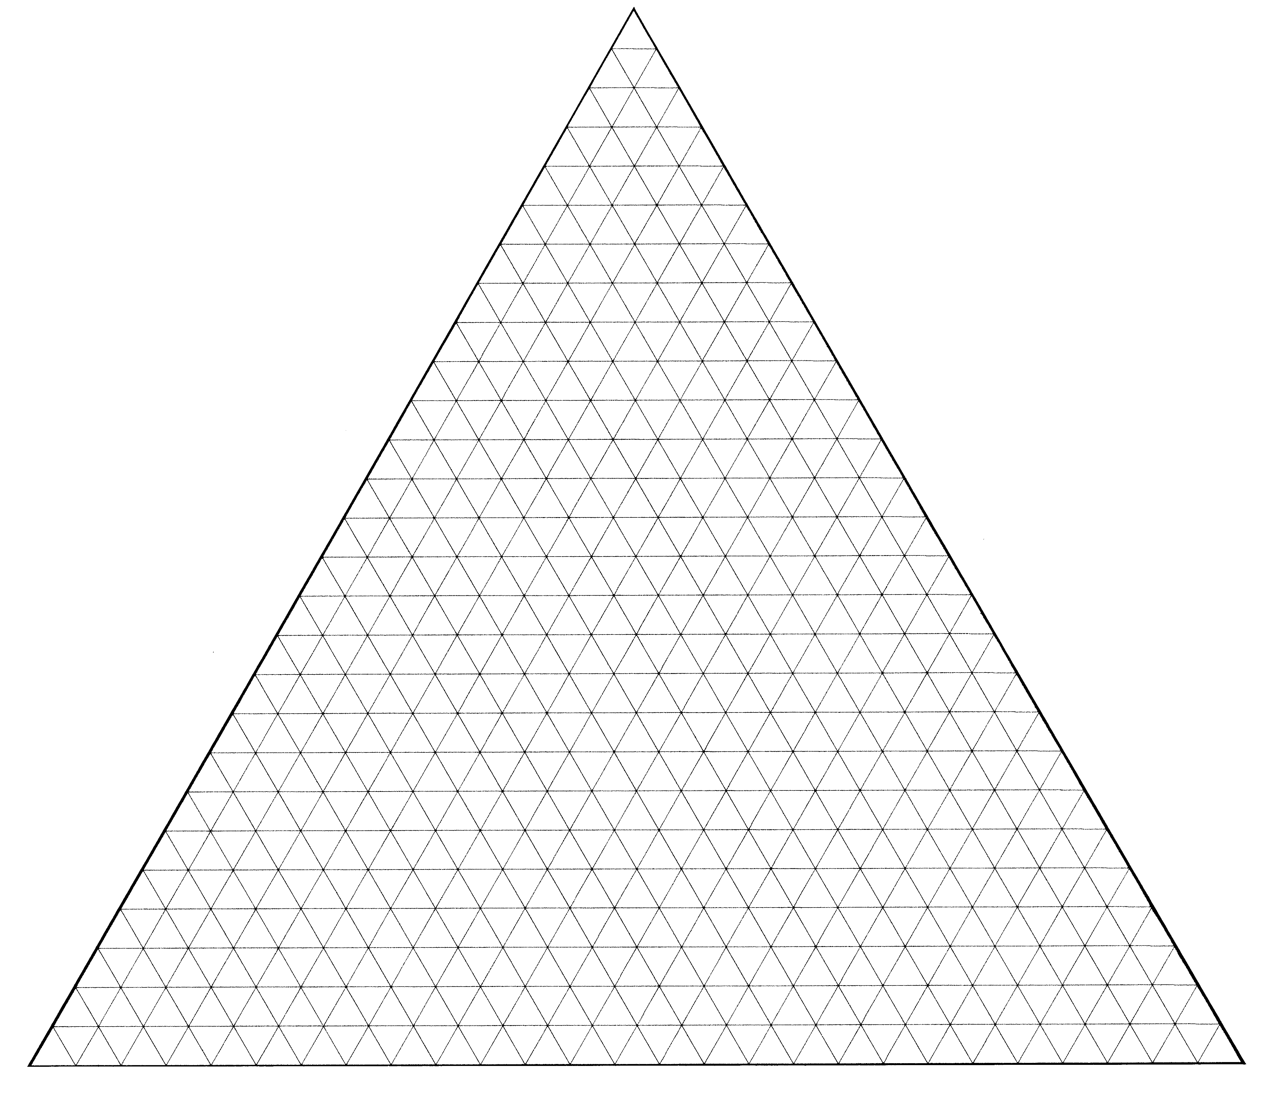

|  |  |  |  |  |  |  |
| --- | --- | --- | --- | --- | --- | --- |
| **Stage** | 0 | 1 | 2 | 3 | 4 | *n* |
| **Total number of**  **unshaded regions** | 1 |  |  |  |  |  |