**Applications of Geometric Sequences**

1. You drop a ball from the bleachers which are 16 feet high. Each time the ball bounces, the height decreases by half of the previous height. After 1 bounce, the height of the ball is 8 feet.
2. Complete the table below by identifying height of the ball after each bounce.

|  |  |  |
| --- | --- | --- |
| **Bounces** | **Height** | **Recursive Pattern** |
| 0 | 16 | 16 |
| 1 | 8 | 16 ( 1/2 ) |
| 2 |  |  |
| 3 |  |  |
| 4 |  |  |
| 5 |  |  |

1. What is the recursive rule for the sequence of heights?
2. Graph the relationship between the ball’s height and the number of bounces on the coordinate plane below. Label and scale the axes appropriately.



1. Write an explicit rule for the sequence of heights. Let *h* represent the height of the ball after each bounce and *b* represent the number of the bounce.

1. Find the height of the ball after the 11th bounce.
2. A certain type of bacteria cell splits into two bacteria cells every hour. Suppose a culture of bacteria begins with 3 bacteria cells.
3. Complete the table below by identifying the number of bacteria cells at the beginning of each hour.

|  |  |  |
| --- | --- | --- |
| **Hours** | **Bacteria Cells** | **Recursive Pattern** |
| 0 | 3 | 3 |
| 1 | 6 | 3 ( 2 ) |
| 2 |  |  |
| 3 |  |  |
| 4 |  |  |
| 5 |  |  |

1. What is the recursive rule for the sequence of bacteria cells?
2. Graph the relationship between the number of hours that have passed and the number of bacteria cells on the coordinate plane below. Label and scale the axes appropriately.

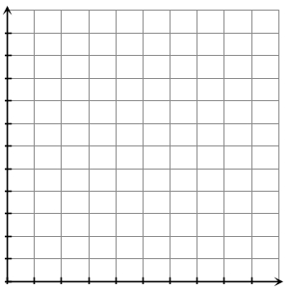

1. Write an explicit rule for the sequence of bacteria cells. Let *b* represent the number of bacteria cells and *h* represent the number of hours.

1. Find the number of bacteria cells after 7 hours.
2. Find the patterns in the geometric sequences below. Write a recursive rule to describe each sequence, and find the next three terms.

1. 5, 30, 180, ______, ______, ______
2. -2, 6, -18, 54, ______, ______, ______
3. 9 $,\frac{9}{2},\frac{9}{4},\frac{9}{8},$______, ______, ______
4. Each of these problems involves a geometric sequence. How would you describe the difference between a geometric sequence and an arithmetic sequence?