Mohegan Sun Arena
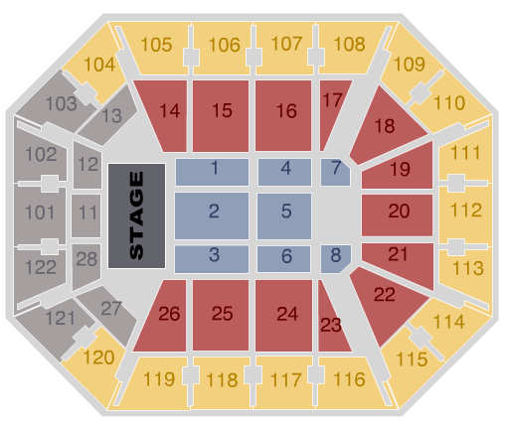
Mohegan Sun’s Arena has seating sections that are shaped trapezoids. Seats in these seating sections follow a certain pattern. The problems below focus on seating section 22.

Seating section 22 has 7 seats in row 1, 8 seats in row 2, 9 seats in row 3, and so on. There are 16 rows in this seating section.

- Write a recursive rule for the number of seats in any row of section 22.

- Write an explicit rule for the number of seats in any row of section 22.

- Complete this table showing the number of seats in each row and the total number of seats up to and including each of the 16 rows. You may use a spreadsheet if one is available.  - How many seats are in row 16, the last row? Explain how you arrived at your answer.  - How many seats are there all together in section 22? Explain how you arrived at your answer. | Row # # of Seats # of Total Seats up to and Including this Row  1 7 7  2 8 15  3 9 24  4  5  6  7  8  9  10  11  12  13  14  15  16

- Which row in seating section 22 has 17 seats? Explain how you could find the answer without looking at the table.

7. If you are in section 22, and there are 84 seats in your section in front of you, in what row are you sitting? Explain how you arrived at the answer.

