Burning Hydrocarbons

When hydrocarbons are burned, they create energy. For example, when methane reacts with oxygen carbon dioxide, water, and energy are formed. This process is called combustion.

The table below shows approximately how much energy (kJ/mole) is released from completely burning a fixed amount of each hydrocarbon.

Simple Hydrocarbon # of Carbon Atoms Energy Released from Combustion (kJ/mole)  Methane 1 920  Ethane 2 1560  Propane 3 2200  Butane 4 2840  Pentane 5  Hexane 6  Heptane 7  Octane 8 | 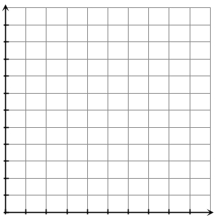

- What pattern do you see in the table above?

- Use the pattern to complete the table.

- Draw a graph in the coordinate plane above showing the relationship between the number of carbon atoms and how much energy is released (kJ/mole) from the combustion of the simple hydrocarbon.

- On your graph, what pattern do the plotted points make?

- Based on the data from the table and graph, which hydrocarbon releases the most amount of energy? Explain your answer.

