Hydrocarbons on Titan

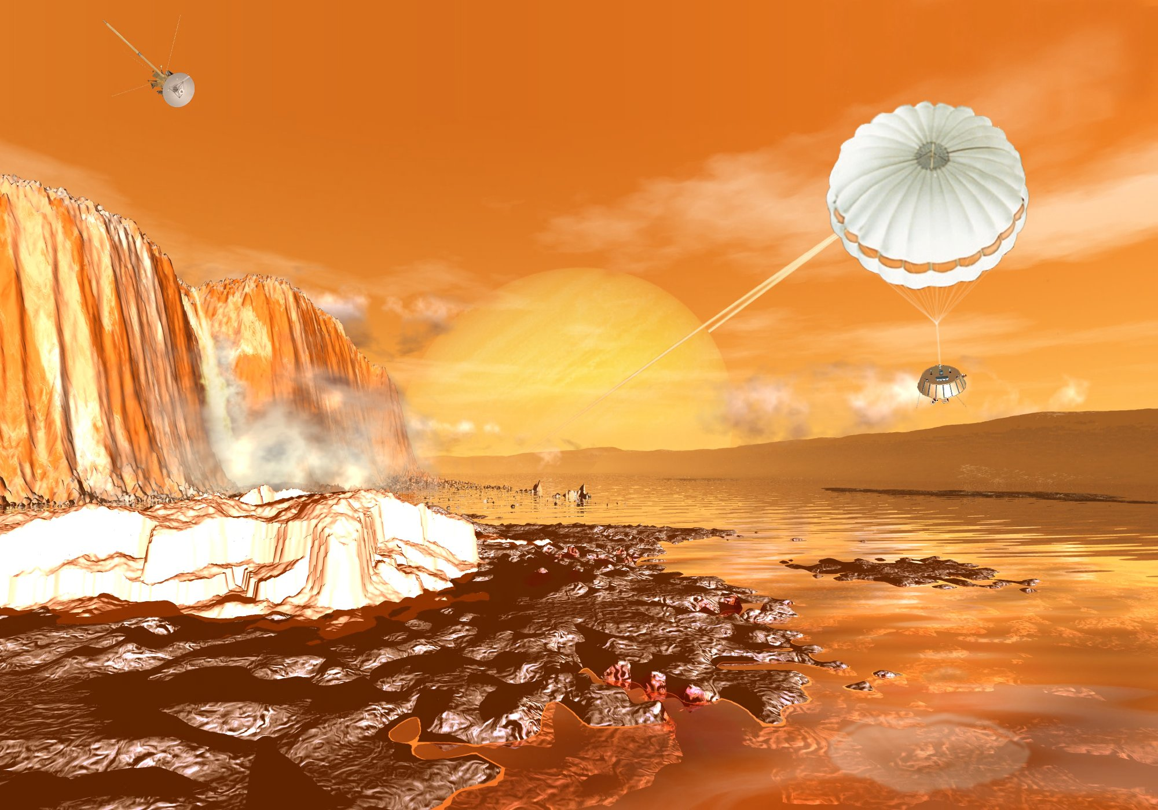

Artist’s Rendition of Hyugens Probe on the Surface of Titan

Hydrocarbons are molecules made up only of hydrogen and carbon. They are found on Earth in crude oil and natural gas, and are the primary source of energy used throughout the world. Due to an increasing demand for energy, the Earth’s supply of hydrocarbon fuel is diminishing.

In 2004, the Cassini spacecraft orbited Titan, Saturn’s largest moon, sending images of Titan’s atmosphere and surface to Earth. The images confirmed that Titan has lakes which contain hydrocarbons. These hydrocarbons are gases on Earth, but due to Titan’s surface temperature, they are liquids, or even solids, on Titan. The image above is an artist’s rendition of the surface of Titan with the Hyugens probe parachuting toward Titan’s surface.

You have been selected for a mission to Titan departing Earth in 2020. The goal of the mission is to explore and catalog the mixture of simple hydrocarbons in the lakes of Titan and report your findings. Simple hydrocarbons are made up of specific patterns of hydrogen and carbon atoms. Each simple hydrocarbon has a name and its own properties.

As a first step, your task is to build models of hydrocarbons and find their mathematical pattern. You must use the following guidelines:

- Carbon atoms are represented by black Styrofoam spheres.
- Hydrogen atoms are represented by yellow Styrofoam spheres.
- Each carbon atom must have four links. Each link can connect another carbon atom or a hydrogen atom. The carbon atoms must lie along a straight line. This is called a straight-chain hydrocarbon.
- Each hydrogen atom can only have one link. Hydrogen atoms must be connected to a carbon atom.

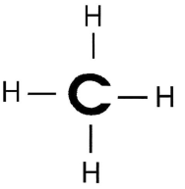
The first hydrocarbon is called methane and it looks like this:

- Build a model of methane using one black Styrofoam (carbon atom) and four yellow Styrofoam (hydrogen atoms). Check with your mission instructor (teacher) before continuing.

- Build a model with 2 carbon atoms (black). Continue to follow the guidelines provided on the previous page. Check with your mission instructor (teacher) before continuing. Then count the number of hydrogen atoms.

- Continue building models using three and four carbon atoms (black). Follow the guidelines for hydrocarbons listed on the previous page.

- Complete the following table:

Hydrocarbon Molecules
Name of Molecule | Number of Carbon Atoms | Number of Hydrogen Atoms
Methane | 1 | 4
Ethane | 2
Propane | 3
Butane | 4
Pentane

- Draw a rough stick model of a hydrocarbon with five carbon atoms using C for carbon atoms and H for hydrogen atoms.

- Complete the following sentence:
As the number of carbon atoms increases by 1, the number of hydrogen atoms
_________________________________.
- Use the coordinate plane below to graph the relationship between the number of carbon atoms and the number of hydrogen atoms in the hydrocarbons. Label and scale the axes appropriately.

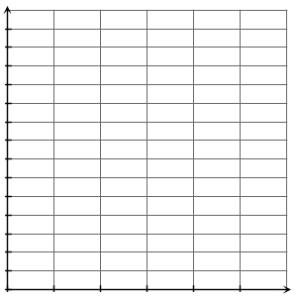

- Are you able to extend the graph to determine how many hydrogen atoms would be in a hydrocarbon with six carbon atoms? If so, what would you find?

- What would happen if you extended the graph to the left? Is the result meaningful?

- If we know there are 20 hydrogen atoms in a hydrocarbon with 9 carbon atoms, how many hydrogen atoms are there in a hydrocarbon with 10 carbon atoms?

- Which of the following equations can be used to find the number of hydrogen atoms if we know the number of carbon atoms? Use the table to verify your answer.
(A) h = 4c + 0 (B) h = 2c + 4 (C) h = 2c + 2

- What do the variables h and c represent in the previous equations?

- Use your equation from Question 11 to find the number of hydrogen atoms in a hydrocarbon with 20 carbon atoms.

- Suppose there are 22 hydrogen atoms in a hydrocarbon. Use your equation from Question 11 to determine how many carbon atoms would be present.

- Is it possible to have a hydrocarbon molecule with 25 hydrogen atoms? Explain.

In this activity, we examined many different representations of the relationship between the number of carbon atoms and hydrogen atoms. We used a table (Question 4), verbal description (Question 6), graph (Question 7), and an equation (Question 11).

- Which representation did you find most useful? Why?

- Which representation is the most difficult to understand? Why?

- What similarities and differences do you see in the four representations?

