Module 3  Facilitator Guide | Focus on Teaching and Learning

Section 5

Connecticut Core Standards for Mathematics

Grades K–5

Systems of Professional Learning

Connecticut Core Standards Systems of Professional Learning
The material in this guide was developed by Public Consulting Group in collaboration with staff from the Connecticut State Department of Education and the RESC Alliance. The development team would like to specifically thank Ellen Cohn, Charlene Tate Nichols, and Jennifer Webb from the Connecticut State Department of Education; Leslie Abbatiello from ACES; and Robb Geier, Elizabeth O’Toole, and Cheryl Liebling from Public Consulting Group.
The Systems of Professional Learning project includes a series of professional learning experiences for Connecticut Core Standards District Coaches in English Language Arts, Mathematics, Humanities, Science, Technology, Engineering, Mathematics (STEM), and Student/Educator Support Staff (SESS).
Participants will have continued support for the implementation of the new standards through virtual networking opportunities and online resources to support the training of educators throughout the state of Connecticut.
Instrumental in the design and development of the Systems of Professional Learning materials from PCG were: Sharon DeCarlo, Debra Berlin, Jennifer McGregor, Judy Buck, Michelle Wade, Nora Kelley, Diane Stump, and Melissa Pierce.

Published 2014. Available online at http://ctcorestandards.org/

Session at-a-Glance

Section 5: Assessing Learning Progress (75 minutes)

Training Objectives:
To help participants understand the differences in assessment of learning and assessments for learning.
For participants to experience assessments for learning from a student perspective.
For participants to have a shared understanding of the four attributes of the formative assessment process.
For participants to work together to describe various ways to elicit evidence of student learning.
Participants will begin Section 5 by working through a mini-lesson around the Two Interpretations of Division task from Illustrative Mathematics. Just as with the Two Machines, One Job problem in Module 1, while participants work, the facilitator will model both UDL and formative assessment practices that will be discussed later in the section. After the lesson is complete, the facilitator will have participants identify the UDL strategies used and then transition the discussion to the process of formative assessment by asking how the learning that is taking place through the lesson can be assessed.
The facilitator will then provide information on assessments of learning and assessments for learning and explain that they will focus on assessments for learning (the formative assessment process) at this time. The facilitator will review the four attributes of formative assessment: clarifying intended learning, eliciting evidence, interpreting evidence, and acting on evidence.
Participants will then, as a large group, identify the formative assessment practices used by the facilitator in the Two Interpretations of Division mini-lesson as well as by the teacher in the Multiplying Whole Numbers and Fractions video.
Participants will wrap-up the activity by working together to complete a graphic organizer that shows the association between teaching, learning, and formative assessment practices.

Supporting Documents:
- Two Interpretations of Division
- Identifying UDL Strategies
- Describing Assessment Goals
- Assessment ‘of’ and Assessment ‘for’ Learning Template
- Four Attributes of Formative Assessment
- Reflecting on Formative Assessment

Materials:
- Chart paper, markers

PowerPoint Slides:
46–65

Session Implementation
Section 5
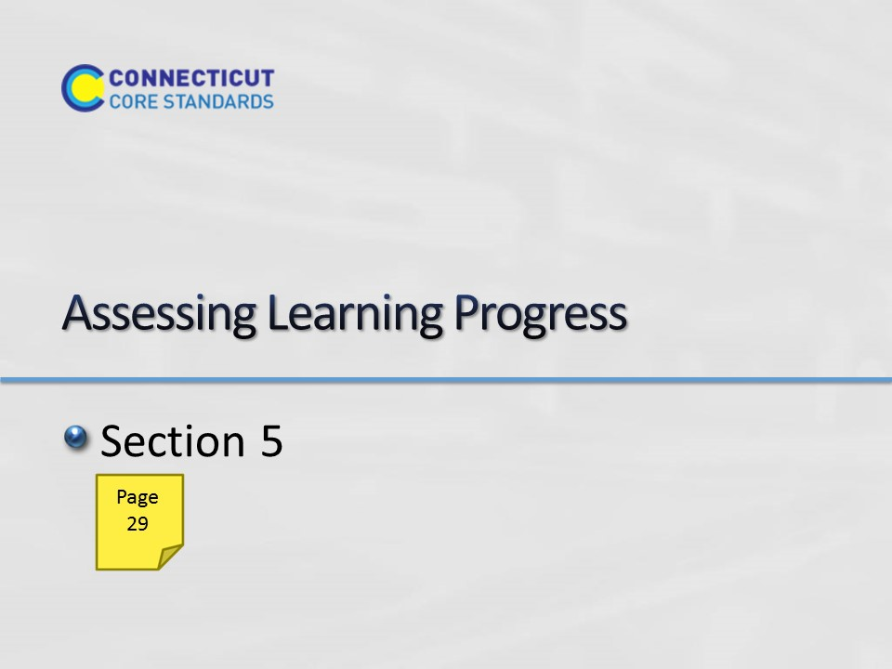Slide 46
Section 5: Assessing Learning Progress
Section 5 Time: 75 minutes
Section 5 Training Objectives:
- To help participants understand the differences in assessment of learning and assessments for learning.
- For participants to experience assessments for learning from a student perspective.
- For participants to have a shared understanding of the four attributes of the formative assessment process.
- For participants to work together to describe various ways to elicit evidence of student learning.
Section 5 Outline:
- Participants will begin Section 5 by working through a mini-lesson around the Two Interpretations of Division task from Illustrative Mathematics. Just as with the Two Machines, One Job problem in Module 1, while participants work, the facilitator will model the formative assessment practices that will be discussed later in the section. After the lesson is complete, the facilitator will have participants identify the UDL strategies that can be used with students around this task and then transition the discussion to the process of formative assessment by asking how the learning that is taking place through the lesson can be assessed.
- The facilitator will then provide information on assessments of learning and assessments for learning and explain that they will focus on assessments for learning (the formative assessment process) at this time. The facilitator will review the four attributes of formative assessment: clarifying intended learning, eliciting evidence, interpreting evidence, and acting on evidence.
- Participants will then, as a large group, identify the formative assessment practices used by the facilitator in the Two Interpretations of Division mini-lesson as well as by the teacher in the Multiplying Whole Numbers and Fractions video.
- Participants will wrap-up the activity by working together to complete a graphic organizer on ways to elicit evidence of student understanding (attribute 2).

Supporting Documents
Two Interpretations of Division
Identifying UDL Strategies
Describing Assessment Goals
Assessment ‘of’ and Assessment ‘for’ Learning Template
Four Attributes of Formative Assessment
Reflecting on Formative Assessment
Materials
Chart paper
Markers
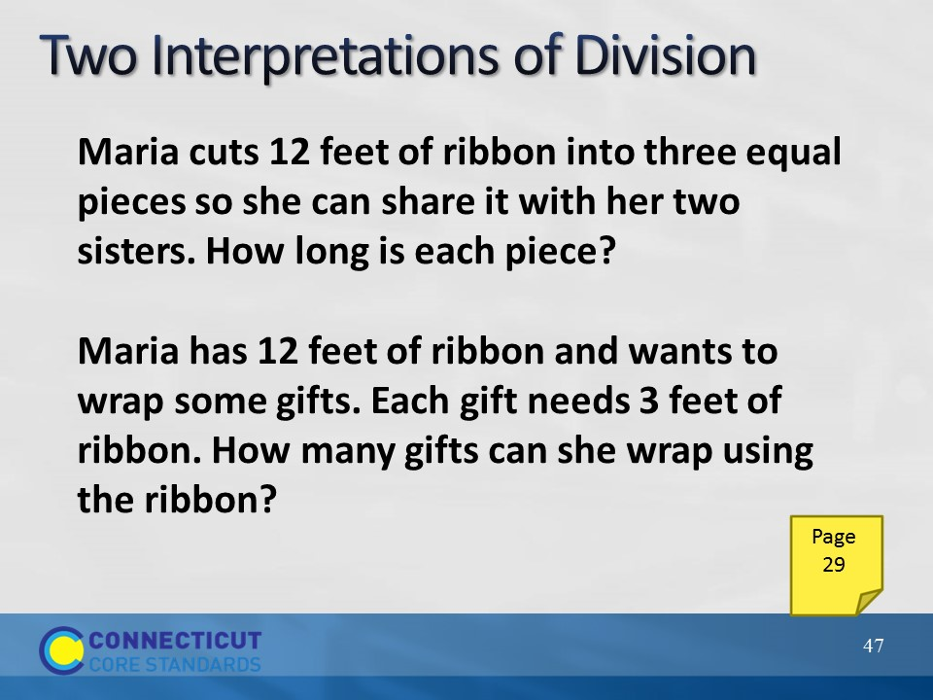Slide 47
Have participants read the Two Interpretations of Division task on page 29 in their Participant Guide and work on this alone for 6–7 minutes. Explain that this is a Grade 3 task from Illustrative Mathematics (http://www.illustrativemathematics.org/illustrations/344) aligned to 3.OA.3.1. Provide participants with the following framework on chart paper: Work alone for 5 minutes. Work with your group for 5 minutes. Discuss as a large group for 5 minutes.
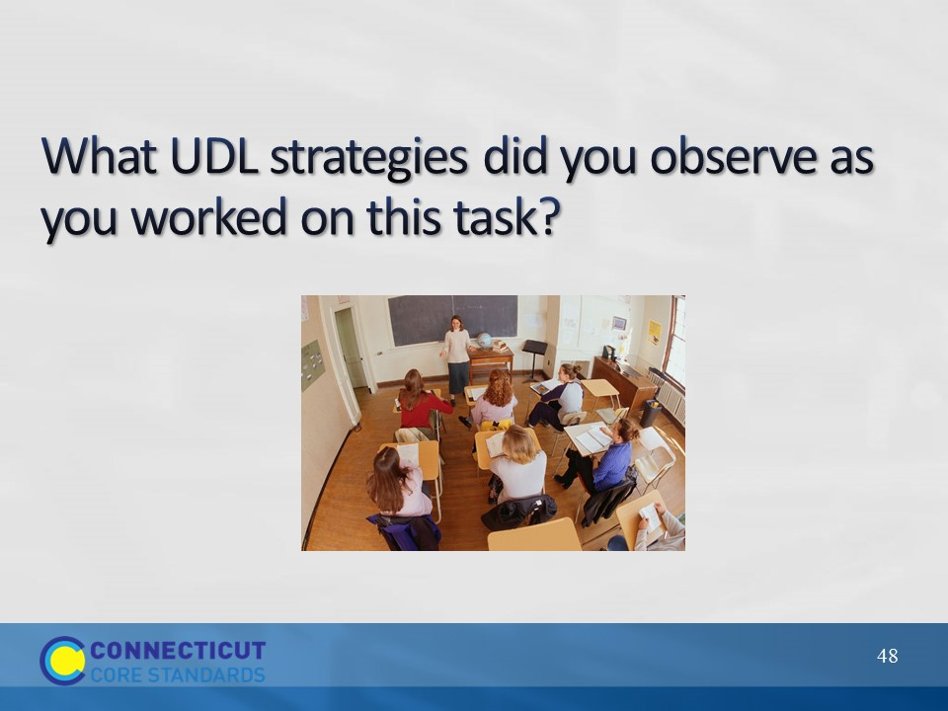Slide 48
Have participants turn to page 30 in their Participant Guide. Then, have the participants identify the UDL strategies that may be used if students worked on the task and then transition the discussion to assessment practices by asking how the learning that is taking place through the lesson can be assessed. Examples of UDL strategies that can be discussed are: The use of actual ribbon, clarification of language, providing tools such as fraction strips and number lines, having students write their learning goal in their own words, providing the problem solving process, allowing all students to create their own solution strategy, working in groups, reading the problem aloud, as so forth.

Slide 49
On chart paper, record responses to the question on the slide. Use these responses to transition to the next two slides that highlight the difference between assessment OF learning (summative) and assessment FOR learning (formative).
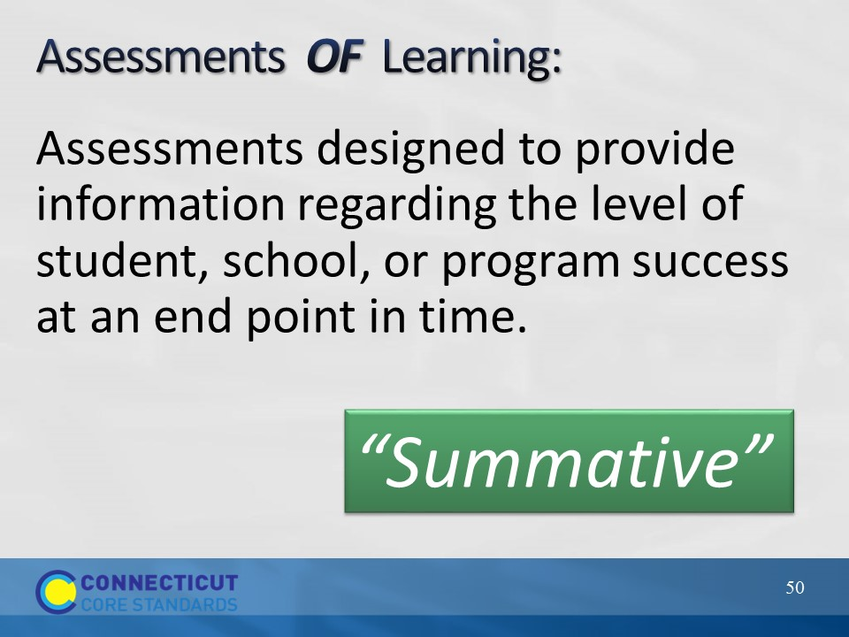Slide 50
The phrase “Assessments OF learning” refers to evaluating progress at an end point in time as this slide indicates. Assessment OF learning’s purpose is summative, intended to provide an evaluative judgment, make inferences, or assign a grade for purposes of local, state, or federal accountability. Summative assessments usually signal a student’s relative position amongst other students (an indication as to why they are sometimes referred to as “high stakes” assessments).
Council of Chief State School Officers. 2012. Distinguishing Formative Assessment From Other Educational Assessment Labels. Retrieved at http://www.ccsso.org/Documents/FASTLabels.pdf
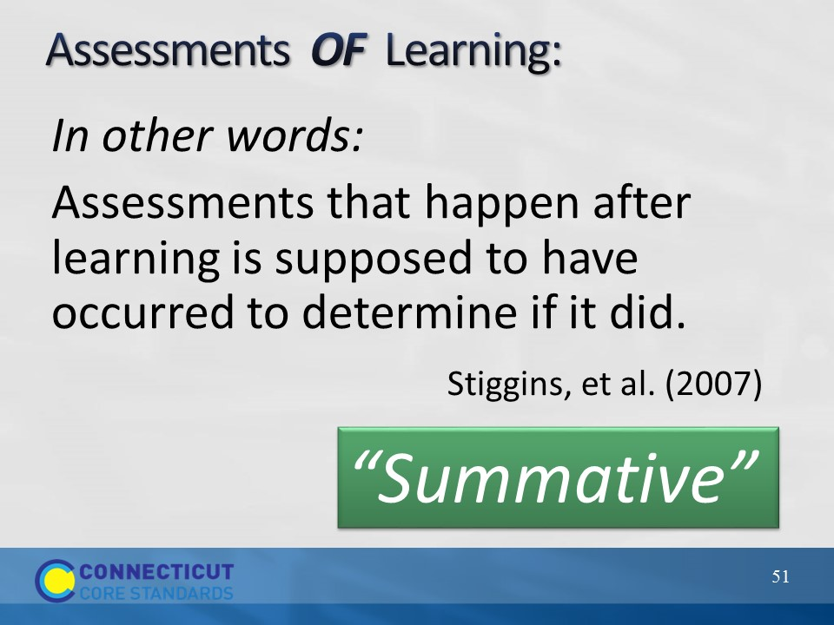Slide 51
NOTE: Stiggins coined the phrase “assessments OF learning” and “assessments FOR learning”.
Reference: Classroom Assessment for Student Learning: Doing it Right – Using it Well. Stiggins, R. J.; Arter, J. A.; Chappuis, J.; Chappuis, S. Pearson Education, Inc. 2007 Upper Saddle River, NJ
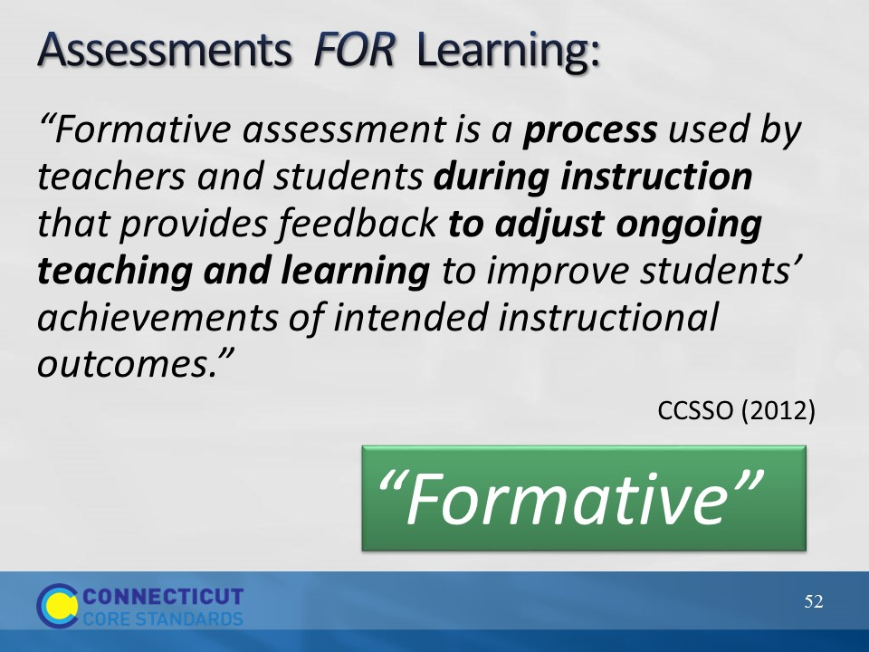Slide 52
Use this slide to highlight the differences between the two types of assessment. “On these occasions, the grading function is laid aside … this is about getting better” (Stiggins et al, 2007), providing an indication of why these assessments are sometimes referred to as “low stakes.” It’s important to note that summative assessments aren’t bad or wrong, they have a different purpose and have their place.
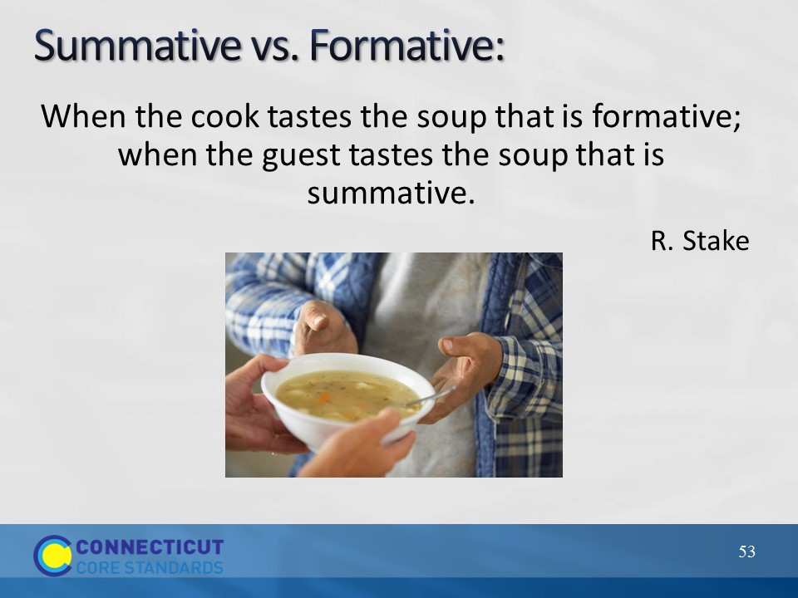Slide 53
After summing up the difference between the two types of assessments with this quote from Robert Stake, go back to the flip chart and the goals of assessment that were generated and ask participants to categorize each goal as being the result of “summative” or “formative” assessment practices. Transition to the next slides by asking why the formative assessment process is so important. Quickly move through the next few slides that provide a rationale from research for a focus on assessment FOR learning.
Quoted in Scriven, Michael. “Beyond Formative and Summative Evaluation.” In M.W. McLaughlin and ED.C. Phillips, eds., Evaluation and Education: A Quarter Century. Chicago: University of Chicago Press, 1991: p. 169. Reported in Patton, Michael Quinn, Utilization-Focused Evaluation: The New Century Text. Edition 3. Thousand Oaks, CA: Sage, 1997: p. 69.
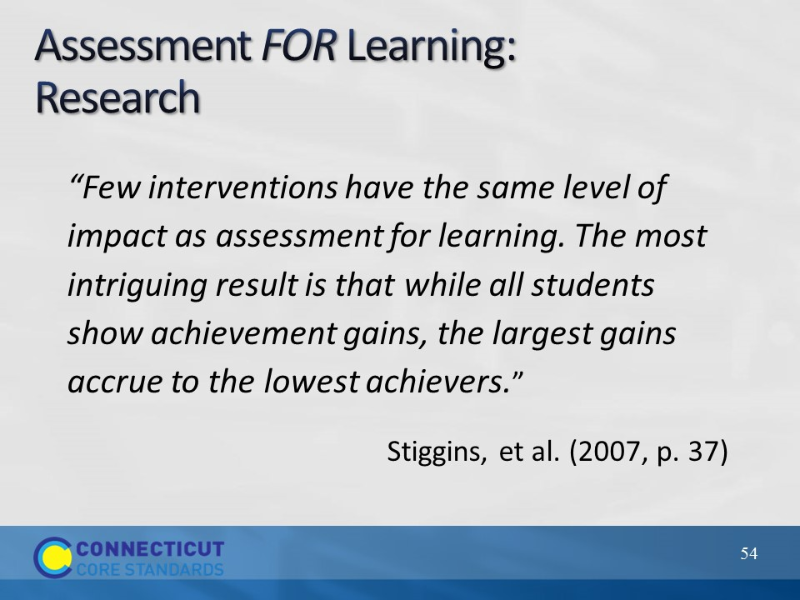Slide 54
This quote speaks for itself as to the impact of formative assessment.
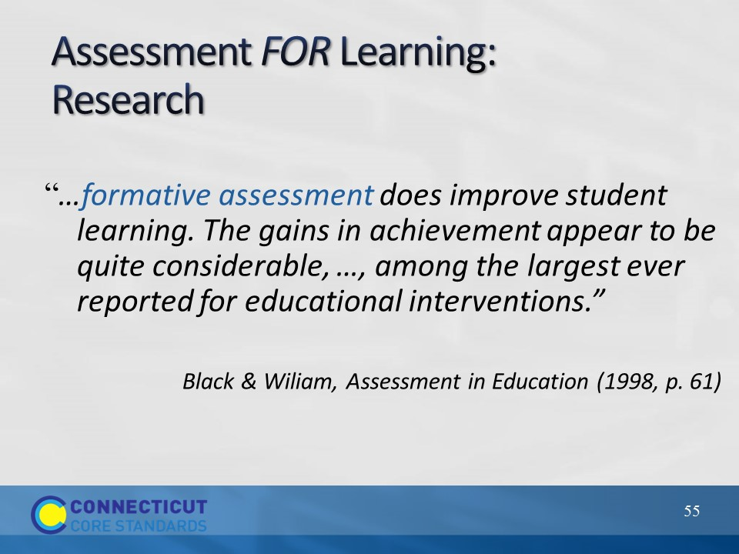Slide 55
In 1998, Paul Black and Dylan Wiliam summarized the findings from more than 250 studies on formative assessment in an article in Assessment in Education.
Reference: Assessment and Classroom Learning. Paul Black, Dylan Wiliam Assessment in Education: Principles, Policy & Practice. Vol. 5, Iss. 1, 1998.
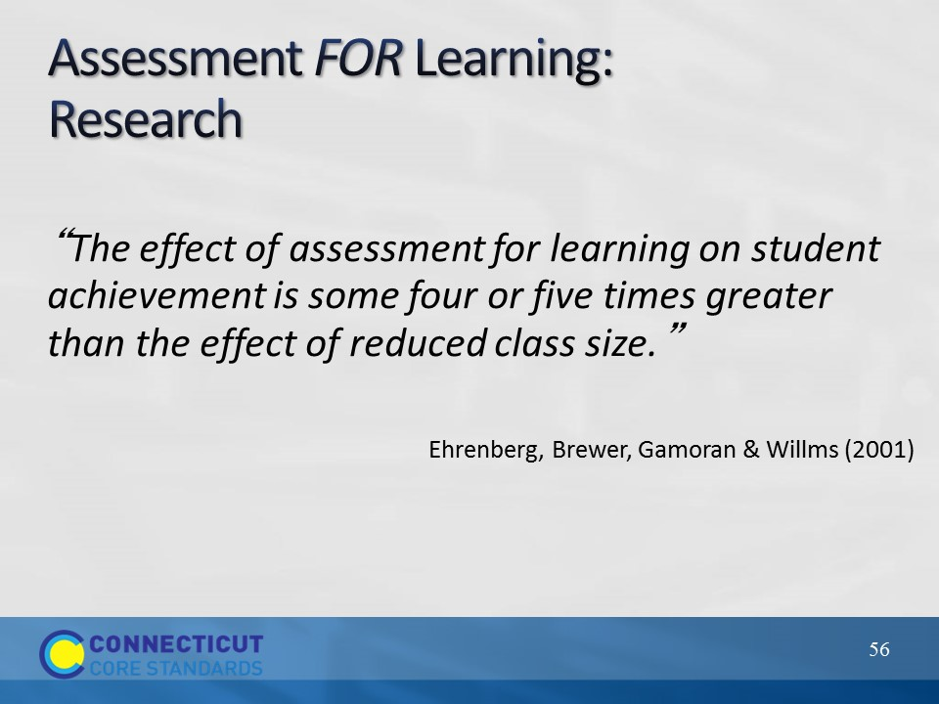Slide 56
This slide provides more evidence regarding the benefits of the formative assessment process. Transition to the next slides by telling participants that this research should motivate educators to want to effectively use formative assessment practices in the classroom.
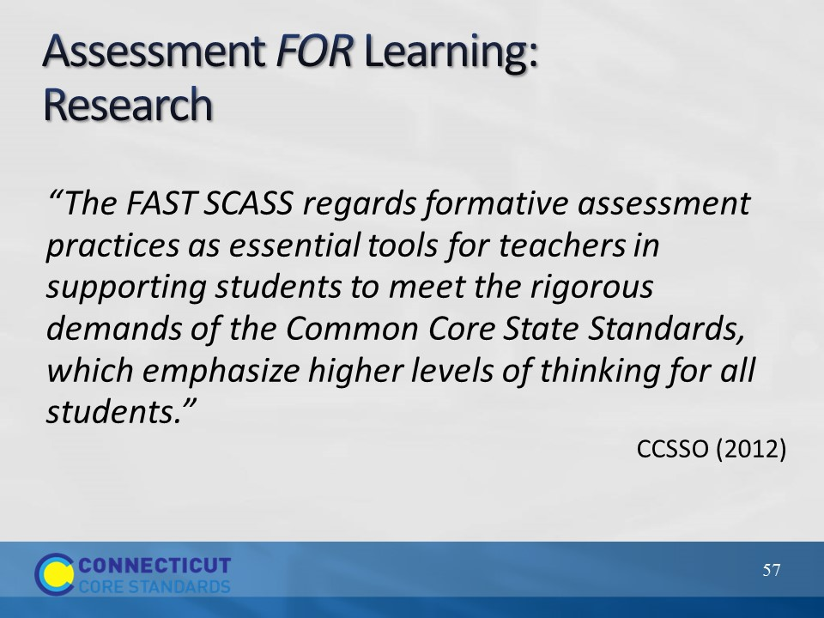Slide 57
Indicate that “FAST SCASS” is the State Collaborative put together by the CCSSO to clarify the meaning and uses of assessments. [Acronym stands for: Formative Assessment for Students and Teachers (FAST) State Collaborative on Assessment and Student Standards (SCASS)]. There are also SCASSes for ELA, mathematics, ELL, special populations, science and large scale assessment. CSDE consultants are members of these collaboratives.
Transition to the next slides by telling participants that this research should motivate educators to want to effectively use formative assessment practices.
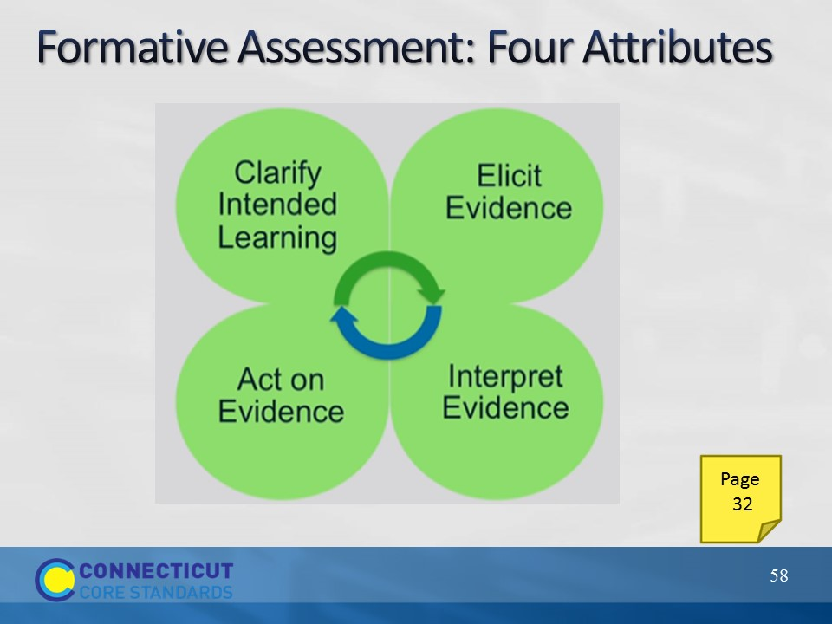Slide 58
These next slides give an overview of the four attributes of formative assessment given in the recently developed SBAC Digital Library of formative assessment practices and professional learning resources for educators. Explain that many participants will also be receiving training at the RESCs on this Digital Library in the next couple of months.
Participants should turn to page 32 in their Participant Guide as the attributes are clarified using the next slides. As these four attributes are described, participants should note in the margins how these attributes were modeled by the facilitator in the Two Interpretations of Division task and/or by the teacher in the Multiplying Whole Numbers and Fractions video.
The attributes are qualities or characteristics that would be present in the process of formative assessment.
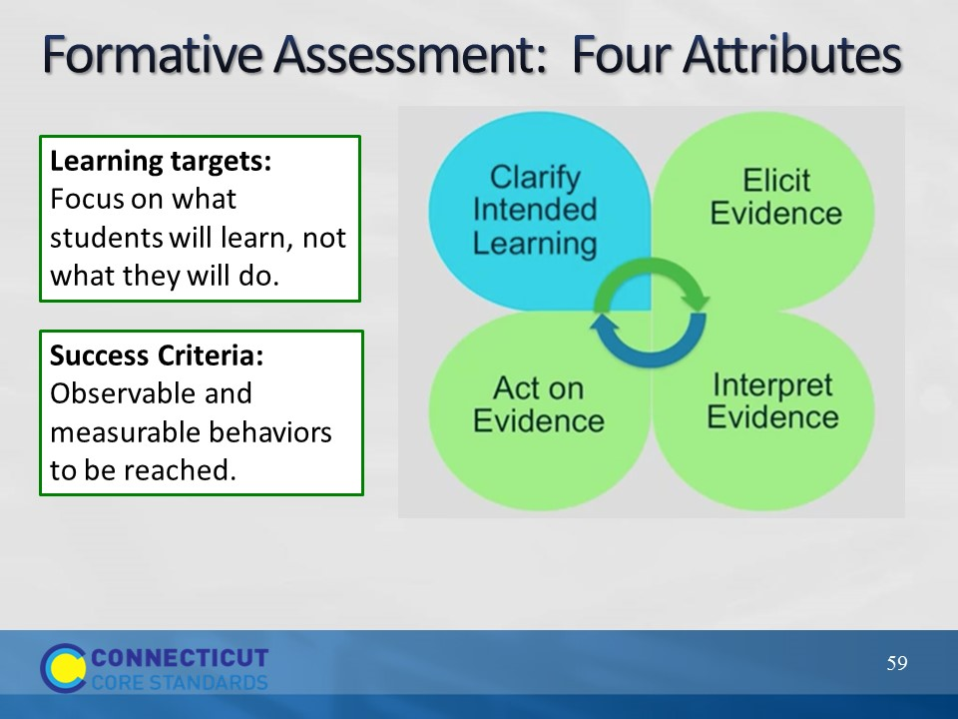Slide 59
Purpose of clarifying intended learning is to help students and teachers understand the expectations and goals for their work together. (This slide is animated, click to get information regarding this attribute.)
Learning targets should be communicated in student-friendly language (like we did with our “I can” statements for the SMP in Module 1).
Success criteria extend from the learning targets. Sharing success criteria may include discussing rubrics and modeling what an exemplar might look like. Use examples of strong and weak work.
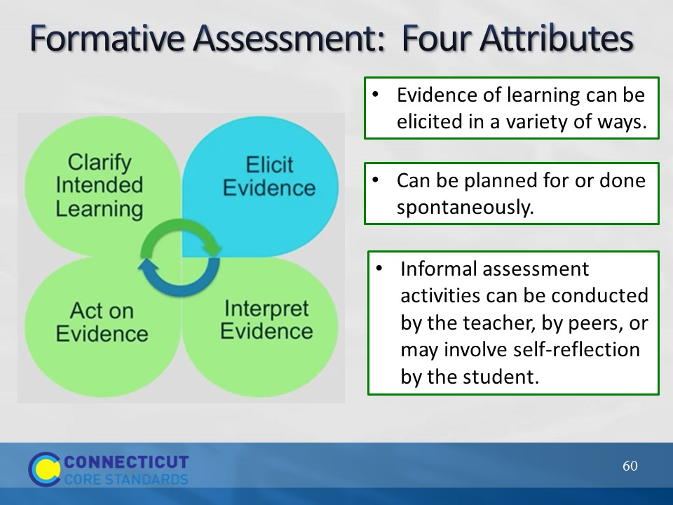Slide 60
The next attribute is “Elicit Evidence.” As the teacher implements formative assessment practices, evidence of learning is elicited. We will come back to this and talk more about ways to elicit evidence later in this section.
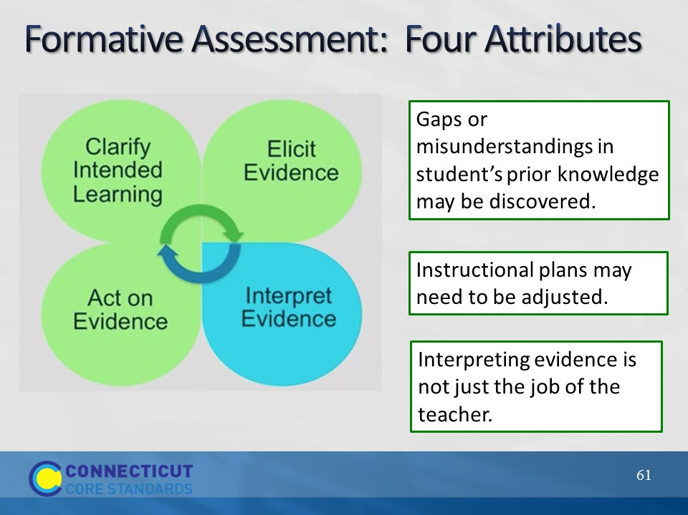Slide 61
Once evidence is elicited, it must be interpreted to determine where students are in relation to the learning target and success criteria.
Students and peer groups can engage in their own learning by having opportunities to interpret their own evidence.
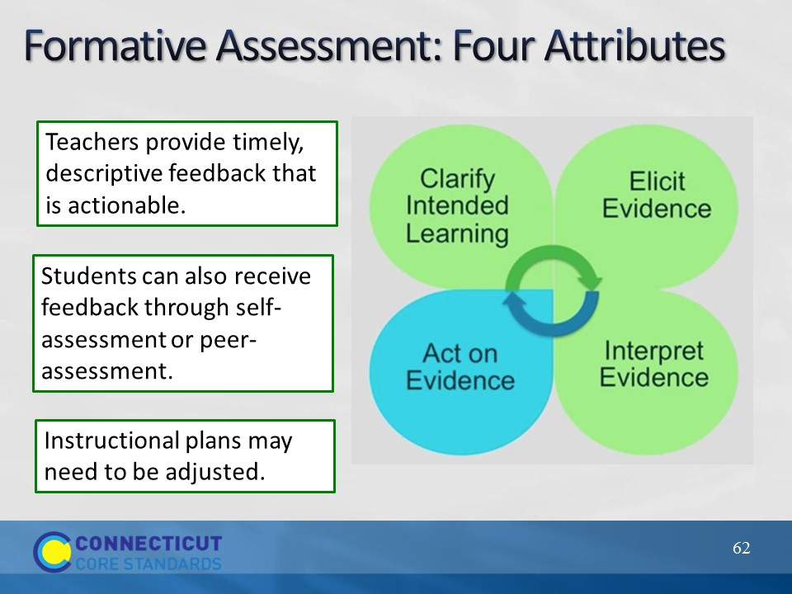Slide 62
Students and teachers act on the interpretation of the evidence. Instructional plans may include mini-tutorials, group work, etc. Provide feedback that is task-involving rather than ego-involving. Best feedback helps students see where they are in relation to the learning target, and then provides hints or suggestions to act on. It puts “the ball back in the student’s court.” Teachers need to set aside the time for students to reflect on and act on the feedback.
The cycle continues as shown by the arrows in the center.
Wiliam, D. (2011). Embedded Formative Assessment. Solution Tree Press. Bloomington, IN.
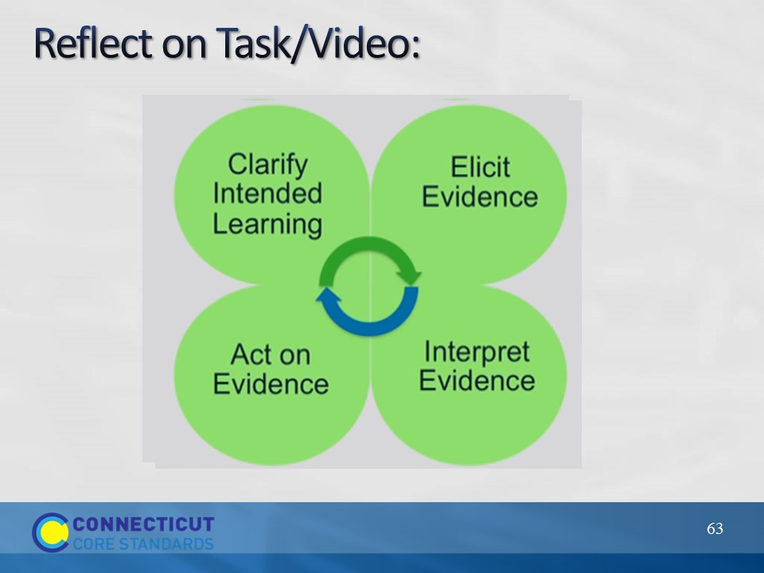Slide 63
Ask participants to reflect on the Two Interpretations of Division task that they did earlier and the tasks/questioning used in the video: Were targets and success criteria made clear? Was the facilitator/teacher effective in eliciting evidence of student learning? After evidence was interpreted, was actionable feedback given? Give participants a minute to jot down some notes in response to this question in their Participant Guide on page 33.
Debrief as a group addressing each of the questions above. (5 minutes)
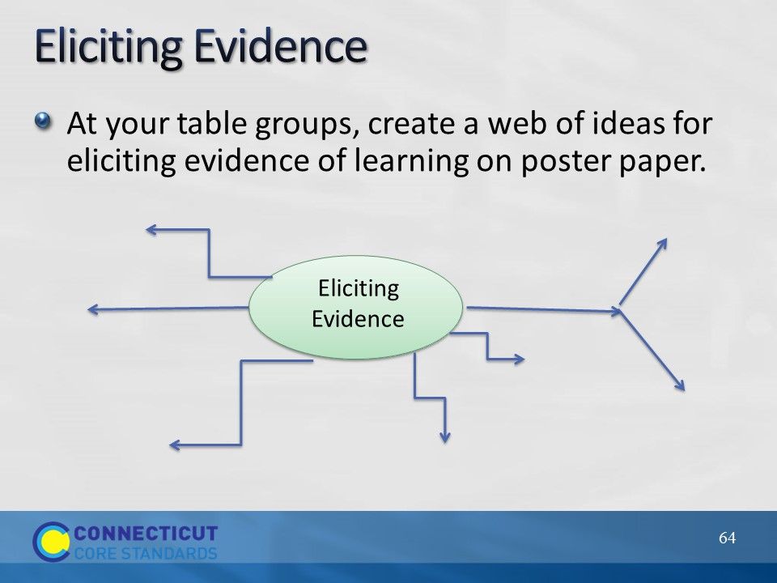Slide 64
Have participants work together to create a web of ideas showing ways to elicit evidence in their classrooms. Either have participants do a gallery walk when they are done or have each group share out a couple of ideas they had included on their poster.

Ideas that may be shared: Questioning, observations, anecdotal comments of individual or group work, mini-white boards, traffic lights/thumbs up-down, think-pair-share, writing prompts, short quizzes, journals/logs, exit cards, student self-assessment, peer assessment, all-student response systems, diagnostic interviews, etc.
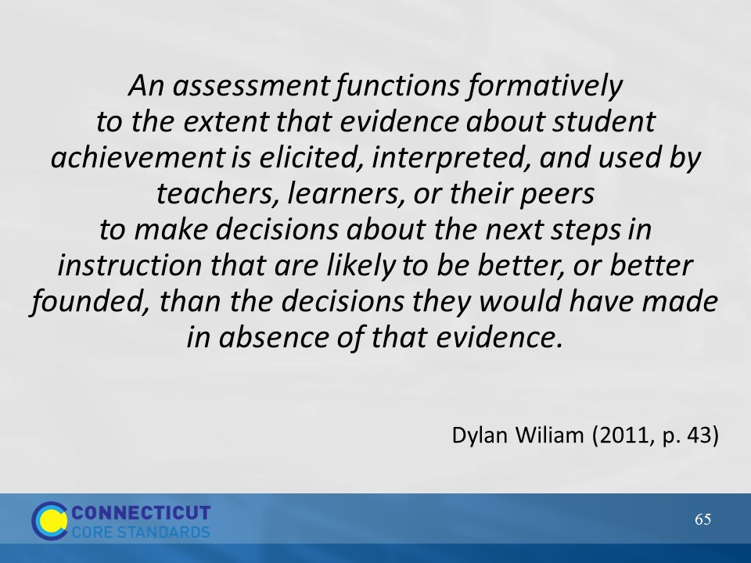Slide 65
This quote by Wiliam (2011) sums up Section 5. Transition now to section 6 where we will look more closely at some formative assessment practices.

