Module 3  Facilitator Guide | Focus on Teaching and Learning

Section 7

Connecticut Core Standards for Mathematics

Grades 6–12

Systems of Professional Learning

Connecticut Core Standards Systems of Professional Learning
The material in this guide was developed by Public Consulting Group in collaboration with staff from the Connecticut State Department of Education and the RESC Alliance. The development team would like to specifically thank Ellen Cohn, Charlene Tate Nichols, and Jennifer Webb from the Connecticut State Department of Education; Leslie Abbatiello from ACES; and Robb Geier, Elizabeth O’Toole, and Cheryl Liebling from Public Consulting Group.
The Systems of Professional Learning project includes a series of professional learning experiences for Connecticut Core Standards District Coaches in English Language Arts, Mathematics, Humanities, Science, Technology, Engineering, Mathematics (STEM), and Student/Educator Support Staff (SESS).
Participants will have continued support for the implementation of the new standards through virtual networking opportunities and online resources to support the training of educators throughout the state of Connecticut.
Instrumental in the design and development of the Systems of Professional Learning materials from PCG were: Sharon DeCarlo, Debra Berlin, Jennifer McGregor, Judy Buck, Michelle Wade, Nora Kelley, Diane Stump, and Melissa Pierce.

Published 2014. Available online at http://ctcorestandards.org/

Session at-a-Glance

Section 7: Moving Forward with the CCS-Math Implementation (20 minutes)

Training Objectives:
To provide participants with the opportunity to work collaboratively to identify common coach and teacher needs around implementing and supporting the implementation of the CCS-Math.
In this short but focused section, participants will work collaboratively to discuss and identify coach and teacher needs around implementing and supporting the implementation of the CCS-Math. Groups will work to answer implementation and support questions on the Needs for Supporting the Implementation of the CCS-Math worksheet and will identify three common needs for each stakeholder. This section will wrap-up with each group writing their common needs on a sticky note and placing it on a piece of chart paper labeled Teacher Needs and Coach Needs. Time permitting, the facilitator will go over the needs posted and elicit feedback from the larger group.

Supporting Documents:
- Needs for Supporting the Implementation of the CCS-Math

Materials:
Chart paper, markers, sticky notes

PowerPoint Slides:
72–73

Session Implementation
Section 7
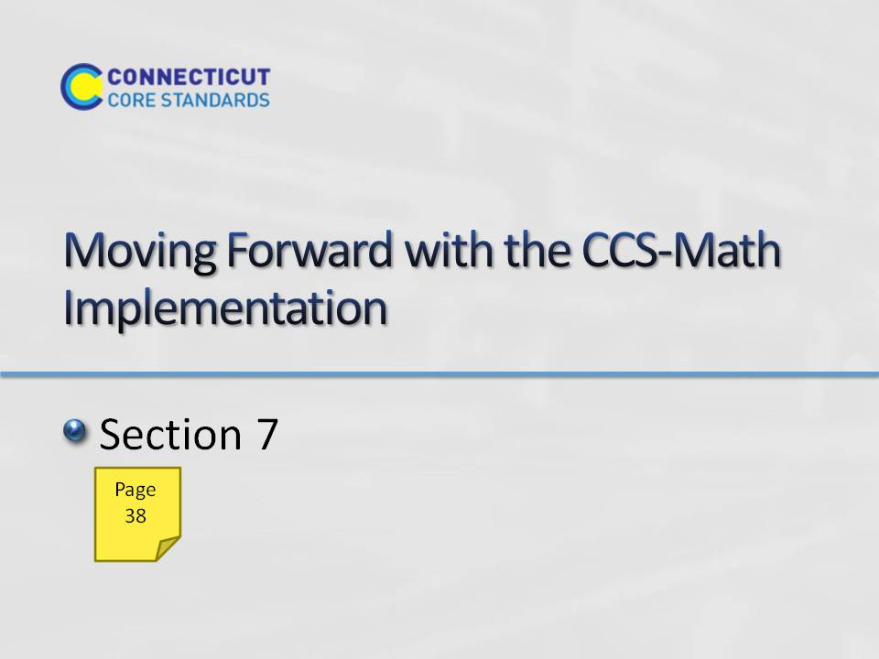Slide 72
Section 7: Moving Forward with the CCS-Math Implementation
Section 7 Time: 20 minutes
Section 7 Training Objectives:
- To provide participants with the opportunity to work collaboratively to identify common coach and teacher needs around implementing and supporting the implementation of the CCS-Math.
Section 7 Outline:
- In this short, but focused section, participants will work collaboratively to discuss and identify coach and teacher needs around implementing and supporting the implementation of the CCS-Math. Groups will work to answer implementation and support questions on the Needs for Supporting the Implementation of the CCS-Math worksheet and will identify three common needs for each stakeholder.
- This section will wrap-up with each group writing their common needs on a sticky note and placing it on a piece of chart paper labeled Teacher Needs and Coach Needs. Time permitting, the facilitator will go over the needs posted and elicit feedback from the larger group.
Supporting Documents
Needs for Supporting the Implementation of the CCS-Math
Section 7 Materials
Chart paper
Markers
Sticky notes
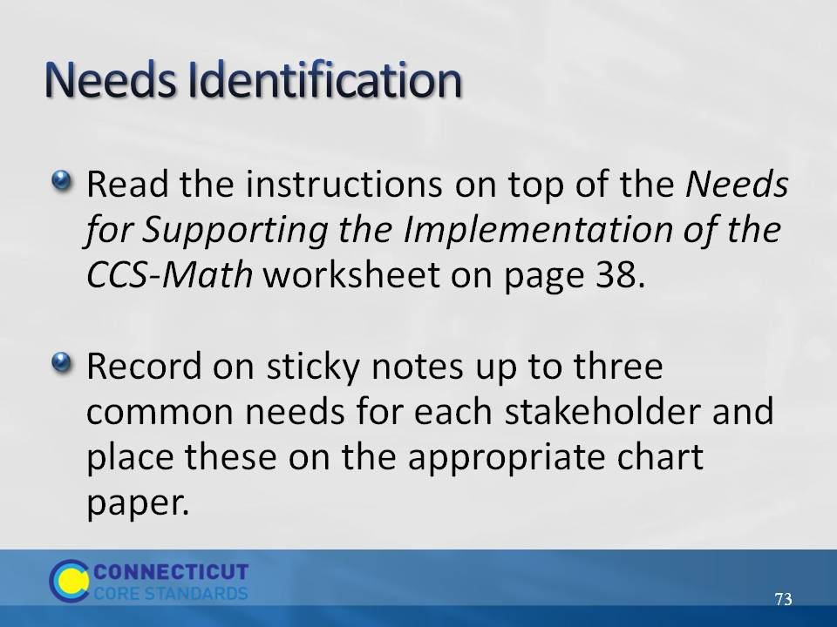Slide 73
Tell participants that they will now work collaboratively to discuss and identify coach and teacher needs around implementing and supporting the implementation of the CCS-Math. Have them turn to page 38 in their Participant Guide and follow along as you provide the instructions.
Have each group write their common needs on a sticky note and place it on the piece of chart paper labeled Teacher Needs or Coach Needs. Time permitting, go over the needs posted and elicit feedback from the larger group.

