Module 3  Facilitator Guide | Focus on Teaching and Learning

Section 6

Connecticut Core Standards for Mathematics

Grades 6–12

Systems of Professional Learning

Connecticut Core Standards Systems of Professional Learning
The material in this guide was developed by Public Consulting Group in collaboration with staff from the Connecticut State Department of Education and the RESC Alliance. The development team would like to specifically thank Ellen Cohn, Charlene Tate Nichols, and Jennifer Webb from the Connecticut State Department of Education; Leslie Abbatiello from ACES; and Robb Geier, Elizabeth O’Toole, and Cheryl Liebling from Public Consulting Group.
The Systems of Professional Learning project includes a series of professional learning experiences for Connecticut Core Standards District Coaches in English Language Arts, Mathematics, Humanities, Science, Technology, Engineering, Mathematics (STEM), and Student/Educator Support Staff (SESS).
Participants will have continued support for the implementation of the new standards through virtual networking opportunities and online resources to support the training of educators throughout the state of Connecticut.
Instrumental in the design and development of the Systems of Professional Learning materials from PCG were: Sharon DeCarlo, Debra Berlin, Jennifer McGregor, Judy Buck, Michelle Wade, Nora Kelley, Diane Stump, and Melissa Pierce.

Published 2014. Available online at http://ctcorestandards.org/
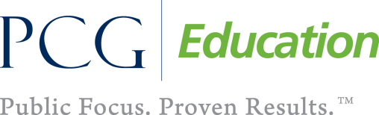 |  | 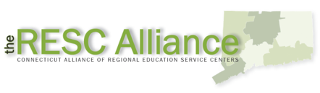

Session at-a-Glance

Section 6: Students’ Role in the Formative Assessment Process (45 minutes)

Training Objectives:
To provide participants with an opportunity to reflect on the role of students in the formative assessment process.
To provide participants with additional opportunities to plan collaboratively around bringing formative assessment practices back to teachers at their school.
Participants will examine two strategies that Wiliam (2011) suggests are key to effective formative assessment: activating students as learning resources for one another and activating students as owners of their own learning. Participants will examine brief descriptions of nine practical techniques for the first strategy, activating students as resources for one another. After reading these techniques individually, participants will discuss in groups the pros/cons of the techniques and which they feel they would like to bring back to their teachers. For the 2nd strategy, activating students as owners of their own learning, participants will share techniques they have used to have students reflect on their own learning.

Supporting Documents:
- Activating Students as Instructional Resources for One Another: Practical Techniques
- Technique Sharing

Materials:
Chart paper, markers

PowerPoint Slides:
66–71

Session Implementation
Section 6
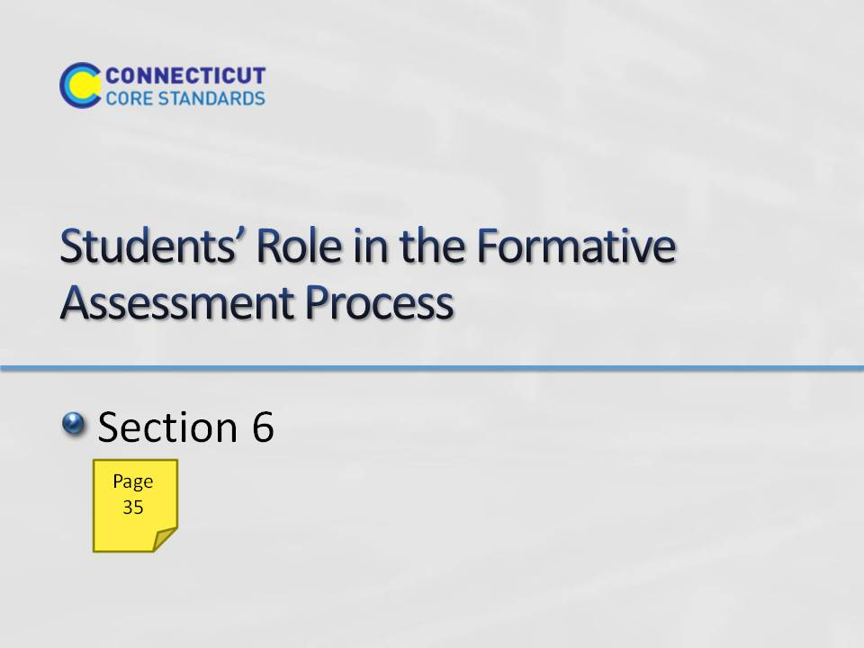Slide 66
Section 6: Students Role in the Formative Assessment Process
Section 6 Time: 45 minutes
Section Training Objectives:
- To provide participants with an opportunity to reflect on the role of students in the formative assessment process.
- To provide participants with additional opportunities to plan collaboratively around bringing formative assessment practices back to teachers at their school.
Section 6 Outline:
- Participants will examine two strategies that Wiliam (2011) suggests are key to effective formative assessment: activating students as learning resources for one another and activating students as owners of their own learning.
- Participants will examine brief descriptions of nine practical techniques for the first strategy, activating students as resources for one another. After reading these techniques individually, participants will discuss in groups the pros/cons of the techniques and which they feel they would like to bring back to their teachers.
- For the 2nd strategy, activating students as owners of their own learning, participants will share techniques they have used to have students reflect on their own learning.
Section 6 Supporting Documents
Activating Students as Instructional Resources for One Another: Practical Techniques
Technique Sharing
Section 6 Materials
Chart paper
Markers
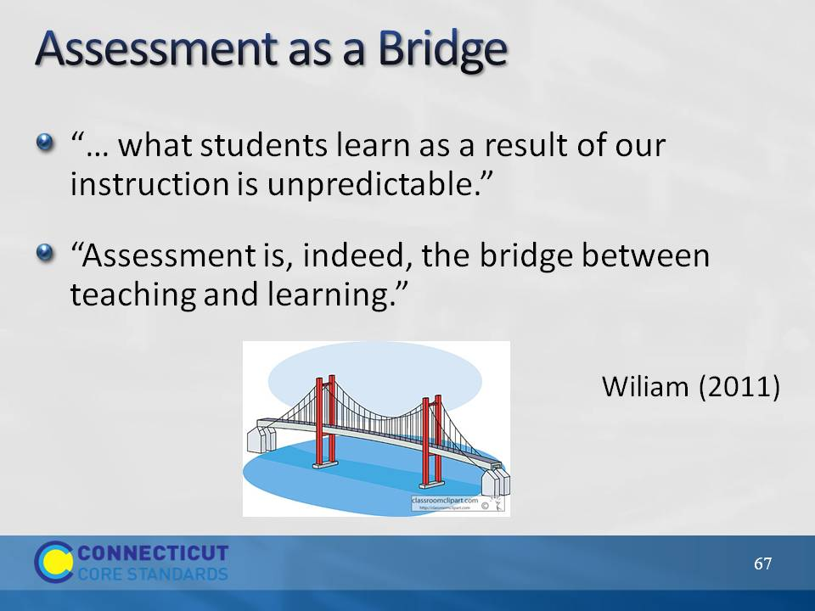Slide 67
Use this slide to connect teaching and learning (the focus of this module) to assessment.
Transition to the focus of this section by saying that the four attributes of formative assessment that we’ve looked at have made clear that formative assessment is a deliberate process used by teachers AND students. In this section we will look closer at the role of students in effective formative assessment and how their role in formative assessment links to the CCS-Math which requires higher levels of thinking for all students.
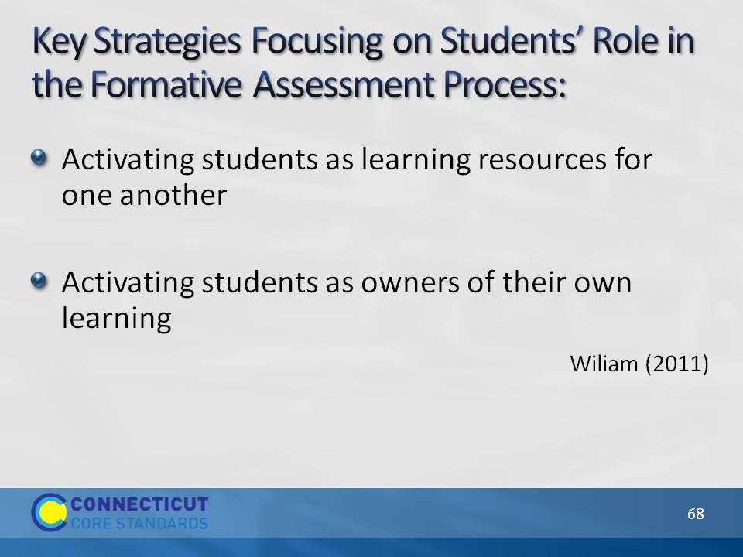Slide 68
We will look at two key strategies that focus on the extent to which students are owners of their own learning (Wiliam, 2011). The next slides describe these two strategies and will give participants an opportunity to think about ways to engage students in the formative assessment process. Mention the connection between these strategies and Connecticut’s “Common Core of Teaching” (http://www.sde.ct.gov/sde/cwp/view.asp?a=2618&q=320862) in which student ownership of learning is clearly an expectation and has ties to teacher evaluation.
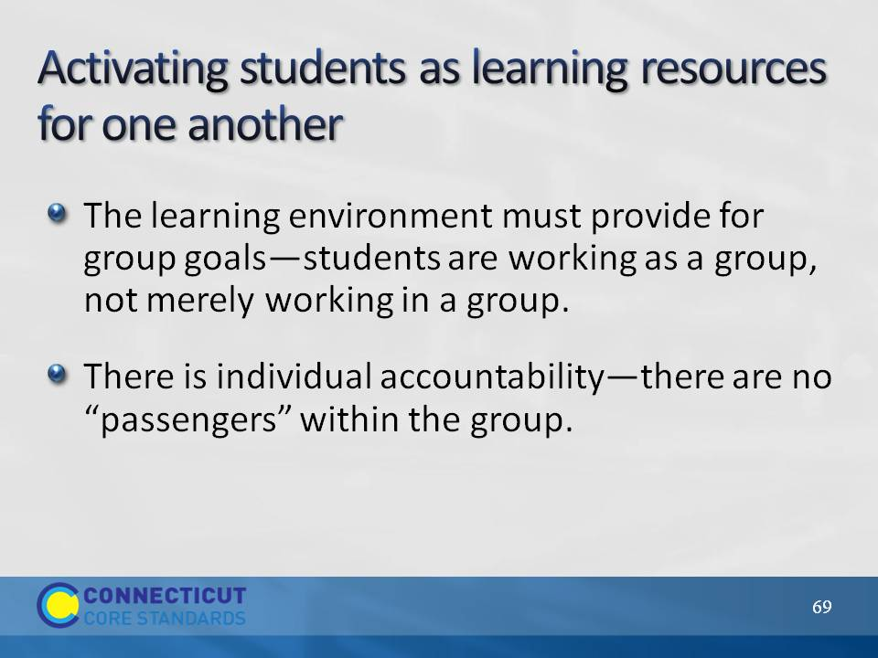Slide 69
Point out to participants that research has shown that this first strategy produces some of the largest gains seen in any educational interventions, provided conditions above are met. (Slavin, Hurley, and Chamberlain (2003) as referenced in Wiliam, 2007).
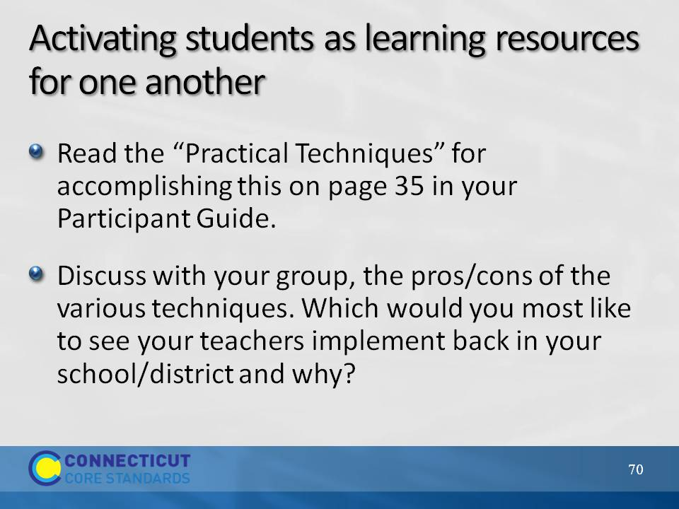Slide 70
Have participants turn in their Participant’s Guide to page 35 and read the “Practical Techniques” for activating students as learning resources for one another. Give them 10 minutes to discuss, in their groups, the pros/cons of the various techniques and share which strategies they would like to bring back to their teachers and why. Space had been provided on page 36 in the Participant Guide for note taking. Note that as long as peer assessment is focused on improvement and not on evaluation, it can be especially powerful—students can be more direct with one another than teachers dare to be. Peer assessment is also beneficial to the individual giving the feedback.
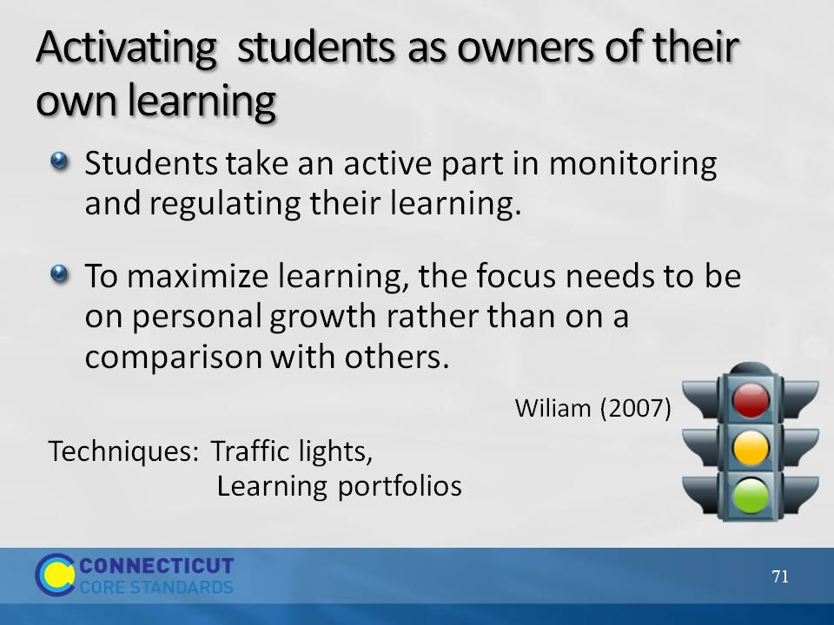Slide 71
The last strategy, activating students as learning resources for one another, can be viewed as a stepping-stone to the strategy given here. Many of the techniques described for the last strategy can be adapted for self-assessment. Two additional practical techniques for having students reflect on their own learning are named on the slide:
- Traffic lights: Students flash green, yellow, or red cards to indicate their level of understanding of a concept.
- Learning portfolio: Keep a record of growth when better work is done, it is added to the portfolio rather than replacing earlier work to allow students to review their learning journeys. Focusing on improvement, the student is more likely to see ability as incremental rather than fixed.
Ask participants if they have other techniques that they have used in order to have students take ownership of their own learning. Take 5–10 minutes to allow participants to share and discuss these techniques. Ask participants to add any techniques that they want to bring back to their school/district to the Technique Sharing worksheet on page 36.

