Module 3  Facilitator Guide | Focus on Teaching and Learning

Section 4

Connecticut Core Standards for Mathematics

Grades 6–12

Systems of Professional Learning

Connecticut Core Standards Systems of Professional Learning
The material in this guide was developed by Public Consulting Group in collaboration with staff from the Connecticut State Department of Education and the RESC Alliance. The development team would like to specifically thank Ellen Cohn, Charlene Tate Nichols, and Jennifer Webb from the Connecticut State Department of Education; Leslie Abbatiello from ACES; and Robb Geier, Elizabeth O’Toole, and Cheryl Liebling from Public Consulting Group.
The Systems of Professional Learning project includes a series of professional learning experiences for Connecticut Core Standards District Coaches in English Language Arts, Mathematics, Humanities, Science, Technology, Engineering, Mathematics (STEM), and Student/Educator Support Staff (SESS).
Participants will have continued support for the implementation of the new standards through virtual networking opportunities and online resources to support the training of educators throughout the state of Connecticut.
Instrumental in the design and development of the Systems of Professional Learning materials from PCG were: Sharon DeCarlo, Debra Berlin, Jennifer McGregor, Judy Buck, Michelle Wade, Nora Kelley, Diane Stump, and Melissa Pierce.

Published 2014. Available online at http://ctcorestandards.org/

Session at-a-Glance

Section 4: Supporting Teachers with UDL (30 minutes)

Training Objectives:
For participants to begin to set goals for their implementation back at their school.
For participants to begin planning next steps around the key ideas of Module 3.
For participants to deepen their peer coaching network.
In this short section, participants are guided through setting one or two goals for an initial introduction of UDL to teachers at their school. For example, a goal might be to have teachers focus on the use of multiple representations.
After setting their goals, teachers will work within their group to back-map the key learning ideas and the steps that need to happen in order to get teachers to the point that the goal is met.
Participants will wrap up the activity by reflecting on and anticipating teacher needs and questions around UDL.

Supporting Documents
- Goal Setting and Next Steps
- Additional Resources and Reflect

Materials
Chart paper, markers

PowerPoint Slides:
37–44

Session Implementation
Section 4
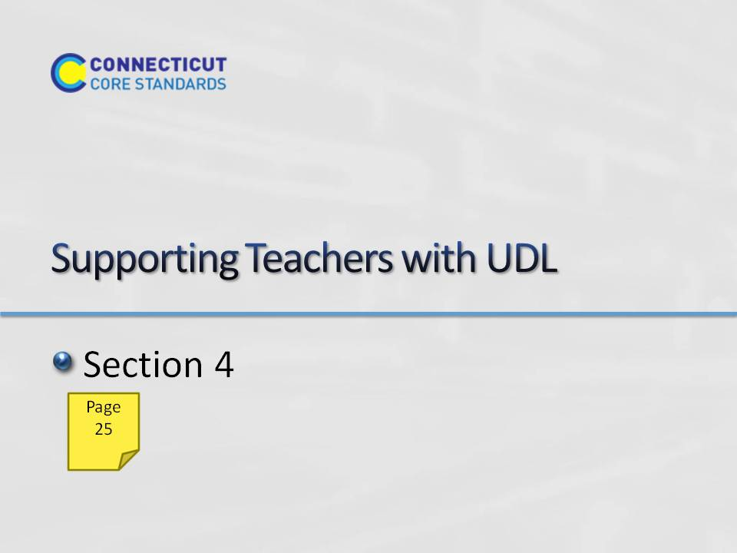Slide 37
Section 4: Supporting Teachers with UDL
Total Time on Section 4: 30 minutes
Section 4 Training Objectives:
- For participants to begin to set goals for their implementation back at their school.
- For participants to begin planning next steps around the key ideas of Module 3.
- For participants to deepen their peer coaching network.
Section 4 Outline:
- Participants are guided through setting one to two goals for an initial introduction of UDL to teachers at their school. For example, a goal might be to have teachers focus on the use of multiple representations. (5 minutes)
- After setting their goals, teachers will work within their group to back-map the key learning ideas and the steps that need to happen in order to get teachers to the point that the goal is met. (20 minutes)
- Participants will wrap up the activity by reflecting on and anticipating teacher needs and questions around UDL. (5 minutes)
Supporting Documents
Goal Setting and Next Steps worksheet
Materials
Chart paper
Markers
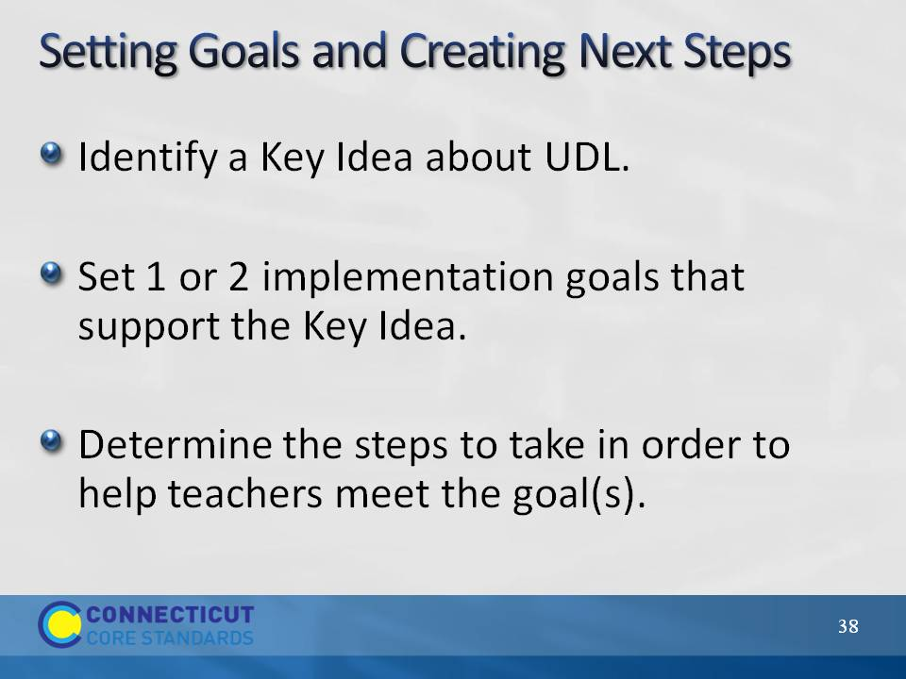Slide 38
Setting Goals and Creating Next Steps
Explain to participants that they will now use their work from Sections 2 and 3 to set goals and create next steps for bringing UDL back to their teachers. Further explain that even if they find themselves at a point in the school year when introducing UDL may not take place immediately, they can still plan for steps they want to take as they begin the 2014–15 school year. Participants will work in groups to identify a key idea about UDL that they want to start their introduction. Participants can reference their work at the end of Section 2. Participants will with set one or two implementation goals that support the key idea and then determine steps they will take in order to help teachers meet the goal(s). Go through the next three slides to provide participants with an example of this process.
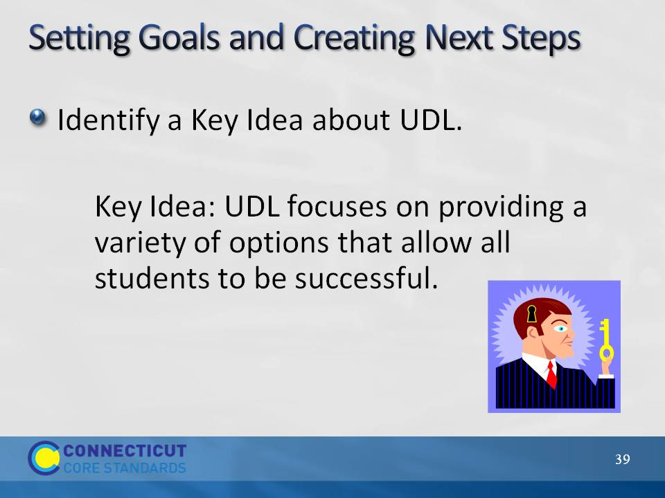Slide 39
Setting Goals and Creating Next Steps
Go over the example of a Key Idea selection.
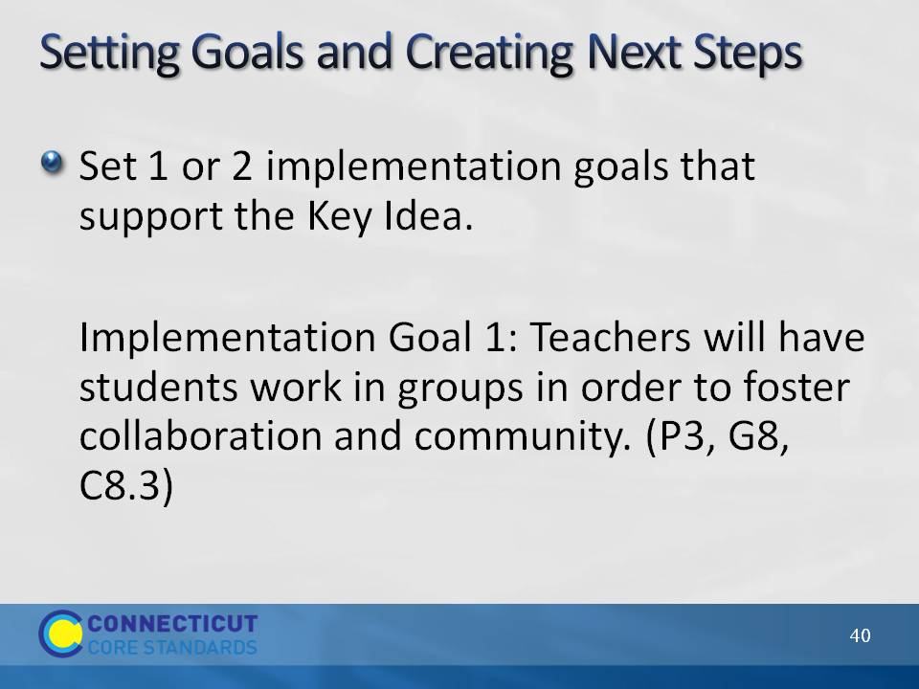Slide 40
Setting Goals and Creating Next Steps
Go over the example of a goal that supports the identified Key Idea. Explain that this goal addresses UDL Principle 3, Guideline 8, and Checkpoint 8.3.
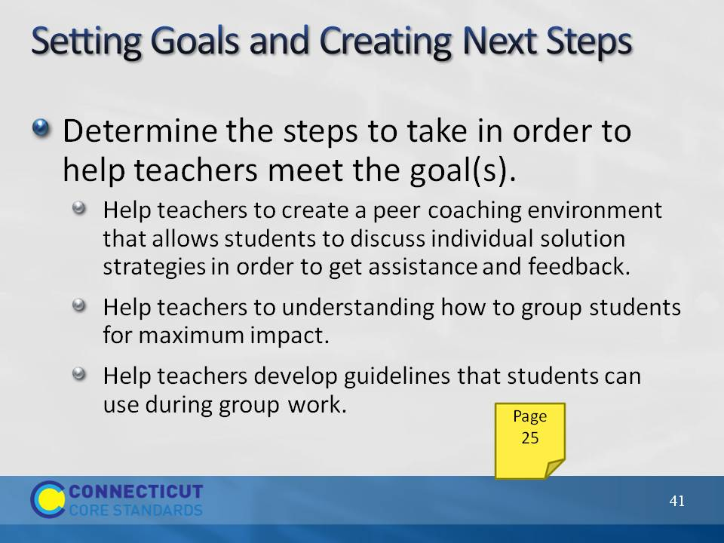Slide 41
Setting Goals and Creating Next Steps
Go over the example of steps to take to meet the set goal. Explain that this is not a comprehensive list, but an example of the types of steps and order in which they will be carrier out that can help teachers to meet the goal.

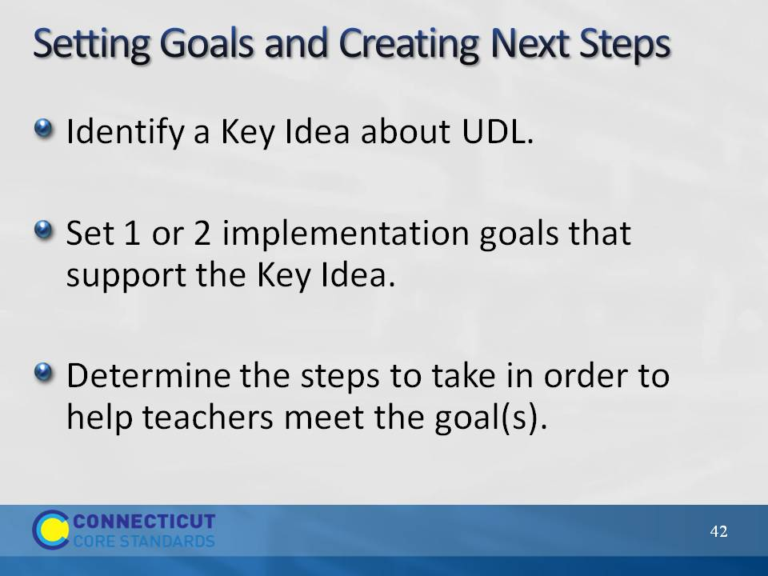Slide 42
Setting Goals and Creating Next Steps
Allow participants 20 minutes to work in their groups. Participants should use the charts on pages 25-26 in the Participant Guide to guide their planning. When time is called allow volunteers to share their plans.
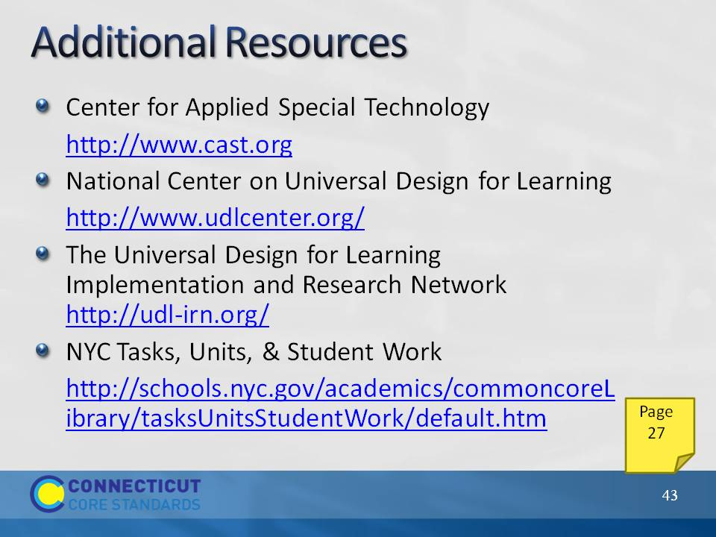Slide 43
Additional Resources
Go over the additional resources on the slides, explaining that each of these provides additional information and examples for implementing UDL at the classroom level. These resources have been provided on page 27 in the Participant Guide.
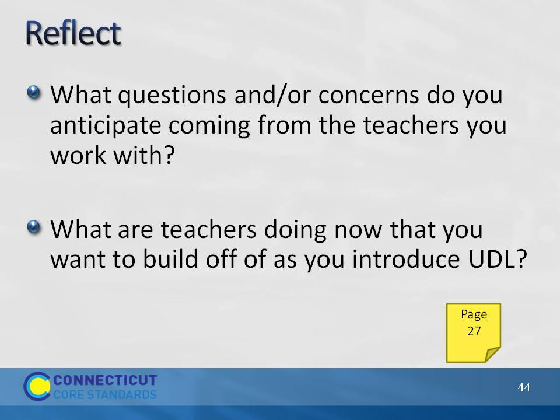Slide 44
Reflect: Wrap up Section 4 by having participants answer the reflection questions on page 27 in the Participant Guide.

