Module 3  Facilitator Guide | Focus on Teaching and Learning

Section 1

Connecticut Core Standards for Mathematics

Grades 6–12

Systems of Professional Learning

Connecticut Core Standards Systems of Professional Learning
The material in this guide was developed by Public Consulting Group in collaboration with staff from the Connecticut State Department of Education and the RESC Alliance. The development team would like to specifically thank Ellen Cohn, Charlene Tate Nichols, and Jennifer Webb from the Connecticut State Department of Education; Leslie Abbatiello from ACES; and Robb Geier, Elizabeth O’Toole, and Cheryl Liebling from Public Consulting Group.
The Systems of Professional Learning project includes a series of professional learning experiences for Connecticut Core Standards District Coaches in English Language Arts, Mathematics, Humanities, Science, Technology, Engineering, Mathematics (STEM), and Student/Educator Support Staff (SESS).
Participants will have continued support for the implementation of the new standards through virtual networking opportunities and online resources to support the training of educators throughout the state of Connecticut.
Instrumental in the design and development of the Systems of Professional Learning materials from PCG were: Sharon DeCarlo, Debra Berlin, Jennifer McGregor, Judy Buck, Michelle Wade, Nora Kelley, Diane Stump, and Melissa Pierce.

Published 2014. Available online at http://ctcorestandards.org/

Session at-a-Glance

Section 1: Sharing Implementation Experiences (30 minutes)
To review the key ideas developed on the Standards for Mathematical Content in Module 2.
To share, discuss, and address experiences with, and common challenges of, supporting teachers in implementing the Standards for Mathematical Practice and Standards for Mathematical Content.
The facilitator will begin by reviewing the key ideas developed on the Standards for Mathematical Content in Module 2. Then, in groups, participants will share experiences and describe any “aha moments” from their continued implementation of the Standards for Mathematical Practice and with assisting teachers with strategies for teaching the Standards for Mathematical Content. Participants will look for themes or choose one or two important successes, challenges, and/or insights to share with the larger group. These will be recorded on chart paper so that common themes and additional strategies can be discussed as a large group. Participants can record new ideas on the Moving Forward with the Content Standards and New Ideas for Implementing the CCS-Math Content Standards templates in their Participant Guide. The facilitator will wrap up Section 1 by explaining that to build upon their knowledge and experience with the CCS-Math thus far, participants will begin to connect instructional strategies discussed in Modules 1 and 2 to a more focused teaching and learning framework derived from considerations within Universal Design for Learning, and begin to discuss connections between teaching, learning, and formative assessments.

Supporting Documents:
Moving Forward with the Content Standards
New Ideas for Implementing the CCS-Math Content Standards

Materials:
Chart paper, markers

PowerPoint Slides:
6–19

Session Implementation
Section 1
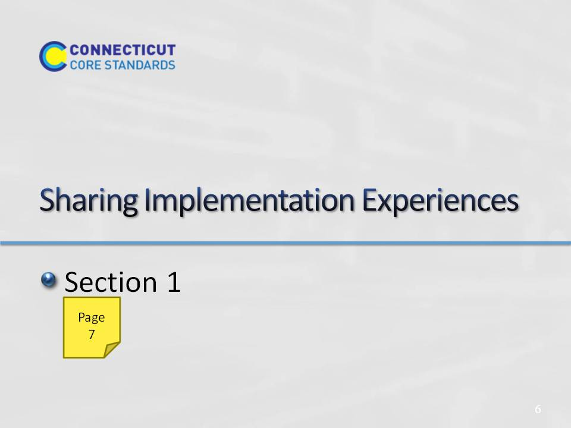Slide 6
Section 1: Sharing Implementation Experiences
Section 1 Time: 30 Minutes
Section 1 Training Objectives:
To review the key ideas developed in the Standards for Mathematical Content in Module 2.
To share, discuss, and address experiences with, and common challenges of, supporting teachers in implementing the Standards for Mathematical Practice and Standards for Mathematical Content.
Section 1 Outline:
- The facilitator will begin by reviewing the key ideas developed on the Standards for Mathematical Content in Module 2.
- In groups, participants will share experiences and describe any “aha moments” from their continued implementation of the Standards for Mathematical Practice (SMP) and with assisting teachers with strategies for teaching the Standards for Mathematical Content. Participants will look for themes or choose one or two important successes, challenges, and/or insights to share with the larger group. These will be recorded on chart paper so that common themes and additional strategies can be discussed as a large group. Participants can record new ideas on the handout Moving Forward with the Content Standards.
- The facilitator will wrap up Section 1 by explaining that to build upon their knowledge and experience with the CCS-Math thus far, participants will begin to connect instructional strategies discussed in Modules 1 and 2 to a more focused teaching and learning framework derived from considerations within Universal Design for Learning, and begin to discuss connections between teaching, learning, and formative assessments.
Supporting Documents
Moving Forward with the Content Standards
Materials
Chart paper
Markers
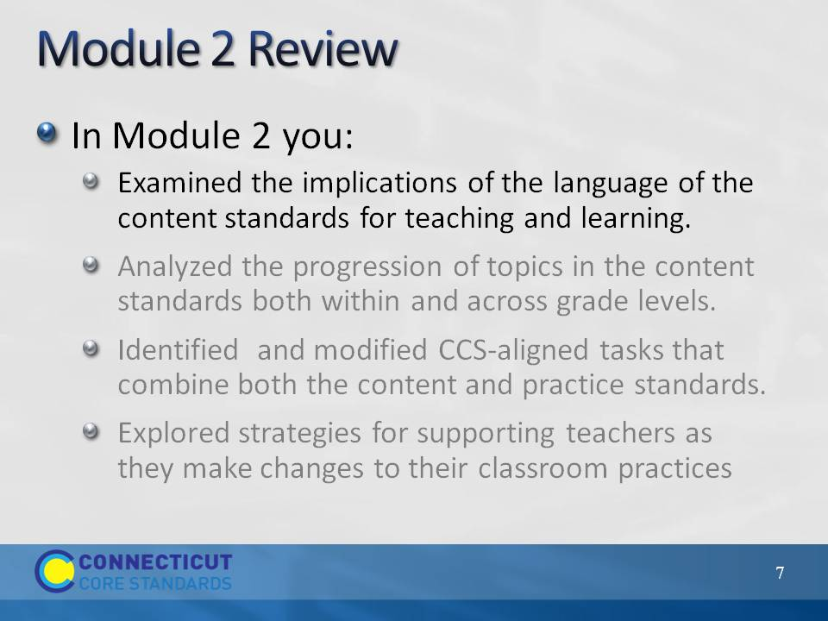Slide 7
Review the four objectives of Module 2 with participants. As you quickly go through slides 7–18 you will support each bullet one-by-one with key slides from the Module 2 PowerPoint. Begin here with the first bulleted objective.
- Examined the implications of the language of the content standards for teaching and learning. Remind participants that they discussed the differences of and connections between conceptual understanding, procedural skill and fluency, and application of mathematics. Use slides 8–10 to support this objective.
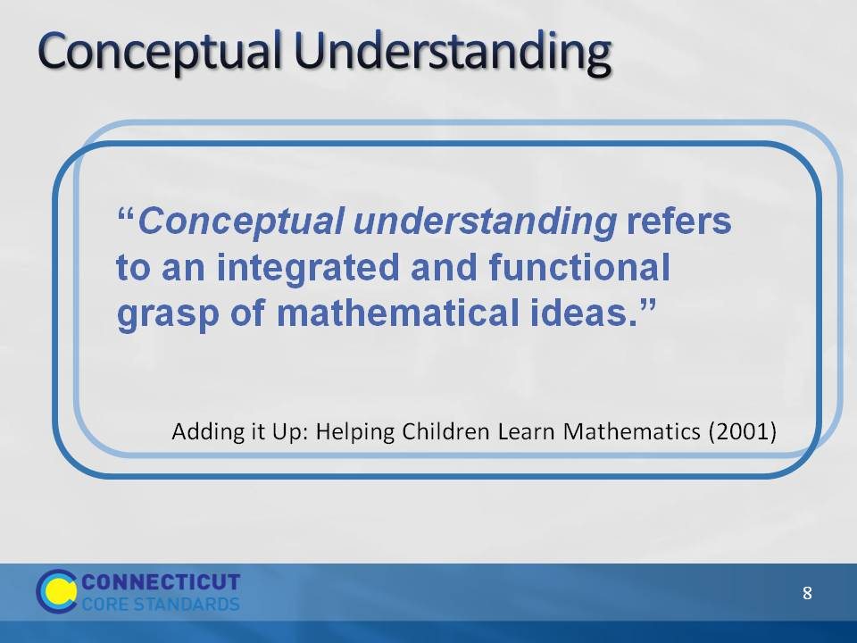Slide 8
Conceptual Understanding
Review the quote on the slide, as well as the quote provided to participants in their Module 2 Participant Guide.
“Students demonstrate conceptual understanding in mathematics when they provide evidence that they can recognize, label, and generate examples of concepts; use and interrelate models, diagrams, manipulatives, and varied representations of concepts; identify and apply principles; know and apply facts and definitions; compare, contrast, and integrate related concepts and principles; recognize, interpret, and apply the signs, symbols, and terms used to represent concepts. Conceptual understanding reflects a student’s ability to reason in settings involving the careful application of concept of definitions, relations, or representations of either.” (Balka, Hull, & Harbin Miles, n.d.)
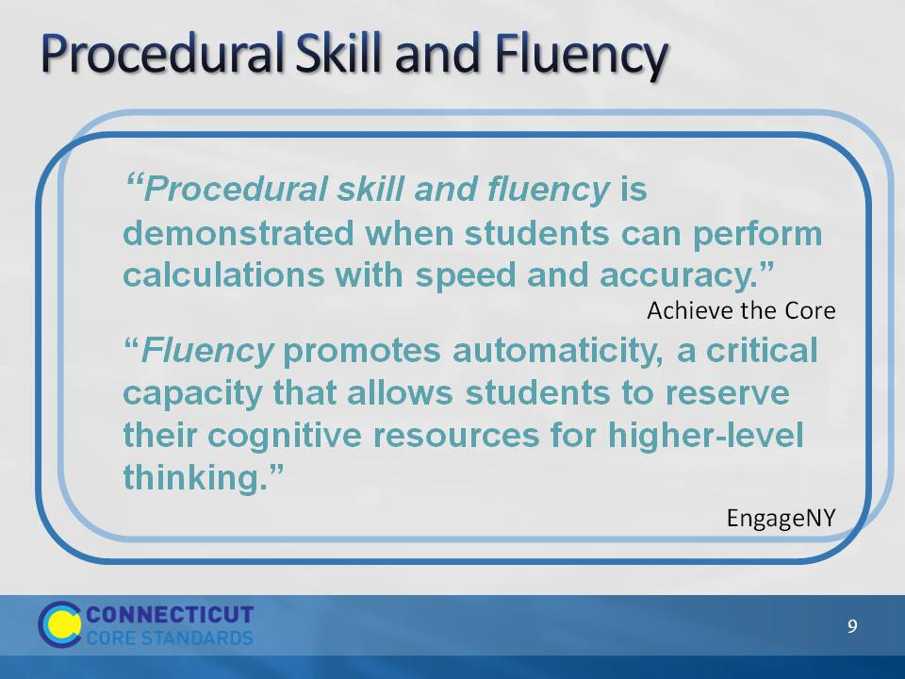Slide 9
Procedural Skill and Fluency
Review the quotes on the slide.
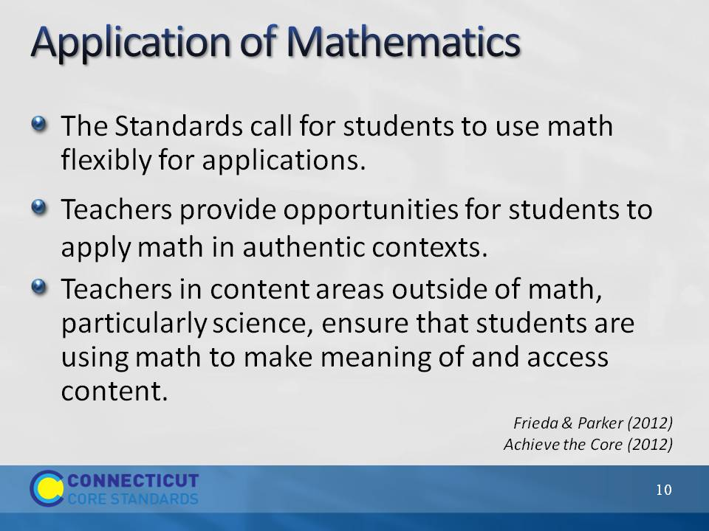Slide 10
Application of Mathematics
Go through points on the slide. Ask participants how they have had students apply mathematics. Get two or three examples. Ask participants why this is important.
Application of mathematics is important because without this step or expectation students are learning math as a set of rules, procedures, etc. that have no real meaning in the world outside of the classroom. Students need to learn how math works and how it is used. Note here that when the conversation of application of mathematics typically comes up the phrase “real-world problems” is usually somewhere in the conversation. As teachers think about the types of problems that students will solve in order to apply their mathematical understanding, have them think about problems that would be “real world” to their students. This means that the problems should be contextually relevant and easily understood by the students at their particular grade level. Also note that, just as we saw with the fluency standard, not all standards focus on application. But, when the standard does point to solving problems through an application of mathematics, we really want to see how students can flexibly use what they know and understand. Finally, ask participants to briefly discuss how they can engage students in authentic problem-solving scenarios.
Before moving to the next slide that has examples of contextually relevant problems, focus participants on the third bullet on the slide and ask for one or two volunteers to give examples of how the CCS-Math standards can be supported and connected to the standards from other content areas in order for students to see and apply mathematics outside of their typical math lesson time.
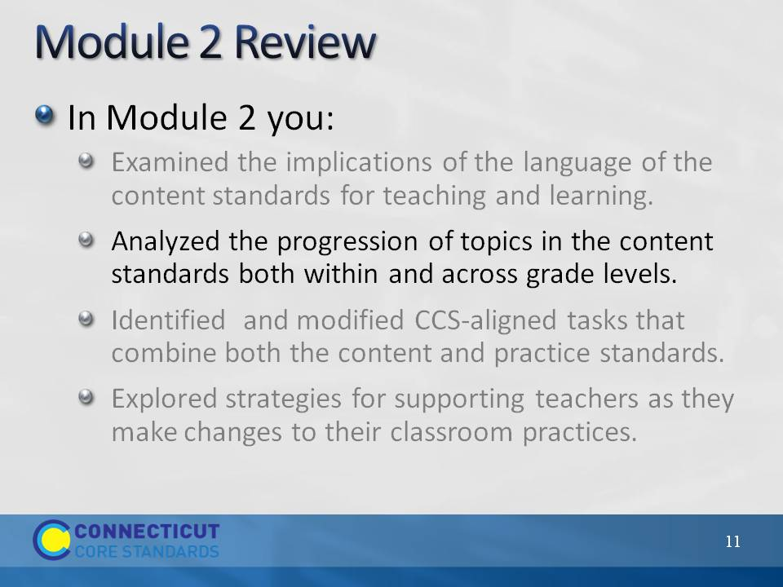Slide 11
Review the second bulleted objective: Analyzed the progression of topics in the content standards both within and across grade levels. Remind participants that they completed the card sorting activity in order to see the vertical and horizontal connections between and within standards and domains. Use slides 12 and 13 to refocus participants on the overall distribution and progressions of the content standards.
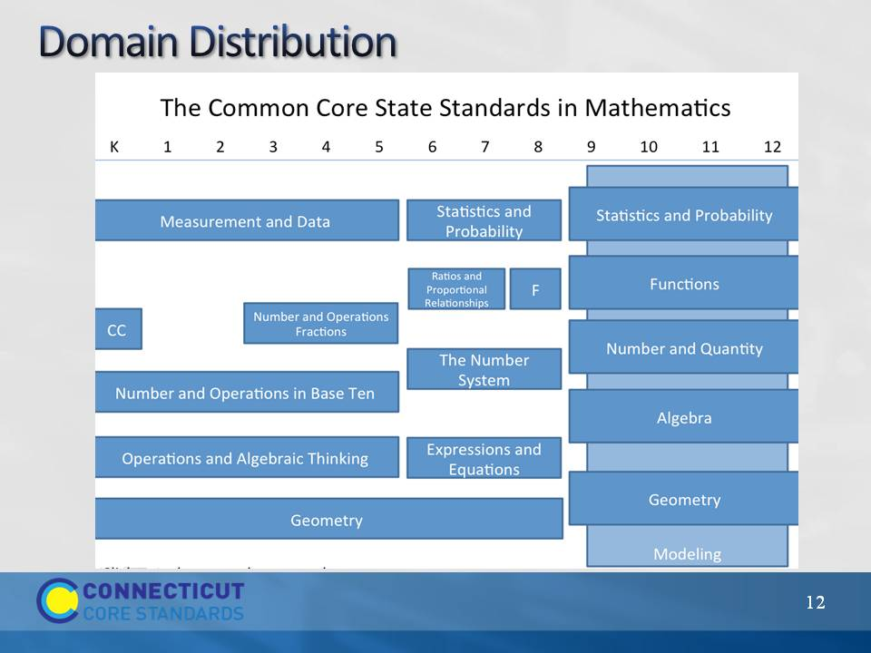Slide 12
Domain Distribution
Remind participants that when students are developmentally ready and have a solid foundation in Number and Operations in Base Ten, Number and Operations – Fractions is layered on beginning in third grade. In high school, there are five “conceptual categories.” In the background of these is the Modeling conceptual category, modeling standards appear throughout the high school standards and are indicated by a star symbol (★). Each conceptual category is broken up into 4–6 domains.
Transition to the next slide by reminding participants that the domains and conceptual categories were determined based on a very specific and coherent roadmap for learning called a progression.
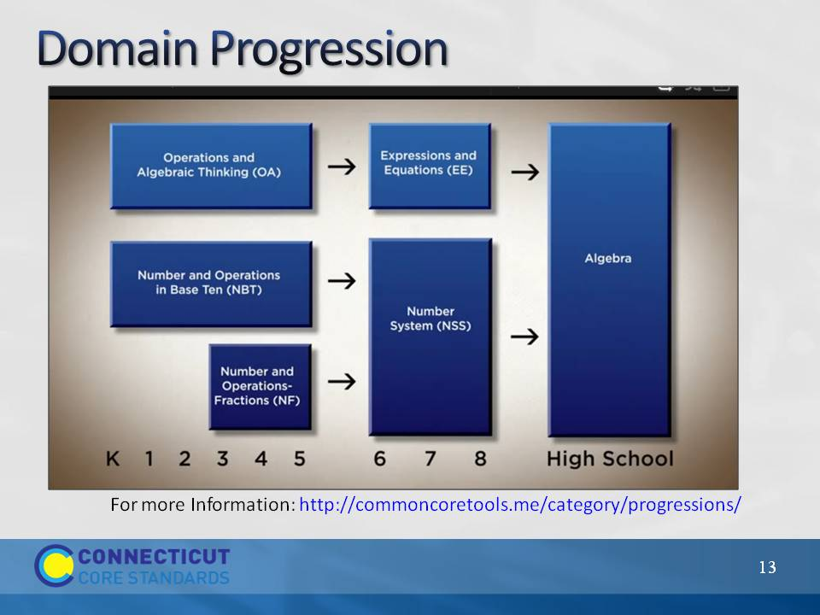Slide 13
Domain Progression
Remind participants that the domains were written so concepts build on each other grade after grade so that, in this particular progression, there is a clear pathway to high school Algebra.
More information about specific domain progressions can be found at the Common Core Tools Website: http://commoncoretools.me/category/progressions/. Have participants make a note of this resource.
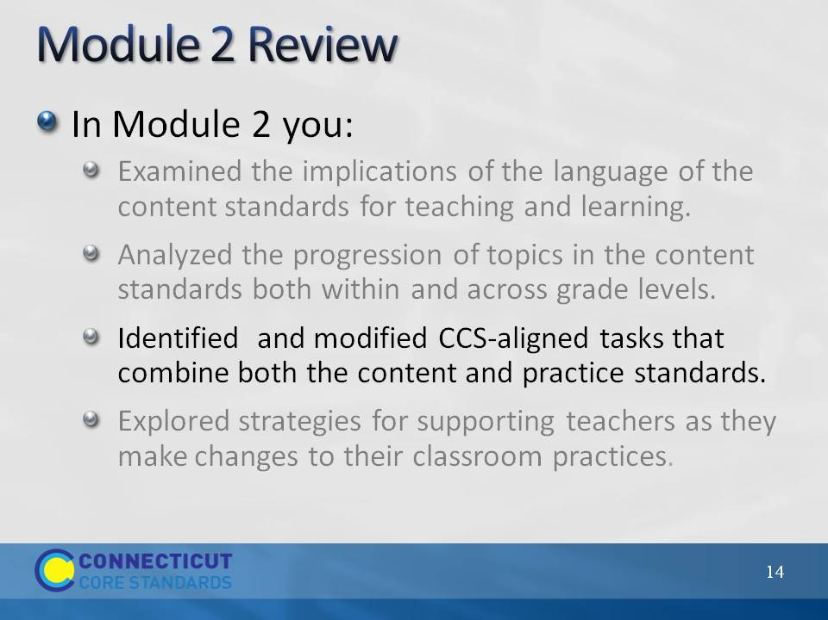Slide 14
Review the third bulleted objective: Identified and modified CCS-aligned tasks that combine both the content and practice standards. Use slides 15 and 16 to refocus participants on the big question that was examined, How can I help teachers incorporate cognitively rigorous mathematics tasks that will benefit ALL students?
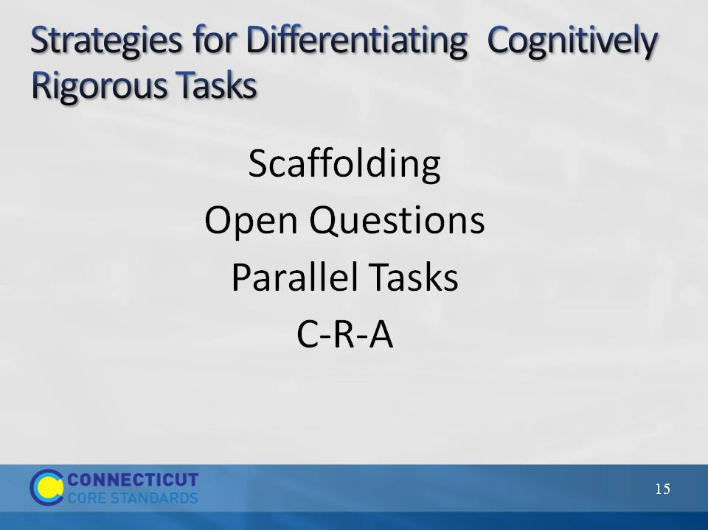Slide 15
Strategies for Differentiating Cognitively Rigorous Tasks
In Module 2, participants discussed the four strategies listed on the slide. Remind participants that one of the key things to keep in mind when differentiating mathematics tasks is that teachers will want to be sure to make modifications or offer choices in tasks that allow students the needed point for entry into the mathematics, but at the same time keeping the level of rigor high. Often mathematics is differentiated by providing “easier” tasks to students who may not yet be ready for the main task. These “easier” tasks sometimes lower the level of rigor to the point that the students’ engaged in that task are never given the opportunity to engage in deeper reasoning about the mathematics. Whenever possible, teachers should maintain the level of rigor, but make modifications in such a way that a solution is still within the students’ reach.
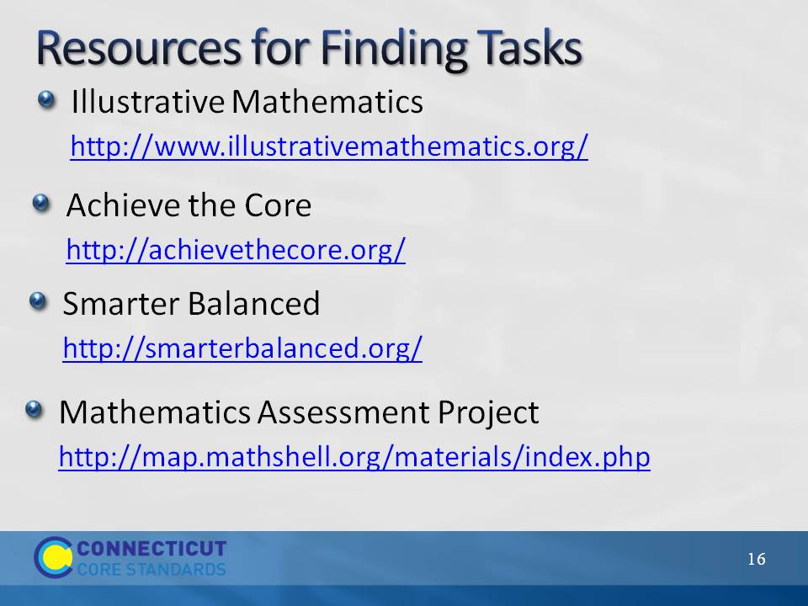Slide 16
Resources for Finding Tasks
Remind participants of some of the resources available for finding cognitively rigorous tasks. Ask participants which they have used and which they have recommended to teachers. Be sure to chart any additional recommendations so that participants can add them to their own list.
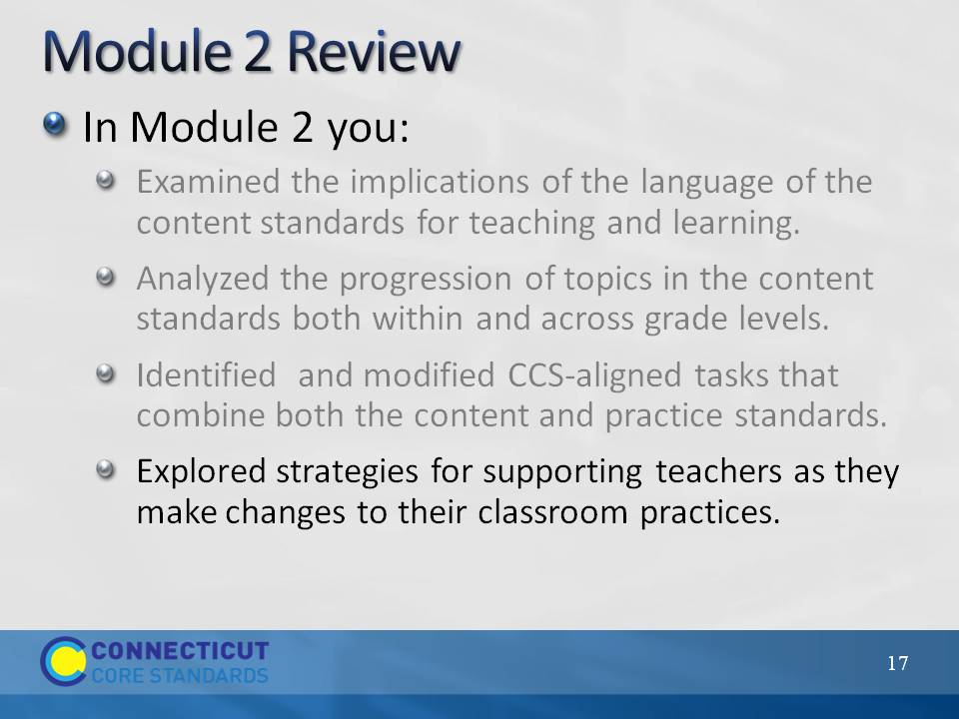Slide 17
Wrap up the review by focusing on the fourth bulleted objective: Explored strategies for supporting teachers as they make changes to their classroom practice. Use slide 18 to briefly discuss the strategies presented at the end of Module 2.
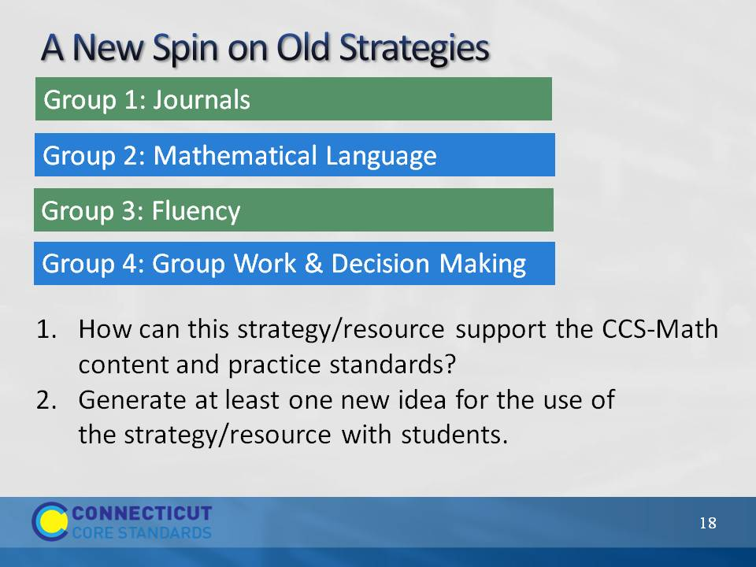Slide 18
A New Spin on Old Strategies
As you remind participants of the strategies that were reviewed at the end of Module 2, ask participants if they have had the opportunity to discuss these with teachers, and if so, which were discussed and how the strategies were received. Transition this short discussion into a discussion of participants overall CCS-Math implementation that begins on the next slide.
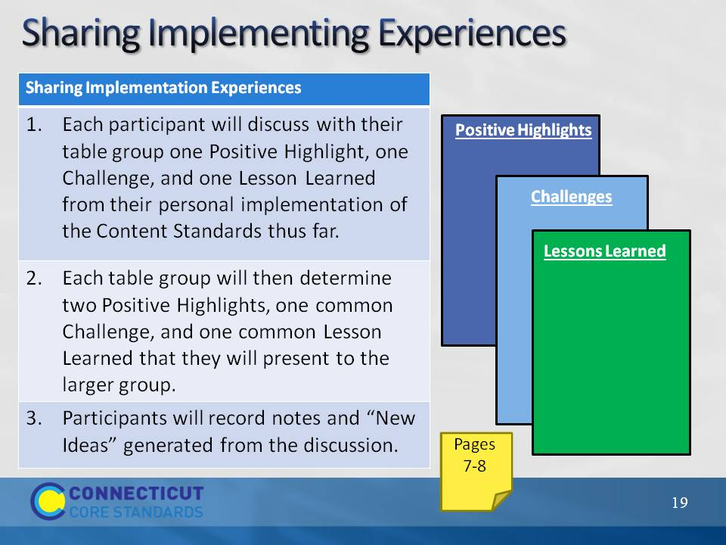Slide 19
Now that you have quickly reviewed the key points from Module 2, ask participants to now reflect on the work that they have done back at their school, in their role as a Core Standards Coach, with helping teachers learn more about and implement the CCS-Math. Have each participant discuss with their table group one positive highlight, one challenge, and one lesson learned from their personal implementation of the Practice Standards thus far. Each table group will then determine two positive highlights, one common challenge, and one common lesson learned that they will present to the larger group. They can record notes from their discussion on page 7 in the Participant Guide.
As table groups present, record the participants’ responses on the chart paper titled Positive Highlights, Challenges, and Lessons Learned. After all groups have presented, summarize what has been charted and then ask the large group if anyone has a solution to any of the common challenges. Encourage participants to record “New Ideas” on page 8 in the Participant Guide.
Wrap up the activity by explaining that the challenges will be revisited periodically throughout the day.
Transition to the next activity by explaining that participants will now begin to focus more deeply on the classroom practices that support teaching and learning with the CCS-Math.
Note: If teachers have not had the time between the previous module and this module to begin their implementation, have them instead focus on things that they have seen and heard back at their school, including positive highlights of where their school is, challenges that they now recognize they may be facing, and any lesson learned in terms of the outcomes of the first module and where they think they need to go next with the implementation.

