Module 3  Facilitator Guide | Supporting All Students in Writing and Research

Activity 9

Connecticut Core Standards for English Language Arts and Literacy

Grades K–5

Systems of Professional Learning

Connecticut Core Standards Systems of Professional Learning
The material in this guide was developed by Public Consulting Group in collaboration with staff from the Connecticut State Department of Education and the RESC Alliance. The development team would like to specifically thank Ellen Cohn, Charlene Tate Nichols, and Jennifer Webb from the Connecticut State Department of Education; Leslie Abbatiello from ACES; and Robb Geier, Elizabeth O’Toole, and Cheryl Liebling from Public Consulting Group.
The Systems of Professional Learning project includes a series of professional learning experiences for Connecticut Core Standards District Coaches in English Language Arts, Mathematics, Humanities, Science, Technology, Engineering, Mathematics (STEM), and Student/Educator Support Staff (SESS).
Participants will have continued support for the implementation of the new standards through virtual networking opportunities and online resources to support the training of educators throughout the state of Connecticut.
Instrumental in the design and development of the Systems of Professional Learning materials from PCG were: Sharon DeCarlo, Debra Berlin, Jennifer McGregor, Judy Buck, Michelle Wade, Nora Kelley, Diane Stump, and Melissa Pierce.
Published 2014. Available online at http://ctcorestandards.org/

Session at-a-Glance

Part 6: Routine and Daily Writing (35 minutes)
Coaches will read closely CCRA W.10, “Write routinely over extended time frames (time for research, reflection, and revision) and shorter time frames (a single sitting or a day or two) for a range of discipline-specific tasks, purposes, and audiences.” They will interpret this standard and discuss why it does not begin until grade 3.
In Activity 6, coaches will review several exemplar units and lessons for embedded writing tasks. They will record and sort these as to where they occur in the units and lessons. They will discuss various ways they see routine writing being incorporated in the units, and how those writing tasks might serve as formative assessment. They will extend this discussion to include routine writing being done in their school or district.

Activity 9: Reviewing Exemplar Units and Lessons (30 minutes)
In Activity 9, coaches will review several exemplar units and lessons for embedded writing tasks. They will discuss various ways they see routine writing being incorporated in the units and extend the discussion to ways they or their school colleagues embed writing in their lessons. They will copy or describe writing tasks on sticky notes. After completing the exercise, they will post the sticky notes in a spot designated as OPENING, WORK TIME, or CLOSING of the lesson.

Supporting Documents:
Participants will be asked to access electronically during the session, or download and print one or more exemplar units before Module 3 begins.
- Kindergarten: America the Beautiful http://www.readwritethink.org/classroom-resources/lesson-plans/america-beautiful-using-music-1147.html?tab=4#tabs
- Grade 1: Creative Problem Solving with Ezra Jack Keats http://www.readwritethink.org/classroom-resources/lesson-plans/creative-problem-solving-with-1023.html
- Grade 2: Author Study, Tomie DePaola http://www.doe.mass.edu/candi/model/files.html
- Grade 3: Engage NY Grade 3, M.1, U.1 Becoming a Close Reader and Writing to Learn – The Power of Reading Around the World http://www.engageny.org/resource/grade-3-ela-module-1-unit-1
- Grade 4: Using Literary Elements to Determine Theme http://www.doe.mass.edu/candi/model/files.html
- Grade 5: Considering Perspectives and Supporting Opinions – Sports and Athletes’ Impact on Culture http://www.engageny.org/sites/default/files/resource/attachments/5m3a.1.pdf

PowerPoint Slides:
- 75-81

Session Implementation
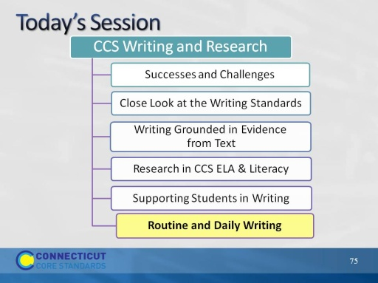Slide 75
This part of the module will examine W.9.
Part 6
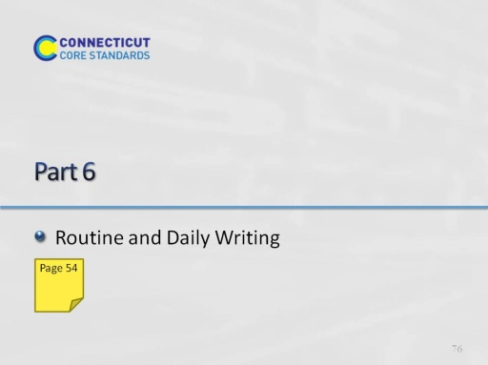Slide 76
Blank
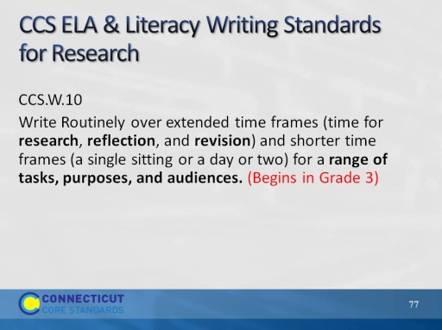Slide 77
The purpose of this slide is to set a CCS context for regular writing practice.
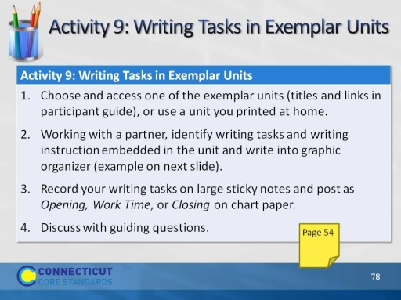Slide 78
Allow 15 minutes for looking at units and doing graphic organizer. Allow another 5 minutes for posting on charts and sharing out by volunteer. 5 minutes for table discussion and 5 minutes to share out with whole group.
Facilitator, be sure to post on one wall 3 chart papers, labeled, “Opening,” “Work Time,” and “Closing.”
The purpose of this activity is for participants to recognize the variety of ways in which routine writing and more formal writing is embedded in CCS-ELA & Literacy-aligned units, and discuss how daily writing supports learning and builds literacy skills, and how it scaffolds students to successfully meet the standards.
(If units printed for ELA Module 2 are available, they may be substituted for this activity. Please ask participants to take notes on the organizer in their participant guides, not on the printed units.)
Links to the units will be provided in the session materials on the CT core standards website:
- Kindergarten: America the Beautiful http://www.readwritethink.org/classroom-resources/lesson-plans/america-beautiful-using-music-1147.html?tab=4#tabs
- Grade 1: Creative Problem Solving with Ezra Jack Keats http://www.readwritethink.org/classroom-resources/lesson-plans/creative-problem-solving-with-1023.html
- Grade 2: Author Study, Tomie DePaola http://www.doe.mass.edu/candi/model/files.html
- Grade 3: Engage NY Grade 3, M.1, U.1 Seeking the Power of Education and Reading http://www.engageny.org/resource/grade-3-ela-module-1-unit-1
- Grade 4: Using Literary Elements to Determine Theme http://www.doe.mass.edu/candi/model/files.html
- http://www.doe.mass.edu/candi/model/files.html
- Grade 5: Considering Perspectives and Supporting Opinions – Sports and Athletes’ Impact on Culture http://www.engageny.org/sites/default/files/resource/attachments/5m3a.1.pdf
- They will record their tasks on a graphic organizer and on individual sticky notes. They may want to have one partner write on the organizer and one do the sticky notes. Go to next slide for example.
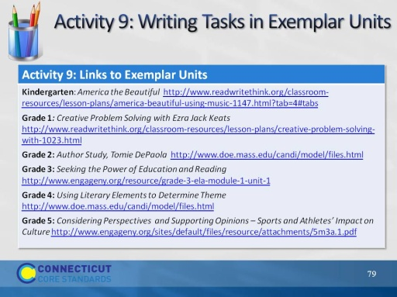Slide 79
Facilitator, you do not have to do anything with this slide. Its purpose is to allow participants who are following along with the PPT on their computers to copy and paste a link into their browser or to link directly from the PPT.
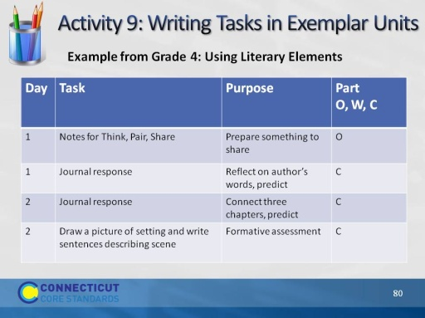Slide 80
Let participants know that some of the units are far more complex than others and may have more writing tasks. A way to save time is, if there is a repeated writing task, e.g., journal writing, they can write it once and indicate that it is repeated. Explain to participants that at the earliest grades, much of the writing may be shared writing, and that’s OK to record.
The intent is not to get through the unit, but rather to see the variety of ways in which W.10 is reflected in CCS-aligned units.
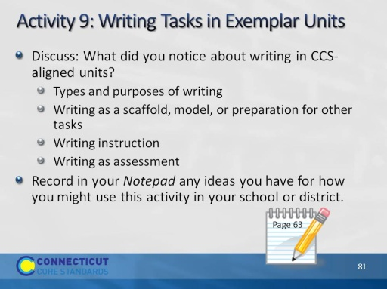Slide 81
Allow 5 minutes for this discussion and another 5 for sharing out.
Explain that this is intended to be an open discussion and these are just suggestions for where the conversation might go.

