Module 3  Facilitator Guide | Supporting All Students in Writing and Research

Activity 8b

Connecticut Core Standards for English Language Arts and Literacy

Grades K–5

Systems of Professional Learning

Connecticut Core Standards Systems of Professional Learning
The material in this guide was developed by Public Consulting Group in collaboration with staff from the Connecticut State Department of Education and the RESC Alliance. The development team would like to specifically thank Ellen Cohn, Charlene Tate Nichols, and Jennifer Webb from the Connecticut State Department of Education; Leslie Abbatiello from ACES; and Robb Geier, Elizabeth O’Toole, and Cheryl Liebling from Public Consulting Group.
The Systems of Professional Learning project includes a series of professional learning experiences for Connecticut Core Standards District Coaches in English Language Arts, Mathematics, Humanities, Science, Technology, Engineering, Mathematics (STEM), and Student/Educator Support Staff (SESS).
Participants will have continued support for the implementation of the new standards through virtual networking opportunities and online resources to support the training of educators throughout the state of Connecticut.
Instrumental in the design and development of the Systems of Professional Learning materials from PCG were: Sharon DeCarlo, Debra Berlin, Jennifer McGregor, Judy Buck, Michelle Wade, Nora Kelley, Diane Stump, and Melissa Pierce.
Published 2014. Available online at http://ctcorestandards.org/

Session at-a-Glance

Activity 8b: Scaffolding a Writing Task (25 minutes)
Coaches will practice writing a focusing question and structuring a scaffolded writing task for the text they have been working with in Modules 2 and 3.

Supporting Documents:
- Template for Structuring a Writing Task (separate handout)

PowerPoint Slides:
- 72-74

Session Implementation
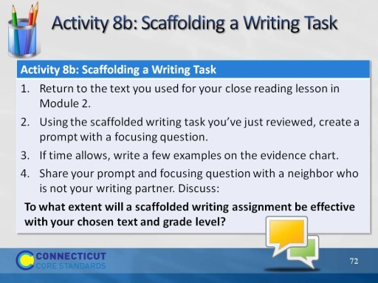Slide 72
For this activity, explain that participants will be using the story or text for which they wrote a series of text-dependent questions in Module 2. If both partners are attending this session today, it would be good for them to work together on 8a and 8b.

If a participant did not attend Module 2, or does not have a text, he or she may work with a text from the box of books at the location, or with an Appendix B exemplar. However, he or she will need to choose quickly after 8a in order to have enough time to complete 8b.

Allow 20 minutes for 8b: 15 to create a prompt and 5 to debrief.
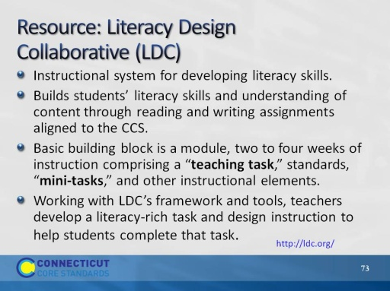Slide 73
The purpose of this slide is to briefly introduce a powerful resource. LDC is a national community of educators providing a teacher-designed and research-proven framework, online tools, and resources for creating literacy-rich assignments and courses across content areas. They have developed an entire system of templates to create instruction leading to literacy performance tasks in every discipline. These templates and tasks have recently been extended to lower grades.
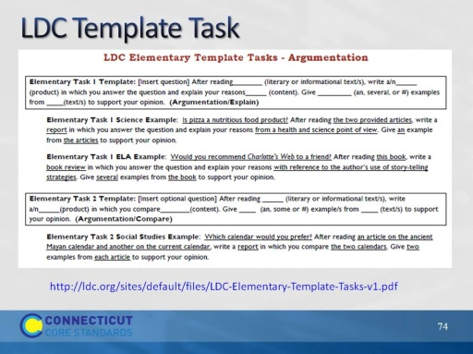Slide 74
Facilitator, read a few examples to show the versatility of these templates. Encourage participants to explore this website if they have not done so. There are examples of full units of study leading to these types of performance tasks.

