Module 3  Facilitator Guide | Supporting All Students in Writing and Research

Activity 8a

Connecticut Core Standards for English Language Arts and Literacy

Grades K–5

Systems of Professional Learning

Connecticut Core Standards Systems of Professional Learning
The material in this guide was developed by Public Consulting Group in collaboration with staff from the Connecticut State Department of Education and the RESC Alliance. The development team would like to specifically thank Ellen Cohn, Charlene Tate Nichols, and Jennifer Webb from the Connecticut State Department of Education; Leslie Abbatiello from ACES; and Robb Geier, Elizabeth O’Toole, and Cheryl Liebling from Public Consulting Group.
The Systems of Professional Learning project includes a series of professional learning experiences for Connecticut Core Standards District Coaches in English Language Arts, Mathematics, Humanities, Science, Technology, Engineering, Mathematics (STEM), and Student/Educator Support Staff (SESS).
Participants will have continued support for the implementation of the new standards through virtual networking opportunities and online resources to support the training of educators throughout the state of Connecticut.
Instrumental in the design and development of the Systems of Professional Learning materials from PCG were: Sharon DeCarlo, Debra Berlin, Jennifer McGregor, Judy Buck, Michelle Wade, Nora Kelley, Diane Stump, and Melissa Pierce.
Published 2014. Available online at http://ctcorestandards.org/

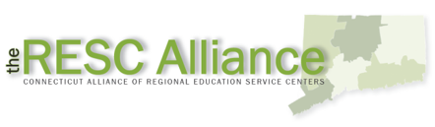

Session at-a-Glance

Activity 8a: Examining a Framework (20 minutes)
Coaches learn more about the Basal Alignment Project and are introduced to a framework for scaffolding writing to sources. They read through the framework to become familiar with the steps and they number each of the steps. Then they review an example of a scaffolded writing task written with the framework. They number the steps in the example task with the steps they identified in the framework.

Supporting Documents:
- Achieve the Core. Student Achievement Partners. Writing to Sources: Guided Instruction. Retrieved from http://www.solution-tree.com/media/pdf/WriteLikeReportersK_5FREYCFF335.pdf
- “Writing Task for Lesson on ‘Lou Gehrig’” and “Writing Task for Lesson on ‘San Juan.’” Retrieved from http://achievethecore.org/page/209/knowing-thinking-and-writing-detail-pg

PowerPoint Slides:
- 69-71

Session Implementation
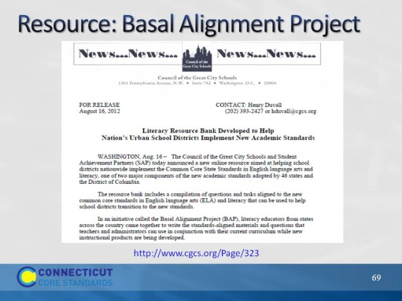Slide 69
The purpose of this slide is to introduce the Basal Alignment project. This project is led by Student Achievement Partners, but is carried out by teacher volunteers. The goal is to rewrite lessons from basal reading programs to align with the Common Core. It is an Edmodo site, which can be joined free of charge.
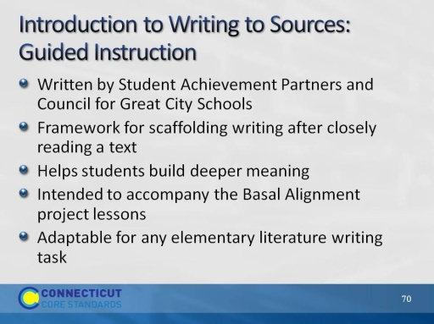Slide 70
A recent addition to the Basal Alignment Project are Writing to Sources lessons, aligned with the BAP reading lessons.
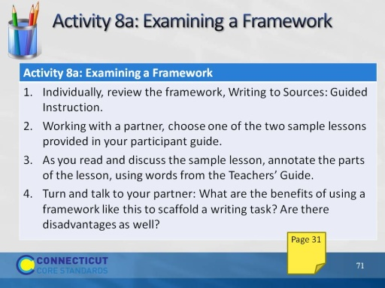Slide 71
Allow 20 minutes for this activity, about 8 to review the framework, and 10 to annotate the sample lesson, then another 2 for the turn and talk prompt.
The Writing to Sources framework is available on Edmodo, in the Basal Alignment Project https://www.edmodo.com/home#/group?id=1121902&sub_view=folders

