Module 3  Facilitator Guide | Supporting All Students in Writing and Research

Activity 6

Connecticut Core Standards for English Language Arts and Literacy

Grades K–5

Systems of Professional Learning

Connecticut Core Standards Systems of Professional Learning
The material in this guide was developed by Public Consulting Group in collaboration with staff from the Connecticut State Department of Education and the RESC Alliance. The development team would like to specifically thank Ellen Cohn, Charlene Tate Nichols, and Jennifer Webb from the Connecticut State Department of Education; Leslie Abbatiello from ACES; and Robb Geier, Elizabeth O’Toole, and Cheryl Liebling from Public Consulting Group.
The Systems of Professional Learning project includes a series of professional learning experiences for Connecticut Core Standards District Coaches in English Language Arts, Mathematics, Humanities, Science, Technology, Engineering, Mathematics (STEM), and Student/Educator Support Staff (SESS).
Participants will have continued support for the implementation of the new standards through virtual networking opportunities and online resources to support the training of educators throughout the state of Connecticut.
Instrumental in the design and development of the Systems of Professional Learning materials from PCG were: Sharon DeCarlo, Debra Berlin, Jennifer McGregor, Judy Buck, Michelle Wade, Nora Kelley, Diane Stump, and Melissa Pierce.
Published 2014. Available online at http://ctcorestandards.org/

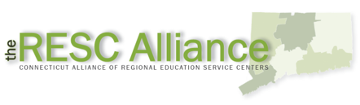

Session at-a-Glance

Part 4: Research in CCS-ELA & Literacy (60 minutes)
Participants will review the vertical progression of standards related to research. In groups, they will review several CCS exemplar units to see how research is developed. Each group will create a poster to describe their unit. Participants will participate in a hosted gallery walk to view the posters.

Activity 6: Research in CCS-aligned Units (45 minutes)
Working in groups of four, participants s will review Common Core-aligned research units, modules, or tasks, and will create an illustrated poster, showing the steps in the research process for their unit. They will then participate in a Hosted Gallery Walk so that each participant has an opportunity to see how research is approached in a variety of aligned units.

Supporting Documents
Exemplar Units: Participants will be asked to access electronically during the session
- Grade 1: Informational Text, Research, and Inquiry Circles: Animals and Habitats http://www.doe.mass.edu/candi/model/files.html
- Grade 2: Reading and Writing About Whales http://www.readwritethink.org/classroom-resources/lesson-plans/reading-writing-about-whales-196.html?tab=2#tabs
- Grade 3: Researching to Build Knowledge and Teach Others: Adaptations and the Wide World of Frogs http://www.engageny.org/sites/default/files/resource/attachments/3m2a.pdf
- Grade 4 Researching Simple Machines “How Do they Help Do Work?” http://www.engageny.org/resource/grade-3-ela-module-2a
- Grade 5: Researching to Build Knowledge and Teaching Others: Biodiversity in Rainforests of the Western Hemisphere http://www.engageny.org/resource/grade-5-ela-module-2a

PowerPoint Slides:
- 48-62

Session Implementation
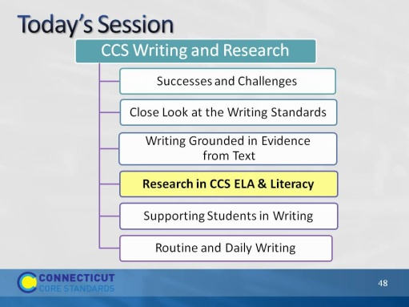Slide 48
One group of writing standards is focused on research skills. However, the CCS are explicit in pointing out that research is integrated throughout the standards.
Part 4
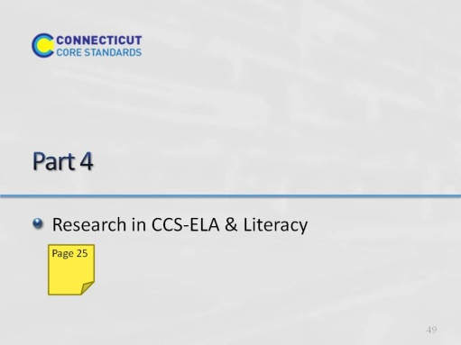Slide 49
Part 4 is allotted 60 minutes.
In this section, we’ll look at the standards related to research and technology, and think about what that means for elementary students and teachers, especially at the earliest grades. One of the best ways to do this is to look at units that have been developed by teachers and writers who have worked closely with the authors of the CC.
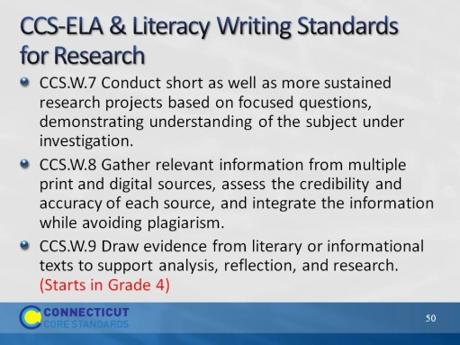Slide 50
The purpose of this slide is to show the writing standards that focus on research skills.
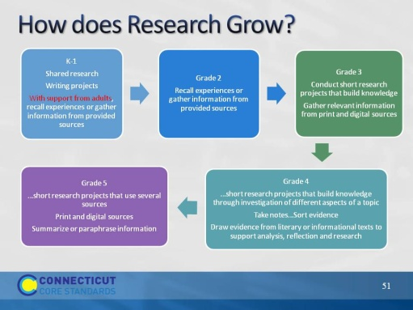Slide 51
Increased independence, more complex tasks, more complex sources, multiple sources. In grade 4, addition W.9, which links Grade 4 reading standards with writing standards.
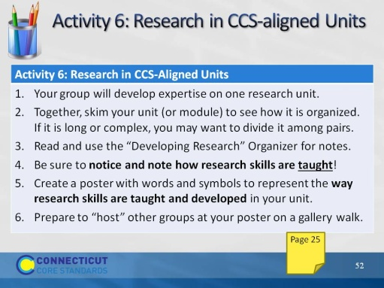Slide 52
The review of the units and the hosted gallery walk are allotted 45 minutes. Allow 20 minutes to review the units, another 10 to create the poster, and 15 for the hosted gallery walk. It will be tight. Emphasize the importance of dividing large units, especially the NY modules which have 3 units in a research module.

Facilitator: If you’d like, you can creatively use the cards that participants were dealt this morning to form 5 groups. Or if you’d like, you can just number off; for example a group of 30 can number off by sixes to form five groups of six each. Don’t go bigger than 6 in a group. Instead, add another of the research units from the Engageny website: Grade 4, Module 2B Reading Closely and Writing to Learn: Animal Defense Mechanisms
http://www.engageny.org/sites/default/files/resource/attachments/4m2b.module.1.pdf
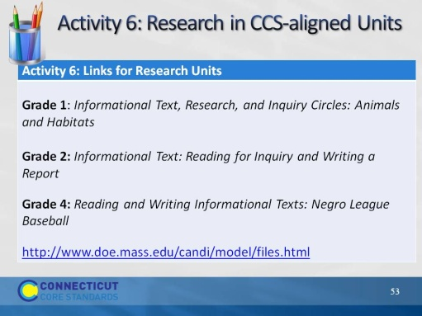Slide 53
Facilitator: You do not have to do anything with this slide; it is for the convenience of participants who are following along with the PPT. There will be hard copies of each of the modules for the participants to choose. Since all three modules are located on the same website, there is only one web address for them to retrieve a copy of all three units.

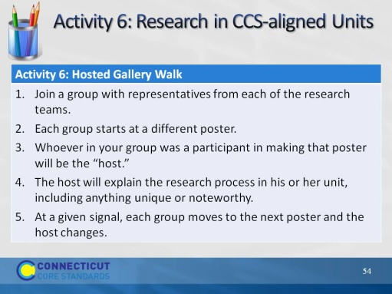Slide 54
Re-group participants so that each new group has one member from each former team. There should be a representative from each unit in each group. So, if there were six teams working on the three units (2 teams per unit) they should make six new groups with representatives from the six research teams. These groups should be formed standing up, not seated. Although some participants reviewed the same unit, they will create different charts. They should be hung together in order to see the different areas that each team focused on as well as the “missed opportunities” for building research skills within the unit.
Tell groups what the signal will be (e.g. rhythmic clap, lights flicking, stopwatch on your cell phone, or on the computer). It can be an audible or visible signal. Depending on the number of groups, allow approximately 2 minutes at a poster, then move participants to the next poster. With movement, this activity should take about 15 minutes.
Hosted Gallery Walk adapted from Expeditionary Learning’s Protocols and Resources on EngageNY: http://www.engageny.org/sites/default/files/resource/attachments/appendix_protocols_and_resources.pdf
The hosted gallery walk involves small-group collaboration to create a product, yet makes individuals responsible for the learning and the teaching.
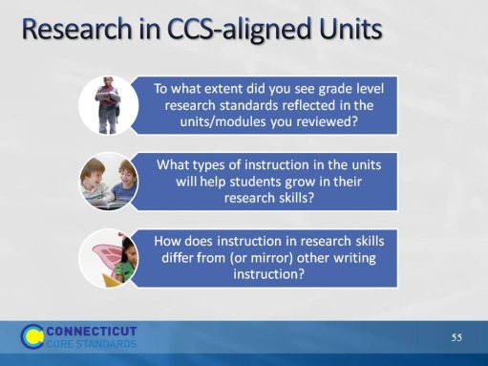Slide 55
This slide provides closure to the Gallery Walk. Encourage volunteers to offer responses, based on their review of units and the Gallery Walk.
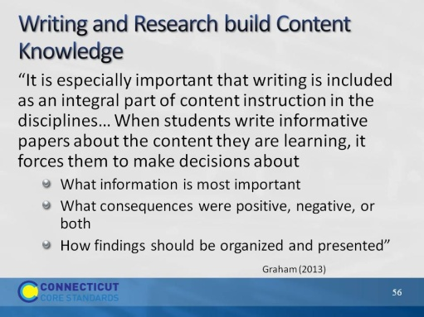Slide 56
This slide reminds coaches of the importance of research for building knowledge in the disciplines. It is especially important that writing is included as an integral part of content instruction in disciplines like science, social studies, and mathematics. This slide reminds coaches of the importance of research for building knowledge in the disciplines.
Full quote: “It is especially important that writing is included as an integral part of content instruction in disciplines like science, social studies, and mathematics. For example, when students write informative papers about the content they are learning in social studies (the consequences of the westward movement in American history as illustrated through the Oregon Trail, for instance), it forces them to makes decisions about (1) what information is most important; (2) what consequences were positive, negative, or both; and (3) how their findings should be organized and presented. Such analyses and interpretation forces students to wrestle with the content, especially if they have to defend the choices they made (e.g., why were the consequences they presented important).”
Graham, S. (2013). Writing Standards. In Morrow, L.M., Wixson, K.K., & Shanahan, T. (Eds.), Teaching with the common core standards. (p. 102).
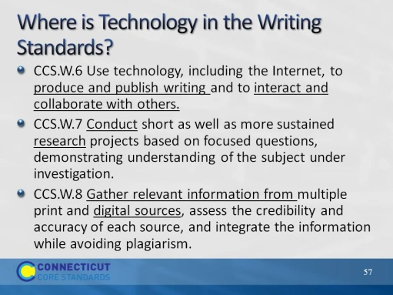Slide 57
Technology is integrated throughout the standards. It is specifically embedded in the research standards. This could be considered a shift from former standards, which frequently isolated technology as an end in itself.
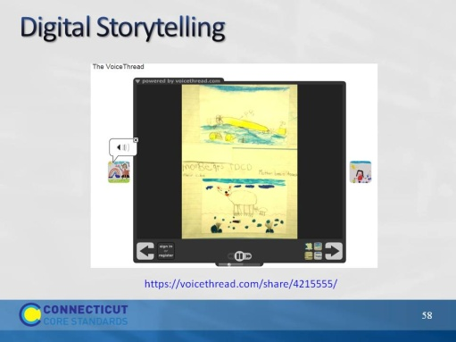Slide 58
The next slides illustrate several technology applications that support the CCS.
This project illustrates the Kindergarten research standards as well as the use of technology. This VoiceThread, All About Polar Bears, Kindergarten ESL by Monica Schnee, won a PBS Teacher Innovator Award. The authors of the "book" are kindergartners who were learning English as a second language. Some of the children barely spoke English, as you can see by the short sentences, and some were advanced students. They had just started to learn how to read and write. This work is a great example of how children learn a second language, how they learn literacy, how they learn oral fluency and practice their oral skills and most importantly, how their parents were able to see and hear how their children are learning English.

The teacher: We spent a lot of time reading books, looking at websites, particularly National Geographic and Nature on PBS. We collected facts, a word that children learned in nonfiction. Then, each student chose a fact, wrote it and had to illustrate it like a true nonfiction illustrator. Therefore, the drawings had to be in "real colors". After we finished our "traditional hard copy" book. We read it to all the kindergartners, including their American peers. Then we practiced our lines and made it into a VoiceThread.
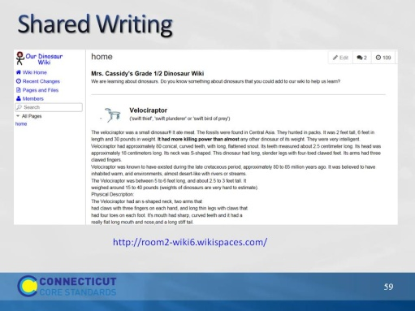Slide 59
http://www.wikispaces.com/content/classroom/about
Project-Based Learning
Project-Based Learning is a dynamic approach to teaching in which students explore real-world problems and challenges. With this type of active and engaged learning, students are inspired to obtain a deeper knowledge of the subjects they're studying.
Wikispaces Classroom provides a simple structure that allows you to create projects, define teams, assign students and manage them all through successful completion of their projects. Starting from pre-built templates, or a blank slate, students can work in private groups until their work is due. At the end of the project you can share the results with the rest of the class or even parents and other participants. In the project illustrated, the teacher asks students to contribute to the wiki.
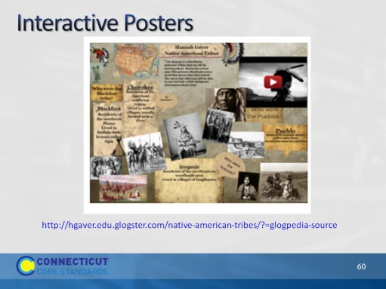Slide 60
A Glog is an interactive visual platform in which users create a “poster or web page” containing multimedia elements including: text, audio, video, images, graphics, drawings, and data.
The teacher creates projects with templates and instructional guidelines, assigns them to the students, provides feedback throughout the assignment, and assesses their finished work.
Once projects are complete, the teacher can share students’ work in a variety of educational settings. Glogs can be embedded in a blog, wiki, or web page or shared with others using Glogster.
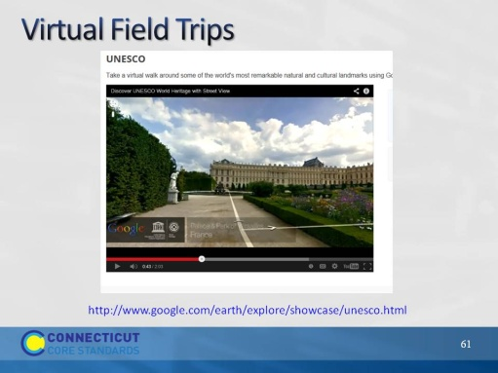Slide 61
With Google Earth, teachers can create customized field trips for shared research. This is great for primary classes.
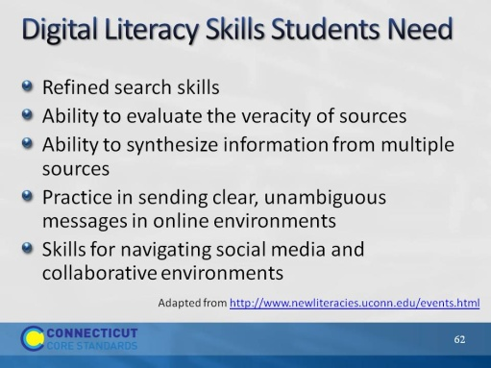Slide 62
The New Literacies Research Lab at the University of Connecticut is the most widely recognized center in the world for conducting research on the new reading comprehension and learning skills required by the Internet and other emerging information and communication technologies. Their work develops research-based evidence to prepare students for their literacy and learning future. They are currently developing an online assessment to determine student’s digital literacy skills. They have determined areas in which students struggle with digital literacy. The list on this slide is derived from their research.

