Module 3  Facilitator Guide | Supporting All Students in Writing and Research

Activity 2

Connecticut Core Standards for English Language Arts and Literacy

Grades K–5

Systems of Professional Learning

Connecticut Core Standards Systems of Professional Learning
The material in this guide was developed by Public Consulting Group in collaboration with staff from the Connecticut State Department of Education and the RESC Alliance. The development team would like to specifically thank Ellen Cohn, Charlene Tate Nichols, and Jennifer Webb from the Connecticut State Department of Education; Leslie Abbatiello from ACES; and Robb Geier, Elizabeth O’Toole, and Cheryl Liebling from Public Consulting Group.
The Systems of Professional Learning project includes a series of professional learning experiences for Connecticut Core Standards District Coaches in English Language Arts, Mathematics, Humanities, Science, Technology, Engineering, Mathematics (STEM), and Student/Educator Support Staff (SESS).
Participants will have continued support for the implementation of the new standards through virtual networking opportunities and online resources to support the training of educators throughout the state of Connecticut.
Instrumental in the design and development of the Systems of Professional Learning materials from PCG were: Sharon DeCarlo, Debra Berlin, Jennifer McGregor, Judy Buck, Michelle Wade, Nora Kelley, Diane Stump, and Melissa Pierce.
Published 2014. Available online at http://ctcorestandards.org/

Session at-a-Glance

Part 2: A Close Look at the Writing Standards (65 minutes)
After reviewing the organization of the CCS-ELA & Literacy Writing Standards, coaches will read and debrief an excerpt from Common Core State Standards ELA & Literacy Appendix A, which includes a definition of the three text types and the special place of argument in the standards. Participants will then be introduced to the extensive collection of student writing in, “In Common: Effective Writing for all Students.” They will examine the differences in grade level expectations of the writing standards for Opinion/Argument, Explanation, and Narrative, by looking at and annotating a progression of On-Demand student writing from the collection.

Activity 2: Types of Writing in the CCS-ELA & Literacy (30 minutes)
Working in teams of 4, each participant reads about one type of writing from Appendix A of the CCSS document (these pages are located in the Appendix of the Participant Guide). Teams discuss, using a Text-rendering Protocol, and synthesize the information by answering questions provided in the participant guide.

Supporting Documents:
- Excerpt (pp. 23-25) from CCSSO & NGA. (2010). Common Core State Standards for English Language Arts & Literacy in History/Social Studies, Science, and Technical Subjects. Washington, DC. http://www.corestandards.org/assets/Appendix_A.pdf
- Directions for Text-rendering Protocol

PowerPoint Slides:
- 11-20

Session Implementation
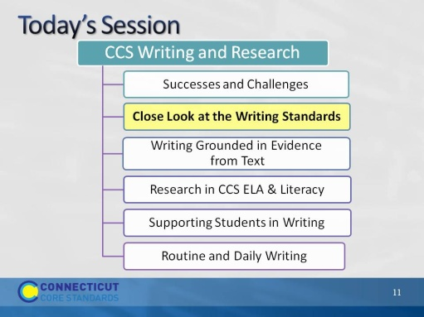Slide 11
In Part 2 of Module 3, we’ll look at the organization of the writing standards and review the first three standards - text types - as they are explained in Appendix A of the CCSS. We’ll then examine the three types of writing by annotating student writing samples.
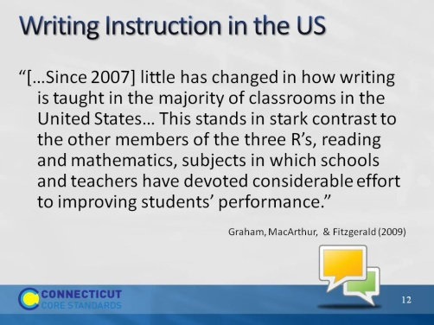Slide 12 | F
From Graham, S. & Harris, K. “Designing an Effective Writing Program,” in Graham, S., MacArthur, C. & Fitzgerald, J. Best Practices in Writing Instruction 2013. New York. Guilford Press.
The purpose of this slide is to bring provide context for this module.
Explain that the text, Best Practices in Writing Instruction, which provides evidence-based practices in writing instruction, was originally written in 2007, and has been revised and updated in 2013 to align with the CC standards. The authors and contributors are widely respected experts in the field of writing instruction.
Ask a participant to read the slide, then direct participants to turn and talk with a neighbor. “Do you agree with the authors’ statement? Why do you think less time is devoted to teaching writing than to teaching reading and math?
After several possible reasons have been offered, share the following information:
The authors make a point that the research behind writing instruction hasn’t changed. We know a lot about designing and teaching effective writing programs, and teachers and schools who regularly devote time to teaching writing, do a “phenomenal” job. Current research shows that beyond grade three, teachers devote little time to teaching writing and students do little writing in or out of school for academic purposes. With a new and rigorous set of standards that make writing a central element, learning to write is strongly emphasized. Students are expected to write for multiple purposes, and use writing to recall, organize, analyze, interpret, and build knowledge about content. With this strong emphasis on writing, it is important for all teachers to teach writing.
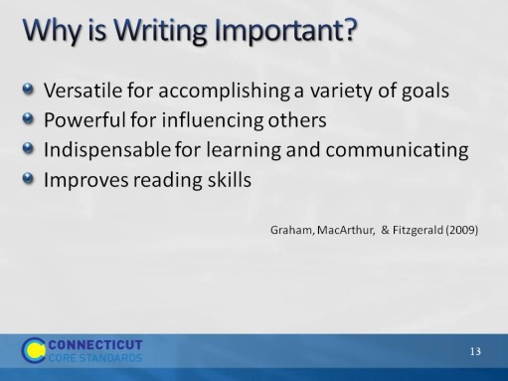Slide 13
The purpose of this is to answer the question: Why is writing important? Versatile:
- Maintain personal links with family and friends
- Share information
- Tell stories
- Create imagined worlds
- Chronicle experiences
- Explore who we are
Powerful: Influences others, e.g. Uncle Tom’s Cabin, The Feminine Mystique
Indispensable for learning and communicating
- Gather, preserve, and transmit information
- Helps us understand what we read better by processing and organizing
Improves reading skills
- Not identical processes, but research shows that instruction that improves writing skills and process also improves reading skills and processes
- Writers gain insight about reading by writing for audiences
- Quantity of writing improves reading comprehension
Graham (2013) pp. 4-6
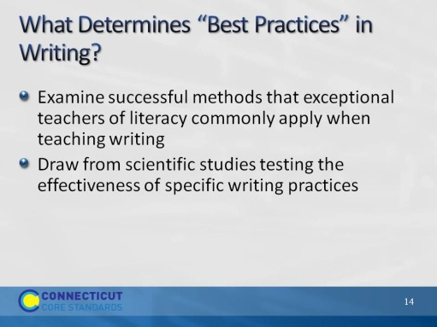Slide 14
Note that throughout this module we will look at both best practices and models.
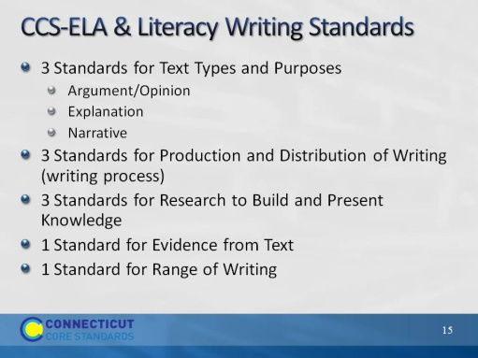Slide 15
RE: Standard 10, Range of Writing: To build a foundation for college and career readiness, students need to learn to use writing as a way of offering and supporting opinions, demonstrating understanding of the subjects they are studying, and conveying real and imagined experiences and events. They learn to appreciate that a key purpose of writing is to communicate clearly to an external, sometimes unfamiliar audience, and they begin to adapt the form and content of their writing to accomplish a particular task and purpose. They develop the capacity to build knowledge on a subject through research projects and to respond analytically to literary and informational sources. To meet these goals, students must devote significant time and effort to writing, producing numerous pieces over short and extended time frames throughout the year.
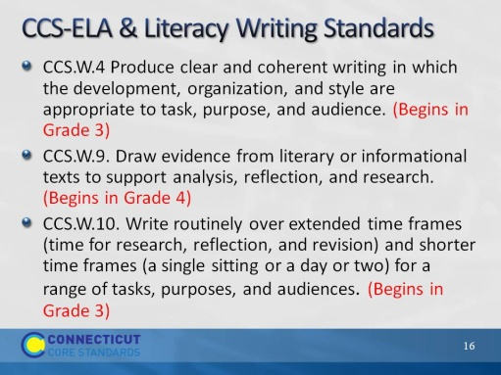Slide 16
Authors of Common Core Standards recognized the nature of writing for young children and were realistic in their expectations for assessing writing of young students on challenging or developmentally inappropriate tasks. Nonetheless, teachers of primary grades students can look to grades 3 and 4 for the missing standards and begin to build stamina and good writing habits for when these standards do begin.
Part 2
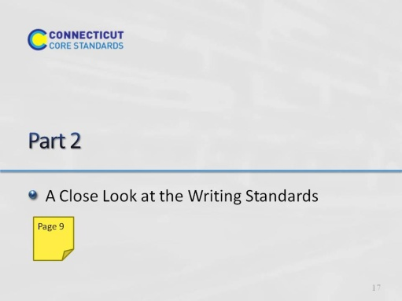Slide 17
65 minutes for all of Part 2, including Activities 2 and 3. Introductory slides, 13-14, should take no more than 5 minutes, leaving 1 hour for the remaining activities.
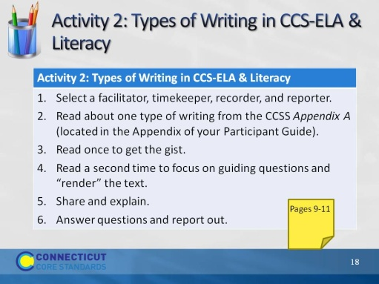Slide 18
Activity 2 will take 30 minutes.
For this activity, group participants in 4’s in any way that works for the groups you have. It’s OK for them to stay with their district if that works out. If there are an odd number, it is better to have a group of 3 than of 5. Direct them to the page in their Participant Guide, and then briefly explain on the next slide. They will definitely need their Participant Guide for this.
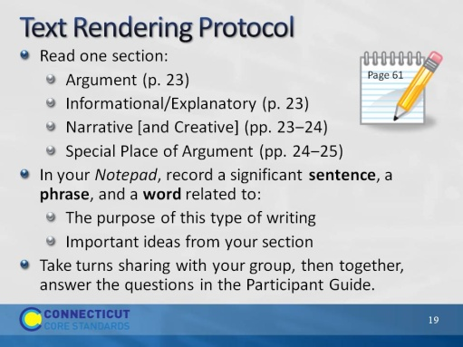Slide 19
Remind participants that full directions, including the questions to answer, are in the Participant Guide.
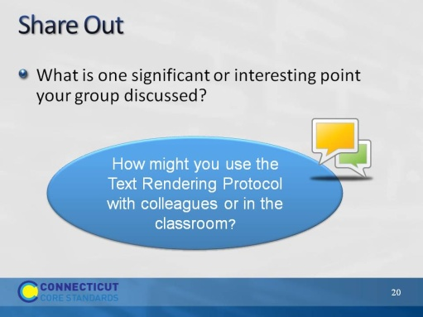Slide 20
Blank.

