Module 3  Facilitator Guide | Supporting All Students in Writing and Research

Activity 1

Connecticut Core Standards for English Language Arts and Literacy

Grades K–5

Systems of Professional Learning

Connecticut Core Standards Systems of Professional Learning
The material in this guide was developed by Public Consulting Group in collaboration with staff from the Connecticut State Department of Education and the RESC Alliance. The development team would like to specifically thank Ellen Cohn, Charlene Tate Nichols, and Jennifer Webb from the Connecticut State Department of Education; Leslie Abbatiello from ACES; and Robb Geier, Elizabeth O’Toole, and Cheryl Liebling from Public Consulting Group.
The Systems of Professional Learning project includes a series of professional learning experiences for Connecticut Core Standards District Coaches in English Language Arts, Mathematics, Humanities, Science, Technology, Engineering, Mathematics (STEM), and Student/Educator Support Staff (SESS).
Participants will have continued support for the implementation of the new standards through virtual networking opportunities and online resources to support the training of educators throughout the state of Connecticut.
Instrumental in the design and development of the Systems of Professional Learning materials from PCG were: Sharon DeCarlo, Debra Berlin, Jennifer McGregor, Judy Buck, Michelle Wade, Nora Kelley, Diane Stump, and Melissa Pierce.
Published 2014. Available online at http://ctcorestandards.org/

Session at-a-Glance

Part 1: Sharing Our Successes and Challenges (15 minutes)
Connecticut Core Standards Coaches will meet in small groups and will take turns presenting about how they shared the messages of Module 2 with others in their school or district.

Activity 1: Sharing About Module 2 (15 minutes)
Coaches will meet in groups of 4 and will share with the others in their group how they shared the messages of Module 2 with others in their school or district.

Supporting Documents:
- Quick Write (in the Notepad) about sharing messages of Module 2 with school and district colleagues

PowerPoint Slides:
- 8-10

Session Implementation
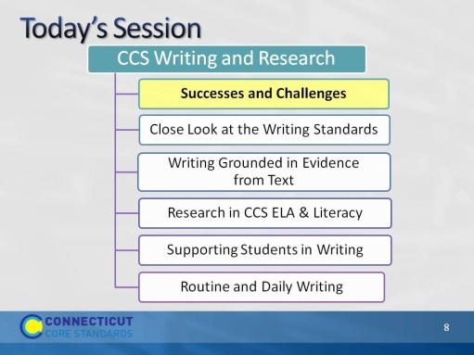Slide 8
The first thing we will do today is take a few minutes to share some of the discussions, plans, or activities that happened in your school or district between Modules 1 and 2.

Part 1
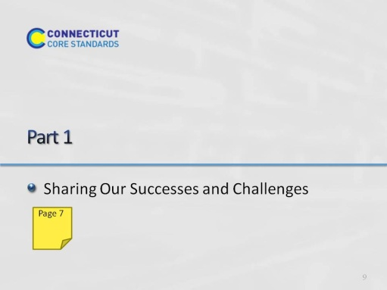Slide 9
15 minutes total including, directions.
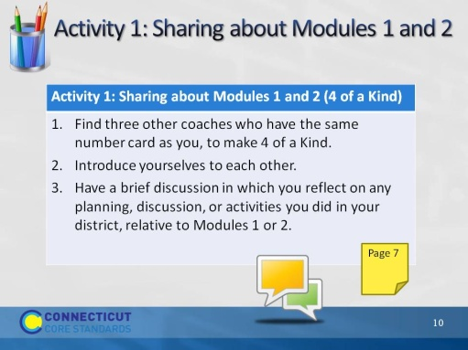Slide 10
Part 1, including this activity, should take no more than 15 minutes. This slide gives directions for Activity 1. It is meant to be an informal “standing up” activity in which folks introduce themselves to others.

