Module 3  Facilitator Guide | Supporting All Students in Writing and Research

Closing Activity

Connecticut Core Standards for English Language Arts and Literacy

Grades 6–12

Systems of Professional Learning

Connecticut Core Standards Systems of Professional Learning
The material in this guide was developed by Public Consulting Group in collaboration with staff from the Connecticut State Department of Education and the RESC Alliance. The development team would like to specifically thank Ellen Cohn, Charlene Tate Nichols, and Jennifer Webb from the Connecticut State Department of Education; Leslie Abbatiello from ACES; and Robb Geier, Elizabeth O’Toole, and Cheryl Liebling from Public Consulting Group.
The Systems of Professional Learning project includes a series of professional learning experiences for Connecticut Core Standards District Coaches in English Language Arts, Mathematics, Humanities, Science, Technology, Engineering, Mathematics (STEM), and Student/Educator Support Staff (SESS).
Participants will have continued support for the implementation of the new standards through virtual networking opportunities and online resources to support the training of educators throughout the state of Connecticut.
Instrumental in the design and development of the Systems of Professional Learning materials from PCG were: Sharon DeCarlo, Debra Berlin, Jennifer McGregor, Judy Buck, Michelle Wade, Nora Kelley, Diane Stump, and Melissa Pierce.
Published 2014. Available online at http://ctcorestandards.org/

Session at-a-Glance

Closing Activities (10 minutes)
Participants will complete a Post-Assessment and an online Session Evaluation.

Supporting Documents:
- Post-Assessment
- Session Evaluation

PowerPoint Slide:
- 93-97

Session Implementation
Closing Activities
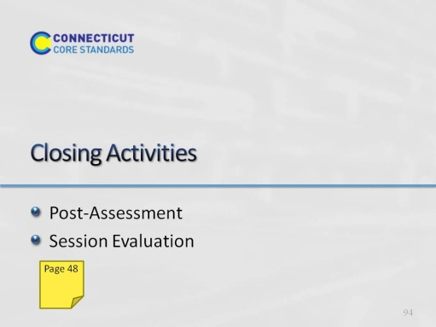Slide 93
Adjusting for time, you may want to ask groups to share some of their ideas from Activity 10.
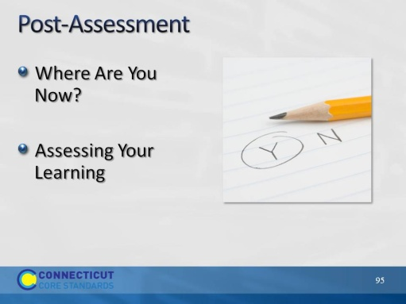Slide 94
The Post-Assessment will be the same as the Pre-Assessment they took in the beginning of the session. This assessment is to gauge their learning based on the activities of the morning. They will find the Post-Assessment in the Participant Guide (3-4 minutes).
Ask for further thoughts, questions.
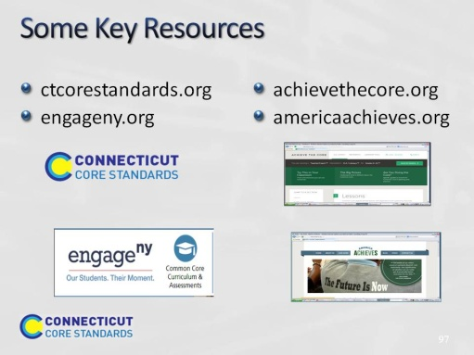Slide 95
Blank.
Slide 96

Blank.

