Module 3  Facilitator Guide | Supporting All Students in Writing and Research

Activity 7

Connecticut Core Standards for English Language Arts and Literacy

Grades 6–12

Systems of Professional Learning

Connecticut Core Standards Systems of Professional Learning
The material in this guide was developed by Public Consulting Group in collaboration with staff from the Connecticut State Department of Education and the RESC Alliance. The development team would like to specifically thank Ellen Cohn, Charlene Tate Nichols, and Jennifer Webb from the Connecticut State Department of Education; Leslie Abbatiello from ACES; and Robb Geier, Elizabeth O’Toole, and Cheryl Liebling from Public Consulting Group.
The Systems of Professional Learning project includes a series of professional learning experiences for Connecticut Core Standards District Coaches in English Language Arts, Mathematics, Humanities, Science, Technology, Engineering, Mathematics (STEM), and Student/Educator Support Staff (SESS).
Participants will have continued support for the implementation of the new standards through virtual networking opportunities and online resources to support the training of educators throughout the state of Connecticut.
Instrumental in the design and development of the Systems of Professional Learning materials from PCG were: Sharon DeCarlo, Debra Berlin, Jennifer McGregor, Judy Buck, Michelle Wade, Nora Kelley, Diane Stump, and Melissa Pierce.
Published 2014. Available online at http://ctcorestandards.org/

Session at-a-Glance

Part 5: Routine and Daily Writing (35 minutes)
Coaches will read closely CCRA W.10, “Write routinely over extended time frames (time for research, reflection, and revision) and shorter time frames (a single sitting or a day or two) for a range of discipline-specific tasks, purposes, and audiences.” They will interpret this standard and discuss this standard.
In Activity 7, coaches will review several exemplar units and lessons for embedded writing tasks. They will record and sort these as to where they occur in the units and lessons. They will discuss various ways they see routine writing being incorporated in the units, and how those writing tasks might serve as formative assessment. They will extend this discussion to include routine writing being done in their school or district.

Activity 7: Reviewing Exemplar Units and Lessons (30 minutes)
Participants review several exemplar units for embedded writing tasks, discuss the ways routine writing is embedded, and consider ways they or their colleagues embed writing in lessons.

Supporting Documents:
Participants will be asked to access electronically during the session, or download and print one or more exemplar units before Module 3 begins.
- Grade 6‒7: The Digestive Process http://achievethecore.org/dashboard/300/search/1/1/6/7/8/page/752/featured-lessons-list-pg
- Grade 7–8: The Long Night of the Little Boats http://achievethecore.org/dashboard/300/search/1/1/6/7/8/page/752/featured-lessons-list-pg
- Grade 6‒8: Voices from Little Rock http://achievethecore.org/page/737/history-social-studies-lessons
- Grade 9–12: Researching the Meaning of the American Dream http://www.readwritethink.org/classroom-resources/lesson-plans/chasing-dream-researching-meaning-30925.html?tab=4#session1
- Grade 11: The Art of Persuasion and the Craft of Argument http://www.doe.mass.edu/candi/model/units/ELAg11-PersuasionArgument.pdf
- Grade 11‒12: I Am an American Day by Learned Hand http://achievethecore.org/dashboard/300/search/1/1/9/10/11/12/page/752/featured-lessons-list-pg

PowerPoint Slides:
- 70-79

Session Implementation
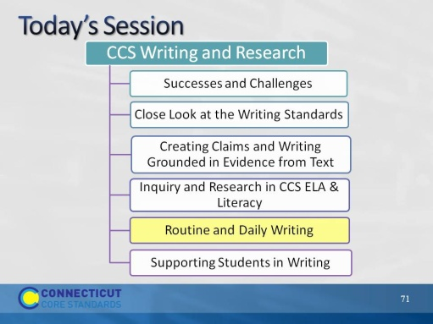Slide 70
Blank.
Part 5
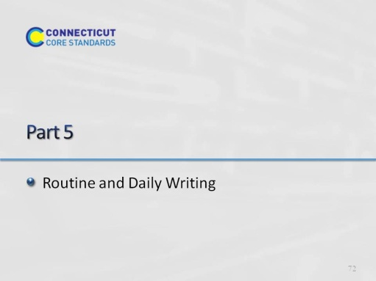Slide 71
Part 5 should take not more than 40 minutes.
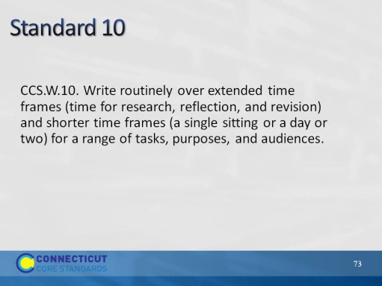Slide 72
Blank.
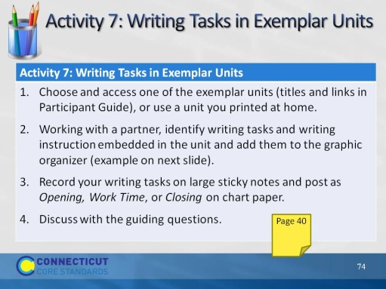Slide 73
Allow 15 minutes for looking at units and doing the graphic organizer. Allow another 5 minutes for posting on charts and sharing out by volunteer. 5 minutes for table discussion and 5 minutes to share out with whole group.
Facilitator, be sure to post on one wall 3 chart papers, labeled, “Opening,” “Work Time,” and “Closing.”
(Participants will be asked to access electronically during the session, or download and print one or more of these before Module 3 begins These are in addition to those used in ELA Module 2:
Grade 6-7: The Digestive Process http://achievethecore.org/dashboard/300/search/1/1/6/7/8/page/752/featured-lessons-list-pg
Grade 7-8: The Long Night of the Little Boats http://achievethecore.org/dashboard/300/search/1/1/6/7/8/page/752/featured-lessons-list-pg
Grade 6-8: Voices from Little Rock http://achievethecore.org/page/737/history-social-studies-lessons
Grade 9- 12: Researching the Meaning of the American Dream http://www.readwritethink.org/classroom-resources/lesson-plans/chasing-dream-researching-meaning-30925.html?tab=4#session1
Grade 11: The Art of Persuasion and the Craft of Argument http://www.doe.mass.edu/candi/model/units/ELAg11-PersuasionArgument.pdf
Grade 11-12: A Close Reading of Learned Hand’s “I am an American Day Address” http://achievethecore.org/dashboard/300/search/1/1/9/10/11/12/page/752/featured-lessons-list-pg

The purpose of this activity is for participants to recognize the variety of ways in which routine writing and more formal writing is embedded in CCS-ELA & Literacy-aligned units, and discuss how daily writing supports learning, builds literacy skills, and scaffolds students to successfully meet the standards.

They will record their tasks on a graphic organizer and on individual sticky notes. They may want to have one partner write on the organizer and one do the sticky notes. Go to next slide for example.
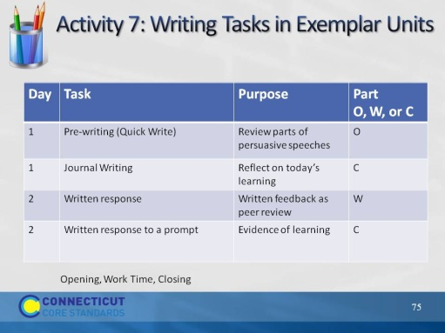Slide 74
Let participants know that some of the units are far more complex than others and may have more writing tasks. A way to save time is, if there is a repeated writing task, e.g., journal writing, they can write it once and indicate that it is repeated.
The intent is not to get through the unit, but rather to see the variety of ways in which W.10 is reflected in CCS-aligned units.
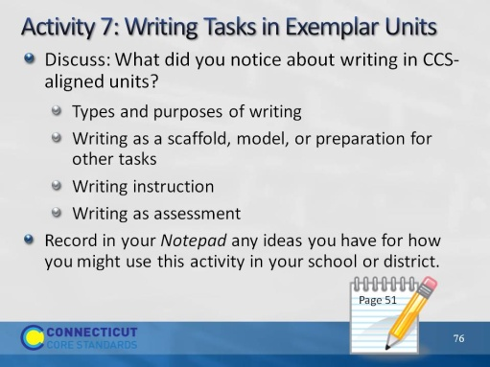Slide 75
Allow 5 minutes for this discussion and another 5 for sharing out.
Explain that this is intended to be an open discussion and these are just suggestions for where the conversation might go.
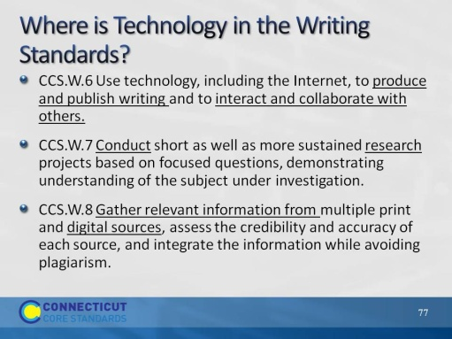Slide 76
Blank.
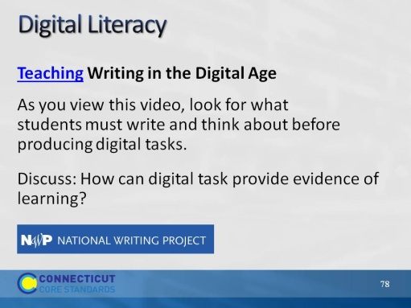Slide 77
http://www.youtube.com/watch?v=O9z71iNrlew
This video follows a teacher as he provides digital performance tasks and digital projects and demonstrates how writing remains the foundation of learning, especially in a computer- and camcorder-filled digital classroom. Produced by National Writing Project NWP with teacher-consultant Joel Malley.
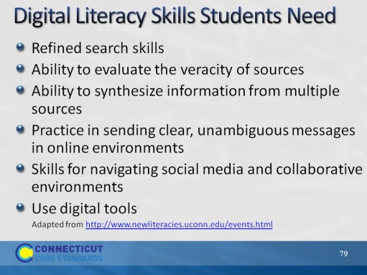Slide 78
The New Literacies Research Lab at the University of Connecticut is the most widely recognized center in the world for conducting research on the new reading comprehension and learning skills required by the Internet and other emerging information and communication technologies. Their work develops research-based evidence to prepare students for their literacy and learning future.
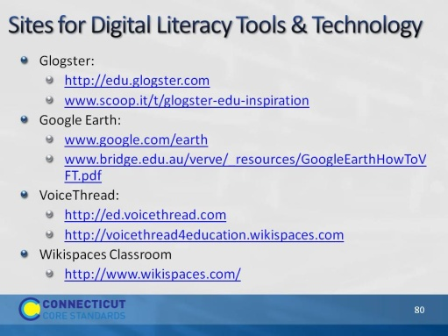Slide 79
The purpose of this slide is to provide links to resources described earlier. It is intended for those who will access the module online.

