Module 3  Facilitator Guide | Supporting All Students in Writing and Research

Activity 4b

Connecticut Core Standards for English Language Arts and Literacy

Grades 6–12

Systems of Professional Learning

Connecticut Core Standards Systems of Professional Learning
The material in this guide was developed by Public Consulting Group in collaboration with staff from the Connecticut State Department of Education and the RESC Alliance. The development team would like to specifically thank Ellen Cohn, Charlene Tate Nichols, and Jennifer Webb from the Connecticut State Department of Education; Leslie Abbatiello from ACES; and Robb Geier, Elizabeth O’Toole, and Cheryl Liebling from Public Consulting Group.
The Systems of Professional Learning project includes a series of professional learning experiences for Connecticut Core Standards District Coaches in English Language Arts, Mathematics, Humanities, Science, Technology, Engineering, Mathematics (STEM), and Student/Educator Support Staff (SESS).
Participants will have continued support for the implementation of the new standards through virtual networking opportunities and online resources to support the training of educators throughout the state of Connecticut.
Instrumental in the design and development of the Systems of Professional Learning materials from PCG were: Sharon DeCarlo, Debra Berlin, Jennifer McGregor, Judy Buck, Michelle Wade, Nora Kelley, Diane Stump, and Melissa Pierce.
Published 2014. Available online at http://ctcorestandards.org/

Session at-a-Glance

Activity 4b: “Writing to Sources” Teachers’ Guide 6‒12 (10 minutes)
Participants read “Writing to Sources: Initial Guided Instruction for ELA 6-12”, underline key concepts that will serve as supports for teachers and students, and discuss with a partner.

Supporting Documents:
- Achieve the Core. Student Achievement Partners. Writing to Sources: Guided Instruction. Retrieved from http://www.solution-tree.com/media/pdf/WriteLikeReportersK_5FREYCFF335.pdf

PowerPoint Slides:
- 41-43

Session Implementation
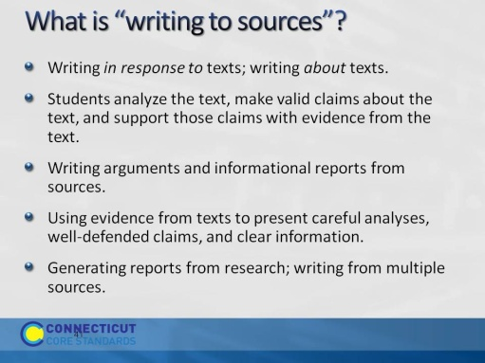Slide 41
Explain that “writing from sources” includes writing tasks such as literary analysis and research projects.
Writing from sources is, in general, analytical writing in response to literary and informational texts. Students are expected to use evidence from texts to present careful analyses, well-defended claims, and clear information.
Inevitably, it is integrated closely with Reading in ELA, history/social studies, science, and technical subjects.

Make this important distinction:
Rather than asking students questions they can answer from their prior knowledge or experience, the standards expect students to answer questions that depend on their having closely read and understood the text and multiple resources.
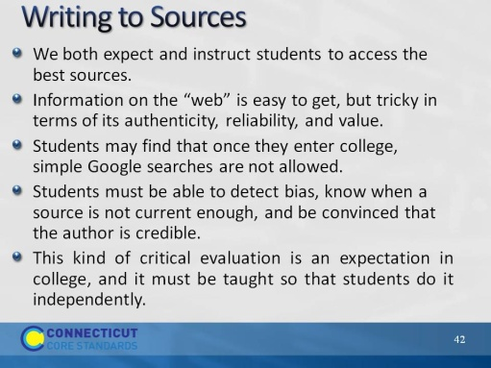Slide 42
Ask for a different volunteer to read each bullet. Ask participants to comment on each bulleted point directly after it is read.
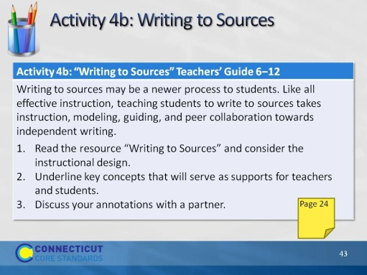Slide 43
Blank.

