Module 3  Facilitator Guide | Supporting All Students in Writing and Research

Activity 4a

Connecticut Core Standards for English Language Arts and Literacy

Grades 6–12

Systems of Professional Learning

Connecticut Core Standards Systems of Professional Learning
The material in this guide was developed by Public Consulting Group in collaboration with staff from the Connecticut State Department of Education and the RESC Alliance. The development team would like to specifically thank Ellen Cohn, Charlene Tate Nichols, and Jennifer Webb from the Connecticut State Department of Education; Leslie Abbatiello from ACES; and Robb Geier, Elizabeth O’Toole, and Cheryl Liebling from Public Consulting Group.
The Systems of Professional Learning project includes a series of professional learning experiences for Connecticut Core Standards District Coaches in English Language Arts, Mathematics, Humanities, Science, Technology, Engineering, Mathematics (STEM), and Student/Educator Support Staff (SESS).
Participants will have continued support for the implementation of the new standards through virtual networking opportunities and online resources to support the training of educators throughout the state of Connecticut.
Instrumental in the design and development of the Systems of Professional Learning materials from PCG were: Sharon DeCarlo, Debra Berlin, Jennifer McGregor, Judy Buck, Michelle Wade, Nora Kelley, Diane Stump, and Melissa Pierce.
Published 2014. Available online at http://ctcorestandards.org/

Session at-a-Glance

Part 3: Creating Claims and Writing Grounded in Evidence from Text (105 minutes)
Participants listen to a brief review of Instructional Shift 2, Reading, Writing, and Discussion grounded in evidence from text, and examine the meaning of “writing, grounded in evidence from text.” They see the types of writing that will be required from the sixth, eighth, and eleventh grades on in the SBAC assessments. In Activity 4a, they participate in a Jigsaw Protocol, using a chapter from Best Practices in Writing Instruction (2013). In Activity 4b and 4c, they read “Writing to Sources” and discuss with a partner, using the discussion prompts as a guide. Then in 5a, 5b, and 5c they watch two videos and review samples of student writing.

Activity 4a: Writing About Text (40 minutes)
Working in teams, participants use a Jigsaw Protocol to read and debrief Tim Shanahan’s chapter, (2013) “Best Practices in Writing about Text.” Participants, in table groups, read one section of the text, highlighting key ideas (please remind participants not to write on the handout). Together they summarize the section, and decide how they will teach that section to other participants. They create a graphic to help them do so. Each participant makes a copy of the graphic.
Participants re-organize into groups of 5 and each read a different section of the chapter. They take turns “teaching” the other participants about their section.
Participants return to their original table groups, discuss, and record their take-ways for this session in the Notepad section of the Participant Guide.

Supporting Documents:
- Shanahan, T. (2013). Best practices in writing about text. In S. Graham, C. A. MacArthur, & J. Fitzgerald (Eds.), Best practices in writing instruction (2nd ed., ch. 14, pp. 334-350). New York: Guilford Press

PowerPoint Slides:
- 27-40

Session Implementation
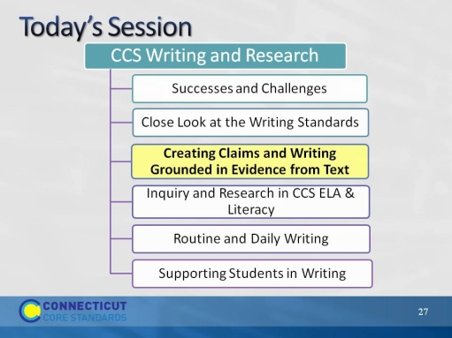Slide 27
This part of the module will focus on Shift 2, writing, grounded in evidence from the text, and what it means for the secondary student.
Part 3
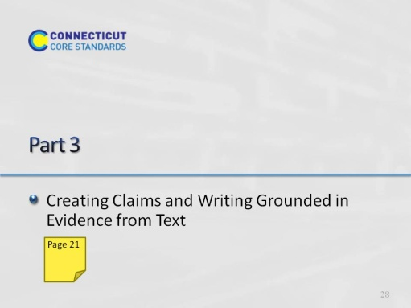Slide 28
Part 3 is allotted 105 minutes in total. This includes introductory slides, Activities 4a, b, and c, and Activities 5a, b, and c. Activity 4 is 50 minutes total, and Activity 5 is 45 minutes total. That leaves about 10 minutes for introduction and conclusion of this part.
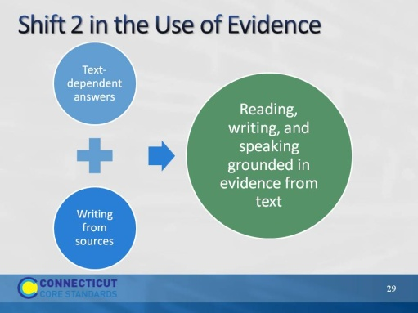Slide 29
Remind participants that in Module 1, we saw that one of three significant instructional shifts required by the CCS is “Reading, writing, and speaking, grounded in evidence from text. With regard to writing, where in the standards do we find that?
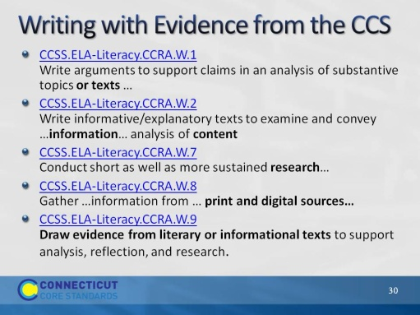Slide 30
The purpose of this slide is to show that writing from sources/writing with evidence is spread throughout the writing standards. Standard 9 also refers back explicitly to the reading standards at each grade level.
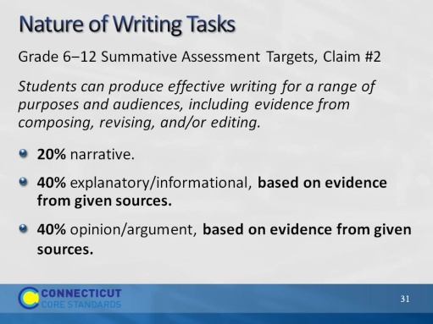Slide 31
This instructional shift is reflected on the Smarter Balanced assessments as well.
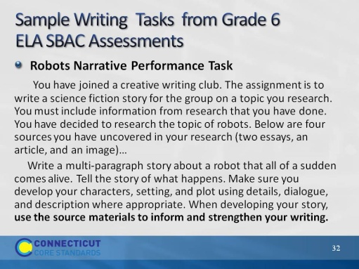Slide 32
These items were adapted to fit the screen and taken from http://www.smarterbalanced.org/sample-items-and-performance-tasks/
Smarter Balanced sample items illustrate the rigor and complexity of the English language arts/literacy and mathematics items and performance tasks students will encounter on the Consortium’s next-generation assessments.
The sample items and performance tasks are intended to help teachers, administrators, and policymakers implementing the Common Core State Standards (CCSS) and preparing for next-generation assessments. They provide an early look into the depth of understanding of the CCSS that will be measured by the Smarter Balanced assessment system. While the items and tasks are not intended to be used as sample tests, educators can use them to begin planning the shifts in instruction that will be required to help students meet the demands of the new assessments.
The sample items and tasks can be viewed by grade band (grades 3-5, 6-8, and high school) or content focus. They showcase the variety of item types—including technology-enhanced items and performance tasks—that will be included in the Smarter Balanced assessment system. In addition, items illustrating the connections across grades within the CCSS—as well as the range of student achievement within a computer adaptive test—are also available. Most constructed-response and technology-enhanced items can be scored automatically, and many items include downloadable scoring rubrics.
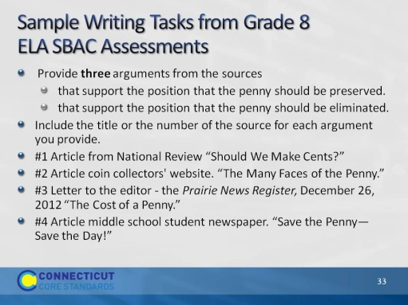Slide 33
The sample English language arts/literacy items and performance tasks include a mixture of published and commissioned reading passages and sources. For the operational assessment in the 2014-15 school year, Smarter Balanced intends to use primarily published passages—reflecting the emphasis in the Common Core on exposure to “high-quality, increasingly challenging literary and informational texts”—and the full text of these passages will be available to students.
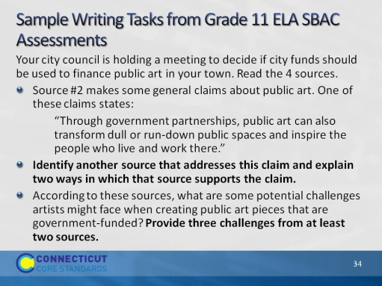Slide 34
Have a participant read this quote. Discuss how we teach students, not writing, not argument, not narrative. We should be teaching students how to be writers and thinkers. If we can do that, they should be able to perform well on tests AND in writing beyond our classroom. Taken from Wollman‐Bonilla, J. E. (2004). Principled teaching to(wards) the test? Language Arts, 81, 502‐511.
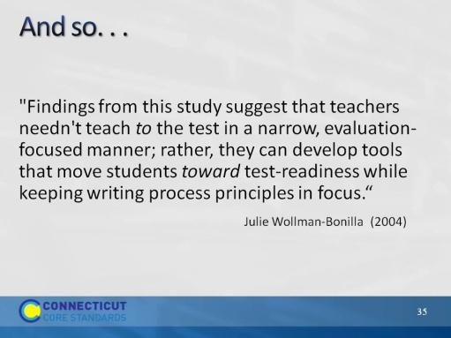Slide 35
“Best practices” to teach writing from text are drawn from two sources: common practices of exemplary teachers of writing and the resulting student work, and scientific studies.
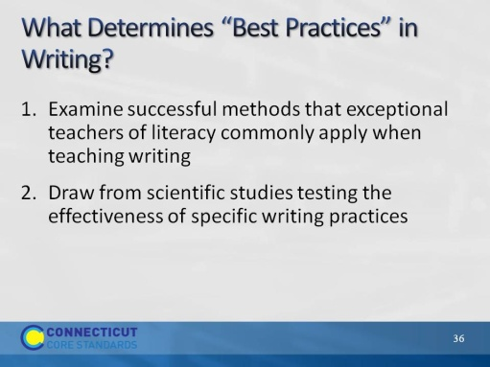Slide 36
Direct participants to turn and talk with a neighbor about practices they believe to be best practices in writing instruction. Then show the next slide and read the details in the facilitator’s notes. Ask participants to listen for the practices they named. Ask them if they are surprised by any, or if they named any they think should have been there and are not.

Create a supportive environment where writing can flourish
Clear, specific, and challenging goals
Arrangements in which students work together
Write often, and for a variety of purposes
Real audiences
Personal choices
Write for extended periods
Teach writing strategies
Strategies for writing process–planning, drafting, revising, and editing
Pre-writing activities
Graphic Organizers
Characteristics of text types and genres
Teach foundational writing skills
Handwriting, typing, spelling
Syntax
Conventions
Graphic organizers
Sentence and paragraph structure
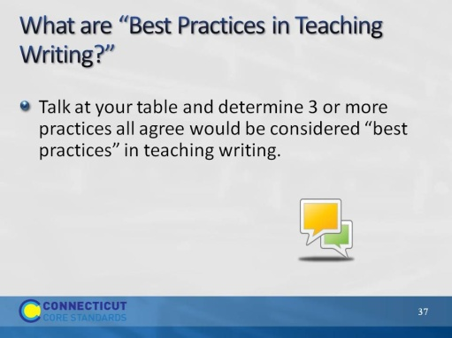Slide 37
Direct participants to turn and talk with a neighbor about practices they believe to be best practices in writing instruction. Then show the next slide and read the details in the facilitator’s notes. Ask participants to listen for the practices they named. Ask them if they are surprised by any, or if they named any they think should have been there and are not.

Create a supportive environment where writing can flourish
Clear, specific, and challenging goals
Arrangements in which students work together
Write often, and for a variety of purposes
Real audiences
Personal choices
Write for extended periods
Teach writing strategies
Strategies for writing process–planning, drafting, revising, and editing
Pre-writing activities
Graphic Organizers
Characteristics of text types and genres
Teach foundational writing skills
Handwriting, typing, spelling
Syntax
Conventions
Graphic organizers
Sentence and paragraph structure
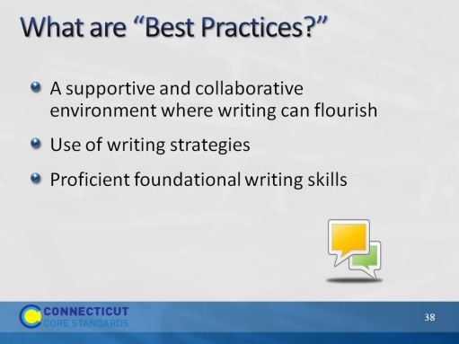Slide 38
Read the list below, ask participants to listen for the practices they named. Ask them if they are surprised by any, or if they named any they think should have been there and are not.

Create a supportive environment where writing can flourish
Clear, specific, and challenging goals
Arrangements in which students work together
Write often, and for a variety of purposes
Real audiences
Personal choices
Write for extended periods
Teach writing strategies
Strategies for writing process – planning, drafting, revising, and editing
Pre-writing activities
Graphic organizers
Characteristics of text types and genres
Teach foundational writing skills
Handwriting, typing, spelling
Syntax
Convention
Sentence and paragraph structure
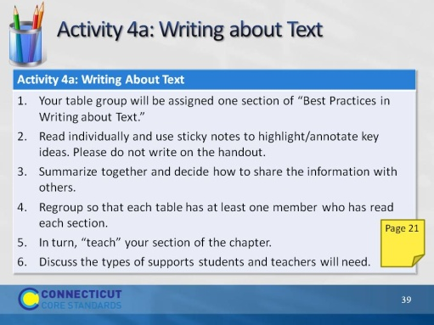Slide 39
This activity will take 50 minutes. Directions for this activity are in the Participant Guide.
Say: “The purpose of this activity is to become familiar with four research-supported approaches to writing about text.” Direct participants to turn to the correct page in their guide, then briefly review the directions. When step 6 is completed, move to the next slide.
Assign a number to each table group, re-organizing the tables as needed to even out the size of the groups.
- Assign each table one section of “Best Practices in Writing about Text.”
Sections are as follows:
- Intro ‒ pp. 334–335
- Writing to Text Models – pp 336–338
- Summarizing Text – pp. 338–340
- Writing about Text – bottom p. 340–p. 343
- Text Synthesis – pp. 343–347
- Direct participants to read individually and use stikcy notes to highlight/annotate for key ideas. Remind participants to not write on the handout as these will collected and reused at future sessions. (10 minutes)
- Each table summarizes their section together, and decides how to best share the information with others in a 3 minute presentation. (10 minutes)
- Regroup so that each table now has at least one member who has read each section.
- In turn, “teach” your section of the chapter. (15 minutes – 3 minutes per group)
- Discuss: How can these research-based practices be adapted for secondary students? What support will students need in order to do the types of writing described in this chapter. What support will teachers need? (10 minutes)
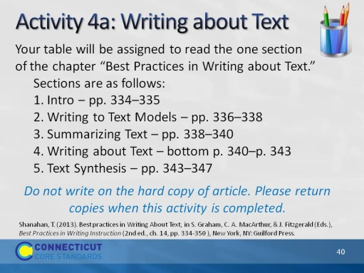Slide 40
Blank.

