Module 2  Facilitator Guide | Focus on Content Standards

Section 4

Connecticut Core Standards for Mathematics

Grades K–5

Systems of Professional Learning

Connecticut Core Standards Systems of Professional Learning
The material in this guide was developed by Public Consulting Group in collaboration with staff from the Connecticut State Department of Education and the RESC Alliance. The development team would like to specifically thank Ellen Cohn, Charlene Tate Nichols, and Jennifer Webb from the Connecticut State Department of Education; Leslie Abbatiello from ACES; and Robb Geier, Elizabeth O’Toole, and Cheryl Liebling from Public Consulting Group.
The Systems of Professional Learning project includes a series of professional learning experiences for Connecticut Core Standards District Coaches in English Language Arts, Mathematics, Humanities, Science, Technology, Engineering, Mathematics (STEM), and Student/Educator Support Staff (SESS).
Participants will have continued support for the implementation of the new standards through virtual networking opportunities and online resources to support the training of educators throughout the state of Connecticut.
Instrumental in the design and development of the Systems of Professional Learning materials from PCG were: Sharon DeCarlo, Debra Berlin, Jennifer McGregor, Judy Buck, Michelle Wade, Nora Kelley, Diane Stump, and Melissa Pierce.

Published 2014. Available online at http://ctcorestandards.org/

Session at-a-Glance

Section 4: Meeting the Expectations of the Content Standards by Teaching with Cognitively Rigorous Tasks (85 minutes)

Training Objectives:
- For participants to understand the definition of a cognitively rigorous task.
- To deepen participants understanding of why incorporating cognitively rigorous tasks into their mathematics instruction is important.
- To examine strategies that can be used to incorporate cognitively rigorous tasks that will benefit all students.
Participants begin by viewing the video Dan Meyer: Math Class Needs a Makeover, which is about problem solving. Participants will discuss the video and compare their previous experience with solving Two Machines, one Job with Dan Meyer’s message in the video.
Participants are then shown how scaffolds can be removed slowly from a problem in order to deepen the level of cognitive rigor. Participants use Hess’s Cognitive Rigor Matrix to discuss the problem example.
Participants will brainstorm how cognitively rigorous mathematics tasks can be used to benefit all students and will be presented with four strategies that can be used to differentiate cognitively rigorous tasks for all students, as needed, in order to provide multiple entry points into the mathematics while maintaining the problem’s rigor.
Participants will wrap up the activity by making connections back to “conceptual understanding,” “fluency,” and “application” and how each of these is addressed through cognitively rigorous tasks.

Supporting Documents:
- Hess’s Cognitive Rigor Matrix for Mathematics and Science
- Strategies for Differentiating Cognitively Rigorous Tasks
- Resources for Finding Tasks
- Reflect

Materials:
- Chart paper, markers

Video:
- Dan Meyer: Math Class Needs a Makeover
http://www.ted.com/talks/dan_meyer_math_curriculum_makeover.html

PowerPoint Slides:
- 41–59

Session Implementation
Section 4
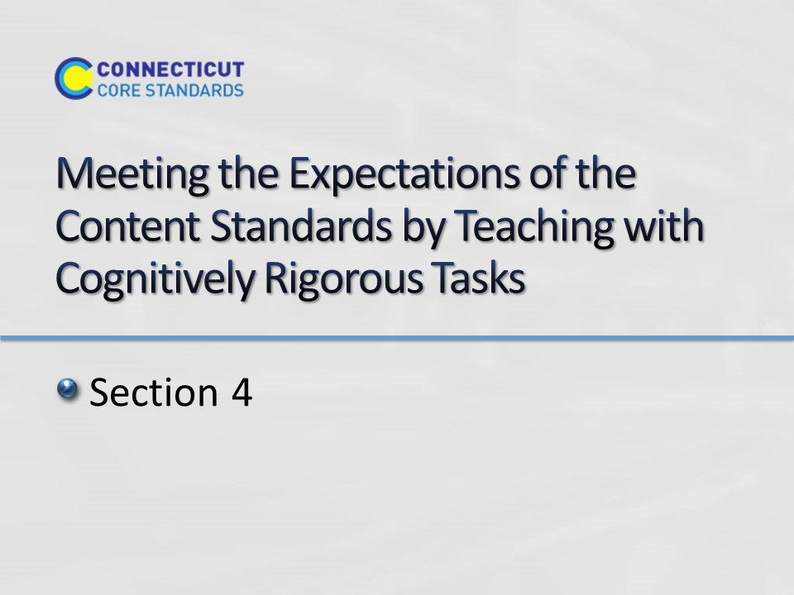
Slide 41
Section 4: Meeting the Expectations of the Content Standards by Teaching with Cognitively Rigorous Tasks
Total Time on Section 4: 85 minutes
Section 4 Training Objectives:
- For participants to understand the definition of a cognitively rigorous task.
- To deepen participants understanding of why incorporating cognitively rigorous tasks into their mathematics instruction is important.
- To examine strategies that can be used to incorporate cognitively rigorous tasks that will benefit all students.
Section 4 Outline:
- Participants begin by viewing the video Dan Meyer: Math Class Needs a Makeover which is about problem solving. Participants will discuss the video and compare their previous experience with solving Two Machines, One Job with Dan Meyer’s message in the video.
- Participants are then shown how scaffolds can be removed slowly from a problem in order to deepen the level of cognitive rigor. Participants use Hess’s Cognitive Rigor Matrix to discuss the problem example.
- Participants will brainstorm how cognitively rigorous mathematics tasks can be used to benefit all students and will be presented with four strategies that can be used to differentiate cognitively rigorous tasks for all students, as needed, in order to provide multiple entry points into the mathematics while maintaining the problem’s rigor.
- Participants will wrap up the activity by making connections back to “conceptual understanding,” “fluency,” and “application” and how each of these is addressed through cognitively rigorous tasks.
Supporting Documents
Hess’s Cognitive Rigor Matrix for Mathematics and Science
Strategies for Differentiating Cognitively Rigorous Tasks notes page
Resources for Finding Tasks
Reflect worksheet
Materials
Chart paper, markers
Video
Dan Meyer: Math Class Needs a Makeover
Background Resources
- Use the following to gain a deeper understanding of Bloom’s Taxonomy, Depth of Knowledge, and Hess’ Cognitive Rigor Matrix that will be used during this section.
  - Bloom’s Taxonomy: http://cft.vanderbilt.edu/guides-sub-pages/blooms-taxonomy/
  - Depth of Knowledge: http://schools.nyc.gov/NR/rdonlyres/2711181C-2108-40C4-A7F8-76F243C9B910/0/DOKFourContentAreas.pdf
  - Karen Hess & Cognitive Rigor Matrix: http://vimeo.com/20998609 and http://www.sde.idaho.gov/site/common/webinars/Cognitive%20Rigor%20Matrix%20Article_Hess,%20Carlock,%20Jones,%20and%20Walkup.pdf
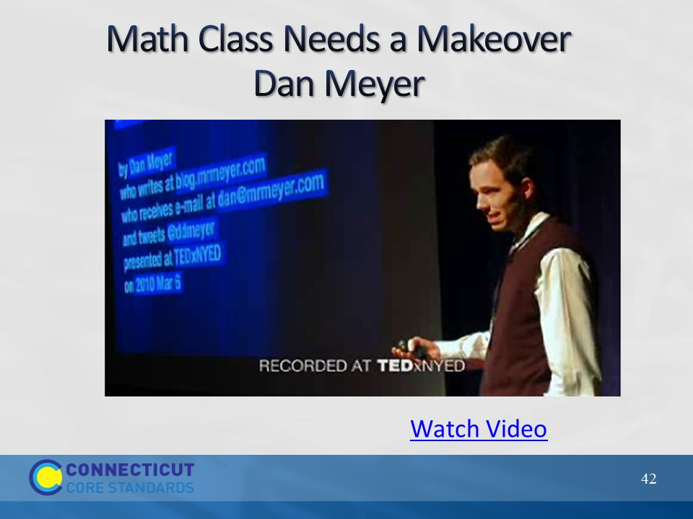
Slide 42
Math Class Needs a Makeover
Begin the activity by explaining to participants that they are going to watch a video in which math expert Dan Meyer discusses the types of problems that students should be doing in math class. Further set up the video by explaining that the examples given in the video are from a secondary classroom. Ask participants to not focus so much on the task itself but the message that is being delivered as it will be the topic of the discussion that will follow.
Click on “Watch Video” to play the video Math Class Needs a Makeover from here: http://www.ted.com/talks/dan_meyer_math_curriculum_makeover.html. The video is 11:39 long.
After viewing, debrief the video with participants by first asking for their thoughts on Dan Meyer’s message. After two or three volunteers share, explain to participants that one of the keys to using the types of problems that Dan Meyer talks about is taking a math problem and removing part, if not all, of the scaffolding that is in place within the problem itself and moving the scaffolding into the process of teaching. Transition to the next slide by having participants think back to their experience in Module 1 when they solved the Two Machines, One Job problem.
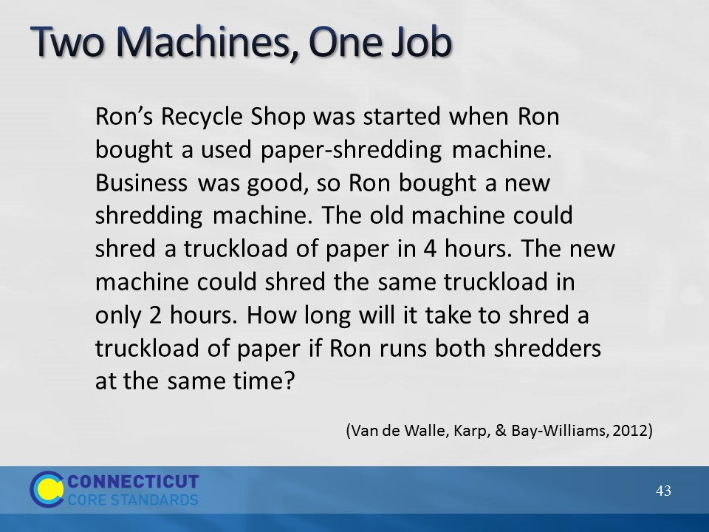
Slide 43
Ask participants to look and determine what, if any, scaffolds are in place within the problem itself. When thinking about scaffolds in this context they should look for anything in the problem that is given, but that students could actually figure out for themselves. This should be a short discussion because all of the scaffolding took place within the teaching during the task through suggestions to draw pictures when someone was stuck, through asking and answering questions to help an individual participant move forward, etc. Scaffolding took place in the moment and was individualized to each persons’ needs. Allow participants to briefly discuss the differences in their experience with solving a problem with scaffolds built in to the teaching rather than having scaffolds built into the problem.
Now, have participants turn to Hess’ Cognitive Rigor Matrix for Math and Science on page 21 in their Participant Guide. Go over how to read the matrix; revised Bloom’s Taxonomy are on left hand side going down and Webb’s Depth of Knowledge levels go across the page. In their groups have participants determine where, for them, the Two Machines, One Job problem falls on the matrix. As time permits, ask groups to share their determination and what evidence, in the problem and the implementation of the problem, they used to make this judgment.
Transition to the next slide by explaining to participants that they will now look at a K-5 problem.
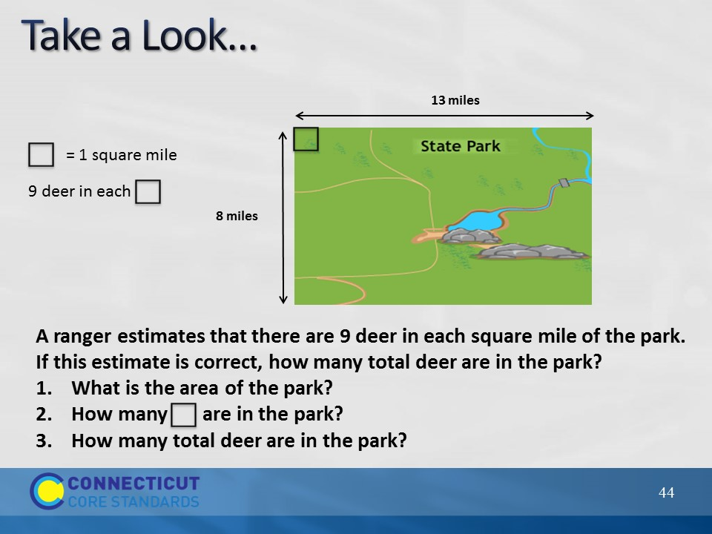
Slide 44
Have participants look at the problem on the slide and determine its placement on the Cognitive Rigor Matrix and have groups share their response.
Note: This is a 4th grade sample assessment task that has been modified to provide extensive scaffolding. At the end of this activity, participants will view the actual assessment task without the scaffolds in place. Due to the added scaffolding, this problem would fall somewhere around the Apply/DOK Level 1 range because students are asked to follow a given set of steps and only need to apply the formula for area and complete the multiplication to answer the problem.
After participants have shared their response and an agreement is made on the matrix placement, transition to the next slide by asking how the problem might change if some or all of the scaffolding is removed.
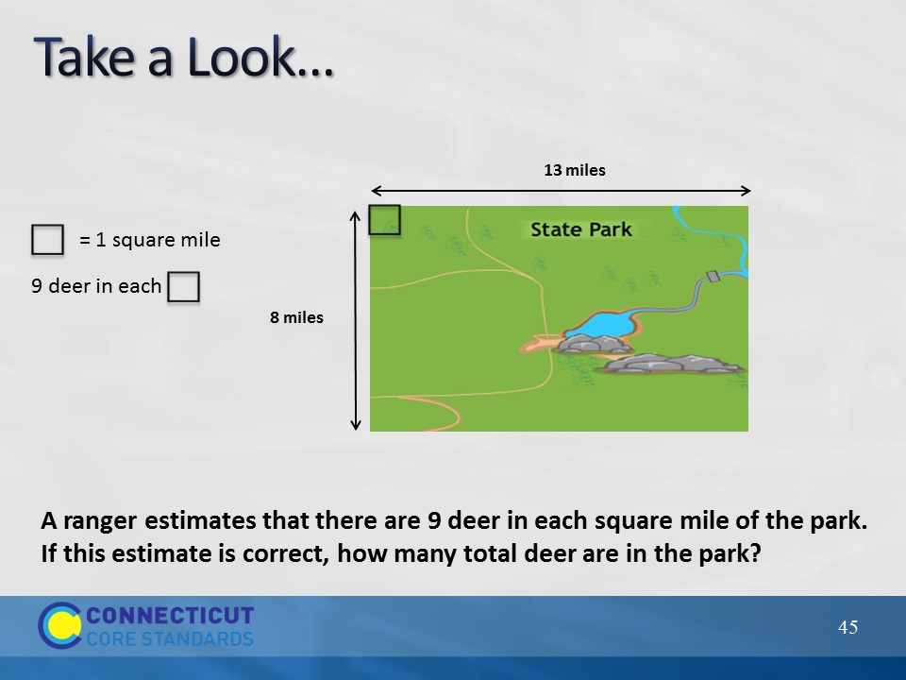
Slide 45
Have participants determine if removing the scaffold (the steps to follow) changes the problems placement on the matrix. Some participants may say that the placement has not change, however an argument can be made here that the problem is still in the Apply range but has moved to DOK 2 because students need to make the determination of having to calculate the area vs. being specifically asked to find the area in the previous version. As there are elements of both DOK 1 and DOK 2 present in the problem, a definitive level may not be agreed upon, however that is okay because the two are very closely related. As long as participants are not way off on their placement determination go ahead and move to the next slide where more of the scaffolding has been removed.
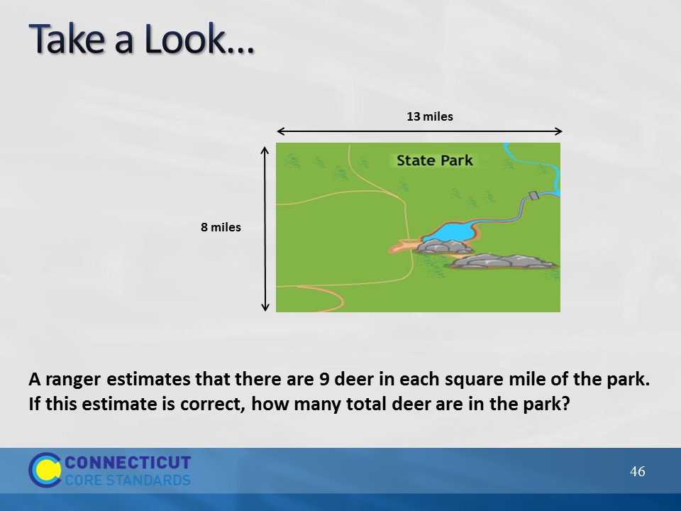
Slide 46
Have participants repeat the process of determining the problem’s placement on the matrix. But note, as more of the scaffolding falls away, where the problem actually falls is beginning to become more dependent on what students know and how the teacher implements the problem. For example, if students do not understand what a ‘square mile means’, they may need investigate the problem further with the teacher’s assistance which may push the problem further into the Analyze range. However, if a student understands this concept and is easily able to calculate the area and multiply to find the total number of deer, and this would then stay in the Apply range.
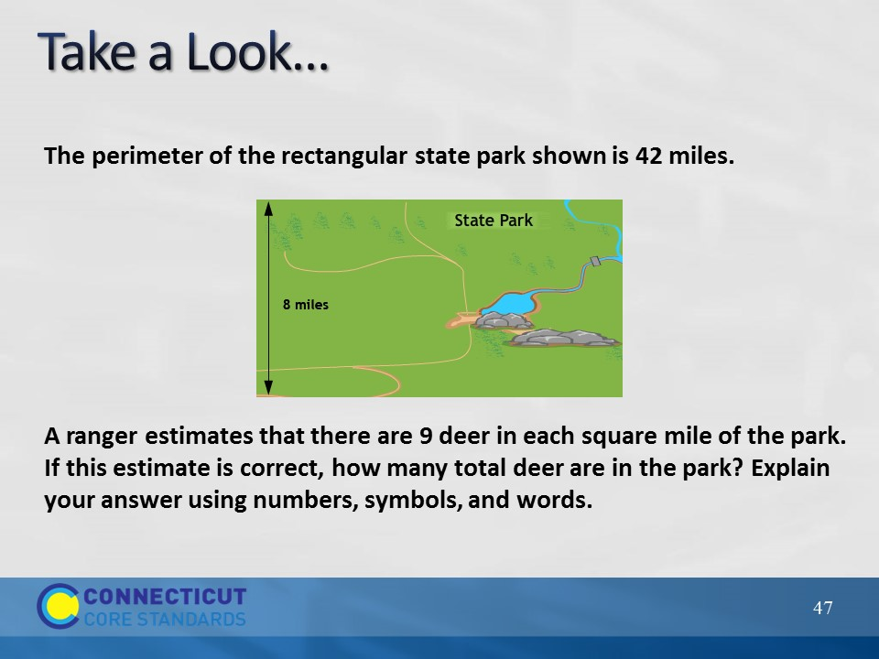
Slide 47
Take a Look
Have participants examine the original task and determine its placement on the matrix. The problem has changed significantly because students have to understand the relationship between perimeter and area and be able to work towards determining the area after they have completed calculations to construct the perimeter. Again, the placement on the matrix will be dependent somewhat on students’ understanding and teacher implementation, but if focusing on what the tasks is asking it should be placed somewhere around the Apply/Analyze and DOK 3 range. Again, make sure that participants understand that not every problem is going to fit nicely into one spot on the matrix, but that they should be able to find a general area based on the criteria given.
Provide background on the task and discuss the Content and Practice Standards addressed. Finally, ask participants what challenges they may face when asking teachers to move students towards thinking at this level of mathematics. A key point to bring out in the discussion if it is not brought out by participants is that many teachers may feel that not all students are ready to work tasks such as this. Use the answer to this question to transition to the next slide.
Note:
Use the following as the task is debriefed with the participants:
Task Background: The following is background information provided by the Dana Center about this specific task: “In the grade 3 CCSSM, students developed their understanding of area and perimeter by solving real-world and mathematical problems involving rectangles with a missing side length. In the grade 4 CCSSM, students now apply this securely held knowledge for the first time to solve multistep problems. This task is innovative because students go much deeper than just demonstrating their ability to solve area and perimeter problems. They reason about the model and the relationship between area and perimeter. Students must move in and out of context as they create a coherent representation of the problem, consider the units involved, and attend to the meaning of quantities.”
Content Standards covered by the task: 4.OA.3, 4.NBT.5 and build off of 3.MD.7b and 3.MD.8.
Slide 48
The Big Question
Explain to participants that if students are going to be expected to work cognitively rigorous tasks, such as those Dan Meyer discussed, as they enter middle and high school, we have to prepare them for this in K–5. The question now becomes “How can I help teachers incorporate cognitively rigorous tasks that will benefit all students?” This is the question participants will focus on now. Explain to participants that they will now examine strategies that can be used to provide multiple pathways into the mathematics of cognitively rigorous tasks so that all students can benefit from its use.
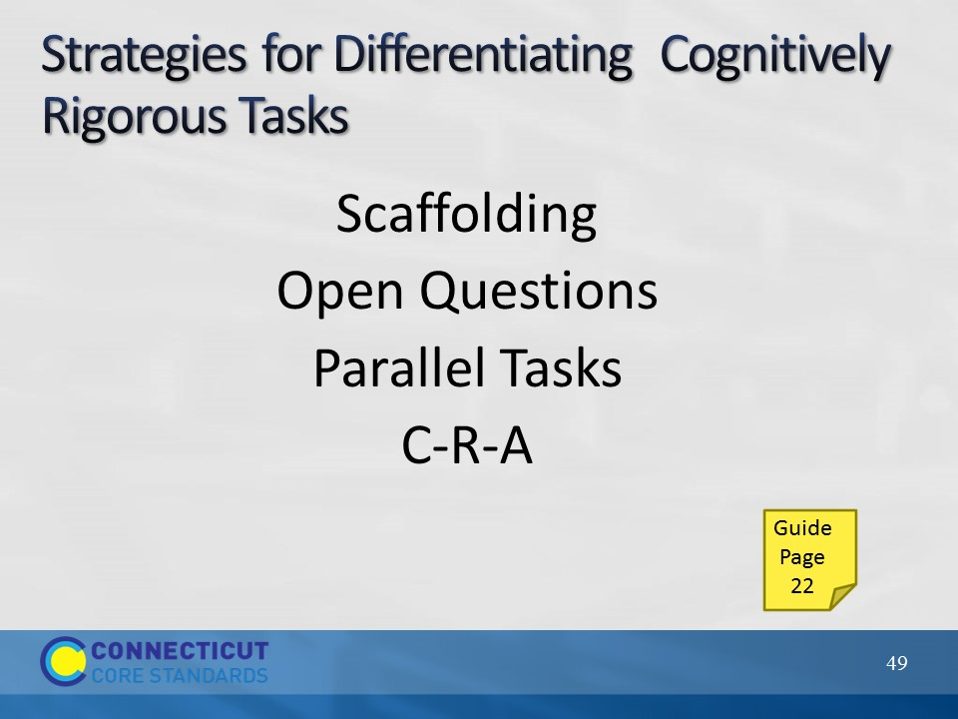
Slide 49
This begins the discussion of the four strategies listed on the slide. Explain that one of the key things to keep in mind when differentiating mathematics tasks is that teachers will want to be sure to make modifications or offer choices in tasks that allow students the needed point for entry into the mathematics, but at the same time keeping the level of rigor high. Often mathematics is differentiated by providing ‘easier’ tasks to students who may not yet be ready for the main task. These ‘easier’ tasks sometimes lower the level of rigor to the point that the students’ receiving that task are never given the opportunity to engage in deeper reasoning about the mathematics. Whenever possible, teachers should maintain the level of rigor, but make modifications in such a way that a solution is still within the students’ reach. The five strategies that will be discussed are those that teachers can use to do just that.
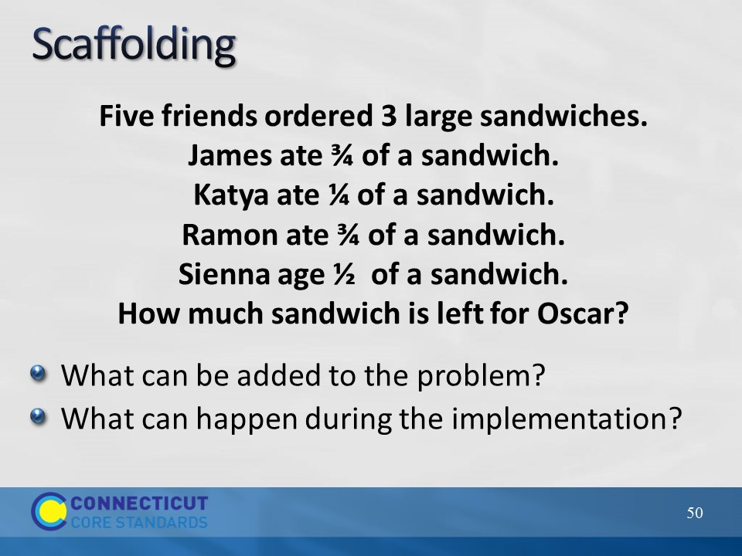
Slide 50
Begin by revisiting scaffolding. Explain to participants that just as we stripped the scaffolding away from the deer problem earlier to increase the level of rigor of the problem, scaffolding can be added back in, as needed, to help students reason about the mathematics. These scaffolds can be added back in through the problem itself or through the implementation (questioning, group work, representations, etc). The key here would be to start with the original or root task and then add the scaffolding as needed by the student, when the student reaches the point of not being able to go any further. Teachers should plan the scaffolds out beforehand so that they are ready to provide them within the lesson.
Have participants discuss scaffolds that can be added to the problem and those that can be added during implementation. Chart participants’ responses for later reference.
Problem background:
This is a Grade 4 sample item from Smarter Balanced. Note that while this is a sample assessment item the context used here is using the problem as an instructional task. This task addresses standard 4.NF.3.2a and 2d. Notes from SBAC on this task: “By grade 4 students should understand that each sandwich in this problem represents the same whole, and therefore operations with fractions can be used in solving this problem.”
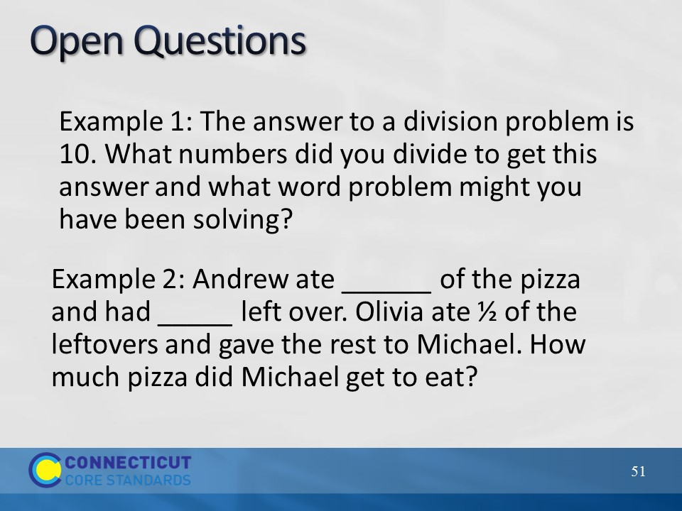
Slide 51
Open Questions
Explain to participants that open questions are questions posed in problem form to students that allow multiple responses and approaches to correctly answer the questions. These types of questions allow all students, no matter their developmental and readiness level, to participate in small and large group mathematical discussions.
Show Example 1 and ask participants to solve this individually. Then, have participants share their answers and briefly discuss how even though they may have used different numbers and created a different problem everyone was essentially working on the same concept. Have participants determine where on the Cognitive Rigor Matrix this problem might fall.
Repeat this process for the remaining examples on this slide and on the next slide.
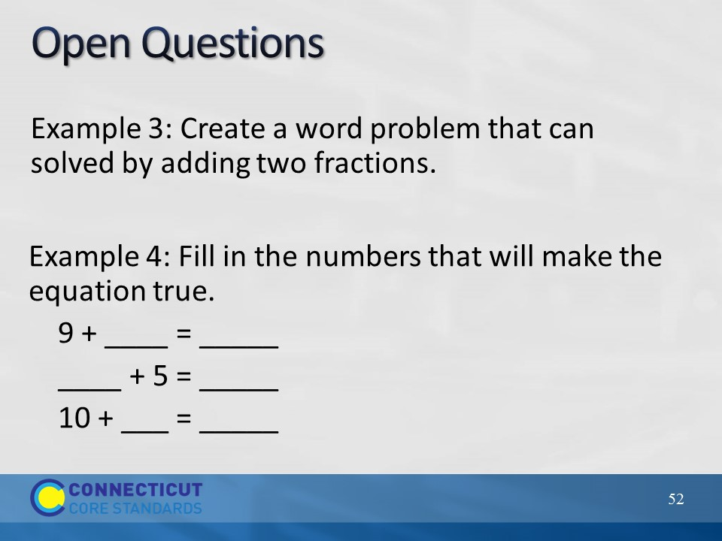
Slide 52
After going over the two examples, ask participants to think for a moment about how they might introduce this strategy to teachers and what example they might use during their introduction. Participants may need to utilize the standards to create an example of an open question if one of the four examples here will not work for a particular grade level, or they may modify one of the examples shown here. After participants complete their notes, move on to the next strategy, parallel tasks.
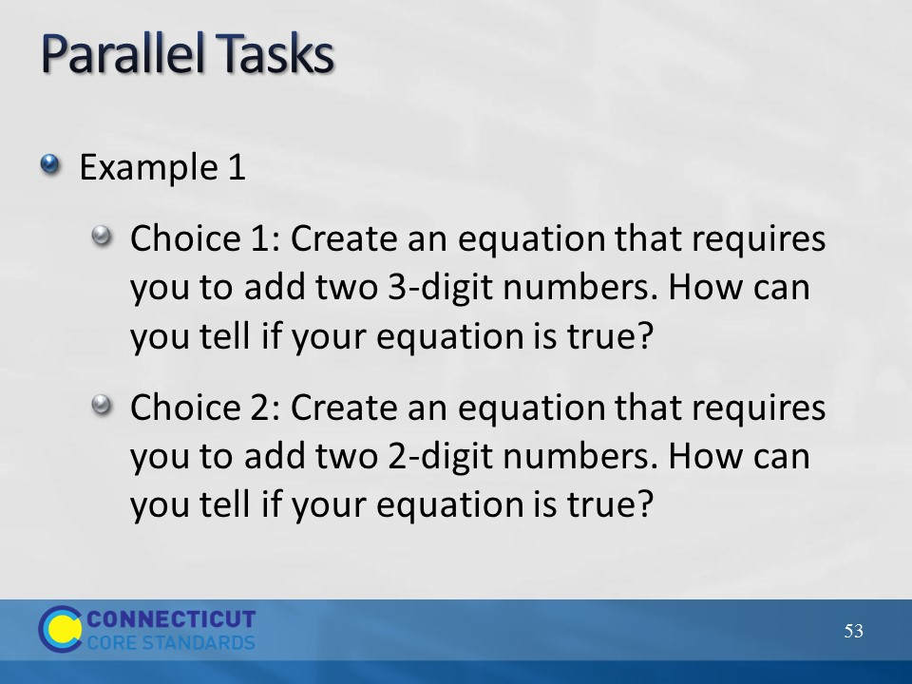
Slide 53
Explain to participants that parallel tasks are sets of tasks that students can choose from that are close enough to address the same standard(s) but different enough to allow for the multiple entry points into the mathematics. Also, just as with open questions, students, no matter which task they have selected, are able to equally engage in mathematical discussions.
Go over Example 1 on the slide and Example 2 on the next slide.
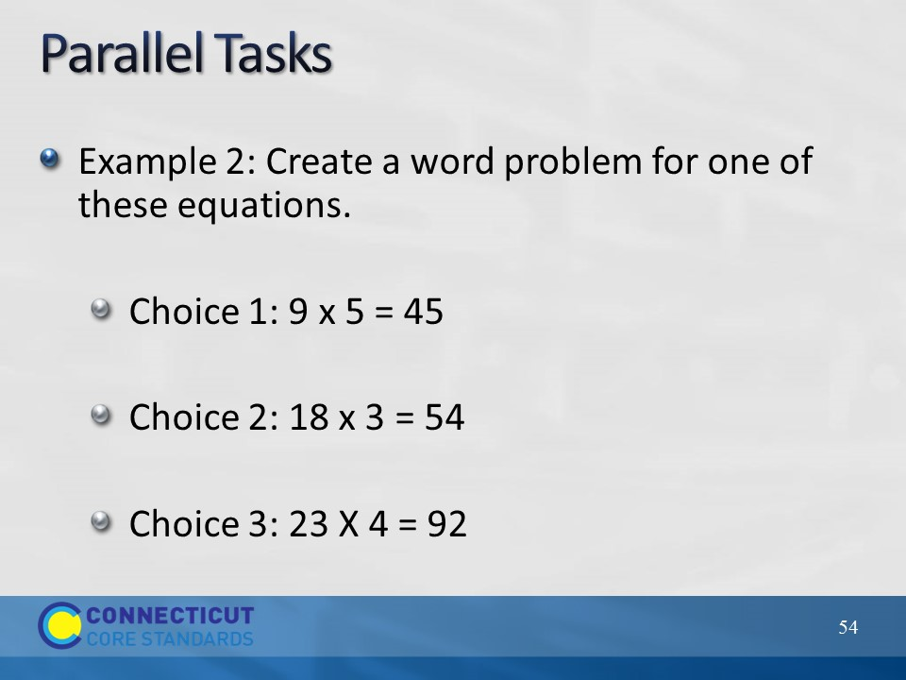
Slide 54
After going over the example, have participants discuss at their table how parallel tasks are related to open questions. Then, have them think about how they might introduce this strategy to teachers and what example they might use during their introduction. Participants may need to utilize the standards to create an example of an open question if one of the four examples here will not work for a particular grade level, or they may modify one of the examples shown here.
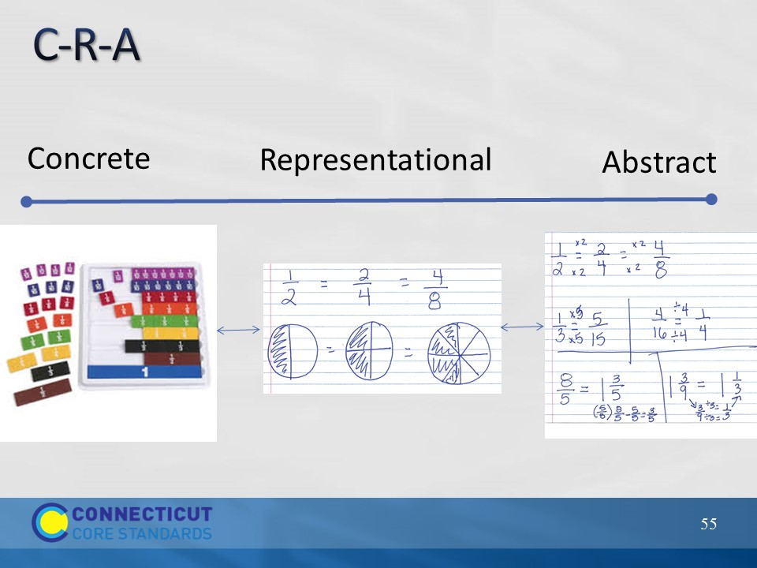
Slide 55
Explain to participants that C-R-A stands for concrete to representational to abstract and is a strategy for differentiation that does not involve changing the problem, but rather, involves changing the models students use to solve the problem. C-R-A can be thought of as a continuum where we want all students to eventually get to the point of using abstract (mathematical symbols) models to represent a problem, but some students may need to step back on the continuum to representational models (drawings) or even to concrete models (some form of manipulative). Teachers should move students along the continuum, both forward and backward, as needed. Again, however, with the end goal of getting to the abstract. Have participants again think about the Two Machines, One Job experience from Module 1. How many needed to draw a picture before solving the problem using abstractly? This is the same situation that students may encounter.
For additional information on C-R-A see http://www.coedu.usf.edu/main/departments/sped/mathvids/strategies/cra/html
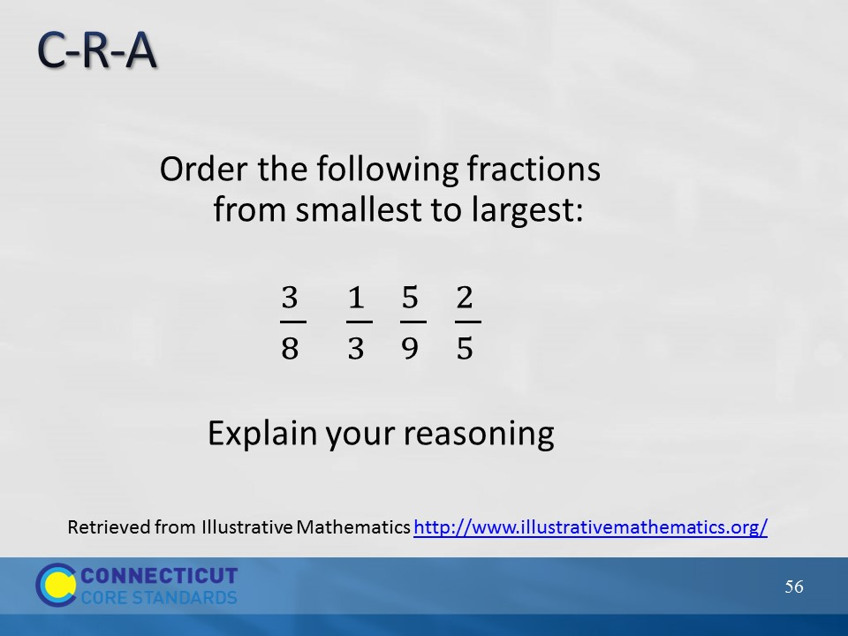
Slide 56
Have participants discuss with their group how they might use C-R-A to help students complete the task on the slide, and determine how they might move a student forward on the continuum based on the student’s entry point. Participants can generate their ideas on chart paper and as time permits, present their strategies to the larger group.
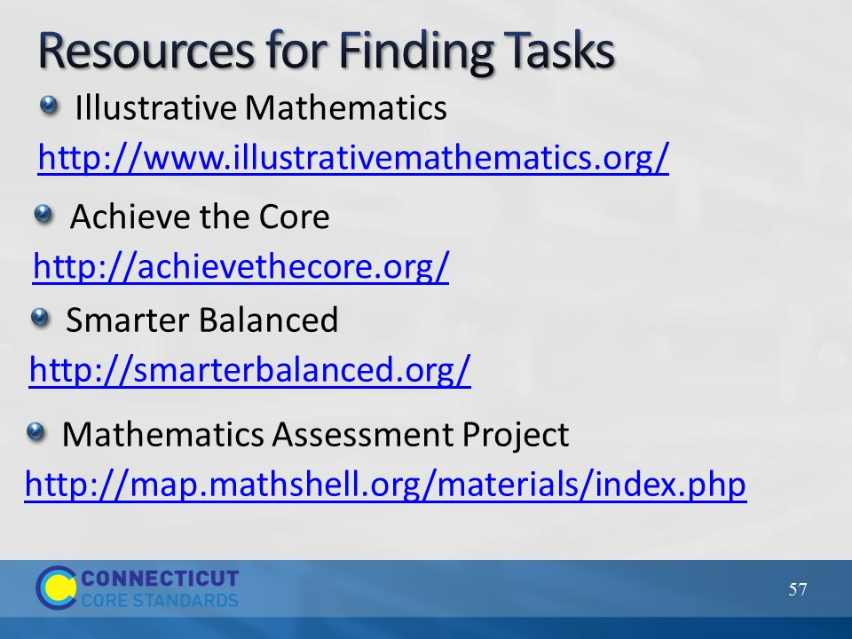
Slide 57
Explain to participants that the strategies that they just examined and discussed can be used with tasks from their curricular materials or, if needed, they can find additional tasks online. If time permits and if an internet connection is available, show participants the tasks available at each of the resources on the slide.
Wrap up this section by having participants complete the reflection, either individually or in small groups, on the next slide.
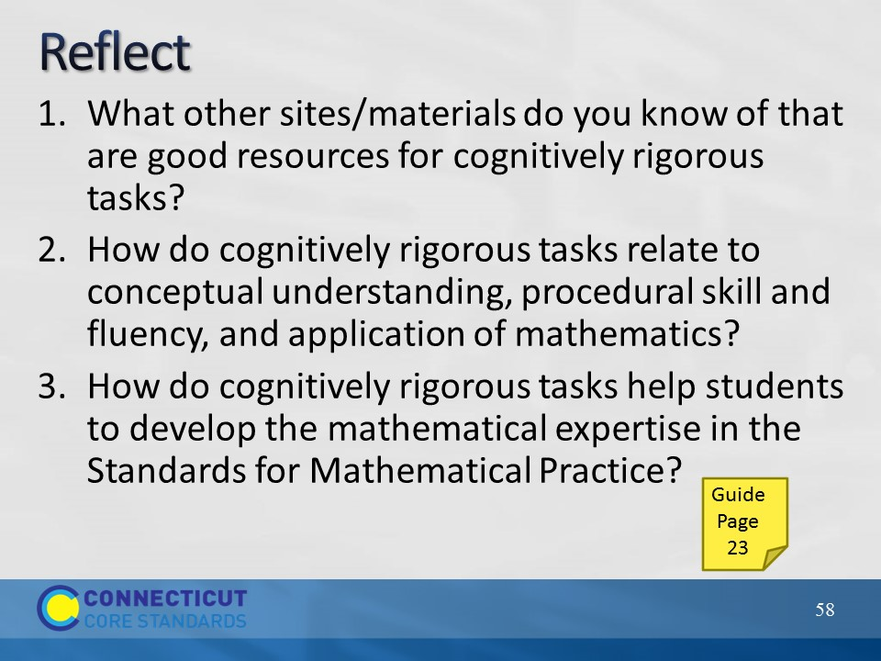
Slide 58
Reflect
Allow participants to respond to the reflection questions on the slide and in their Participant Guide on page 23. As time permits have volunteers share their thinking.
Transition to the next section by telling participants that now that they have looked at strategies for creating multiple entry ways into the mathematics through the problems provided, they will now examine instructional strategies that can be used by teachers to implement tasks. Because participants will be moving from table to table in the next activity, ask participants to put their personal belongings to the side.

