Module 2  Facilitator Guide | Focus on Content Standards

Closing Activity

Connecticut Core Standards for Mathematics

Grades K–5

Systems of Professional Learning

Connecticut Core Standards Systems of Professional Learning
The material in this guide was developed by Public Consulting Group in collaboration with staff from the Connecticut State Department of Education and the RESC Alliance. The development team would like to specifically thank Ellen Cohn, Charlene Tate Nichols, and Jennifer Webb from the Connecticut State Department of Education; Leslie Abbatiello from ACES; and Robb Geier, Elizabeth O’Toole, and Cheryl Liebling from Public Consulting Group.
The Systems of Professional Learning project includes a series of professional learning experiences for Connecticut Core Standards District Coaches in English Language Arts, Mathematics, Humanities, Science, Technology, Engineering, Mathematics (STEM), and Student/Educator Support Staff (SESS).
Participants will have continued support for the implementation of the new standards through virtual networking opportunities and online resources to support the training of educators throughout the state of Connecticut.
Instrumental in the design and development of the Systems of Professional Learning materials from PCG were: Sharon DeCarlo, Debra Berlin, Jennifer McGregor, Judy Buck, Michelle Wade, Nora Kelley, Diane Stump, and Melissa Pierce.

Published 2014. Available online at http://ctcorestandards.org/

Session at-a-Glance

Closing Activities (15 minutes)
Participants will complete a Post-Assessment and an online Session Evaluation.

Supporting Documents:
- Post-Assessment
- Session Evaluation (online)

PowerPoint Slides:
- 64–68

Session Implementation
Closing Activities
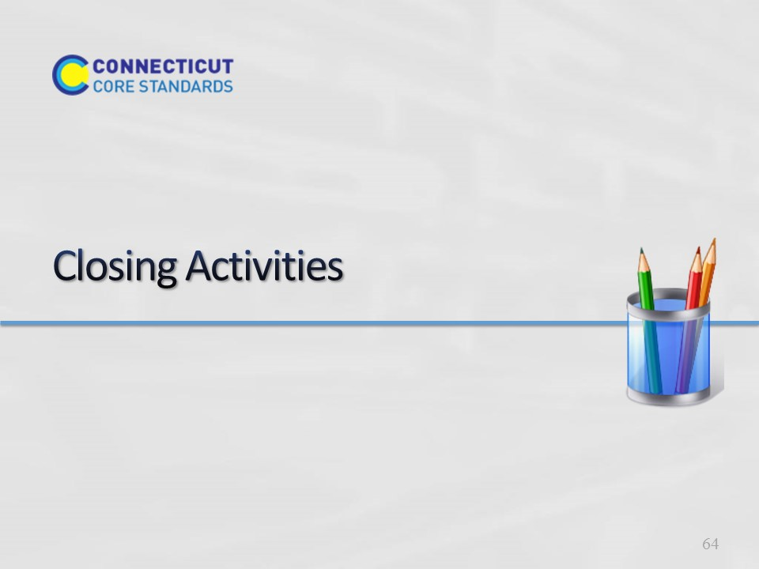
Slide 64
The goal of the Closing Activites is for participants to determine how they will take the key information back to their peers at their school so that everyone gains a shared understanding.
Total Time on Closing Activities: 5 minutes
Closing Activities at a Glance:
1. Review the Module 2 Outcomes.
2. Have participants complete the Post-Assessment.
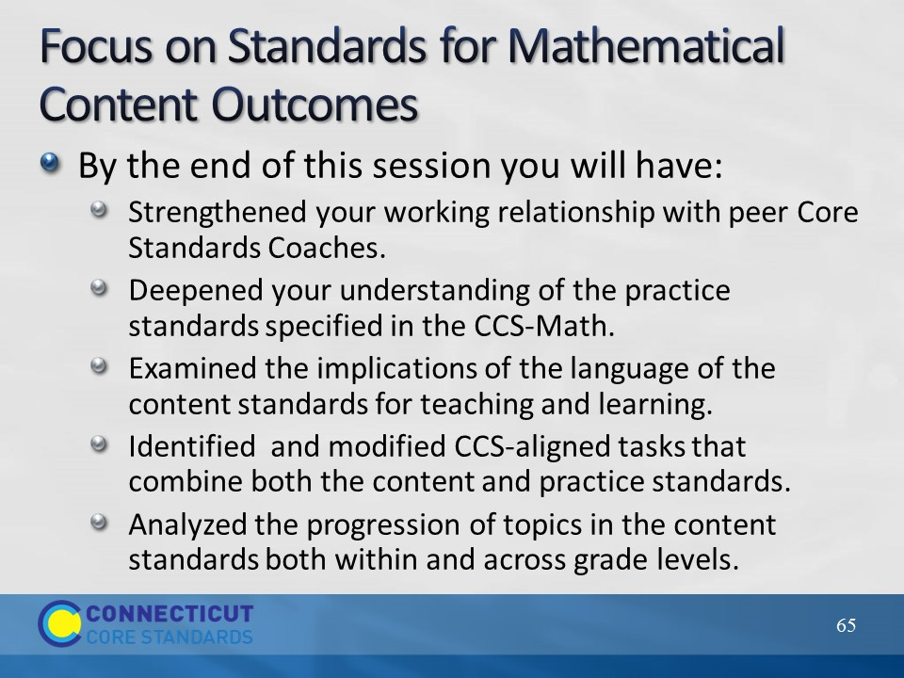
Slide 65
Review the outcomes for the day.
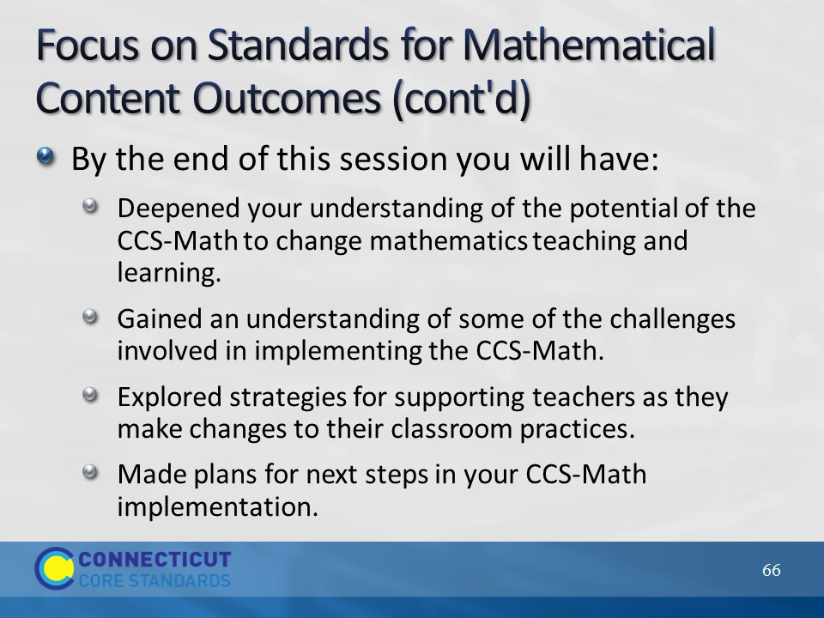
Slide 66
Review the outcomes continued.
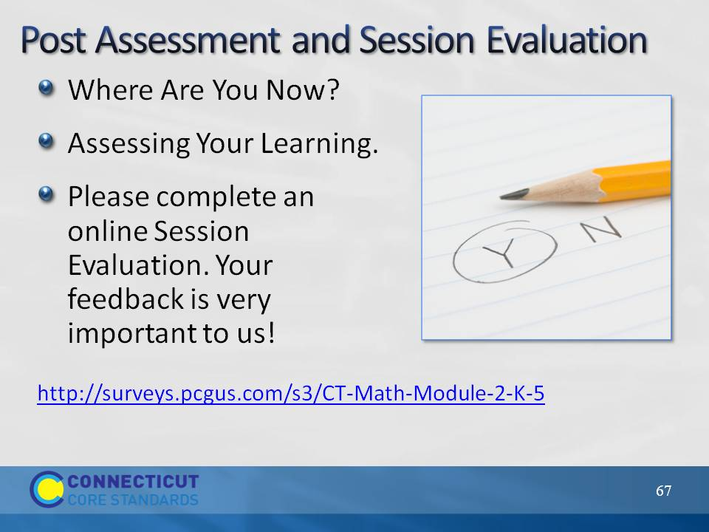
Slide 67
This Post-Assessment is the same as the Pre-Assessment they took in the beginning of the session. This assessment is to gauge their learning based on the activities of the full day session.
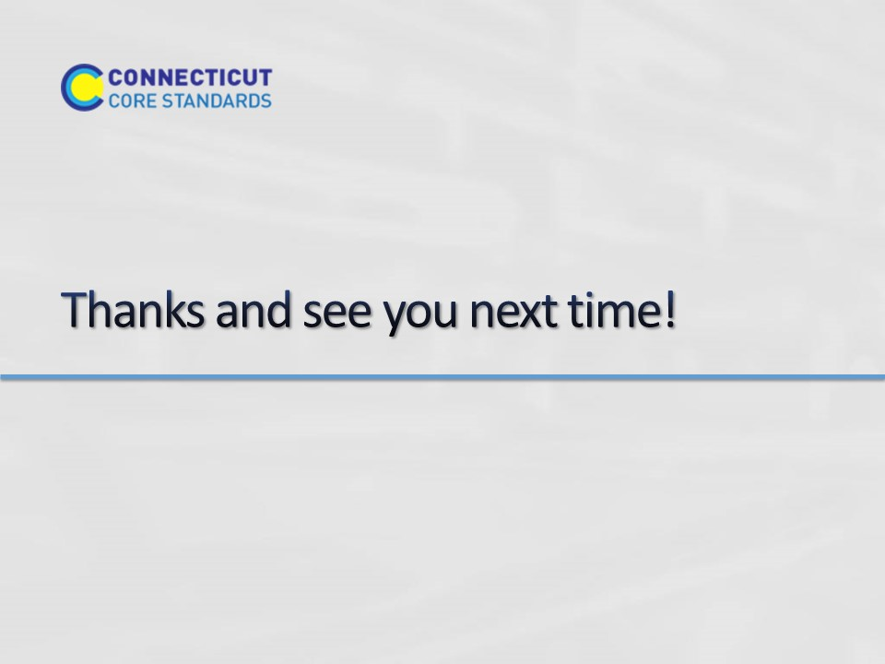
Slide 68
(Blank)

