Module 2  Facilitator Guide | Focus on Content Standards

Section 4

Connecticut Core Standards for Mathematics

Grades 6–12

Systems of Professional Learning

Session at-a-Glance

Section 5: Supporting Change (85 minutes)

Training Objectives:
- To help participants identify elements of lessons that work to develop conceptual understanding, procedural skill and fluency, and application of mathematics.
- To provide participants with instructional strategies for teaching the content standards through problem solving, for helping students to develop procedural skill and fluency, and to provide students with opportunities to apply their mathematical understandings.
- To have participants create a plan for disseminating big ideas from the session with teachers at their school.
- To have participants anticipate specific teacher questions and challenges around implementing lessons that incorporate the Standards for Mathematical Content.

Supporting Documents:
- Video Observation Sheets
- A New Spin on Old Strategies
- Group 1: Math Journals
- Group 2: Mathematical Language
- Group 3: Instructional Implementation Sequence: Attaining the CCSS Mathematical Practices Engagement Strategies (separate handout)
- Group 4: Group Work and Decision Making
- Next Steps

Videos:
- What’s Your Sign: Integer Addition
https://www.teachingchannel.org/videos/adding-integers-lesson-idea
- Zero Pairs, Manipulatives, and a Real-World Scenario
https://www.teachingchannel.org/videos/teaching-subtracting-integers

Materials:
- Chart paper, markers

PowerPoint Slides:
- 60–63

Session Implementation
Section 5
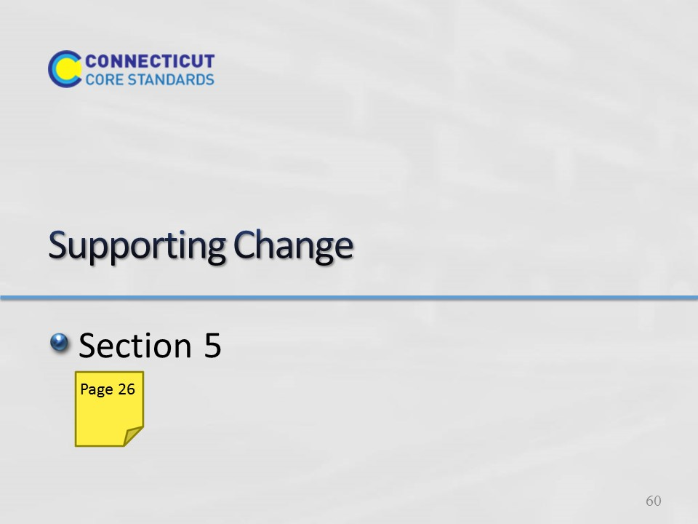
Slide 60
Section 5: Supporting Change
Section 5 Time: 85 minutes

Section Training Objectives:
- To help participants identify elements of lessons that work to develop conceptual understanding, procedural skill and fluency, and application of mathematics.
- To provide participants with instructional strategies for teaching the content standards through problem solving, for helping students to develop procedural skill and fluency, and to provide students with opportunities to apply their mathematical understandings.
- To have participants create a plan for disseminating big ideas from the session with teachers at their school
- To have participants anticipate specific teacher questions and challenges around implementing lessons that incorporate the Standards for Mathematical Content

Section 5 Outline:
- Participants will begin by watching the videos What’s Your Sign? and Zero Pairs, Manipulatives, and a Real-World Scenario. During each video, participants will take notes on the corresponding Video Observation worksheet. After watching both videos, they will discuss the strategies that were seen and the evidence provided as a large group and chart strategies to use as a master resource.
- Participants will then begin to think about areas of instructional practice that will need to be addressed with the teachers with whom they work. Participants will be asked to consider this through the lens of approaching teachers with the idea of rather than learning to teach in a completely new way, working towards enhancing the instructional strategies in place now so that they help students to meet the expectations of the CCS-Math. To experience this, participants will explore ways that current strategies, such as concept cards/maps, journals, group work, decision making and so forth, can be restructured to meet the new expectations. Participants will jigsaw each of the instructional strategy areas during which they will examine instructional strategies and/or examples, discuss how the examples can be implemented, and generate at least one new idea to share with others.
- Participants will return to their ‘home’ group and discuss their strategy and new idea and as a group will wrap-up the activity by working together to make a plan for helping the teachers they work with understand and implement the key ideas and strategies presented in the module.

Section 5 Supporting Documents
- Video Observation Sheets
- A New Spin on Old Strategies
- Group 1: Math Journals
- Group 2: Mathematical Language
- Group 3: Instructional Implementation Sequence: Attaining the CCSS Mathematical Practices Engagement Strategies (separate handout)
- Group 4: Group Work and Decision Making
- Next Steps

Section 5 Materials
Chart paper, Markers

Notes: If time is a factor at this point in the day, you may opt to only play one video, giving participants enough time to review each of the strategies in the Jigsaw activity.

Slide 61
What’s Your Sign?
Pass out the CCSS Instructional Practice Guide. Explain to participants that they will watch two videos; both lessons focus on operations with integers in Grade 7 classrooms. While watching the videos, participants can make notes on the Video Observation sheet provided in the Participant Guide on pages 26-27. The goal of watching the videos is to get participants looking for examples of the important aspects of teaching the Content Standards that have been discussed throughout this session, but to also look at additional teaching strategies that they want to bring back to teachers at their school.

Begin by watching the first video, What’s Your Sign?: Integer Addition, that shows part of a Grade 7 lesson. Click on “Watch Video” to play the video from here: https://www.teachingchannel.org/videos/adding-integers-lesson-idea. The video is 5 minutes long.
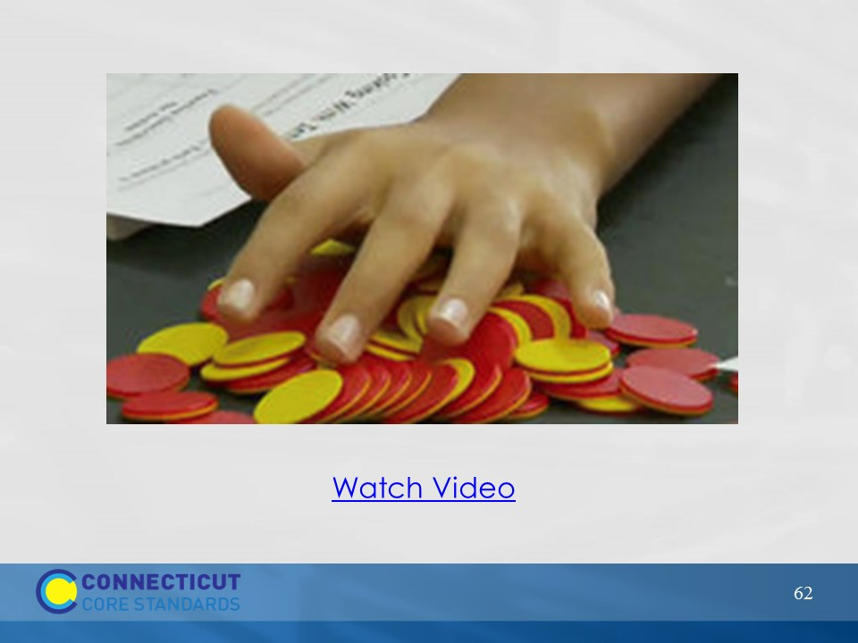
Slide 62
Zero Pairs, Manipulatives, and a Real-World Scenario
Watch the video Zero Pairs, Manipulatives, and a Real-World Scenario. Click on “Watch Video” to play the video from here: https://www.teachingchannel.org/videos/teaching-subtracting-integers. The video is 6 minutes long.

Chart the instructional strategies used by the teachers in the two videos.

Explain to participants that they will now have an opportunity to explore some additional strategies and resources for teaching the CCS-Math Content Standards.
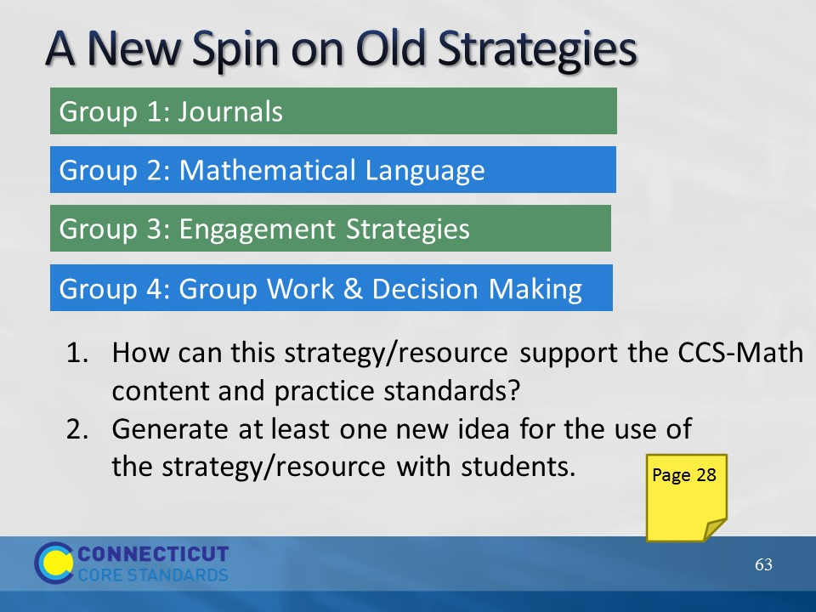
Slide 63
A New Spin on Old Strategies
Participants will work in small groups to examine four different Math strategies and/or resources. The group that the participant sat in to watch the video will become their home group. Have participants number off at each table until everyone has a number representing 1, 2, 3, or 4. Then, participants will move into their Jigsaw groups (1’s will become Group 1 and discuss Journals, 2’s will become Group 2 and discuss Mathematical Language, etc.). On the notes page in the Participant Guide, each participant should note key points that come out of the discussion and the group should develop at least one new way to implement the strategy being discussed. (Allow 15 minutes for the Jigsaw discussions)

When time is called, participants will move back to their ‘home’ group and each person will have 5 minutes to discuss their strategy/resource.

Notes about setting up and managing movement to tables:
- In cases where you are working with a large number of participants, create multiple Jigsaw groups (e.g., two to three groups labeled as Group 1, two to three groups labeled as Group 2, etc.) so that there are no more than six participants at any one table at any one time.
- •Make sure that each table is clearly labeled (using the cardstock that has been provided) so that groups are not trying to figure out where they are going as they move.
- •Give participants a 1 minute wrap up warning at each table so that they can conclude their conversations and prepare to move to the next table.

“Set up” this activity to participants by explaining that they might explore strategies they already know. However, a new spin has been put on each strategy in order to meet the challenges presented by the CCS-Math. Also, explain that at there is space within the Participant Guide on pages 28-29 on which they can make notes about the important points they want to bring back to their ‘home’ group and to teachers at their school.

After the ‘home’ group discussion is complete, debrief the strategies/resources as a large group and highlight and chart some new ideas generated.
Transition to the last part of this section by asking participants how they will now share this information back at their school site and allow participants to make notes on the Next Steps worksheet on page 39 in the Participant Guide.

