Module 2  Facilitator Guide | Focus on Content Standards

Section 4

Connecticut Core Standards for Mathematics

Grades 6–12

Systems of Professional Learning

Session at-a-Glance

Section 4: Meeting the Expectations of the Content Standards by Teaching with Cognitively Rigorous Tasks (85 minutes)

Training Objectives:
- For participants to understand the definition of a cognitively rigorous task.
- To deepen participants understanding of why incorporating cognitively rigorous tasks into their mathematics instruction is important.
- To examine strategies that can be used to incorporate cognitively rigorous tasks that will benefit all students.
Participants begin by viewing the video Dan Meyer: Math Class Needs a Makeover which is about problem solving. Participants will discuss the video and compare their previous experience with solving Two Machines, one Job with Dan Meyer’s message in the video.
Participants are then shown how scaffolds can be removed slowly from a problem in order to deepen the level of cognitive rigor. Participants use Hess’s Cognitive Rigor Matrix to discuss the problem example.
Participants will brainstorm how cognitively rigorous mathematics tasks can be used to benefit all students and will be presented with four strategies that can be used to differentiate cognitively rigors tasks for all students, as needed, in order to provide multiple entry points into the mathematics while maintaining the problem’s rigor.
Participants will wrap up the activity by making connections back to “conceptual understanding,” “fluency,” and “application” and how each of these is addressed through cognitively rigorous tasks.

Supporting Documents:
- Video Observation Sheet
- Hess’s Cognitive Rigor Matrix for Mathematics and Science
- Strategies for Differentiating Cognitively Rigorous Tasks
- Resources for Finding Tasks
- Reflect

Materials:
- Chart paper, markers

Video:
- Dan Meyer: Math Class Needs a Makeover
http://www.ted.com/talks/dan_meyer_math_curriculum_makeover.html

PowerPoint Slides:
- 41–58

Session Implementation
Section 4
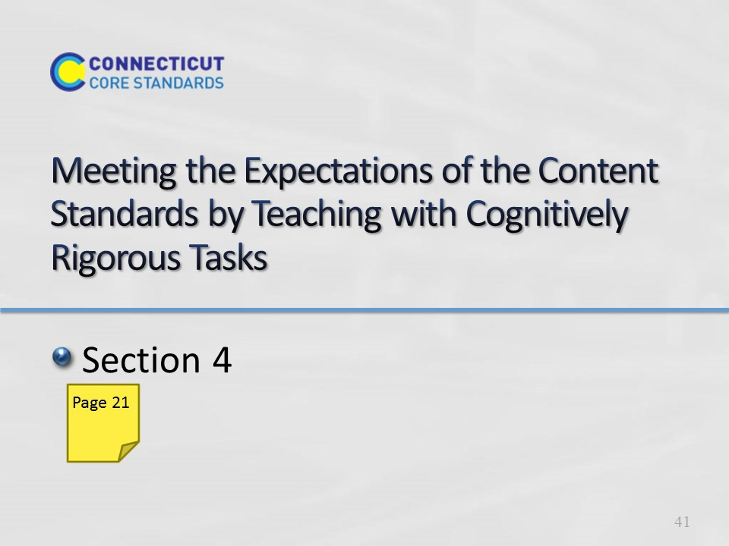
Slide 41
Section 4: Meeting the Expectations of the Content Standards by Teaching with Cognitively Rigorous Tasks

Total Time on Section 4: 85 minutes

Section 4 Training Objectives:
- For participants to understand the definition of a cognitively rigorous task.
- To deepen participants understanding of why incorporating cognitively rigorous tasks into their mathematics instruction is important.
- To examine strategies that can be used to incorporate cognitively rigorous tasks that will benefit all students.

Section 4 Outline:
- Participants begin by viewing the video Dan Meyer: Math Class Needs a Makeover, which is about problem solving. Participants will discuss the video and compare their previous experience with the Kites Activity with Dan Meyer’s message in the video.
- Participants are then shown how scaffolds can be removed slowly from a problem in order to deepen the level of cognitive rigor. Participants use Hess’s Cognitive Rigor Matrix to discuss the problem example.
- Participants will brainstorm how cognitively rigorous mathematics tasks can be used to benefit all students and will be presented with four strategies that can be used to differentiate cognitively rigorous tasks for all students, as needed, in order to provide multiple entry points into the mathematics while maintaining the problem’s rigor.
- Participants will wrap up the activity by making connections back to “conceptual understanding,” “fluency,” and “application” and how each of these is addressed through cognitively rigorous tasks.

Supporting Documents
Video Observation Sheet
Hess’s Cognitive Rigor Matrix for Mathematics and Science
Strategies for Differentiating Cognitively Rigorous Tasks notes page
Resources for Finding Tasks
Reflect worksheet

Materials
Chart paper, markers

Video
Dan Meyer: Math Class Needs a Makeover

Background Resources
- Use the following to gain a deeper understanding of Bloom’s Taxonomy, Depth of Knowledge, and Hess’ Cognitive Rigor Matrix that will be used during this section.
- Bloom’s Taxonomy: http://cft.vanderbilt.edu/guides-sub-pages/blooms-taxonomy/
- Depth of Knowledge: http://schools.nyc.gov/NR/rdonlyres/2711181C-2108-40C4-A7F8-76F243C9B910/0/DOKFourContentAreas.pdf
- Karen Hess & Cognitive Rigor Matrix: http://vimeo.com/20998609 and http://www.sde.idaho.gov/site/common/webinars/Cognitive%20Rigor%20Matrix%20Article_Hess,%20Carlock,%20Jones,%20and%20Walkup.pdf
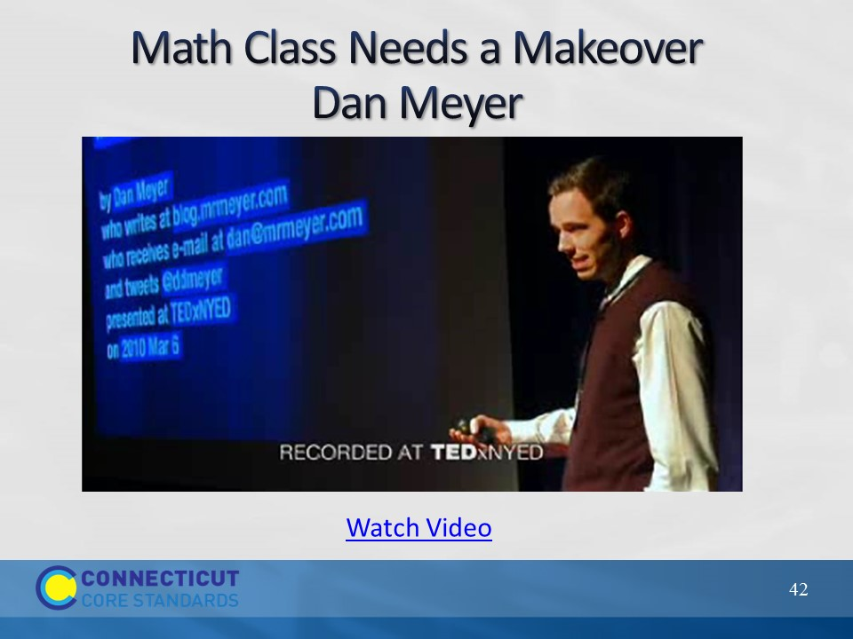
Slide 42
Math Class Needs a Makeover
Begin the activity by explaining to participants that they are going to watch a video in which math expert, Dan Meyer, discusses the types of problems that students should be doing in math class.

Click on “Watch Video” to play the video Math Class Needs a Makeover from here: http://www.ted.com/talks/dan_meyer_math_curriculum_makeover.html. The video is 11:39 long.

After viewing, debrief the video with participants by first asking for their thoughts on Dan Myer’s message. After two or three volunteers share, explain to participants that one of the keys to using the types of problems that Dan Meyer talks about is taking a math problem and removing part, if not all, of the scaffolding that is in place within the problem itself and moving the scaffolding into the process of teaching. Transition to the next slide by having participants think back to their experience in Module 1 when they worked on the Kites Activity.
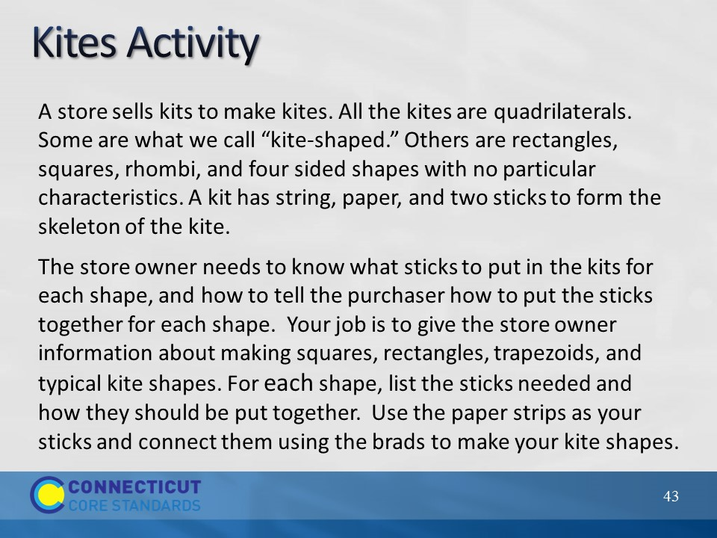
Slide 43
Ask participants to look and determine what, if any, scaffolds are in place within the problem itself. When thinking about scaffolds in this context they should look for anything in the problem that is given, but that students could actually figure out for themselves. Did scaffolding take place during the task through clarification or through asking and answering questions to help individuals move forward, etc.? Allow participants to briefly discuss the differences in their experience with solving a problem with scaffolds built in to the teaching rather than having scaffolds built into the problem.

Now, have participants turn to Hess’ Cognitive Rigor Matrix for Math and Science on page 22 in their Participant Guide. Go over how to read the matrix; revised Bloom’s Taxonomy are on left hand side going down and Webb’s Depth of Knowledge levels go across the page. In their groups, have participants determine where, for them, the Kites Activity falls on the matrix. As time permits, ask groups to share their determination and what evidence, in the problem and the implementation of the problem, they used to make this judgment.

Transition to the next slide by explaining to participants that they will now look at another problem.
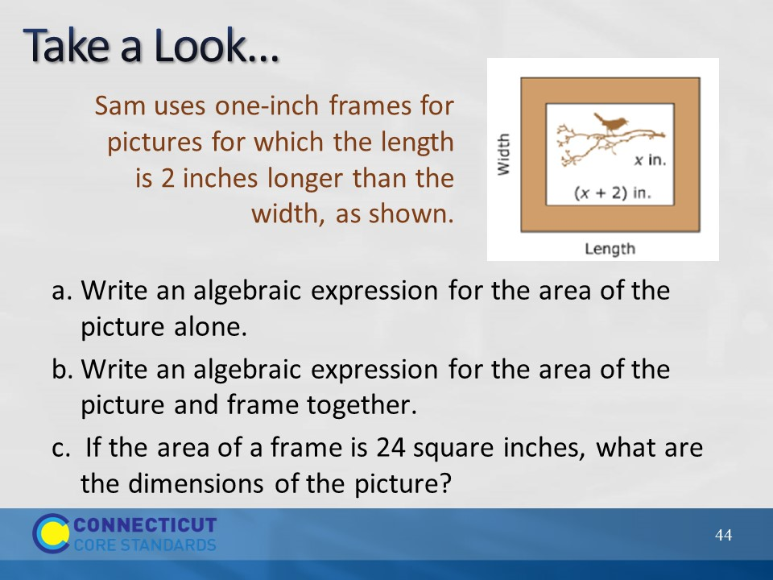
Slide 44
Have participants look at the problem on the slide and determine its placement on the Cognitive Rigor Matrix and have groups their share their response.

Note: This has been modified from a high school PARCC sample assessment task (A-SSE.1) for the purposes of this module. Due to the scaffolding, this problem would fall on the Cognitive Rigor Matrix somewhere around the Apply/DOK Level 1 range because students are provided a set of steps and only need to determine the dimensions of the frame, apply the formula for area, subtract the algebraic expressions, and solve a linear equation for x.

After participants have shared their response and an agreement is made on the matrix placement, transition to the next slide by asking how the problem might change if some or all of the scaffolding is removed.

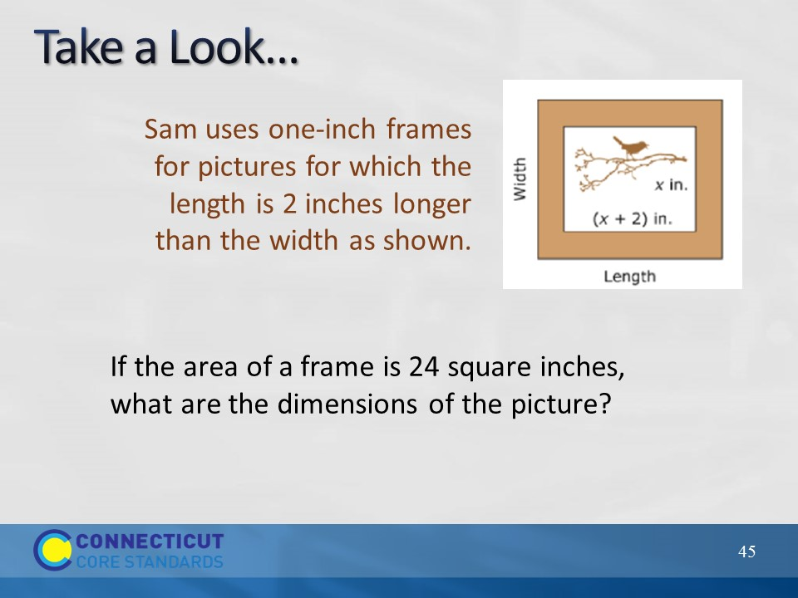
Slide 45
Have participants determine if removing the scaffold (the steps to follow) changes the problems placement on the matrix. Some participants may say that the placement has not changed, however an argument can be made here that the problem is still in the Apply range but has moved to DOK 2 because students need to make the determination of having to calculate the area of the picture, and the picture and frame, vs. being specifically asked to find the area in the previous version. As there are elements of both DOK 1 and DOK 2 present in the problem, a definitive level may not be agreed upon, however that is okay because the two are very closely related. As long as participants are not way off on their placement determination go ahead and move to the next slide where more of the scaffolding has been removed.
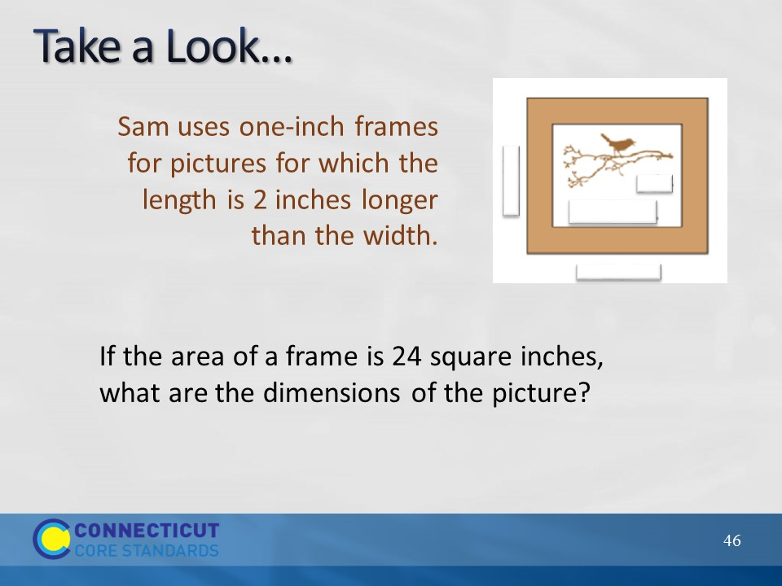
Slide 46
Have participants repeat the process of determining the problem’s placement on the matrix. But note, as more of the scaffolding is covered up, where the problem actually falls is beginning to become more dependent on what students know and how the teacher implements the problem. For example, if students do not understand what a ‘one-inch frame’ means, they may need to ask the teacher clarifying questions which may push the problem further into the Analyze range. However if students understands the concepts involved and is easily able to determine the algebraic expression that represents the area of the frame, then this would stay in the Apply range.
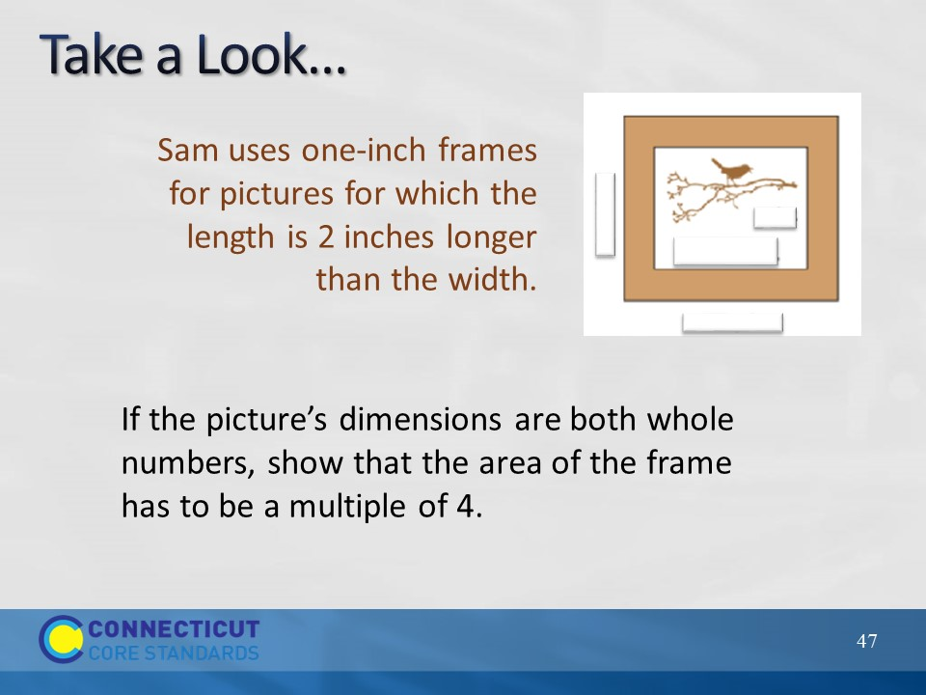
Slide 47
Take a Look
Have the participants examine the revised task and determine its placement on the matrix. The problem has changed significantly because students are generalizing relationships and interpreting the expression for the area of the frame as a multiple of 4. Again, the placement on the matrix will be dependent somewhat on students’ understanding and teacher implementation, but if focusing on what the tasks is asking, it should be placed somewhere around the Apply/Analyze and DOK 3 range. Again, make sure that participants understand that not every problem is going to fit nicely into one spot on the matrix, but that they should be able to find a general area based on the criteria given.

Finally, ask participants what challenges they may face when asking teachers to move students towards thinking at this level of mathematics. A key point to bring out in the discussion, if it is not brought out by participants, is that many teachers may feel that not all students are ready to work tasks such as this. Use the answer to this question to transition to the next slide.

Task Background: This particular task has been adapted from an Algebra I PARCC Assessment prototype task for the purposes of this Module. (Original task can be found at: http://www.parcconline.org/sites/parcc/files/HS-Alg1Math2PictureFrame.pdf)

Content Standards covered by the task as originally written: A-SSE.1-2 (identified as major content in the Algebra I course). The task was aligned to MP 7 and MP 2.
Slide 48
The Big Question
Explain to participants that if students are going to be expected to work cognitively rigorous tasks as they enter college, such as those Dan Meyer discussed, we have to prepare them for this in K-12. The question now becomes “How can I help teachers incorporate cognitively rigorous tasks that will benefit all students?” This is the question participants will focus on now. Explain to participants that they will now examine strategies that can be used to provide multiple pathways into the mathematics of cognitively rigorous tasks so that all students can benefit from its use.
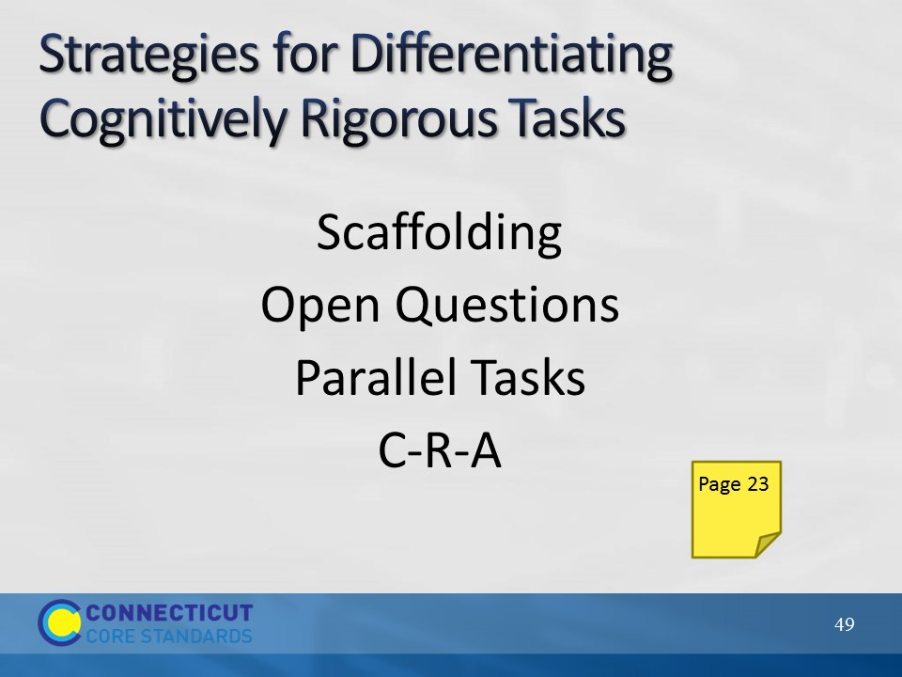
Slide 49
This begins the discussion of the four strategies listed on the slide. Explain that one of the key things to keep in mind when differentiating mathematics tasks is that teachers will want to be sure to make modifications or offer choices in tasks that allow students the needed point for entry into the mathematics, but at the same time keeping the level of rigor high. Often mathematics is differentiated by providing ‘easier’ tasks to students who may not yet be ready for the main task. These ‘easier’ tasks sometimes lower the level of rigor to the point that the students’ receiving that task are never given the opportunity to engage in deeper reasoning about the mathematics. Whenever possible, teachers should maintain the level of rigor, but make modifications in such a way that a solution is still within the students’ reach. The five strategies that will be discussed are those that teachers can use to do just that.
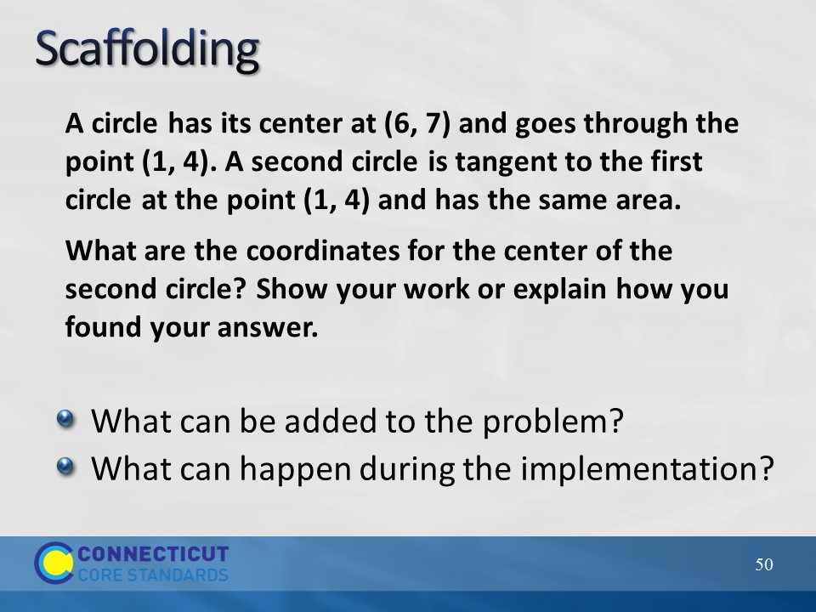
Slide 50
Begin by revisiting scaffolding. Explain to participants that just as we stripped the scaffolding away from the picture frame problem earlier to increase the level of rigor of the problem, scaffolding can be added back in, as needed, to help students reason about the mathematics. These scaffolds can be added back in through the problem itself or through the implementation (questioning, group work, representations, etc.). The key here would be to start with the original or root task and then add the scaffolding as needed by the student, when the student reaches the point of not being able to go any further. Teachers should plan the scaffolds out beforehand so that they are ready to provide them within the lesson.

Have participants discuss scaffolds that can be added to the problem and those that can be added during implementation. Chart participants’ responses for later reference.

Problem background:
This is a high school sample item from Smarter Balanced. Note that while this is a sample assessment item the context used here is using the problem as an instructional task. This task addresses standard CCSS.8.G.8 and CCSS.8.EE.6. Notes from SBAC on this task: “This item is the less difficult of two items designed to assess the same content. It lends itself to multiple approaches, including the proportional reasoning from grade 7, distance between points in the coordinate plane from grade 8, and the trigonometric approaches in high school. Smarter Balanced is exploring different student response formats for items of this type.”

For a rubric on how this item would be scored, go to: http://www.smarterbalanced.org/wordpress/wp-content/uploads/2012/09/math-rubrics/43046Rubric.pdf
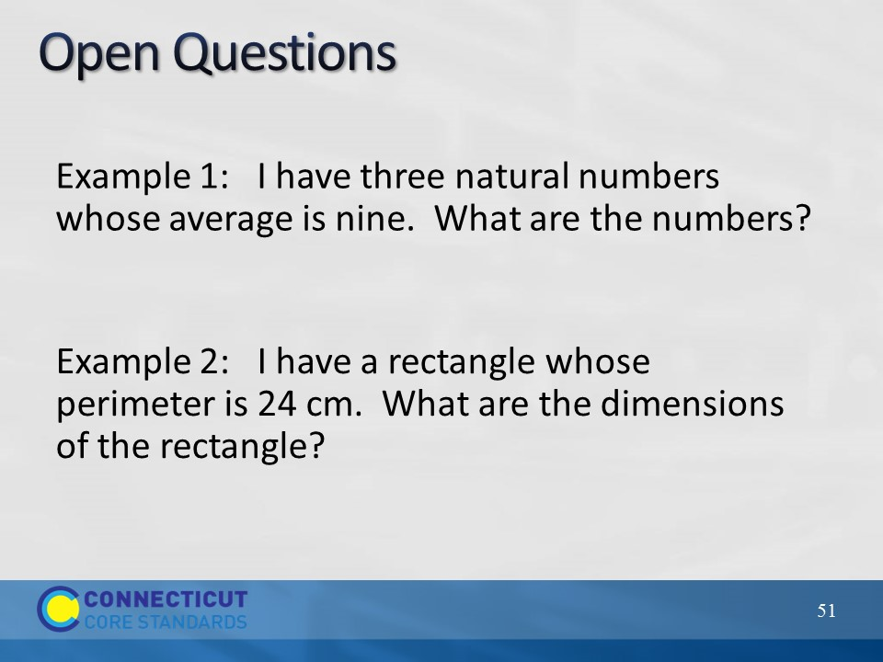
Slide 51
Open Questions
Explain to participants that open questions are questions posed in problem form to students that allow multiple responses and approaches to correctly answer the questions. These types of questions allow all students, no matter their developmental and readiness level, to participate in in small and large group mathematical discussions.
Show Example 1 and ask participants to solve this individually. Then, have participants share their answers and briefly discuss how even though they may have used different numbers and created a different problem everyone was essentially working on the same concept. Have participants determine where on the Cognitive Rigor Matrix this problem might fall.

Repeat this process for the remaining examples on this slide and on the next slide.
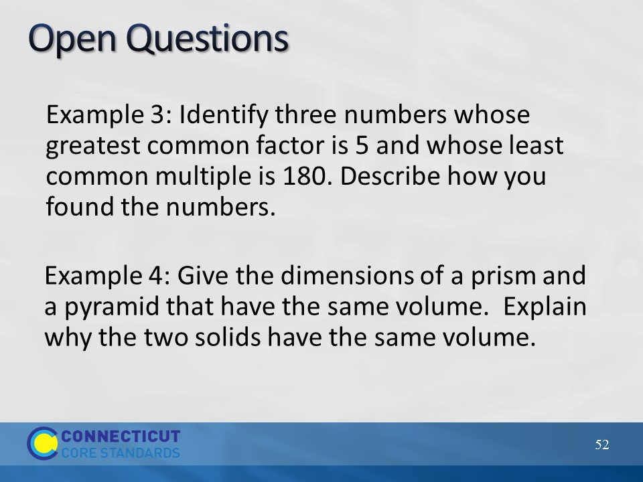
Slide 52
After going over the two examples, ask participants to think for a moment about how they might introduce this strategy to teachers and what example they might use during their introduction. Participants may need to utilize the standards to create an example of an open question if one of the four examples here will not work for a particular grade level, or they may modify one of the examples shown here. After participants complete their notes, move on to the next strategy, parallel tasks.
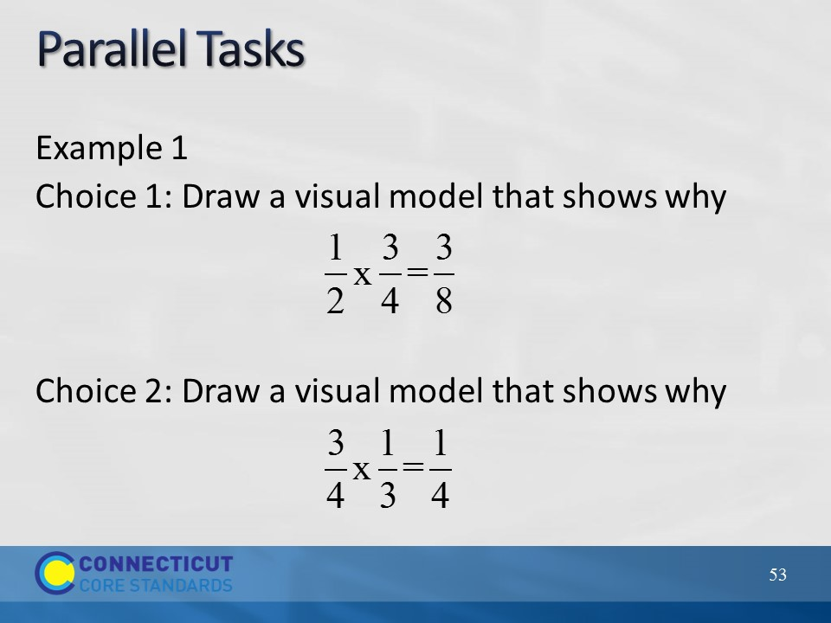
Slide 53
Explain to participants that parallel tasks are sets of tasks that students can choose from that are close enough to address the same standard(s) but different enough to allow for the multiple entry points into the mathematics. Also, just as with open questions, students, no matter which task they have selected, are able to equally engage in mathematical discussions. Go over Example 1 on the slide and Example 2 on the next slide.
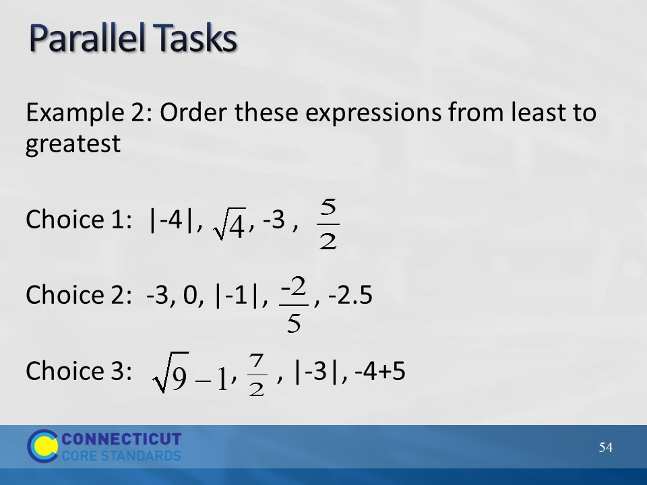
Slide 54
After going over the example, have participants discuss at their table how parallel tasks are related to open questions. Then, have them think about how they might introduce this strategy to teachers and what example they might use during their introduction. Participants may need to utilize the standards to create an example of an open question if one of the four examples here will not work for a particular grade level, or they may modify one of the examples shown here.
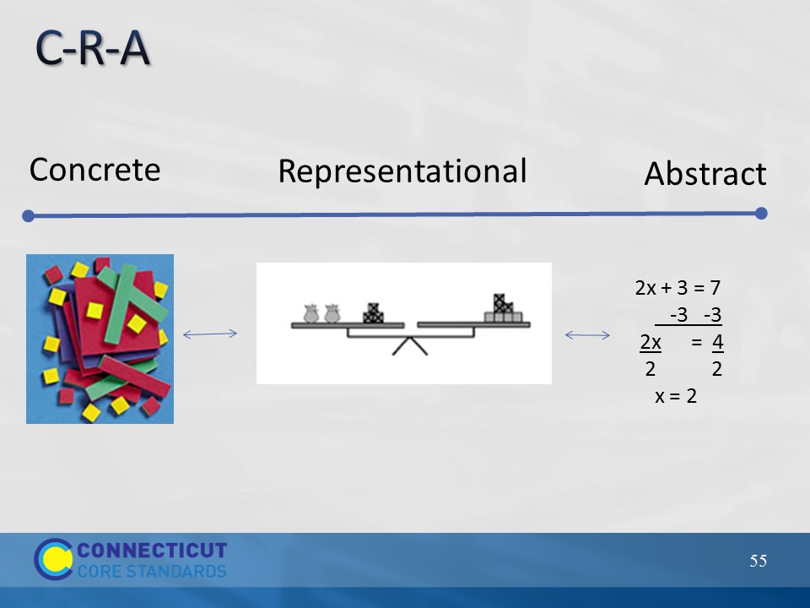
Slide 55
Explain to participants that C-R-A stands for concrete to representational to abstract and is a strategy for differentiation that does not involve changing the problem, but rather, involves changing the models students use to solve the problem. C-R-A can be thought of as a continuum where we want all students to eventually get to the point of using abstract (mathematical symbols) models to represent a problem, but some students may need to step back on the continuum to representational models (drawings) or even to concrete models (some form of manipulative). Teachers should move students along the continuum, both forward and backward, as needed. Again, however, with the end goal of getting to the abstract.

The following site provides more information on the CRA approach for facilitators: http://www.coedu.usf.edu/main/departments/sped/mathvids/strategies/cra.html
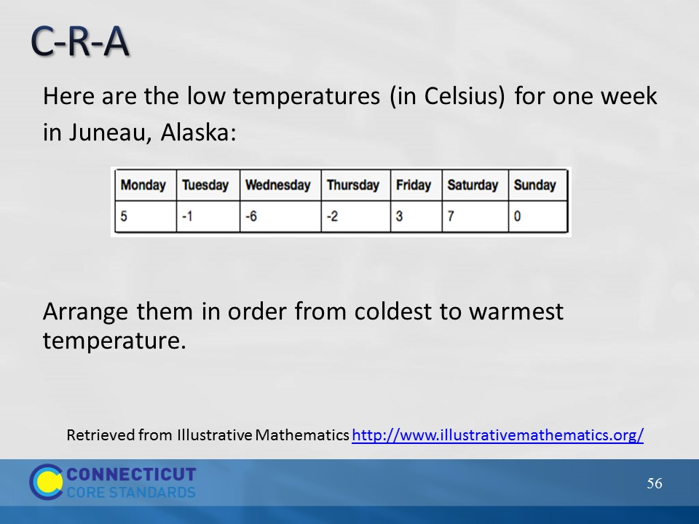
Slide 56
Have participants discuss with their group how they might use C-R-A to help students complete the task on the slide, and determine how they might move a student forward on the continuum based on the student’s entry point.
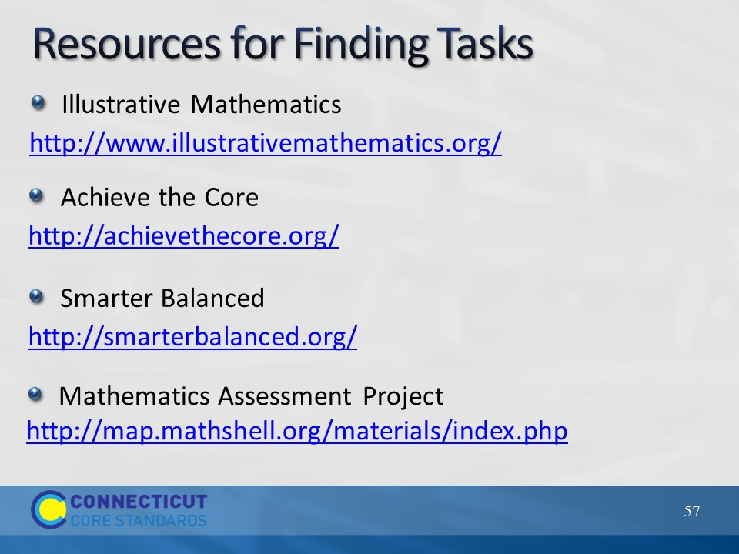
Slide 57
Explain to participants that the strategies that they just examined and discussed can be used with tasks from their curricular materials or, if needed, they can find additional tasks online. If time permits and if an internet connection is available, show participants the tasks available at each of the resources on the slide.
Wrap up this section by having participants complete the reflection, either individually or in small groups, on the next slide.
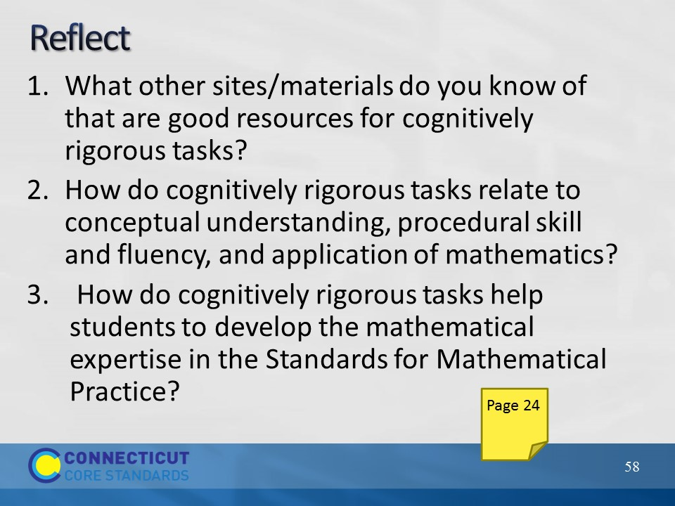
Slide 58
Reflect
Allow participants to respond to the reflection questions on the slide and in their Participant Guide on page 24. As time permits have volunteers share their thinking.

Transition to the next section by telling participants that now that they have looked at strategies for creating multiple entry ways into the mathematics through the problems provided, they will now examine instructional strategies that can be used by teachers to implement tasks. Because participants will be moving from table to table in the next activity, ask participants to put their personal belongings to the side.

