Module 2  Facilitator Guide | Supporting All Students in Close Reading, Academic Language, and Text-Based Discussion

Introductory Activities

Connecticut Core Standards for English Language Arts and Literacy

Grades K–5

Systems of Professional Learning

Session at-a-Glance

Introductory Activities (20 minutes)
- Welcome and agenda
- Forming today’s community
- Review of main topics in Module 1
- Quick write (sharing the materials and messages from Module 1 with school and district colleagues)
- Module 2 outcomes
- Pre-Assessment

Supporting Documents:
- Pre-Assessment (in the Participant Guide)
- Notepad section of the Participant Guide for the Quick Write

PowerPoint Slides:
- 1–10

Session Implementation
Introduction
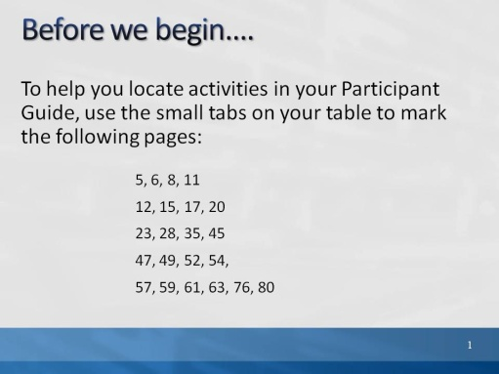Slide 1
Blank.
Slide 2
(Slides 1-7, including the Pre-Assessment, will take about 20 minutes total.)
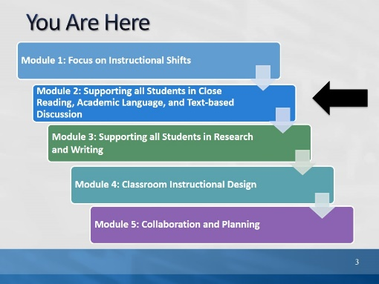Slide 3
This slide provides a visual showing how the topics for the professional development modules fit together. Briefly explain to participants.
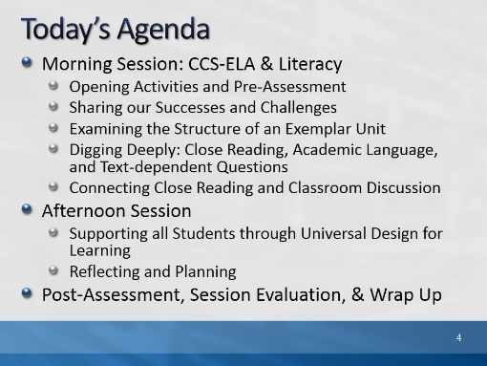Slide 4
Review the agenda, noting there will be a break for lunch as well as a short morning and afternoon break. You may want to add the importance of coming back from breaks on time to ensure enough time to complete all the work of the day.
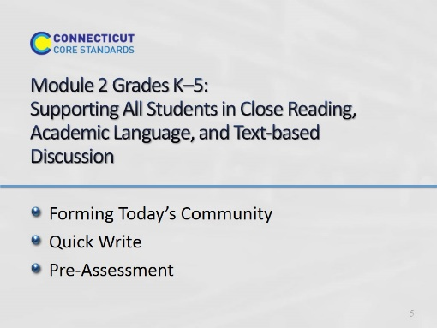Slide 5
Since participants will not be with exactly the same group of coaches as they were in Module 1, it is important to identify who is in the room, and to give them an opportunity to introduce themselves.

Remind participants that regardless of which session they attended for Module 1, they saw the same examples, learned the same information, and had similar conversations. They are all part of the same community of coaches with a goal of deepening understanding of the CT Core Standards and instructional shifts across the entire state.
In order to find out who is in the room, we’ll do a brief exercise “Like Me.” (next slide)
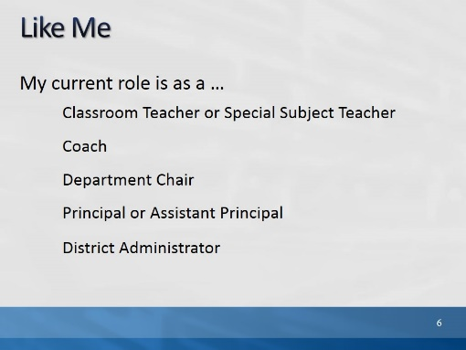Slide 6
(On each click, a sentence completer will appear.)

1. Direct participants: “Stand if the sentence completer describes your current role in education, and say, ‘Like me.’” Please look around the room to familiarize yourself with others who are in a similar role to you.”
2. Read each phrase aloud, e.g., “I am a coach.” As each group stands, ask each person to introduce themselves and their district, school. Thank them and direct them to sit down, rather than remain standing. (Facilitator: Note approximately how many folks in each role.)
3. Ensure that each person has had a chance to introduce themselves by asking, “Have I missed any one?”
4. Then ask folks to raise their hands if they are representing a particular subject area or all subject areas: Supporting all subject areas, Science and Technology, History/Social Studies, ELA. Remind participants to look around for others in their same subject area. (Facilitator: Make a note of approximate numbers to be aware of for later groupings.)
5. Last, ask how many folks are here “solo” and if any participants are new today and did not attend Module 1. It will be important over the course of the day to occasionally divide those who have come in large groups from one district and to fully include all participants and to make certain any new participants are seated with participants who did attend Module 1.
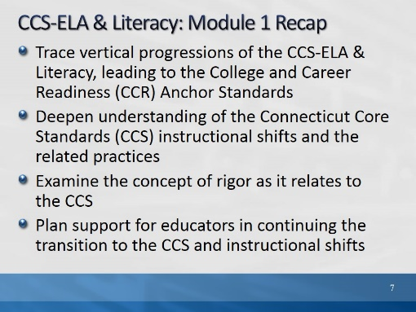Slide 7
Review Module 1 Activities:
- Purpose of Module 1 was to establish a baseline of information for future modules, deepen our understanding through collaborative discussion, and ensure that all coaches were able to share the same information with educators in their schools and districts about the ELA & Literacy Standards and shifts.
- We did an activity where pairs selected and traced a standard through three grades (or grade bands), and discussed with their tables the implications of vertical progressions.
- We then examined the three instructional shifts, viewed and debriefed video lessons, and created anchor charts which we later visited in a gallery walk.
- We reviewed a written lesson plan and accompanying video of the lesson through the lens of the EQuIP Rubric.
- We read a short article and discussed rigor as it relates to the Common Core.
- And we spent time in individual reflection, paired and shared discussion, and collaborative planning.
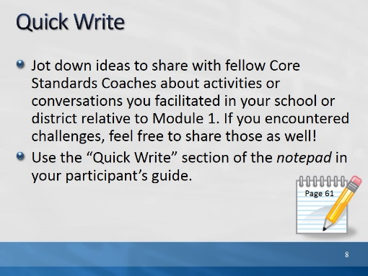Slide 8
Blank.
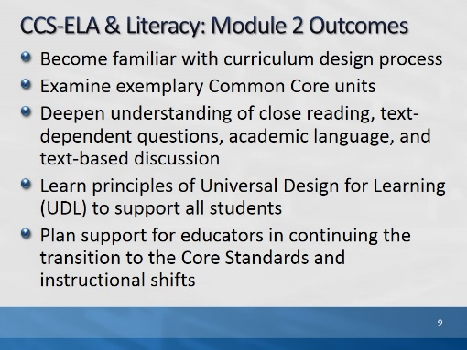Slide 9
Review the expected outcomes:
- This module will continue to build a foundation for participants’ work and will focus on key outcomes such as:
- Design of CT Core Standards-aligned units and lessons
- Deeper understanding of practices associated with close reading
- Designing supports for all students with Universal Design for Learning
- This module builds on the baseline Core Standards knowledge established in Module 1.
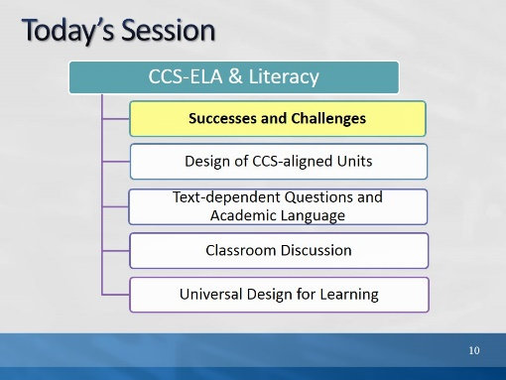Slide 10
The purpose of the morning is to look closely at parts of effective units and lessons that align with the CCS-ELA & Literacy.
- The activities for today will mirror the types of instructional practices which will support students in achieving proficiency on the standards and assessments.
- First, we will review your experiences with sharing the information from Module 1 with your colleagues.
- Then, we will look carefully at structures and protocols for close reading, text-based questions, academic language, and text-based discussions; all parts of effective lesson and unit planning.
- Finally, in the afternoon, we will then look at instructional supports and related instructional practices to assist all students in obtaining proficiency on the CCS-ELA & Literacy.

