Module 2  Facilitator Guide | Supporting All Students in Close Reading, Academic Language, and Text-Based Discussion

Activity 8

Connecticut Core Standards for English Language Arts and Literacy

Grades K–5

Systems of Professional Learning

Session at-a-Glance

Activity 8: Applying UDL Supports to a Lesson (15 minutes)
In this activity, participants will revisit the UDL Wheel, UDL Framework and Guidelines, and the UDL supports in the Participant Guide. Using these resources, they will review their lesson with their partner and consider the UDL supports that could be added to close reading, text-dependent questions, academic language, and discussions to support all students.

Supporting Documents:
- UDL Framework and Guidelines with examples of instructional practices that align with the CCS-ELA & Literacy and instructional shifts and include UDL Supports
- UDL Wheel http://udlwheel.mdonlinegrants.org/
- Draft close reading lesson

PowerPoint Slides:
- 92–94
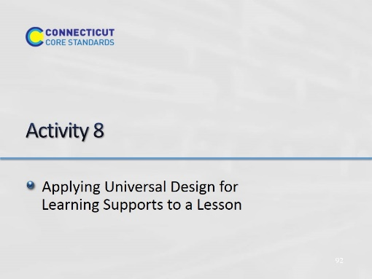Slide 92
Blank.
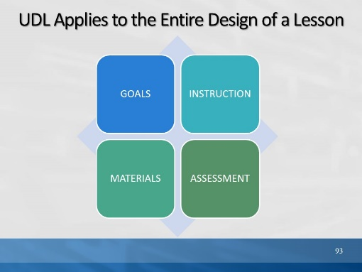Slide 93
When designing lessons, consider UDL supports and practices for the lesson goals, the materials and methods, the instruction, and how students are assessed.

Activity 8
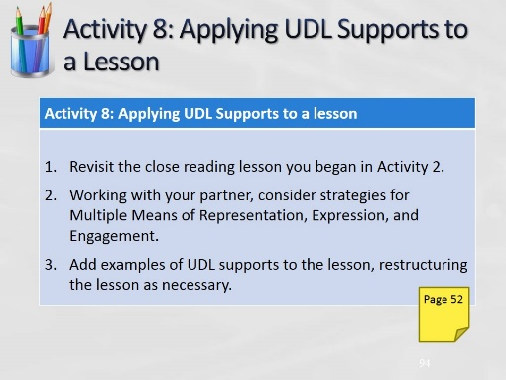Slide 94
(Allow 15 minutes for this activity; adjust time as needed.)

