Module 2  Facilitator Guide | Supporting All Students in Close Reading, Academic Language, and Text-Based Discussion

Activity 6a and 6b

Connecticut Core Standards for English Language Arts and Literacy

Grades K–5

Systems of Professional Learning

Session at-a-Glance

Activity 6a and 6b: Viewing a Video and Choosing a Protocol (25 minutes)
Participants view a video of a fourth grade class engaged in text-based discussion, and will consider the importance of protocols for creating a productive environment for students. They will also note where formative assessment opportunities arise during the lesson. After viewing and discussing the video, participants select a protocol from a list of discussion protocols, learn about it, and explain it to others. Each pair of participants selects a discussion protocol to use in their close reading lesson.

Supporting Documents:
- Directions
- List of Discussion Protocols
- Lesson Plan Template

Video:
- Science Talk from Expeditionary Learning http://vimeo.com/76178452

PowerPoint Slides:
- 57–60

Session Implementation
Activity 6a
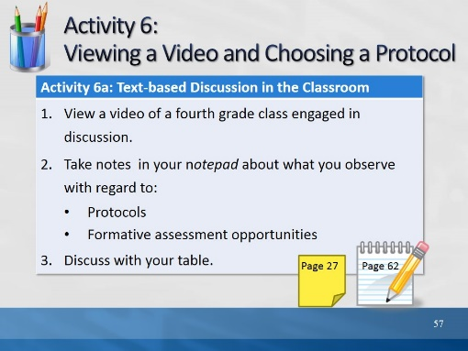Slide 57
Description of the Activity:
In Activity 6a, participants will view a video of a fourth grade class engaged in text-based discussion, and will consider the importance of protocols for creating a productive environment for students. They will also note where formative assessment opportunities arise during the lesson. The video can be found here: Science Talk from Expeditionary Learning http://vimeo.com/76178452

After viewing and discussing the video, in Activity 6b participants will select a protocol from a list of discussion protocols in their Participant Guides, learn about it, and explain to others.
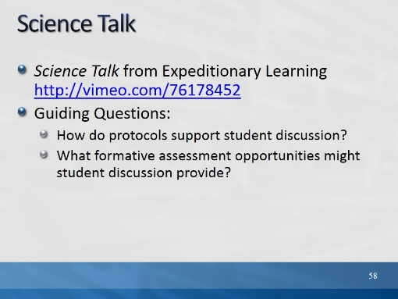Slide 58
These guiding questions also appear in the Participant Guide.

Activity 6b
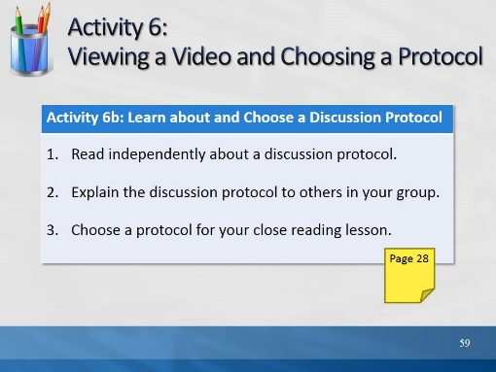Slide 59
Description of the Activity:
Participants will view a video of a fourth grade class engaged in text-based discussion, and will consider the importance of protocols for creating a productive environment for students. They will also note where formative assessment opportunities arise during the lesson. After viewing and discussing the video, participants will select a protocol from a list of discussion protocols, learn about it, and explain to others. The video can be found here: Science Talk from Expeditionary Learning http://vimeo.com/76178452
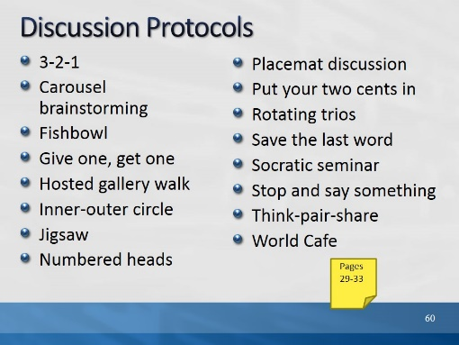Slide 60
Explain to participants that these protocols are described in their Participant Guide. At their table, each of them should choose a different protocol and study it briefly. Then they will describe it to others at their table.

