Module 2  Facilitator Guide | Supporting All Students in Close Reading, Academic Language, and Text-Based Discussion

Activity 10

Connecticut Core Standards for English Language Arts and Literacy

Grades K–5

Systems of Professional Learning

Session at-a-Glance

Activity 10: Action Planning (25 minutes)
Participants will develop a strategy for sharing Module 2’s key messages and instructional resources (e.g., PowerPoint presentations, videos, resource links, and aligned instructional practices) with colleagues.

Supporting Documents:
- Key Messages Template

PowerPoint Slides:
- 99–100

Session Implementation
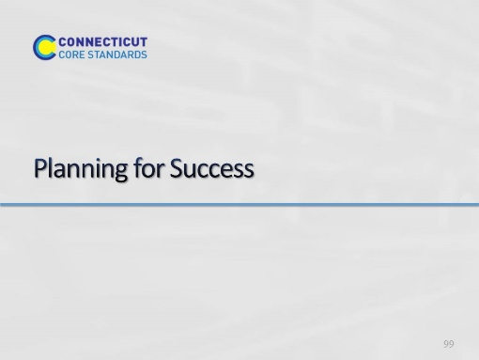Slide 99
Blank.
Activity 10
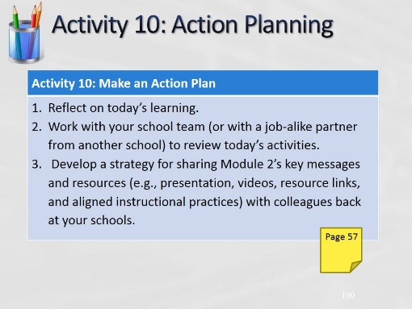Slide 100
(Allow 25 minutes for this activity; adjust time as needed.)

