Module 1  Facilitator Guide | Focus on Practice Standards

Section 4

Connecticut Core Standards for Mathematics

Grades K–5

Systems of Professional Learning

Session at-a-Glance

Section 4: Supporting Students to “Make sense of problems and persevere in solving them” (35 minutes)
Participants will begin by working through the Two Machines, One Job Activity. Participants will debrief the task as a large group and talk about the experience from a personal standpoint. Participants will then work together to discuss what would be needed to help students make sense of this problem and to persevere in solving it. Using this information and the experience of the Two Machines, One Job Activity, participants will create a description of a classroom environment that is set up to help students “Make sense of problems and persevere in solving them.”

Supporting Documents:
- Two Machines, One Job Activity

Materials
- Chart paper and markers

PowerPoint Slides:
- 67–69

Session Implementation
Section 4
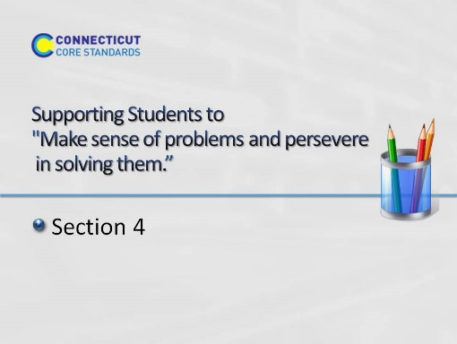
Slide 67
Section 4: Supporting Students to “Make sense of problems and persevere in solving them.”
Section 4:Training Objectives:
- For participants to experience a mathematics task from a student’s perspective in order to gain a deeper understanding of what it means to make sense of a problem and persevere in solving it.
Section 4 Outline:
1. Participants will begin by working through the Two Machines, One Job task. Participants will debrief the task as a large group and talk about the experience from a personal standpoint. 2. Participants will then work together to discuss what would be needed to help students make sense of this problem and to persevere in solving it. Using this information and the experience of the Two Machines, One Job task, participants will create a description of a classroom environment that is set up to help students “Make sense of problems and persevere in solving them.”
Supporting Documents
Two Machines, One Job
Materials
Chart paper, markers, tape
Key Implementation Notes:
In this activity participants will work a challenging problem and then discuss what information they needed in order to make sense of the problem and how they helped themselves to persevere. Note that this problem is NOT a K-5 problem. However, it was chosen in order to have participants feel, see, and understand what students go through as they work to make sense of problem and persevere in solving them. With that in mind, be sure to move throughout the room as participants work, ask questions that will help participants move forward if they get stuck, and to listen closely as groups work. Make note of interesting comments, ideas, and strategies that you will want to make sure to raise in the large group discussion.
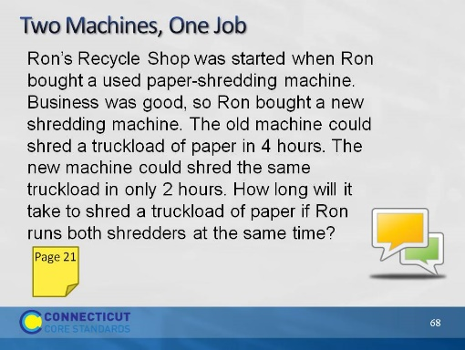
Slide 68
Two Machines, One Job: Explain to participants that you want to give them an opportunity to see, think, and feel what their students do when solving problems. Have them first read the problem (on the slide and in the Participant Guide on page 26) and take 3 minutes to start working on this alone. When three minutes are up, have participants work in small groups to solve the problem. The first 5 minutes of their group work should entail each group member taking one minute to present their initial thoughts. No one else should talk as they should be in listening mode only. After the 5 minutes of sharing has been completed, have participants work together to expand on those ideas and solve the problem. Give them 20 minutes to work and explain that each group should put their final solution on chart paper. If you see that groups are struggling, stop the work about every 5 minutes and have the whole group discuss where they are, what their thinking is, and strategies that they are trying. This is a good way to help those that are struggling to hear other ideas and perspectives rather than waiting until right at the end. Also, use this time to answer questions that participants might have about the problem. Just be careful not to give away a possible solution with your answers. When time is finally called, have groups share their work and, as a large group, talk about what made this problem challenging, what did they have to do to make sense of the problem, and what it felt like to persevere with this problem. This will give participants a quick look into what we are asking students to do. Also, ask participants to identify specific strategies that you used in order to assist them in persevering with solving this problem. Answers to look for may include strategies such as the following: the questions that were asked, having participants draw a picture, having participants break the problem into smaller parts, and so forth. The goal of this portion of the discussion is to provide examples of instructional strategies that can be used with students to help them persevere when solving challenging problems.
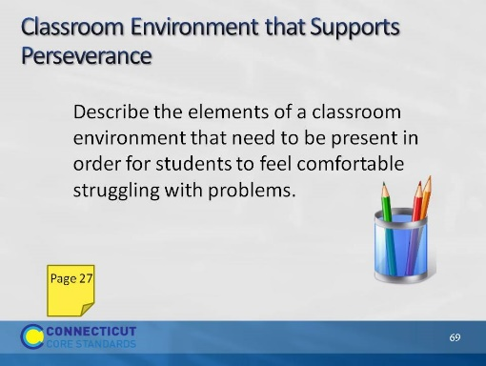
Slide 69
Classroom Environment that Supports Perseverance. Direct participants attention back to the norms they created for working together as adults and ask them to think about the environment that was created that allowed them to feel comfortable with struggling and persevering with the Two Machines, One Job problem. Now, ask them to think about how those environmental elements translate into the classroom environment. Have participants, on page 27, create a description of a classroom environment that supports perseverance. As time permits, have volunteers share their ideas before moving on to the next activity. Key aspects that need to be brought out the conversation include, a safe environment for asking questions, a understanding that mistakes are important steps in learning, an understanding that multiple perspectives are helpful in creating a solution strategy, and that there is not always one right way to solve a problem. Transition to the next section by explaining to participants that even though multiple and varied strategies for solving the same problem are promoted within the standards, one thing that must stay constant is students attention to the precision of the mathematics.

