Module 1  Facilitator Guide | Focus on Practice Standards

Section 2

Connecticut Core Standards for Mathematics

Grades K–5

Systems of Professional Learning

Session at-a-Glance

Section 2: Supporting Change (20 minutes)
Participants will first be introduced to the stages of change and will discuss the implications of working with teachers through these stages. A focus will be placed on creating a professional learning environment in which teachers feel comfortable in expressing their ideas, strengths, and challenges on their personal implementations of the CCS. Participants will then go through the process of setting norms for working within their professional groups in this session as a way to model the types of considerations that will need to be made back at their school. As they engage in this process, participants will work in their group to answer questions such as: In a conversation, what is something that encourages you to speak your mind? What is something that deters you from expressing your ideas? Responses will be recorded on chart paper. Later, in Secton 4, when perseverance is addressed, these norms will be referenced as a way to look at creating a classroom environment in which the Standards for Mathematical Practice can be developed.

Supporting Documents:
- Stages of Change
- Creating an Environment for Personal Change

Materials:
- Chart paper and markers

PowerPoint Slides:
- 17–19

Session Implementation
Section 2
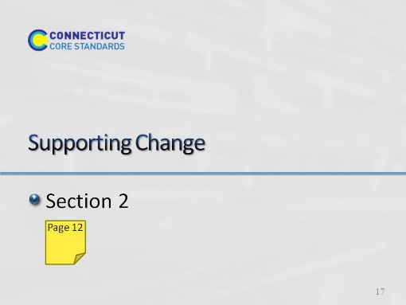
Slide 17
Section 2: Supporting Change
Section 2 Training Objectives:
- To understand the stages of change that teachers will go through as they work through their implementation of the CCS.
- To practice the process for setting norms within a learning group in order to anticipate how they will support teachers through their stages of change.
Section 2 Outline:
- Participants will first be introduced to the stages of change and will discuss the implications of working with teachers through these stages. A focus will be placed on creating a professional learning environment in which teachers feel comfortable in expressing their ideas, strengths, and challenges on their personal implementations of the CCS.
- Participants will then go through the process of setting norms for working within their professional groups in this session as a way to model the types of considerations that will need to be made back at their school. As they engage in this process, participants will work in their group to answer questions such as: In a conversation what is something that encourages you to speak your mind? What is something that deters you from expressing your ideas? Responses will be recorded on chart paper. Later, in Section 4, when perseverance is addressed, these norms will be referenced as a way to look at creating a classroom environment in which the Standards for Mathematical Practice can be developed.
Supporting Documents
Stages of Change
Creating an Environment for Personal Change
Materials
Chart paper, markers
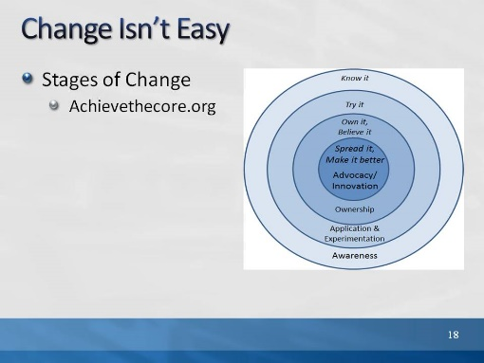
Slide 18
Change Isn’t Easy: Explain to participants that change is often difficult, and full implementation of the new standards cannot and will not happen overnight. It will be a process. In this regard, it is helpful to think about the stages of change and celebrate progress through the stages. Note that the chart on the slide has been provided on page 12.
- Review the stages as follows:
- Stage 1 is Awareness – simply knowing what is being asked and what it means
- Stage 2 is Application and Experimentation – Getting your toes wet, trying out new strategies and perspectives
- Stage 3 is Ownership – That’s the moment you get buy-in; you believe in the change and take it on personally
- Stage 4 is Advocacy and Innovation – This is the point where you are proficient and can help others and make improvements in the work itself.
- Let participants know that, as coaches, they should look for signs of where people are and find appropriate ways to support them where they are, and to leverage current stage. They need to understand that for many teachers, the CCS-Math may represent a new way of understanding math themselves.
- It’s also important to know where you are as a coach on this road and to keep yourself moving, celebrating the progress you make and simultaneously preparing for the next steps.
- After reviewing the stages, ask participants to think about where the teachers in their school are now and how they can help teachers work through these stages of change. Depending on where each school is in their implementation of the CCS, some teachers may only be at the Know It stage, while others may be at the Try It stage or beyond. For those that are at the Know It stage, participants will need to think carefully about the information being presented within each module in order to determine how they will bring the information back to teachers. They will also need to consider how they will help teachers to implement strategies that will be presented in order to help teachers to move to the Try It stage. Knowing where teachers are in the change process will help participants frame their goals for each session in terms of what they need to do to help teachers move forward towards Advocacy and Innovation.
- Transition to the next activity by explaining to participants that because teachers are all at a different place with the change process, the environment for change needs to be one that supports each individual. Transition to the next activity by explaining that one way they can begin to shape the environment for change is to have teachers set norms for how they will work together and discuss the changes that are taking place.
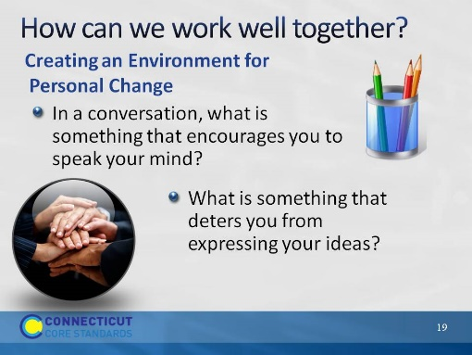
Slide 19
Creating an Environment for Personal Change? Ask participants to silently answer the questions on page 13. Tell them that when everyone at the table has written their answers, they share responses, noting any features of conversation that seem really important in facilitating comfort and productivity. Then ask participants to share one or two important ideas from each table. As they share, chart the responses. Develop a consensus around the list for how participants will try to keep the conversation comfortable and productive for everyone. Hang the completed list on the wall as later, when perseverance and student discourse are addressed, these norms can be referenced. Explain that these norms for working together will be used throughout the work that participants will do within each module and that this is a process that they can use back at their school to help teachers begin to get comfortable with working with each other through the changes required by the CCS.

