Module 1  Facilitator Guide | Focus on Practice Standards

Section 1

Connecticut Core Standards for Mathematics

Grades K–5

Systems of Professional Learning

Session at-a-Glance

Section 1: Understanding the Foundations of the Connecticut Core Standards (55 minutes)
The facilitator will engage the group in a discussion on what participants currently know about the CCS. Participants will first discuss the question in small groups and then will share out their answers during a large group discussion. As participants share, the facilitator will chart their responses. The facilitator will wrap up the discussion by posing the question ‘How is what they know about the CCS different from what they know about past instruction in mathematics?’. The facilitator will use participant responses to transition into a brief period of direct instruction on the three shifts of focus, coherence, and rigor.
After presenting on the shifts of the CCS, the facilitator will lead the participants in an examination of the EQuIP Rubric to begin the discussion on the impact of the shifts at the classroom level. From there, participants will use a method, similar to two-column note taking, to document their personal questions around the shifts and the CCS, leaving space to record answers to their questions that will be generated as the session continues.
Participants will then view segments of the Phil Daro video, Against Answer Getting in order to begin to answer the question ‘Why do we need a change in mathematics teaching and learning?’
The facilitator will wrap up Section 1 by debriefing the video with participants in a large group and using the broader topic of change to transition to the next section on supporting teachers in the process of changing instructional practice.

Supporting Documents:
- What Do We Know
- The Impact of the Shifts
- The Personal Journey of the CCS
- EQuIP Rubric (separate handout)

Materials:
- Chart paper and markers

Video:
- Phil Daro - Against Answer Getting: http://www.youtube.com/watch?v=B6UQcwzyE1U

PowerPoint Slides:
- 6–16

Session Implementation
Section 1
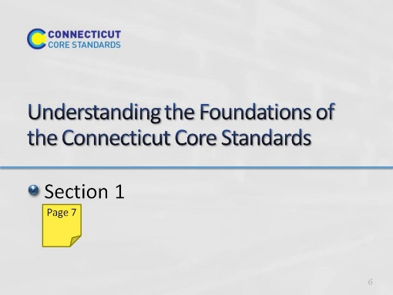
Slide 6
- Blank
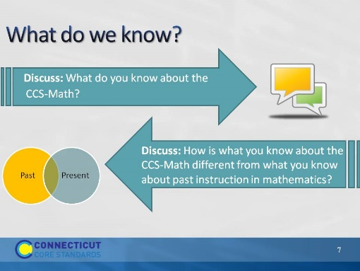
Slide 7
What do we know? – Have participants take five minutes to answer the first question on the slide by talking with the people at their table. Space has been provided on page 7 for participants to make a list of everything they collectively know about the CCS-Math.
When time is called, debrief the small group discussions as a large group and chart participants’ key understandings about the CCS-Math. After a list is generated, ask the question ‘How is what they know about the CCS-Math different from what they know about past instruction in mathematics?’. Possible answers to listen for include: in the past, mathematics focused on basic skills and the CCS require a focus on learning to solve problems and in the past mathematics was taught from perspective of repetitive calculations and now mathematics needs to focus more on solving problems. Use this quick comparison as you proceed to the next few slides that summarize shifts in the CCS. Refer back to participants answers and move quickly through those that the group clearly knows about and linger a bit more on the ones that present new information.
Explain to participants that as you go through the next slides that they can make additional notes in the What do we know about the CCS-Math? on page 7 in the Participant Guide.
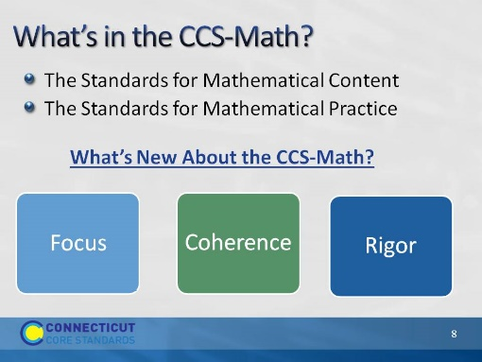
Slide 8
- What’s in the CCS-Math? There are two parts to the Connecticut Core Standards for Mathematics, Standards for Mathematical Content and Standards for Mathematical Practice. Together they define what students should understand and be able to do in their study of mathematics in order to be College and Career Ready.
- The Standards for Mathematical Content are very specific about concepts, procedures, and skills that are to be learned at each grade level, and contain a defined set of endpoints in the development of each. Explain to participants that while today’s focus is on the Standards for Mathematical Practice, we will be going in-depth into the Standards for Mathematical Content in a future session.
- Focus participants back on the Standards for Mathematical Practice. Explain that these standards are often simply called the Practice Standards or the practices, and that is the way they will be referred to during the remainder of this session. The practices include the mathematical habits of mind and mathematical expertise that students should develop such as reasoning, communication, making arguments, and modeling.
- What’s New About the CCS-Math?
- In order to meet both the Content Standards and the Practice Standards, the writer’s of the Common Core explicitly based the standards on three very important fundamentals of mathematics that were missing from or were not as explicit in different versions of mathematics standards. Those are: Focus, Coherence, and Rigor. Explain to participants that we will now take a few moments using the next five slides to explore how these are embedded within the Core Standards.
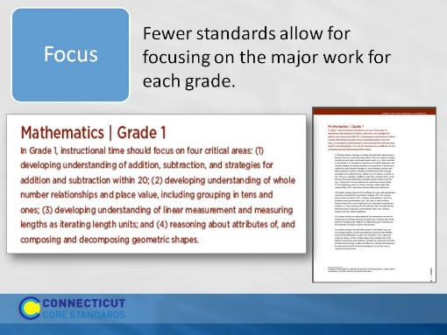
Slide 9
Focus: The writers of the standards worked very hard to reduce the number of expectations at each grade level. This work was not done arbitrarily. They focused on the different domains of mathematics such as Operations and Algebraic Thinking, Number and Operations in Base Ten, Geometry, and Measurement and Data, and determined what work was critical for students at each grade level to address in order to develop the concepts in each domain over time. This reduction in the number of standards allows teachers to shift their instruction to focus on the major work at their grade and to spend more time in each of these critical areas in order for students to develop a deep understanding through investigation, inquiry, and problem solving.
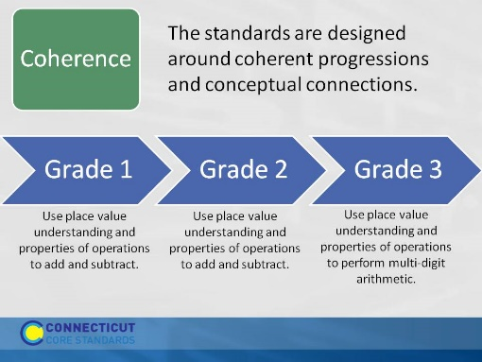
Slide 10
Coherence: Coherence means ensuring that there is a clear sequence of concepts and skills that build on each other across the grades. In the example of Coherence in the Participant Guide on page 8, point out the grade 1 standard 4 and grade 2 standard 5. The connection between these is that in grade 1, students add within 100 using strategies, concrete models, etc. Then, in grade 2, students are expected to fluently add and subtract within 100. Then point out the grade 2 standard 7 and grade 3 standard 2 to show a similar progression for adding and subtracting within 1000.
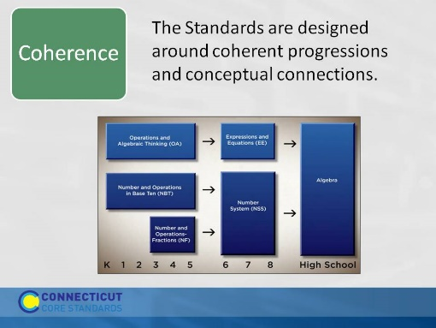
Slide 11
Coherence: The chart on the slide shows one of the progression in the CCS-Math that builds up to algebra in high school. Note that the Operations and Algebraic Thinking standards in grades K–5 lead up to and are designed to help middle school students work with Expressions and Equations, which will then help students to be successful in high school algebra. This same progression takes place with the Number and Operations domains. In K–5 the Number and Operations standards are split over two domains, Base Ten and Fractions. This does not mean that the standards within the domains are not connected, but that there is a focus on each. Fractions are not explicitly focused on until 3rd grade, after students have formed a foundation for Base Ten. Deep work over time within these two Number and Operations domains will support middle school students to be able to work within the Number System, supporting further success as they progress into high school algebra.
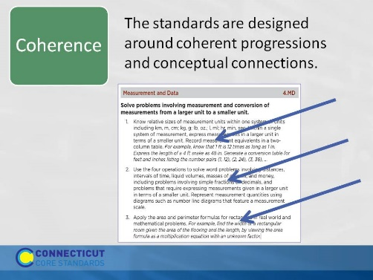
Slide 12
Coherence: Coherence also means ensuring that connections and relationships among ideas are highlighted and made clear. Students should see each standard as an extension of previous learning, not as a new and separate chunk. The arrows on the slide are pointing to examples of key pieces of learning from other domains being integrated into the standards in the Measurement and Data domain, such as using operations to solve word problems covering domain specific topics of time, distance, volume (etc.), using number lines to represent measurements, and using equations to solve domain specific mathematical problems. Each of these examples shows how learning gained in other domains such as Number and Operations in Base Ten and Operations and Algebraic Thinking, crosses over into the domain of Measurement and Data.
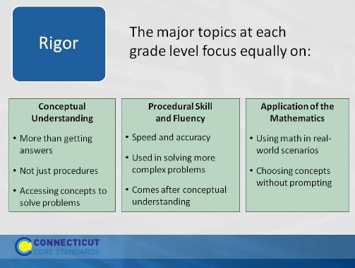
Slide 13
Rigor: Rigor means learning that is based in the deep understanding of ideas AND fluency with computational procedures AND the capacity to use both to solve a variety of real world and mathematical problems. Tell participants that conceptual understanding, procedural skill and fluency, and application of mathematics will be addressed in much more depth in future modules when we discuss planning lessons around specific content learning goals and when we discuss how to assess both the Practice and the Content Standards.
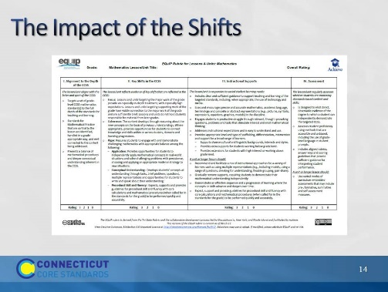
Slide 14
The Impact of the Shifts: Distribute copies of the EQuIP Rubric. Explain to participants that the EQuIP Rubric is a tool for evaluating CCS-Math lesson plans. Allow participants to review the rubric on their own and then as a group. As they discuss the rubric in their groups, ask them to think about their responses to the comparison of mathematics instruction in the past and in the present that were provided in the first activity of this section and to think now about how those changes will impact planning, teaching, and learning at the classroom level. Debrief the small group discussions by adding to the chart of what participants know about the CCS-Math.
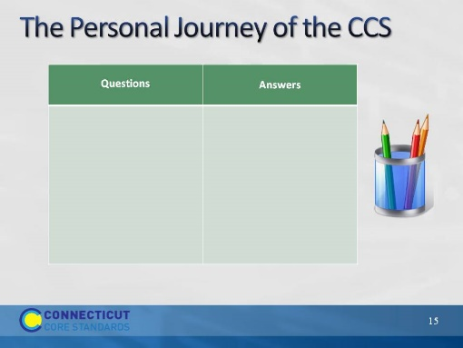
Slide 15
The Personal Journey of the CCS: Explain to participants that before they move on the next section, you want them to take a moment to write down, in the Questions column in the chart on page 10, any questions that they personally have right now about the CCS-Math. Further explain that throughout this and future sessions they can refer back to their list of questions and document the answers as they are found.
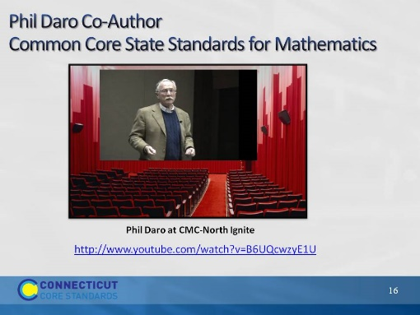
Slide 16
Phil Daro: Tell participants that to find answers to their questions they will now hear from Phil Daro, one of the major figures involved in writing the Common Core Standards and a professor at Stanford University, as he discusses what mathematics instruction should look like in the era of the Common Core and the need for change in mathematics teaching and learning. Play the video and then wrap-up Section 1 by debriefing the video with participants as a large group. Use the overarching topic of change to transition to Section 2, in which participants will begin to look at their role in helping teachers make the changes within their classroom that have been discussed.

