Module 1  Facilitator Guide | Focus on Practice Standards

Section 6

Connecticut Core Standards for Mathematics

Grades 6–12

Systems of Professional Learning

Session at-a-Glance

Section 6: Teaching with the Standards for Mathematical Practice (95 minutes)
Participants are first engaged in an exploration of the instructional strategies of asking effective questions, engaging students in mathematical discourse, and teaching and learning mathematics through multiple representations. Through their exploration, participants will engage in a discussion around how these strategies can be used to help students develop the mathematical practices. Participants will then use this information to assist in an examination of a sample lesson plan through the lens of the EQuIP Rubric. During the lesson examination, participants will focus only on sections of the rubric that specifically discuss the Standards for Mathematical Practice. Participants will build off of this experience and work within a small group to plan a set of instructional suggestions around a given mathematics task that teachers could use with students and that will meet the expectations set forth in the EQuIP. The facilitator will wrap up Section 6 by having participants discuss their experience and identify possible teacher questions and challenges that they may encounter back at their school.

Supporting Documents:
- Asking Effective Questions
- Multiple Representations
- Steps to Getting Students Talking
- Sample Lesson Plans
- Section 6 Problem Set
- Middle School – The Average Price of Jeans
- Algebra – Phone Plans
- Algebra – The Warehouse Problem
- Geometry – Exploration: Angles and Polygons

Materials:
- Chart paper and markers

PowerPoint Slides:
- 73–79

Session Implementation
Section 6
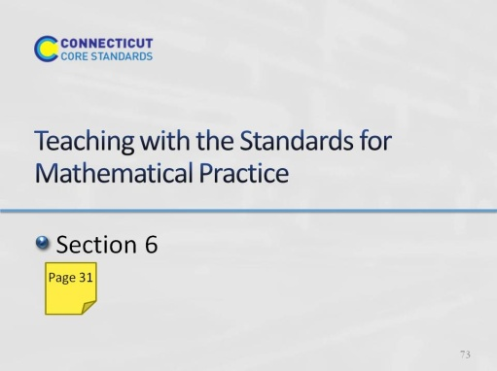
Slide 73
Section 6: Teaching with the Standards for Mathematical Practice
Section 6 Training Objectives:
- To introduce participants to specific instructional strategies that will promote the development of the mathematics practices.
- To help participants plan for the inclusion of the mathematical practices in everyday classroom lessons.
- To provide an opportunity for participants to apply the EQuIP Rubric for evaluating lesson plans.
Section 6 Outline:
- Participants are first engaged in an exploration of the instructional strategies of asking effective questions, engaging students in mathematical discourse, and teaching and learning mathematics through multiple representations. Through their exploration, participants will engage in a discussion around how these strategies can be used to help students develop the mathematical practices.
- Participants will then use this information to assist in an examination of a sample lesson plan through the lens of the EQuIP Rubric. During the lesson examination, participants will focus only on sections of the rubric that specifically discuss the Standards for Mathematical Practice.
- Participants will build off of this experience and work within a small group to plan a set of instructional suggestions around a given mathematics task that teachers could use with students and that will meet the expectations set forth in the EQuIP. The facilitator will wrap up this Section 6 by having participants discuss their experience and identify possible teacher questions and challenges that they may encounter back at their school.
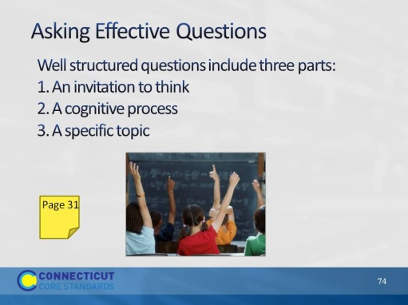
Slide 74
Asking Effective Questions: Begin the discussion by asking for some examples of questions that were asked in the Kites activity and have participants think about why those questions were asked. Then, have participants compare the those questions to the list of questions generated during Section 3 around each of the practices. Lead participants in a discussion of how the questions were similar and how they were different.
Have participants review the Asking Effective Questions handout. As they review, have them highlight or underline ideas that are new to them that they would like to try or that are important for them personally to remember. Also, have participants consider how they will introduce the strategy of asking effective questions to teachers at their school. Point out to participants that in Connecticut, and in alignment with the SBAC Content Specifications, we use Hess’ Cognitive Rigor Matrix which expands on the ideas that Bloom’s taxonomy frames for better questioning. If time permits, ask for volunteers to share their thoughts.
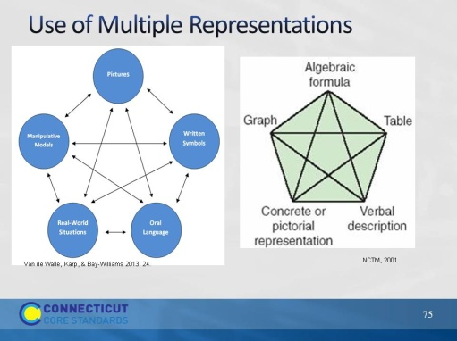
Slide 75
Use of Multiple Representations: Have participants look at the two models for using multiple representations on the slide. Explain that the model on the left can be used by younger students to guide their use of multiple representations while the model on the right can be used by older students. Have participants discuss briefly in their groups how the different representations are connected in both models. Have participants discuss how the use of multiple representations were used in solving the Kites problem and have them provide examples of the Practices that can be supported by their use. Wrap up the discussion by calling on 5–6 participants in rapid succession and having them give one sentence that summarizes their thinking about the use of multiple representations and one strategy for introducing the importance of multiple representations to their teachers.
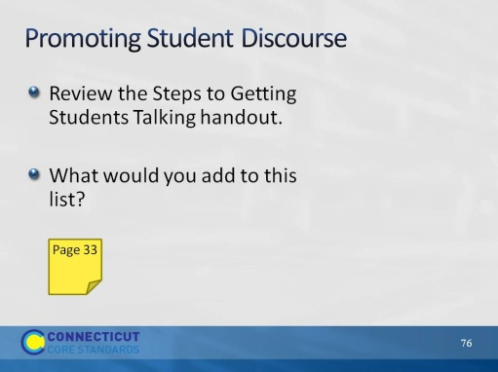
Slide 76
Promoting Student Discourse: Have participants look at their copy of the eight practices and identify how many have “communication of ideas” embedded within them. The answer is that all eight say something about communication somewhere in the standard. This just reiterates the importance of having students talk both in small and large groups as this gives them practice with learning to express their mathematical thinking and ideas.
In small groups, have participants review the Steps to Get Students Talking (page 33) in the Participant Guide and ask each group to come up with two more ideas that they got from the video or from the discussion today to add to the list. Wrap up this discussion by having groups share their two ideas.
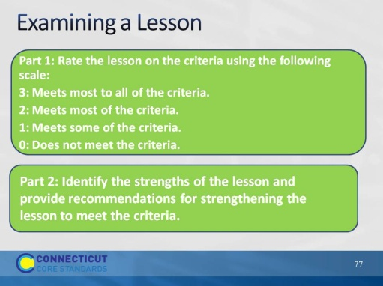
Slide 77
Examining a Lesson. Explain to participants that in this activity they are going to work together as a group to examine a lesson plan designed to teach the standards. They will examine this lesson by using the EQuIP rubric. Note for participants that every criteria on the rubric WILL NOT be used at this point. Have participants note or underline the following criteria as these are the criteria that they will use in their examination:
I. Alignment to the Depth of the CCSS: Bullet 2.
II. Key Shifts in the CCSS: Application under Bullet 3.
III. Instructional Supports: Bullets 1-4.
Within their group, participants should use the lessons and the space on page 38 to complete both parts of the lesson examination.
Part 1: Rate the lesson on the criteria using the following scale:
3: Meets most to all of the criteria.
2: Meets most of the criteria.
1: Meets some of the criteria.
0: Does not meet the criteria
Part 2: Identify the strengths of the lesson and provide recommendations for strengthening the lesson to meet the criteria.
After groups work, engage participants in a large group discussion on their findings. Transition to the next activity by explaining to participants that they will use their experiences with the practices, solving Kites, and examining the lesson to think through instructional suggestions that they might provide a teacher around a central mathematics task within a lesson.
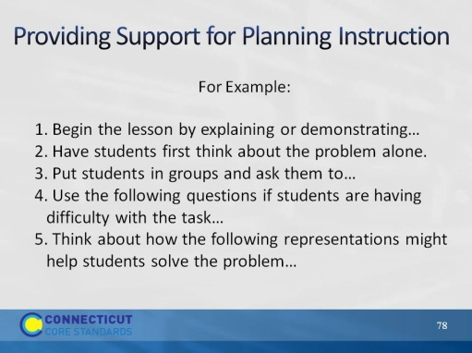
Slide 78
Providing Support for Planning Instruction: Have each group choose one task from those provided. Explain for their lesson, they will create several suggestions that they might give a teacher if they were helping them to plan a lesson around the task. For example their list might look something like:
- Begin the lesson by explaining or demonstrating...
- Have students first think about the problem alone.
- Put students in groups and ask them to...
- Use the following questions if students are having difficulty with the task…
- Think about how the following representations might help students solve the problem...
As time permits have participants share their suggestions with the larger group.
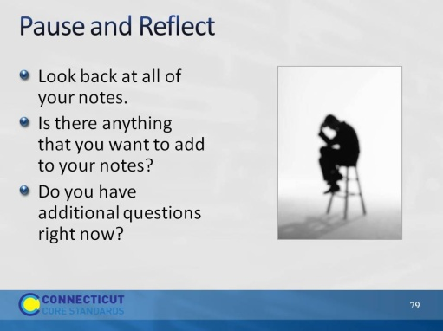
Slide 79
Pause and Reflect: Before moving to the next activity, allow participants two or three minutes to look back over their questions and fill in any new answers found in the second half of the day.

