Module 1  Facilitator Guide | Focus on Practice Standards

Section 3

Connecticut Core Standards for Mathematics

Grades 6–12

Systems of Professional Learning

Session at-a-Glance

Section 3: Understanding the Standards for Mathematical Practice: Developing Mathematical Expertise (90 minutes)
Section 3 begins with participants solving problems that are each aligned to one of the Standards for Mathematical Practice. The facilitator then provides information on each of the eight practices, including information about the standard, what the standard means, instructional supports for helping students to develop the practice, and sample “I Can” statements. Throughout the presentation, participants will answer questions and work in groups to determine which of the problems was an example of the practice, and to create grade level “I Can” statements for each of the practices based on their new understanding of each practice.
The section wraps up with teachers discussing how they would pair the practices based on their attributes and then viewing Bill McCallum’s Mathematical Practices Grouping Chart.

Supporting Documents:
- Problem Set: Practice Standards Alignment
- Understanding the Mathematical Practices

Materials:
- Chart paper and markers

PowerPoint Slides:
- 21–65

Session Implementation
Section 3
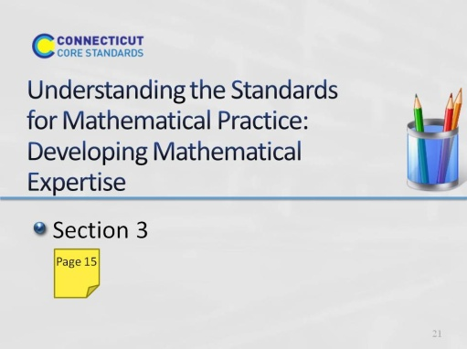
Slide 21
Section 3: Understanding the Standards for Mathematical Practice: Developing Mathematical Expertise
Section 3 Training Objectives:
- To introduce all eight of the Standards for Mathematical Practice and adapting the language of the practices to make each grade level appropriate without reducing rigor.
Section 3 Outline:
- Section 3 begins with participants solving problems that are each aligned to one of the Standards for Mathematical Practice.
- The facilitator then provides information on each of the eight practices, including information about the standard, what the standard means, instructional supports for helping students to develop the practice, and sample “I Can” statements. Throughout the presentation, participants will answer questions and work in groups to determine which of the problems was an example of the practice, and to create grade level “I Can” statements for each of the practices based on their new understanding of each practice.
- The section wraps up with teachers discussing how they would pair the practices based on their attributes and then being shown Bill McCallum’s Mathematical Practices Grouping Chart.
Supporting Documents
Problem Set: Practice Standards Alignment
Understanding the Mathematical Practices
Materials
Chart paper, markers
Key Implementation Notes:
In this activity, participants will work sample problems that will help them to understand what each of the Standards for Mathematical Practice look like in a classroom situation. Participants will work the problems without knowing the Practice Standard they are most aligned with and the alignment is revealed later during the presentation.
Begin the activity by asking participants to form eight GRADE LEVEL table groups. Once grade level groups have been formed, ask participants to turn to the Problem Set in their Participant Guide on pages 15-16. Number the groups. Participants should work the problem that coincides with their group number. Participants should work the problem individually and hold off on the group discussion until directed to do so during the presentation of each of the Practice Standards.
While participants are working the problems, hang eight pieces of chart paper around the room. Each piece of chart paper should be labeled with one of the practices. After participants finish working, the problems in the Problem Set tell them to move around the room and rate their personal understanding of each of the practices. They should use a rating scale of 1–5 with 1 having little or no understanding and 5 having a deep understanding of the practice. This exercise will allow you to gauge participants’ understanding of the practices and help you to determine the pace of the practices presentation.
During the interactive presentation on all eight of the practices, participants will need their copy of the Standards for Mathematical Practice. Suggest that participants use the Understanding the Mathematical Practices on pages 17-24 to make notes and answer questions in each of the designated areas.
Note: You should spend approximately 5-7 minutes per practice for the first four practices, and then 20-25 minutes on the small group discussions of the last four practices and 5-10 minutes debriefing the small group discussions.
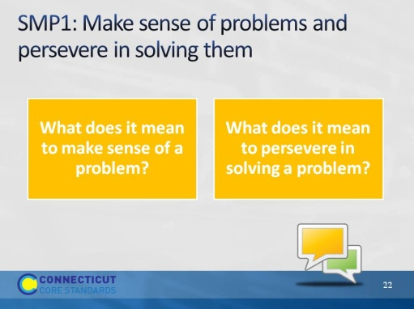
Slide 22
SMP1: Have participants think for a moment about the questions on the slides. Ask for one or two volunteers to share their answer to the questions.
Responses that you want to listen for include points such as:
- Making sense of a problem means that students are able to break the problem into usable parts and determine how each part will be used to answer the question.
- Making sense of a problem means that students are able to use the information in the problem to determine the final questions to be answered.
- Persevering in solving a problem means that students ‘stick with it’ and do not give up when they find themselves challenged.
- Persevering in solving a problem means that students are able to ask questions about the problem that will help them clarify points of the problem and make the final problem question make sense rather than wait for someone to tell them how to solve the problem.
These two questions are answered in more depth over the next four slides.
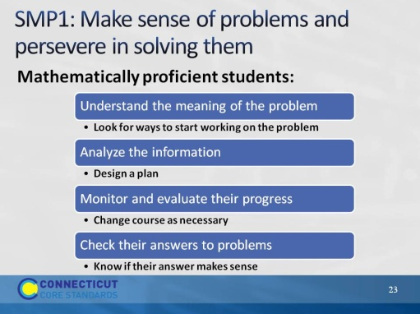
Slide 23
SMP1: Review the checklist of attributes on the slide. As you get to the end of the list, ask for participants who had a problem that required them to do a number of these things as they came up with a solution. Allow groups a minute to discuss with their group to determine if their problem was the one most closely aligned to this practice.
Note: Participants may say that all of the problems had some element of this practice, however the problem on the next slide was chosen because it exemplified this practice more than any of the others.
Slide 24
SMP1: Explain that this problem was chosen as the most closely aligned to this practice. Ask for a volunteer from the group who worked this task to discuss this alignment. Key points to make:
- There is no simple algorithm that will solve the problem directly. Students have to find a way to think about the problem and develop a strategy. It may require several false starts.
- Students may be uncomfortable thinking about a problem that is not routine. They will have to work through that in order to successfully answer the question in the problem.
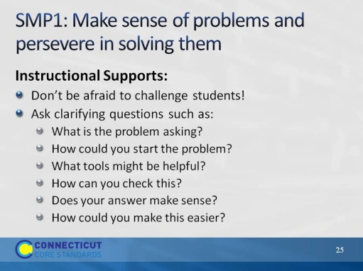
Slide 25
SMP1: Review the instructional supports on the slide. Note for participants that the first support or idea, “Don’t be afraid to challenge students!” will be seen throughout the practices. Ask participants what they think it means to challenge students. During the discussion, focus their thinking on challenging students by requiring students to really think about the mathematics. The Common Core is not about learning how to get an answer, as we heard Phil Daro discuss. The Common Core is about learning to solve problems. Solving problems is much more rigorous than getting answers. Students need to be challenged to gain conceptual understanding of the mathematics being taught and must reach a point of being able to recognize, on their own without prompting, when to apply the mathematics that they have learned to solve problems in new situations. This will be challenging and possibly uncomfortable for many students, however, students will need to be challenged in order to develop their mathematical expertise.
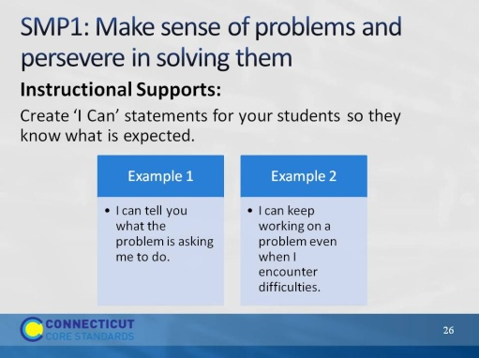
Slide 26
SMP1: Review the ‘I Can” statements on the slide. Ask participants if they would add any statements here that would better fit students at their grade level. As volunteers provide their statements, make sure that they align with the practice so that students are receiving the correct information.
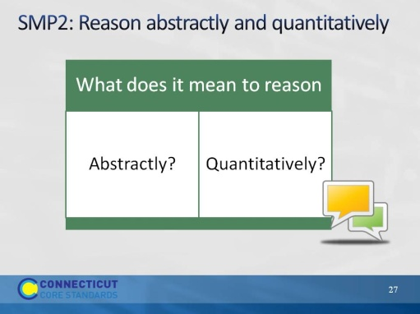
Slide 27
SMP2: Review the questions on the slide. Allow participants to think for a moment and then ask for volunteers to share their answers.
As you listen to participants’ answers, listen for things such as:
- Reasoning abstractly means to reason within a context or within a situation, form theories, understand problems on a complex level through analysis and evaluation, and to know when and how to apply knowledge when solving problems.
- Reasoning quantitatively means to apply their mathematical skills to solve a problem. Students understand the values that they are working with and are able to relate those to the problem itself.
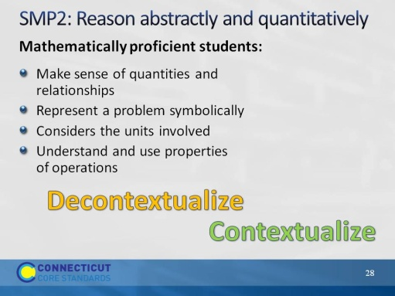
Slide 28
SMP2: Review the points on the slide. At the end of the list, know that some participants may not understand what it means for students to able to decontextualize and contextualize. To decontextualize means to be able to pull the values out of the problem situation and do the work with them that needs to be done. For example, in the problem, Olivia has 4 apples and Sophia has 6 apples. If they both give their apples to Anna, how many apples will Anna have? When decontextualizing, students are able to represent the problem as 4+6=10. And then to contextualize, they are able to put the final values back in to the problem situation. If students were given the number sentence 4+6=10 and are able to create a problem situation that makes the number sentence, this would be considered contextualizing as well.
Before moving to the next slide ask participants to look at the problems they solved and determine whose problem would be aligned with this practice.
Slide 29
SMP2: Reveal that the ‘field trip’ problem was chosen for this practice because, not only do students need to apply Practice 2 when working the problem, but they must also think about their answer within the context of the problem itself. While 167 divided by 48 gives us an answer of 3.47 or 3 with a remainder of 23, a student cannot use their calculated answer to solve the problem because the problem is not asking them to solve 167 divided by 48. The problem is asking them to determine how many buses are needed. Division is one tool that can be used to determine this. Others are estimating, rounding, etc. The final answer is four buses are needed.
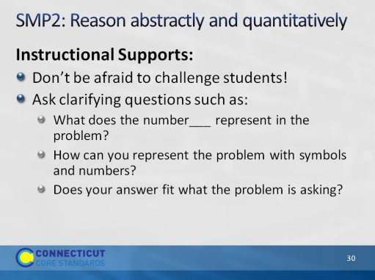
Slide 30
SMP2: Review the instructional supports on the slide.
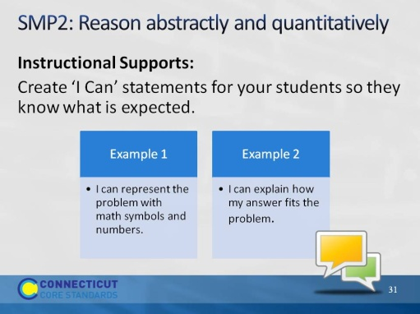
Slide 31
SMP2: Review the ‘I can” statements on the slide. Ask participants if they would add any statements here that would better fit the students at their grade level. As volunteers provide their statements, make sure they align with the practice so that students are receiving the correct information.
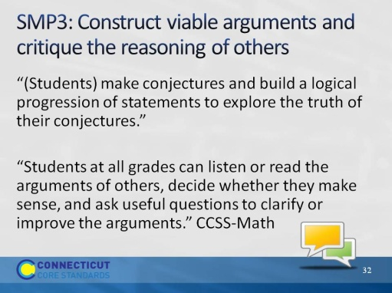
Slide 32
SMP3: Have participants read the two quotes on the slide. Ask them to tell you some thoughts or key words that jump out at them. Chart their responses so that there is a visual to discuss. Some things to watch and listen for are: construct arguments, arguments of others, decide, ask useful questions, and improve arguments. As participants look at the completed list of their responses on chart paper, have them think about what is not said. After a 30 second wait time, explain that this practice is not just about students explaining their work. It is about students telling why what they did worked, or didn’t work. Remember, it’s important for students to know and understand where something went wrong. Not knowing why something did or did not work can lead to misconceptions. Critiquing the reasoning of others does not mean to simply tell if another student got the answer right or wrong. It means that a student has to understand a peer’s approach and be able to tell why the mathematics behind that approach worked or did not work.
Use the next four slides to support these two quotes.
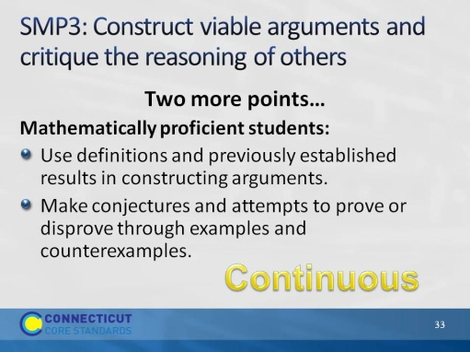
Slide 33
SMP3: Review the points on the slide and further emphasize to participants that this practice is continuous. Constructing viable arguments and critiquing the reasoning of others is something that should be done in small and large group discussions, in a student’s own work, etc. This should happen all the time. Before moving on, have participants determine which of the problems align most closely with this practice.
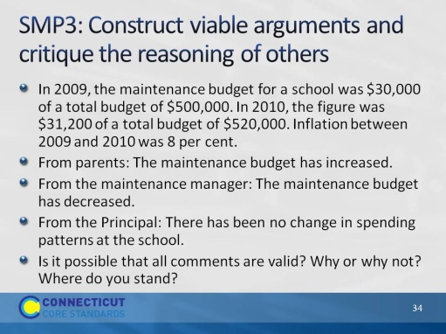
Slide 34
SMP3: Explain that this problem was chosen because students have to justify their answer using mathematics. In a classroom situation, this would be a good opportunity to have students compare answers and strategies. If students reach different answers, ask students to examine each other’s approach and to determine whose answer is right and why. Ask participants if anyone currently does this in their classroom and if so, have them describe the strategies they use. Allow other participants to ask questions. The next two slides provide additional instructional supports for Practice 3.
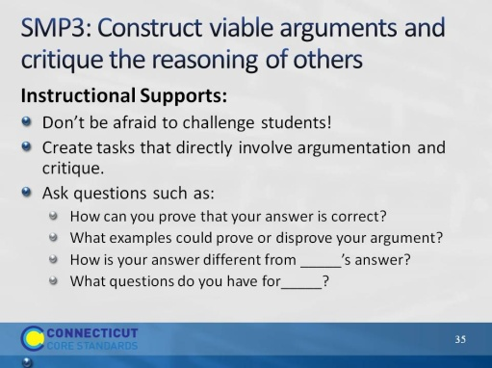
Slide 35
SMP3: Review the instructional supports on the slide.
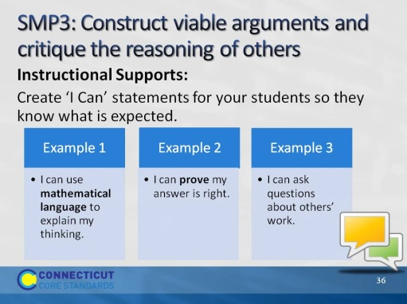
Slide 36
SMP3: Review the ‘I Can’ statements on the slide and ask participants if they would add anything to the list. Allow volunteers to share their ideas and then move to the next practice.
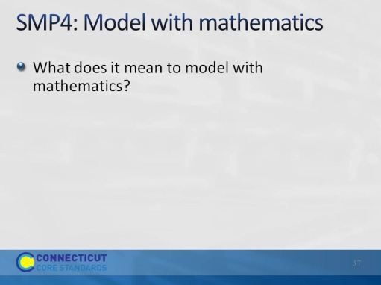
Slide 37
SMP4: Ask participants to think about the question on the slide and explain that Practice 4 is one that tends to be interpreted rather narrowly. Modeling with mathematics is not just about building a concrete model or drawing a picture. It is more about doing those things to model mathematical situations and using those to develop an equation that makes sense for the problem. There is more on this over the next four slides. Before moving on, ask participants which of the problems in the Problem Set best aligns to the practice of modeling with mathematics.
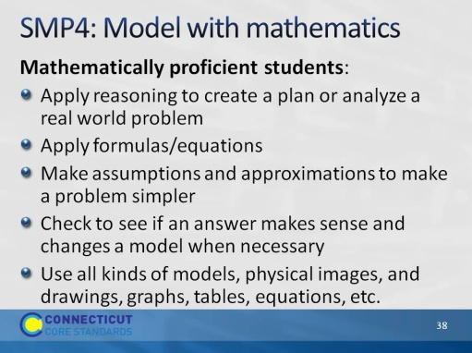
Slide 38
SMP4: Review the points on the slide.
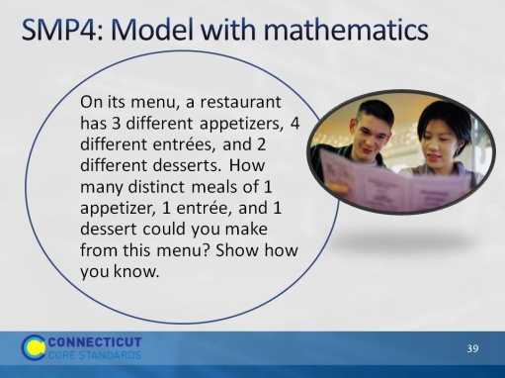
Slide 39
SMP4. Explain that, in this problem, students will generally have to come up with some type of model that will help them to solve the problem.
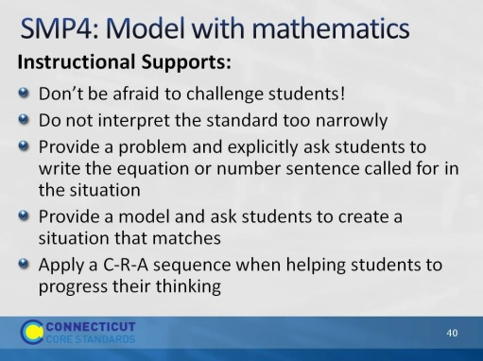
Slide 40
SMP4: Review the instructional supports on the slide. When you get to the last point, ask participants if they have heard of a C-R-A approach? If some have, ask them to explain this approach to the others. If no one has, explain that it is a continuum that they should use with students as they work through problems. Start with the concrete (C) such as using counters or cubes, move to the representational (R) such as pictures and drawings (things you have to create on paper that you cannot hold in your hand and physically manipulate), and then to the abstract (A) using mathematical symbols. As students work through problems, they can go back and forth along this continuum. For example, if a student is having trouble at the abstract stage, they can go back a stage until they are successful and then move forward again.
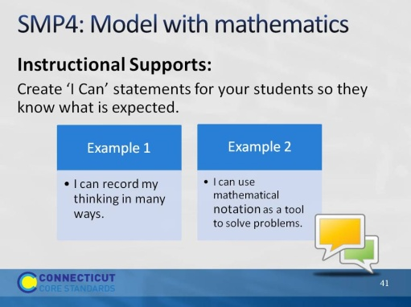
Slide 41
SMP4: Review the ‘I Can’ statements on the slide. Ask participants if they would add anything to the list that would make these statements more grade-level specific.
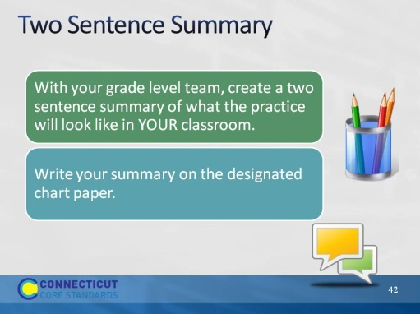
Slide 42
Two Sentence Summaries: Around the room, hang pieces of chart paper that are labeled with the first four practices. There will need to be three pieces of chart paper per practice. Label the first sheet “Grades 6 & 7,” the second sheet “Grades 8 & 9,” and the third sheet “Grades 10-12.” Allow participants 10 minutes to complete this portion of the activity and then move on to the last four practices.
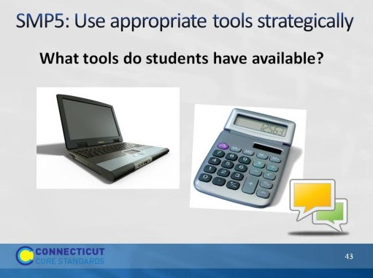
Slide 43
SMP5: Have participants brainstorm a list of the tools that students have available to them—in and out of the classroom—and to then share responses. If not brought up by participants, add tools such as calculators, computers, physical models, sketches, tables and charts, graph paper, geoboards, number lines, word walls, lists of problem solving strategies, their own previous work, etc. These may be things that we do not normally think of as “tools” but all can be used strategically when solving problems.
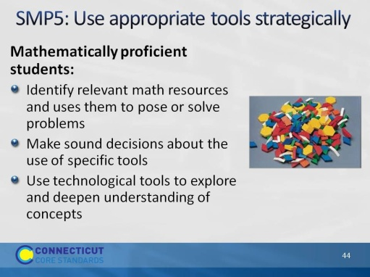
Slide 44
SMP5: Review the points on the slide and ask participants to determine which problem from the Problem Set most closely aligns with this practice.

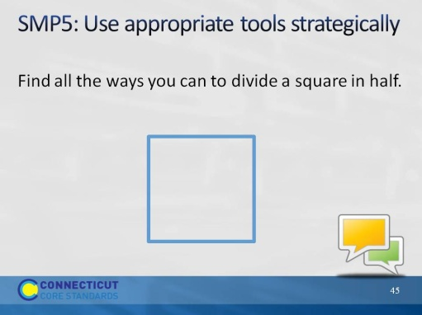
Slide 45
SMP5: Now that participants have had practice looking at four other problems and determining the alignment to the practices, have them talk for a moment at their tables and determine why this problem was chosen to represent the practice of using appropriate tools strategically. As participants talk, points that you will want to listen for (and to bring up, if participants do not) are: students may need simple 'low tech' tools like paper squares to fold and/or draw on or, if available a computer program that will let them do the same. But they will probably need some type of tool in order to solve the problem.
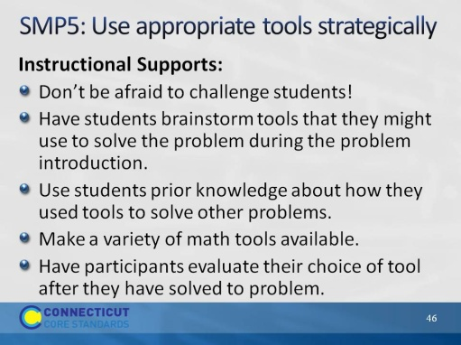
Slide 46
SMP5: Review the instructional supports on the slide.

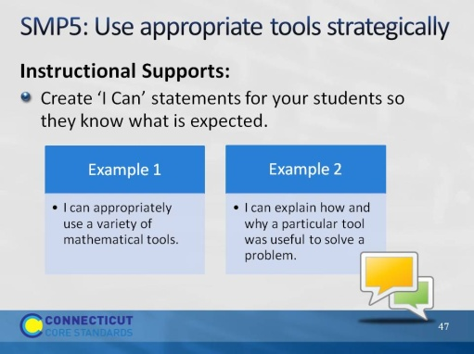
Slide 47
SMP5: Review the ‘I Can’ statements on the slide and ask participants if they want to add anything to make these grade-level specific. Ask for volunteers to share their thoughts and then move to the next practice.
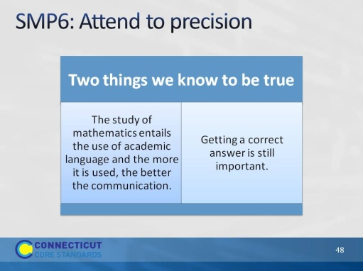
Slide 48
SMP6: Review the two points on the slide. Explain that, while we have to focus much of our attention on how students think and reason within mathematics, we do still want them to be precise as well.
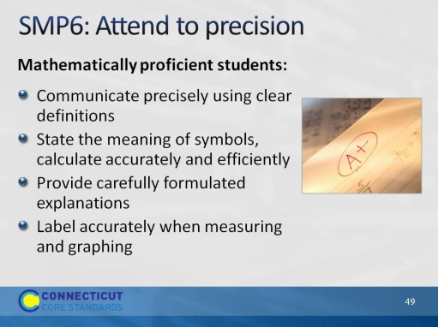
Slide 49
SMP6: Review the points on the slide.
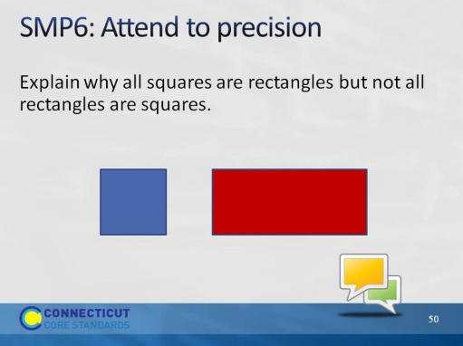
Slide 50
SMP6: Have participants work for three minutes in their small group to determine what types of mathematical language students would need to use when answering this question from the Problem Set.
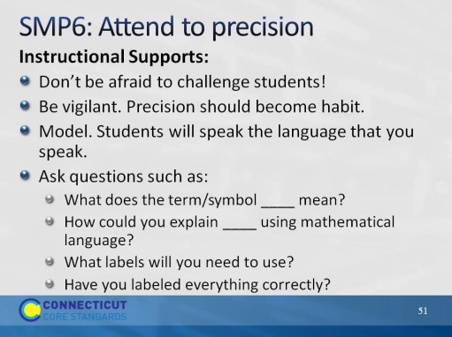
Slide 51
SMP6: Review the instructional supports on the slide.
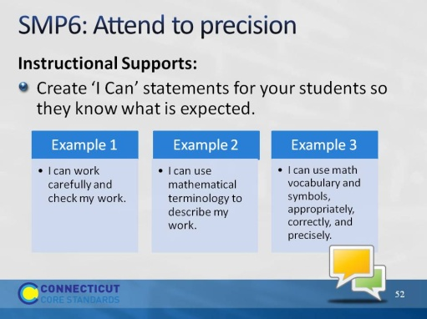
Slide 52
SMP6: Review the ‘I Can’ statements on the slide and ask participants if they would add any to the slide to make them more grade-level specific. After volunteers give their statements, move to the next practice.
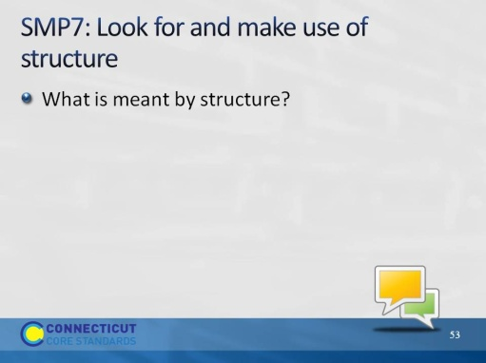
Slide 53
SMP7: Ask participants to think about the question on the slide and, in their table groups, try to come up with an answer to describe structure in mathematics. If participants struggle with this, let them know that, it’s ok. Practices 7 and 8 are two of the most difficult practices for teachers to visualize. This is due in part to the language used within the practice, which doesn’t always align to the language that would be used.
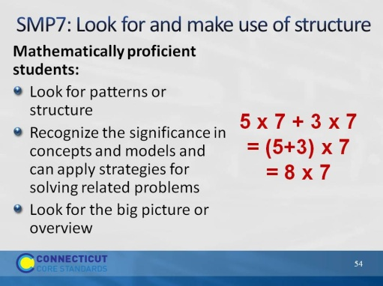
Slide 54
SMP7: Review the points on the slide. Use the example to further describe the idea of using structure. Students use structure when they understand that 8 x 7 is the same as 5 x 7 plus 3 x 7.

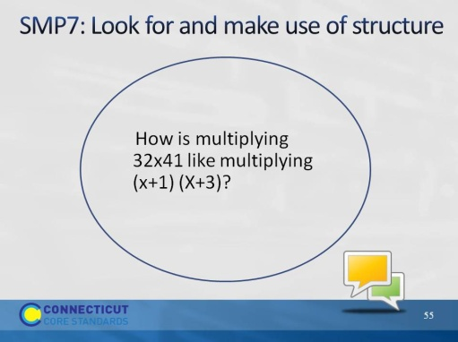
Slide 55
SMP7: Have participants look at their solution to this problem and determine what structure they used to solve this problem. They should notice that 32 is (30+2) and 41 is (40+1), so 32 x 41 is the same as (30+2)(40+1). The steps in the standard algorithm for multiplying 32 x 41 are the same steps as the “FOIL” method for multiplying (x + 1) (x + 3).
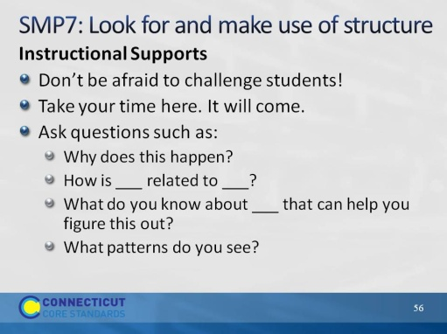
Slide 56
SMP7: Review the instructional supports on the slide.
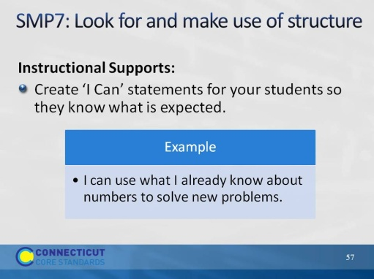
Slide 57
SMP7: Review the ‘I Can’ statement on the slide. Ask participants to come up with at least one other statement that can be used at their grade level. After volunteers have shared their statement, move on to the final practice.
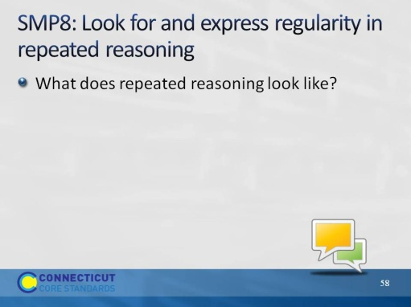
Slide 58
SMP8. To introduce this final practice, have participants think about examples they have seen of students using repeated reasoning in their classroom. An example might be determining a function based on the pattern seen in a table, chart, or graph. The next four slides will be used to support this practice.
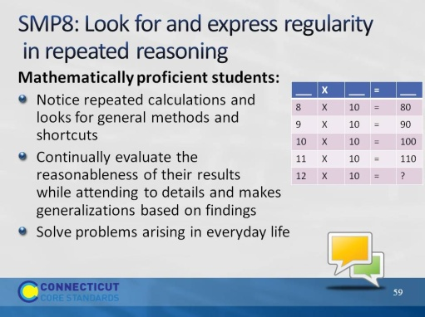
Slide 59
SMP8: Review the points on the slide. Ask participants how students can use repeated reasoning to find the missing value in the chart.

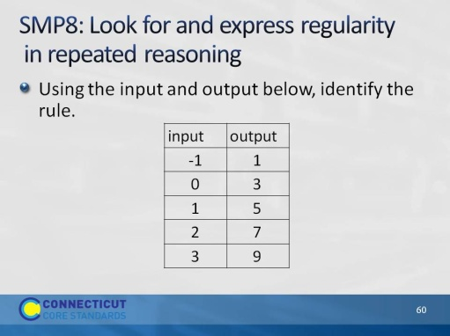
Slide 60
SMP8: Now challenge participants to look at this problem in the Problem Set. Ask for those that worked this problem to share their solution.
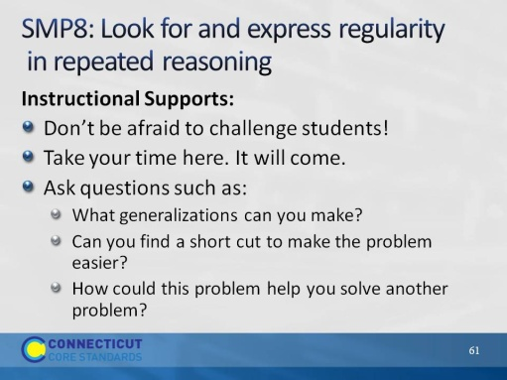
Slide 61
SMP8: Review the instructional supports on the slide.
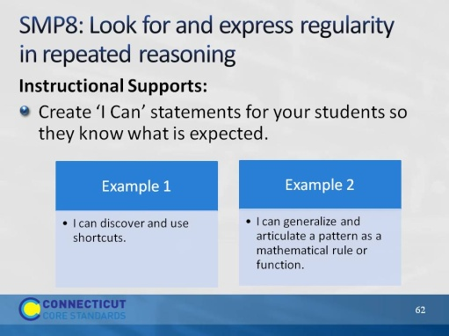
Slide 62
SMP8: Review the ‘I Can’ statements on the slide. Ask participants one last time to modify these to make them grade-level specific. Once volunteers have shared, move to the next slide.
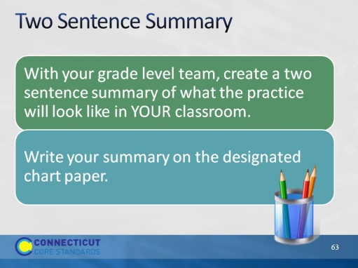
Slide 63
Two Sentence Summaries: Around the room, hang pieces of chart paper that are labeled with the final four practices. There will need to be three pieces of chart paper per practice. Label the first sheet “Grades 6 & 7,” the second sheet “Grades 8 & 9,” and the third sheet “Grades 10-12.” Allow participants 10 minutes to complete this portion of the activity.
Once participants have completed their summaries, have them revisit the chart on which they gave their initial rating of understanding and ask them to change the rating based on the last hours’ worth of work. Discuss with participants changes in their thinking, what they better understand now, and what they want to do once back in their classroom.
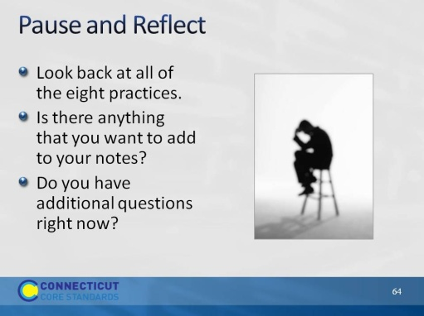
Slide 64
Pause and Reflect: Allow participants two or three minutes to look back over their notes on the practices and make any needed additions. Before moving to the next slide, ask participants how they might group the standards based on the relationships they see and that we have discussed thus far. The next slide will show an example of how the practices have been grouped by some of the writers of the CCSS-Math.
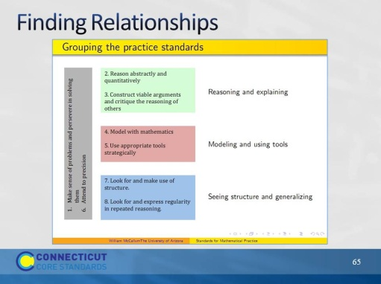
Slide 65
Finding Relationships: Explain to participants that Bill McCallum, one of the writers of the CCSS-Math, put together this chart to show how the practices can be grouped or organized based on their relationships. Ask participants if they would have grouped them differently and why. If participants are unsure of this grouping have them look for evidence in the standards themselves that support the organization found here. Further explain that Practice 1: “Make sense of problems and persevere in solving them” and Practice 6: “Attend to precision” are considered the overarching habits of mind of mathematical thinkers. This does not mean that these two practices are somehow more important. It means that these two practices are related to each of the other six practices. If needed, go back and look at the sample problems that were completed for each of the eight practices and have participants find evidence of Practice 1 and Practice 6 in each. When participants are ready to move on, let them know that because of the relationship that Practices 1 and 6 have to the other six practices, we are going to look more in-depth at each of those practices.

